Inflation Analysis

Project 2 Proposal

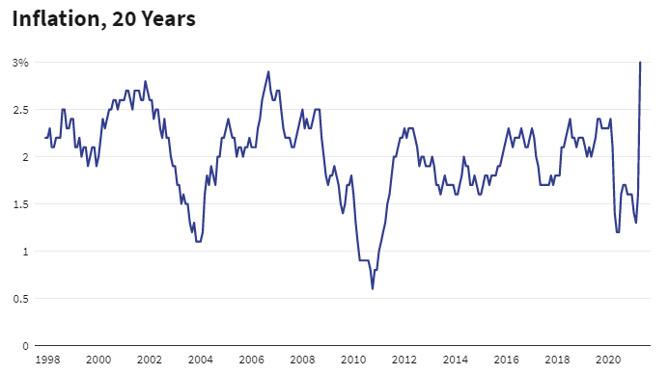

**Matt Maroofi & Don Irwin**

07/17/2021

MIDS W200 - Summer 2021

# 

# OVERVIEW

Our team is interested in presenting data which communicates the current state of inflation.  
  
Inflation has multiple definitions. A generally accepted definition is; a general increase in prices and fall in the purchasing value of money.  
  
There exists asset-price inflation, as well as consumer price inflation and producer price inflation.  
  
Asset price inflation impacts asset owners only. Asset holders those who own stocks, bonds, and real estate, constitute a very small minority of the population.  
  
Consumer price inflation impacts the entire population as it impacts attempting purchase, food, shelter, education, medical care, energy and transportation. …  
  
Producer price inflation feeds into consumer price inflation as it impacts the cost of producing consumer goods.  
  
We intend to aggregate data from the FED, available data series, as well as other available data.  
  
With the datasets available to us we will attempt to answer the following questions:

1. Are the measures of inflation reported by the FED accurate measures of real inflation in the economy?
2. What is the historic relationship between interest rates and inflation?
3. What is the relationship between the money supply M2 and inflation?
4. Is inflation likely to be transitory of permanent?
5. What is the impact of inflation on the working class and barely middle class in the United States?

# Data Types and Sources

The following are some of the data sources we’re investigating for inclusion:

Types:

1. Utility Stock Prices - specific tickers
2. Commodity Prices - indexes
3. Precious Metals -
4. Factory Capacity Utilization
5. Wages
6. Inflation Statistics
7. Interest Rates
8. Unemployment Rate
9. Currency Strength

Sources:

1. <https://fred.stlouisfed.org/docs/api/fred/>
2. <https://www.bls.gov/data/tools.htm>
3. Yahoo Finance

# Approach:

We are going to aggregate and distill different measures of asset price inflation, consumer price, and producer cost inflation.  
  
Our hypothesis is that the increase in the money supply, has led to asset price inflation in the stock, bond, and real estate markets. That coupled with disruption in supply chains, and base effects is pushing inflationary pressures.  
  
These inflationary pressures may be transitory, or they may be persistent.

Figure Three years with highest month over month CPI change on record.

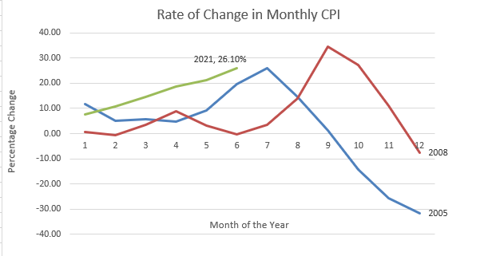

Figure Case Schiller National Price Index, showing price inflation.

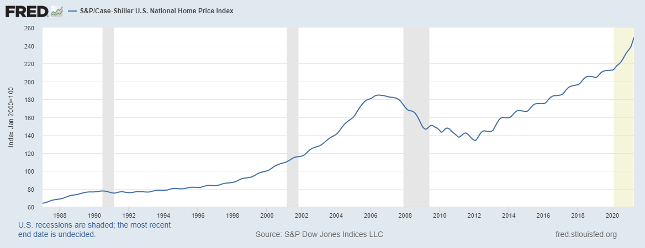

Much of the rise in the stock market is being fueled by stock buyback and retail investment frenzy. There exists a risk that the current inflation, fueled in part by mass increase in the money supply and ongoing quantitative easing by the FED, could give way to deflationary pressures which lay bare the fundamental weakness of the economy ravaged by the pandemic and an erosion in real wages for workers.

Figure Increase in the M3 money supply last 10 years.

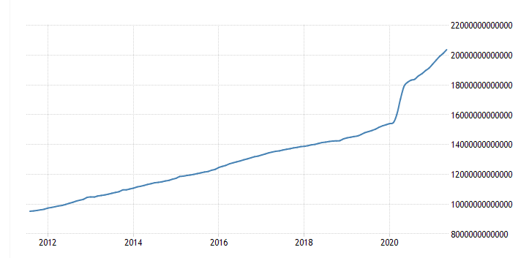

We look forward to reporting back on what the data we analyze reveals.