**REPORT**

***PART 1***

*Project2: Write a program with the following features:*

*1. List all the images files from a folder (including sub-folders)*

*2. Sort files by file name, file size, created date*

*3. Detect and highlight all the images file that have the same name (possible redundancy)*

*4. View an image by clicking on the image path*

*5. Search image files by keyword*

*The Graphical User Interface is written in C/C++*

*All commands are written in Shell Script*

***PART 2***

*Project1: Chat application with 2 users. Chat history is stored in a database*

1. Organization:

* Duong Vu Hoang Linh:
  + Write commands in Shell Script
  + The Graphical User Interface
  + Write report (main)
* Ngo Sy Tung Lam:
  + Store chat history in a database
  + The Graphical User Interface (main)
  + Write report

1. Products:
2. Browse the directory to manage images

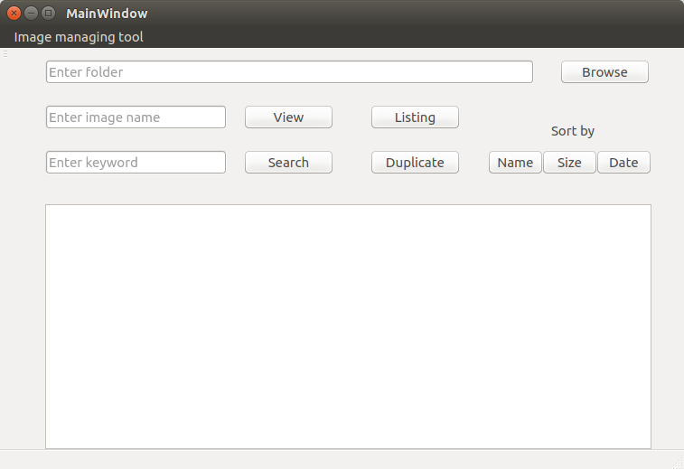

1. List all the images in the directory (including sub-folders) with details

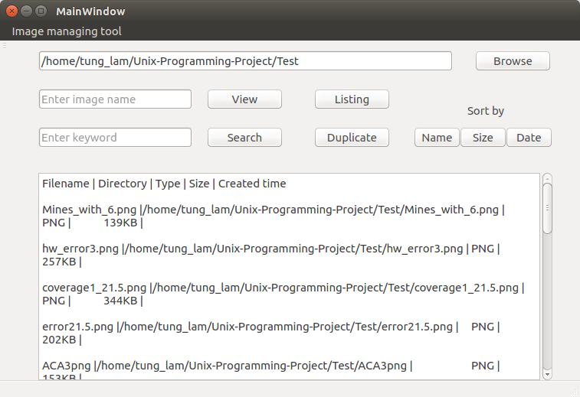

1. Sort images by file name

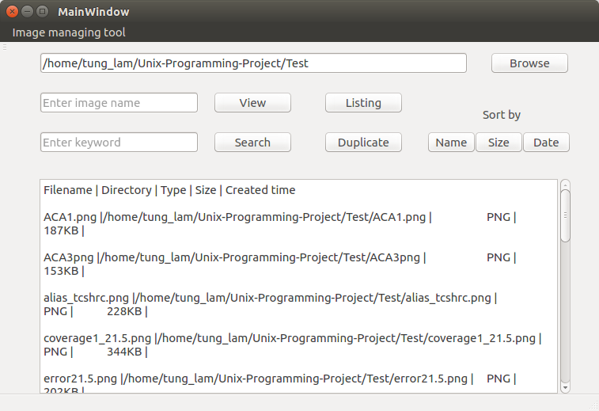

1. Sort images by file size

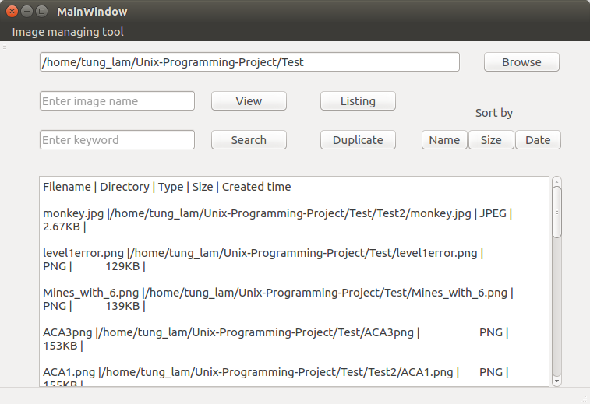

1. Sort images by created date

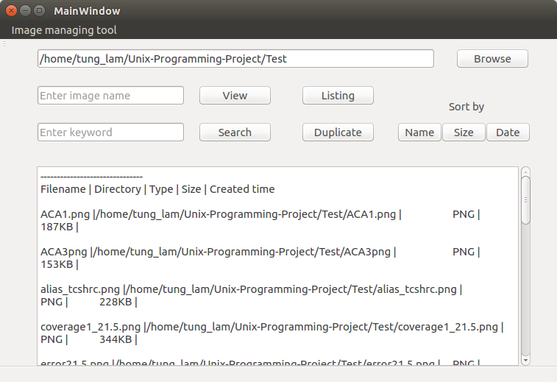

1. Detect and show all the images file that have the same name (possible redundancy)

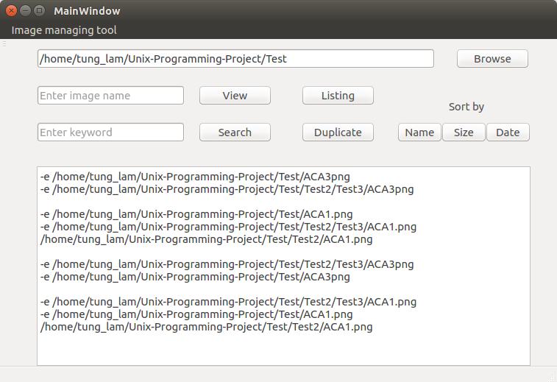

1. View an image by enter the file name

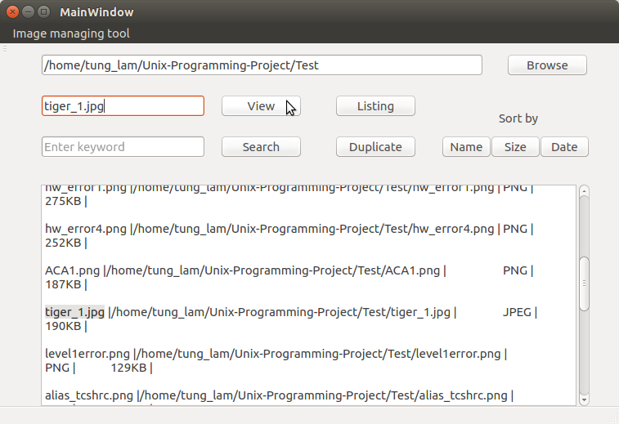

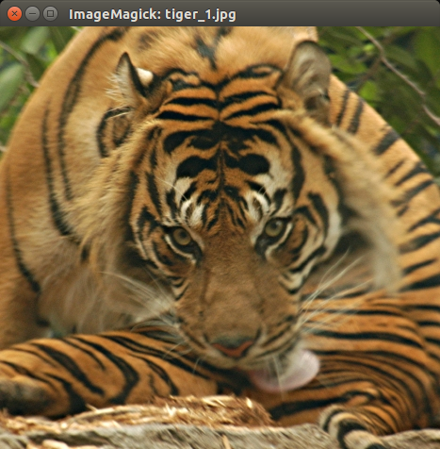

1. Search image files by keyword ( any type of keyword)

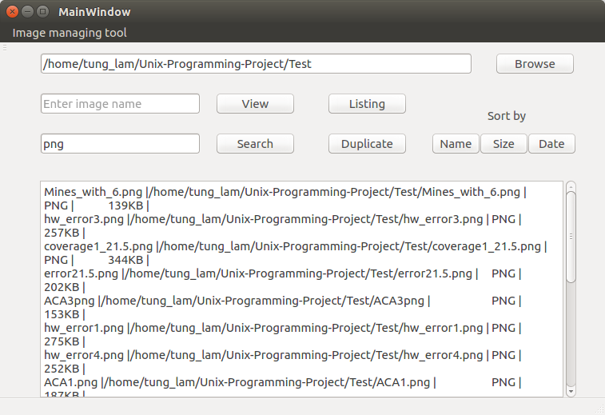

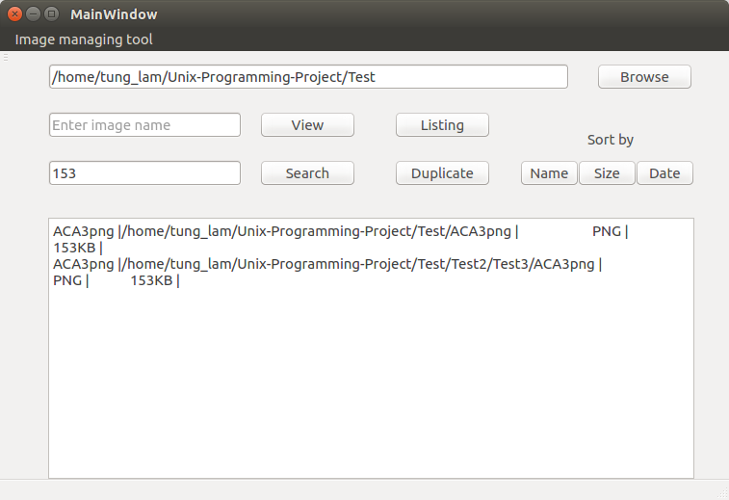

1. Chat windows of 2 users

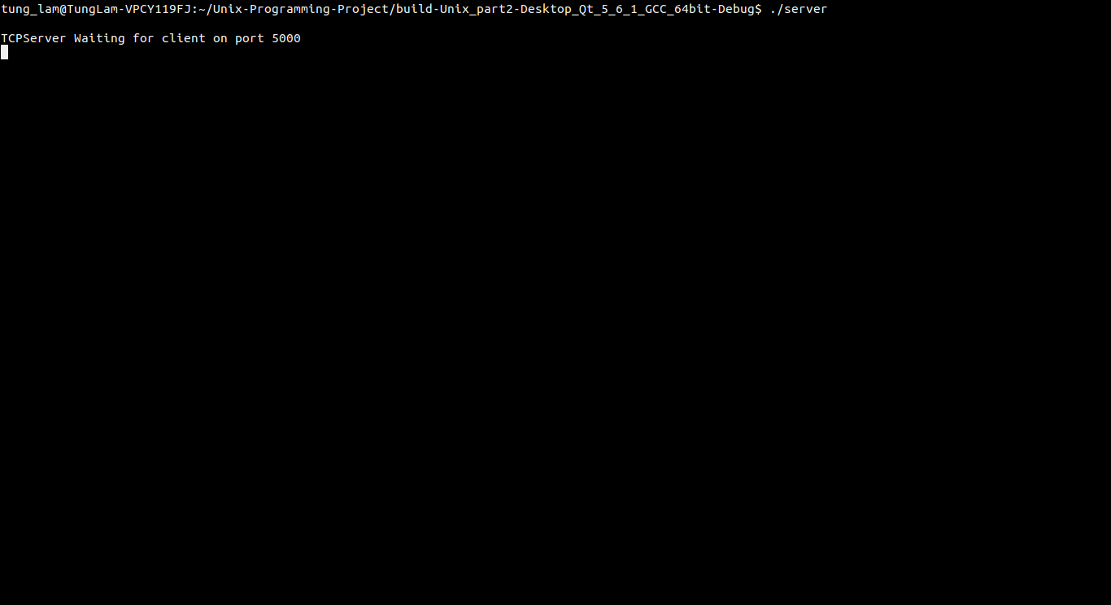

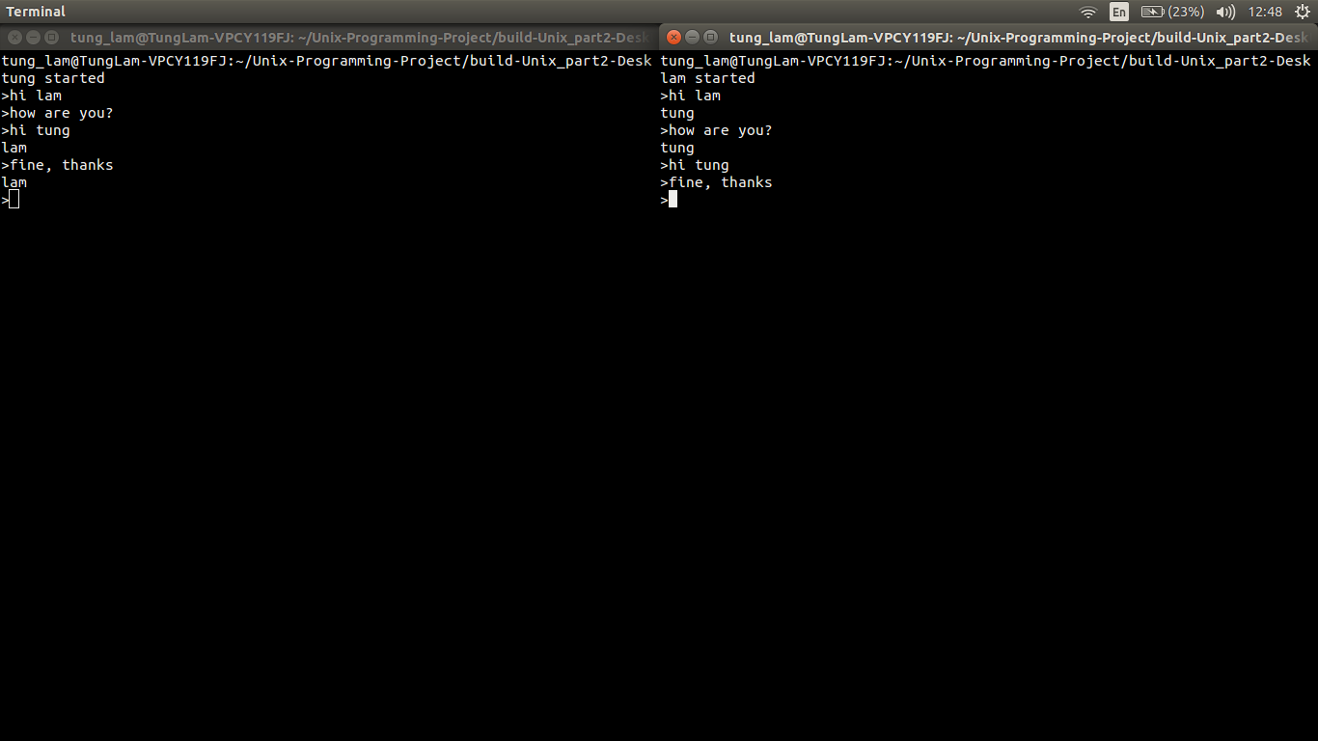

1. Chat history stored in a database

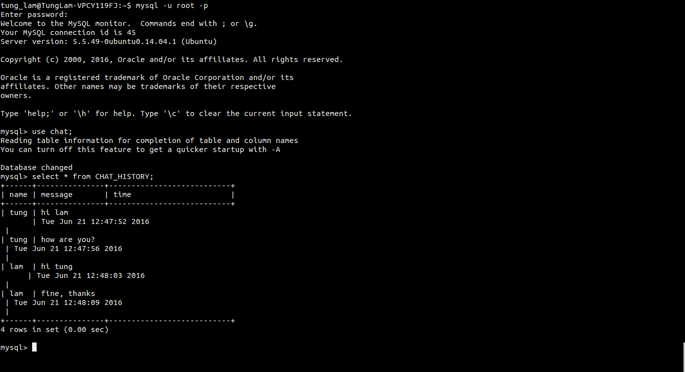

1. Conclusion:
2. Obtainment:

* Practice the skill of coding Shell Script, C, MySQL
* Study to design User Interface by Qt, how to connect Qt with source code files
* Study to use MySQL to store database and how to connect MySQL with C
* Have basic knowledge of socket programing to create a basic chat room.
* Practice time management and work organization

1. Problems:

* Get details of images especial the created time
* Cannot search images by details like file size or created time
* Difficulty highlighting images and making image paths become links
* Difficulty connecting source code files with qt
* Misunderstood between members
* Time management is not reasonable
* Syntax error due to unfamiliar code
* Cannot run the program when pull from other computer
* Can connect the User Interface with the client.c but cannot chat in the UI

1. Experience:

* How to use google to search solve and the problems.
* Install many tools to support the work
* Find another solution to replace the unsolved problems

1. Support Tools:
2. Version control: Git

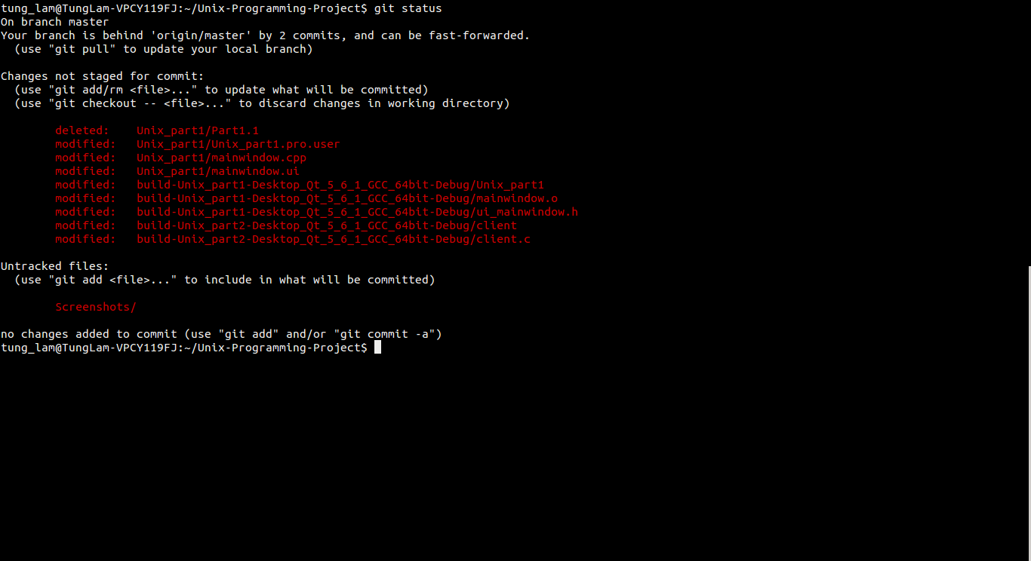

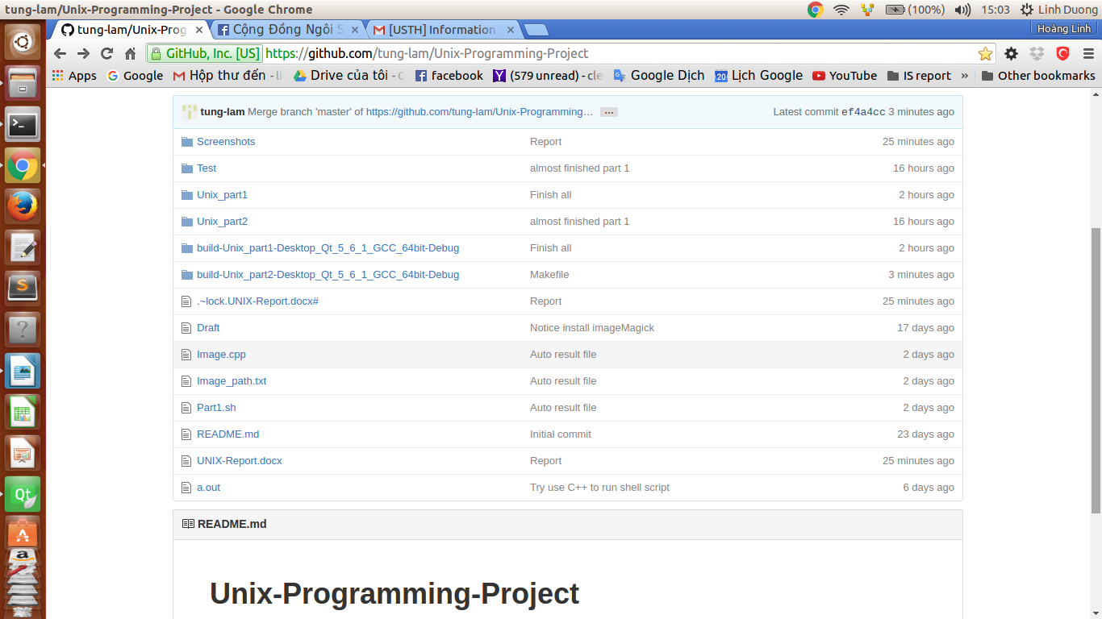

1. User Interface design: Qt

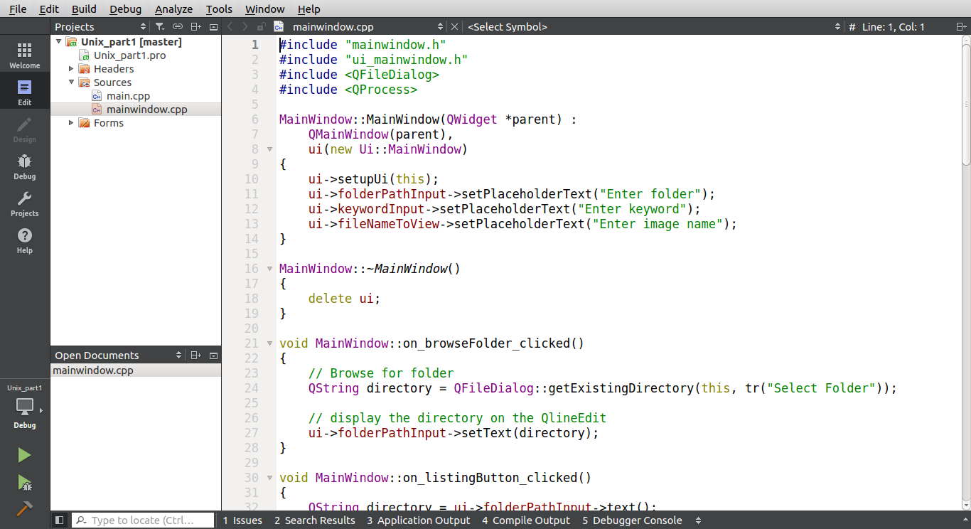

1. Software suite to support managing image: ImageMagicK

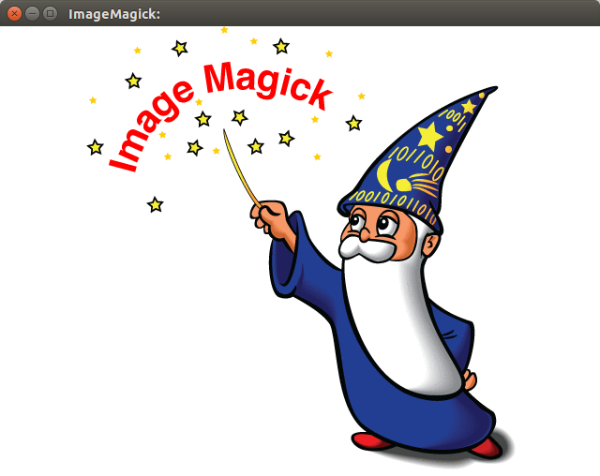

1. Database management: MySQL

