

Requirement & Design Specification
PRN222
Job Management System
Version: 1.0

Group 1
HE19XXXX – Full name
HE19XXXX – Full name

Table of content
Table of content 2
I. Overview 3
1. User Requirements 3
1.1 Actors 3
1.2 Use Cases 4
a. Diagram(s) 4
b. Descriptions 5
2. Overall Functionalities 6
2.1 Screens Flow 6
2.2 Screen Descriptions 6
2.3 Screen Authorization 8
3. System High Level Design 9
3.1 Database Schema 9
3.2 Table Descriptions 9
II. Web Application 11
III. Students Contribution 19
IV. Apendix 19
4.1. Assumptions & Dependencies 19
4.2. Limitations & Exclusions 19
4.3. Business Rules 19

I. Overview
The Job Management System is a web-based application designed to manage job postings, applications, and user accounts efficiently. The system provides different access levels for users, employers, administrators, and guests to ensure secure and organized workflow. It allows users to search and apply for jobs, employers to post and manage job advertisements, and administrators to oversee the entire system.
The project is developed using Java Servlet, JSP, and JDBC technologies, with data managed by the Microsoft SQL Server database system. This system was created to streamline the recruitment process, enhance data management, and improve communication between job seekers and employers.

1. User Requirements

1.1 Actors

# | Actor | Description
1 | Job Seeker | Main user who searches and applies for jobs, and manages personal profiles.
2 | Employer | Employers or recruiters who post job advertisements and manage applicants.
3 | Admin | System administrators responsible for managing users, posts, and reports.
4 | Guest | Unregistered or not logged-in users who can browse basic job listings and register for an account.

1.2 Use Cases

a. Diagram(s)
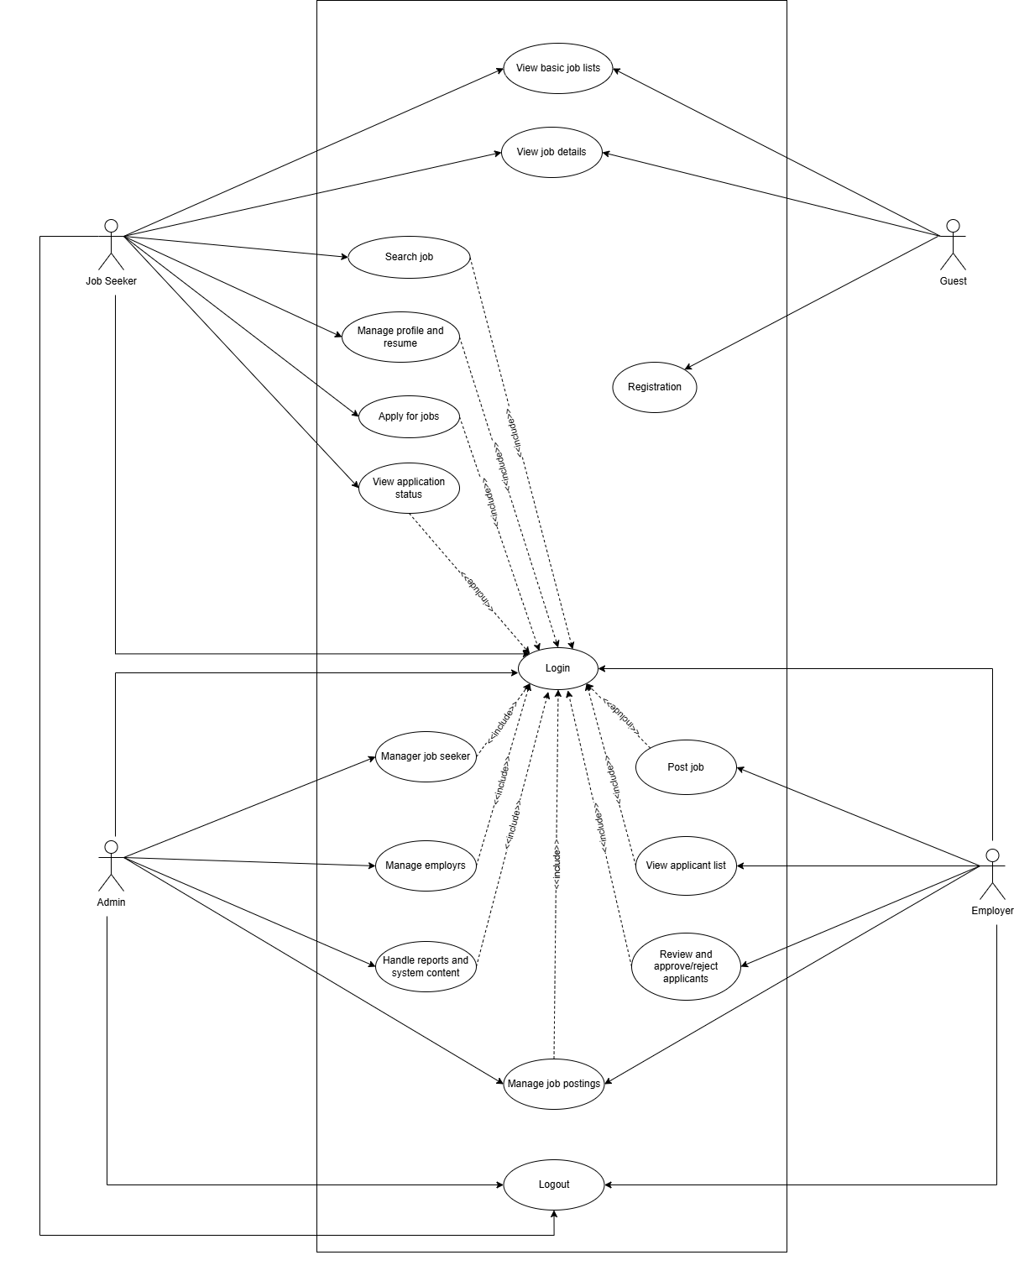

b. Descriptions

ID | Feature | Use Case | Use Case Description
1 | Guest | View basic job listings | Browse and view available job postings without login
2 |  | View job details | View detailed information about specific job posting–
3 |  | Register for account | Create new account to access full system features
4 | Job seeker | Log In / Log Out | Create account, authenticate, and end session
5 |  | Search and view job listings | Search for jobs using filters and view results
6 |  | View job details | View detailed information about specific job posting
7 |  | Manage personal profile and resume | Add, edit, update personal information and resume/CV
8 |  | Apply for jobs | Submit job applications with resume and cover letter
9 |  | View application status | Track and view status of submitted applications
10 | Employer | Log In / Log Out | Authenticate as employer to access hiring features
11 |  | Post job advertisements | Create and publish new job postings
12 |  | View applicant list | View list of candidates who applied for jobs
13 |  | Review and approve/reject applicants | Evaluate applications and make hiring decisions
14 |  | Manage job postings | Edit, update, close, or delete job advertisements
15 | Admin | Log In / Log Out | Authenticate as administrator to access admin panel
16 |  | Manage job seeker | Add, edit, delete, view, suspend user accounts
17 |  | Manage employers | Add, edit, delete, verify employer accounts
18 |  | Manage job postings | Monitor, approve, edit, or remove job advertisements
19 |  | Handle reports and system content | Review user reports, manage content moderation

2. Overall Functionalities

2.1 Screens Flow

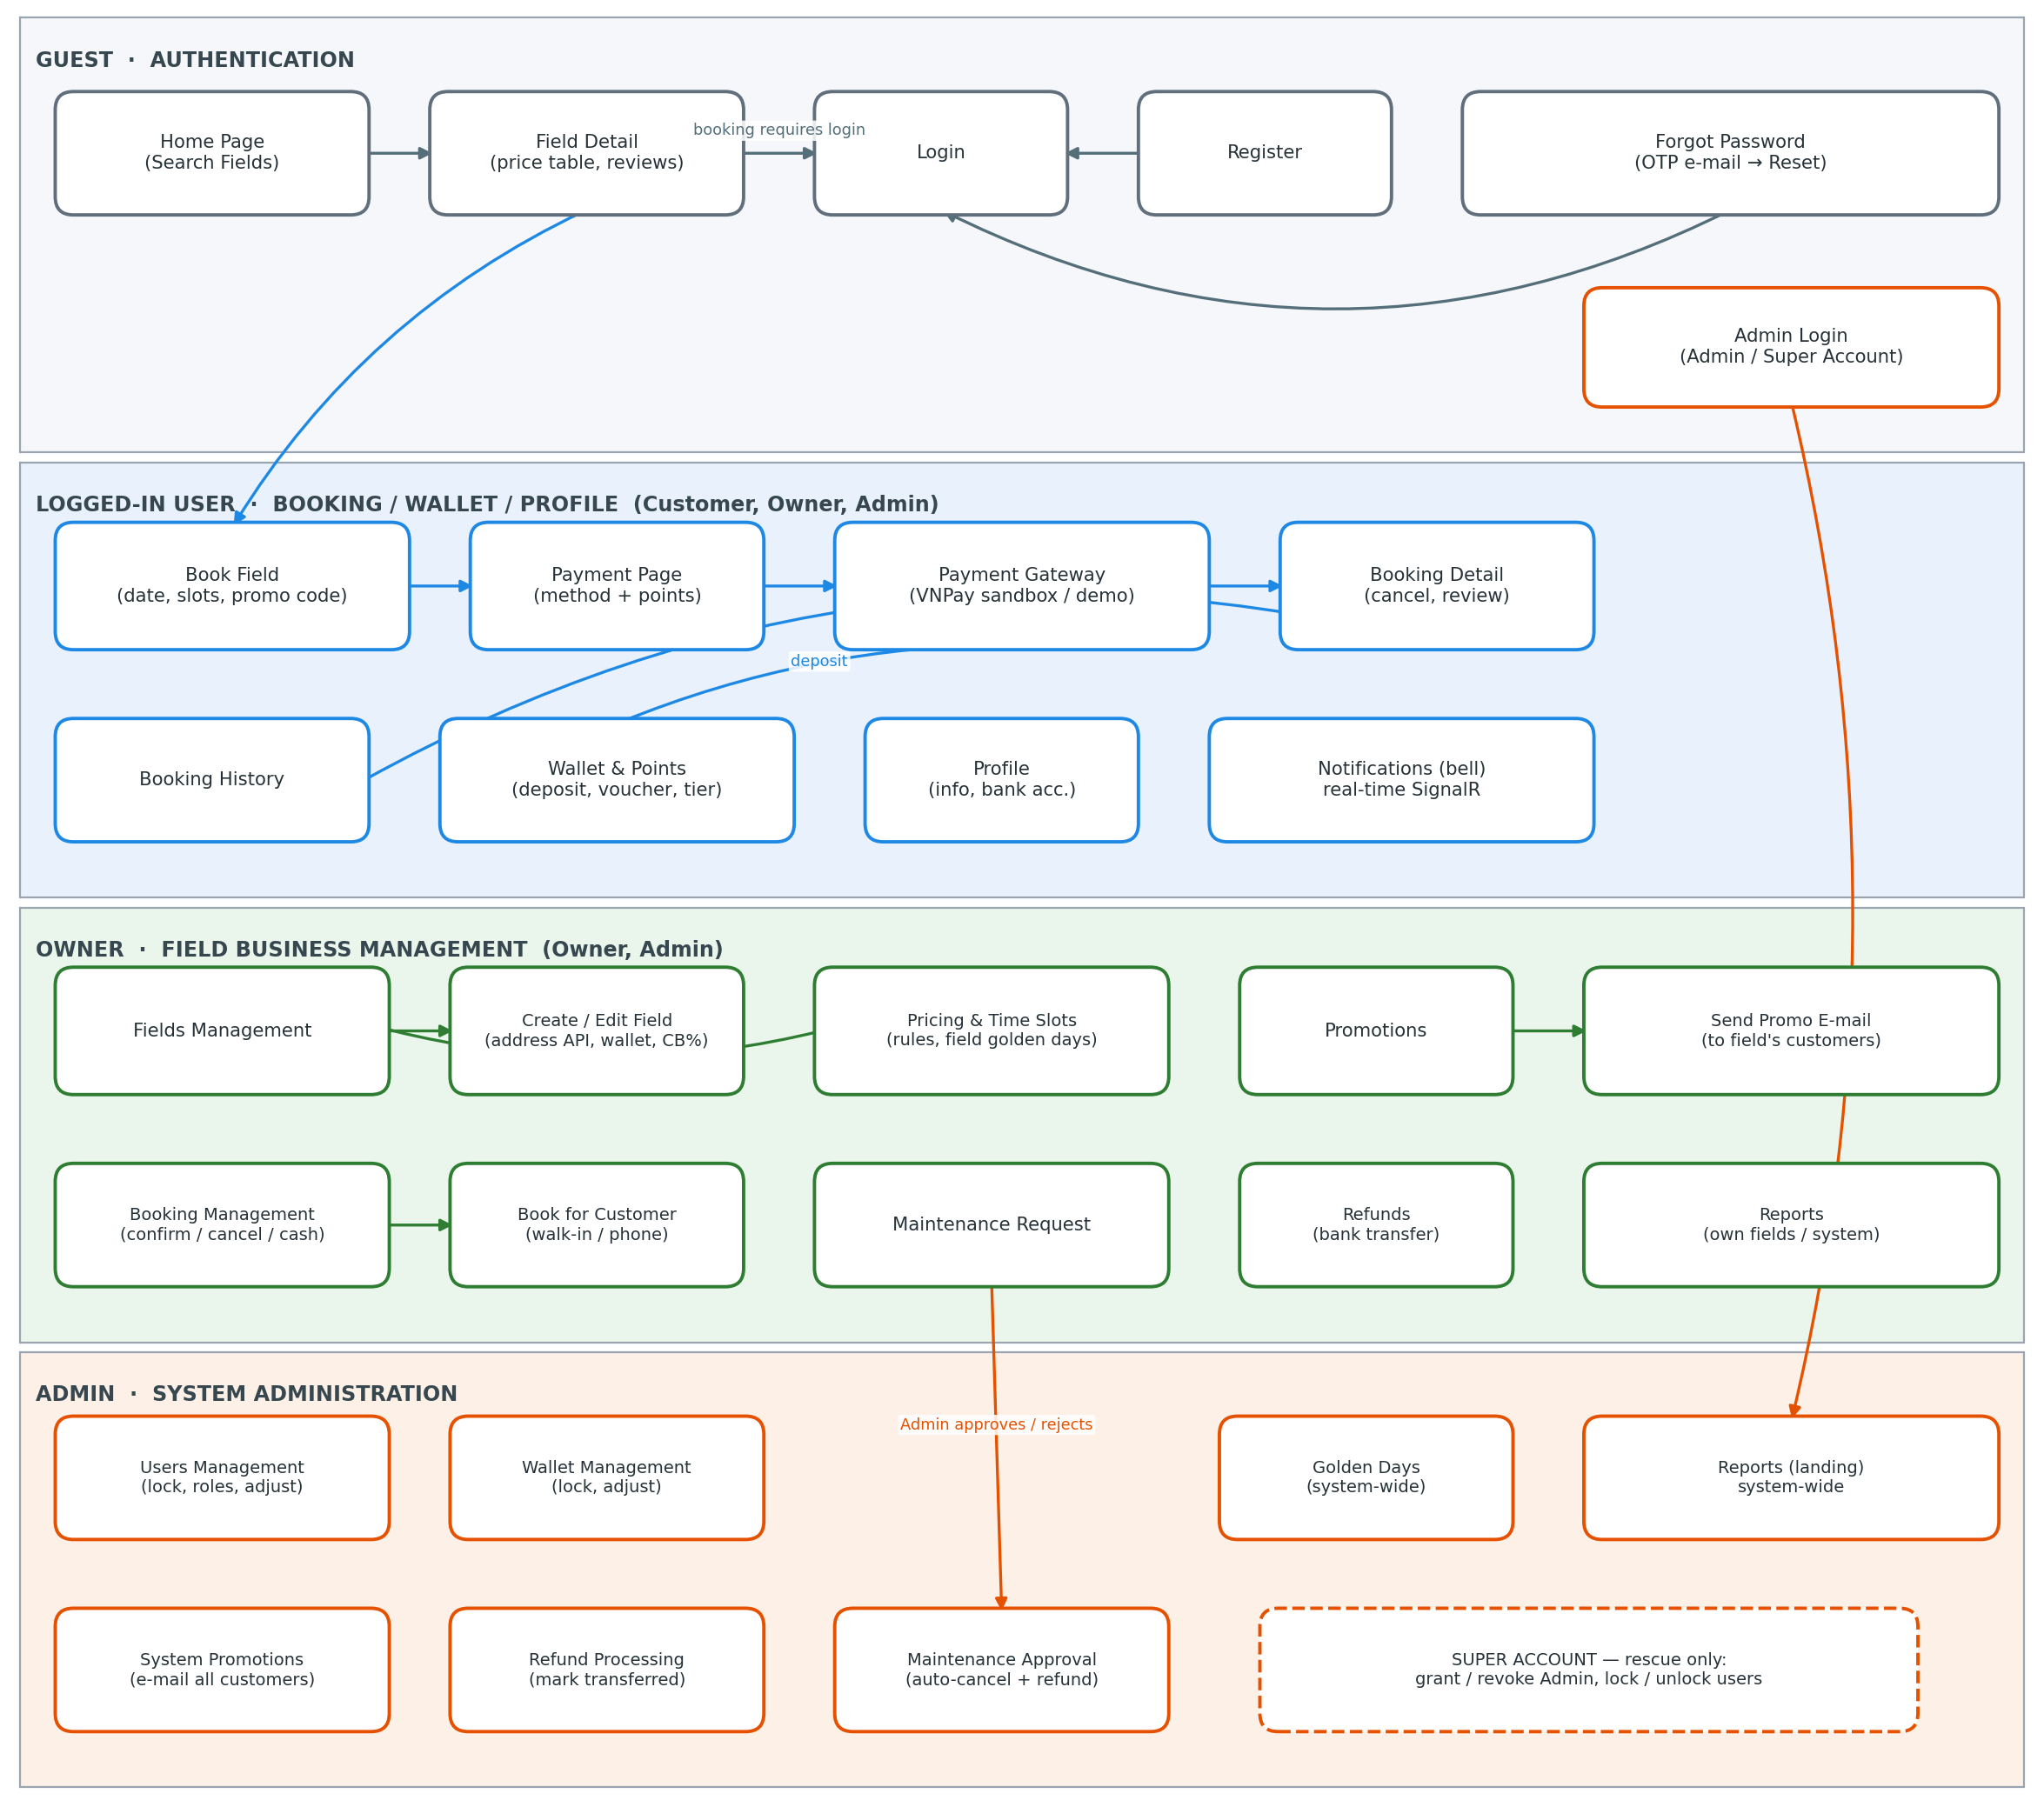

2.2 Screen Descriptions

# | Feature | Screen | Description
1 | Home / Search | Home Page | Displays all active fields with filters by sport type, province/city, maximum price and star rating. Entry point for both guests and logged-in users.
2 | Field Details | Field Detail Page | Shows field images, description, address, reviews and the price of every time slot for the selected date (multi-level pricing rules and golden-day multiplier applied). User picks a date and one or more free slots to book.
3 | Registration | Register Page | Allows a guest to create a Customer account with full name, e-mail, phone and password.
4 | Login | Login Page | Authenticates Customers and Owners by e-mail + password (cookie authentication, 8-hour session). Locked accounts cannot log in and their open sessions are invalidated on the next request.
5 | Password Recovery | Forgot Password / Verify OTP / Reset Password | Sends a 6-digit OTP to the registered e-mail (10-minute expiry, max 5 attempts), then lets the user set a new password.
6 | Admin Login | Admin Login Page | Separate sign-in entrance for Admin and the hidden Super Account (verified against a SHA-256 hash in code before any database query).
7 | Booking | Booking flow (on Field Detail) | Creates one booking per selected time slot (1 booking = 1 field + 1 slot + 1 date). Double booking is blocked by a transaction check plus a unique filtered index. Promotion code and membership-tier discount are applied here.
8 | Booking History | Booking List Page | Lists the user's bookings with status Pending / Confirmed / Completed / Cancelled. Past confirmed bookings are auto-completed and reward points are granted.
9 | Booking Details | Booking Detail Page | Shows full booking, payment and review information. Customer can cancel (at least 2 hours before start, auto refund) and rate the field 1-5 stars after completion.
10 | Payment | Payment Page | Customer chooses the payment method (Wallet / VNPay / MoMo / Cash) and how many points to redeem (1 point = 100d, max 50% of the amount). The amount is always recalculated on the server.
11 | Payment Gateway | VNPay Sandbox / Demo Gateway Page | Redirect-based gateway used for booking payment and wallet deposit: real VNPay sandbox (HMAC-SHA512 signed, signature verified on return) when configured, otherwise a built-in demo gateway with order info, QR and countdown.
12 | Wallet & Points | Wallet & Points Page | Deposit money through the gateway (min 10,000d; bonus 200k gets +15k, 500k gets +50k), view the full transaction ledger (balance after each transaction), redeem points for e-mail vouchers and view membership tier (Silver / Gold / Diamond discounts).
13 | Profile | Profile Page | Updates personal information, bank account (used for bank-transfer refunds) and password.
14 | Notifications | Notification Bell (every page) | Real-time in-app notifications via SignalR: new booking, successful payment, cash request, cancellation, maintenance result, wallet/point changes, refunds and reviews. Unread badge, toast popup and history dropdown with mark-as-read.
15 | Fields Management | Fields Management / Create / Edit Field | Owner manages own fields: images, description, base price, wallet-payment toggle with cashback %, and detailed address selected from the Vietnam administrative-units API (province, then ward).
16 | Pricing & Time Slots | Pricing & Time Slots Page | Owner manages time slots and the multi-level price table per field: time range + weekday/weekend + month (season) range with priority, plus the field's own golden days (price and point multipliers).
17 | Promotions | Promotions / Send Promo E-mail | Owner creates percentage discount codes valid only for his fields and e-mails them to customers who booked those fields. Admin creates system-wide codes and e-mails all customers.
18 | Booking Management | Booking Management Page | Owner/Admin views bookings of managed fields by status; confirms or cancels bookings and confirms/rejects cash payments. The Book-for-Customer sub-screen supports walk-in/phone bookings with an optional immediate cash payment record.
19 | Maintenance | Maintenance Page (Owner / Admin view) | Owner sends a maintenance request (reason + date range). Admin approves or rejects: approval switches the field to Maintenance, blocks booking in that period and auto-cancels + refunds overlapping bookings with e-mail notice.
20 | Refunds | Refunds Page | Lists bank-transfer refund requests (created when a cancelled booking was paid via gateway/cash and the field does not accept wallet). Owner/Admin marks a request as transferred or rejects it with a reason.
21 | Reports | Reports Page | Revenue, paid bookings, customers, revenue-by-day chart, top-5 most-booked fields and a revenue breakdown per field, filtered by date range. Owner sees only his fields; Admin sees the whole system.
22 | Wallet Management | Wallet Management Page | Admin views every wallet, locks/unlocks wallets (a locked wallet cannot deposit or pay) and manually adjusts balances with a mandatory reason.
23 | Golden Days | Golden Days Page | Admin manages system-wide golden days (holidays/events) with price and point multipliers applied to every field.
24 | Users Management | Users Page | Admin locks/unlocks accounts (open sessions are invalidated), changes roles, grants/revokes Admin and manually adjusts wallets & points. The Super Account uses only this page to rescue Admin access.
25 | Logout | Logout | Securely ends the session.

2.3 Screen Authorization

# | Screen | Guest | Customer | Owner | Admin | Super Account
1 | Home / Search Fields | X | X | X | X
2 | Field Detail | X | X | X | X
3 | Register / Login / Forgot Password | X
4 | Admin Login | X |  |  | X | X
5 | Booking (book, history, detail, pay, gateway) |  | X | X | X
6 | Wallet & Points |  | X | X | X
7 | Profile |  | X | X | X
8 | Notifications (bell) |  | X | X | X
9 | Fields Management |  |  | X | X
10 | Pricing & Time Slots |  |  | X | X
11 | Promotions + Send E-mail |  |  | X | X
12 | Booking Management / Book for Customer |  |  | X | X
13 | Maintenance - create request |  |  | X
14 | Maintenance - approve / reject |  |  |  | X
15 | Refunds |  |  | X | X
16 | Reports |  |  | X | X
17 | Wallet Management |  |  |  | X
18 | Golden Days (system-wide) |  |  |  | X
19 | Users Management |  |  |  | X | X
20 | Logout |  | X | X | X | X

3. System High Level Design

3.1 Database Schema
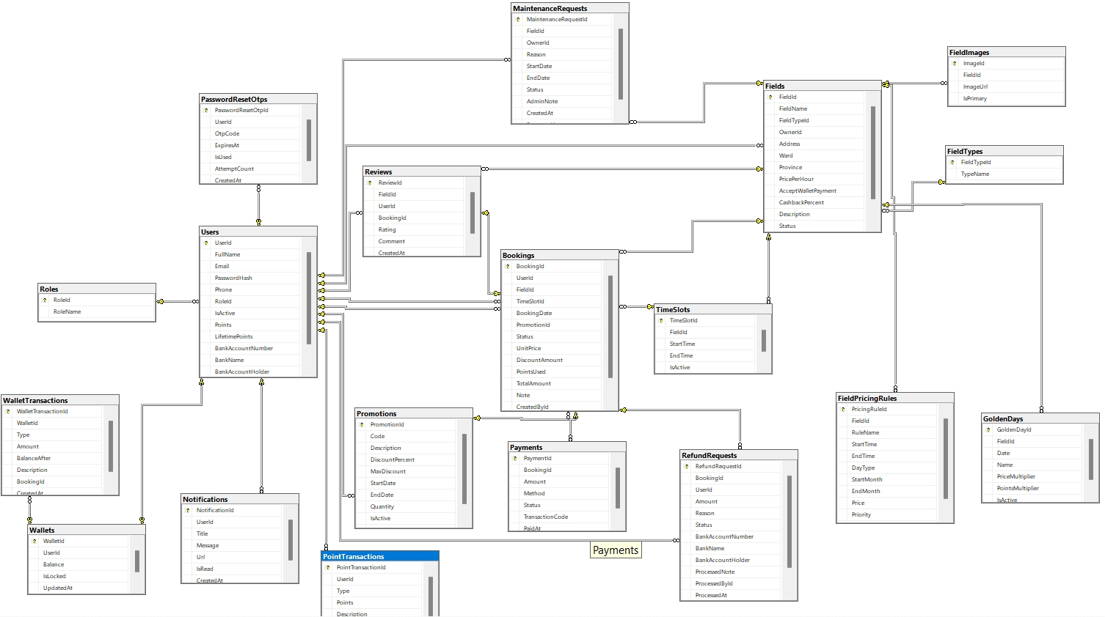

3.2 Table Descriptions

No | Table | Description
1 | Roles | User roles: Admin, Owner, Customer. SuperAdmin exists only as a claims role of the rescue account, not in this table.
2 | Users | Every account: profile, SHA-256 password hash, phone, bank account (for bank-transfer refunds), current point balance and LifetimePoints (basis of the membership tier).
3 | FieldTypes | Sport categories: Football, Badminton, Tennis, Basketball.
4 | Fields | Sports fields: owner, two-level address (Province/Ward from the administrative-units API), base price per hour, wallet-payment flag + cashback percent, status (Active / Maintenance / Closed).
5 | FieldImages | Photos of each field; one image is marked primary.
6 | TimeSlots | Bookable time slots (start - end) of each field; can be deactivated.
7 | FieldPricingRules | Multi-level price rules per field: time range + day type (All/Weekday/Weekend) + month range (season) + priority. The highest-priority matching rule wins; no match falls back to the field's base price.
8 | GoldenDays | Special days with price and point multipliers. FieldId null = system-wide golden day (created by Admin); otherwise a field-specific golden day (created by the Owner).
9 | Promotions | Percentage discount codes with max amount, validity window and usage quantity. OwnerId null = system-wide code; otherwise valid only for that owner's fields. Point-redeemed vouchers are also stored here as one-time codes.
10 | Bookings | One row = one field + one time slot + one date (BookingDetail was removed). Stores the price snapshot (unit price, discount, points used, total) and CreatedById for book-for-customer tracing. The unique filtered index (FieldId, TimeSlotId, BookingDate WHERE Status <> 'Cancelled') blocks double booking at DB level.
11 | Payments | Payments of each booking: method (Wallet / VNPay / MoMo / Cash), status Pending / Paid / Refunded / Failed, gateway transaction code and paid time.
12 | Reviews | 1-5 star rating with comment, written after a completed booking; unique BookingId ensures one review per booking.
13 | Wallets | One virtual wallet per user (1-1). The balance changes only through WalletTransactions; Admin can lock a wallet.
14 | WalletTransactions | Wallet ledger: Deposit / Payment / Refund / Cashback / Bonus / Adjust, each row storing BalanceAfter for reconciliation.
15 | PointTransactions | Point ledger: Earn / Redeem / ReviewBonus / Revoke / Adjust with the related booking when applicable.
16 | MaintenanceRequests | Owner's maintenance requests (reason + date range); Admin approves or rejects with a note. Approval cancels and refunds overlapping bookings.
17 | RefundRequests | Bank-transfer refund requests, created when a cancelled booking was paid via gateway/cash and the field does not accept the wallet. Snapshots the customer's bank account; processed manually by Owner/Admin.
18 | PasswordResetOtps | 6-digit OTP codes for password recovery: 10-minute expiry, used flag and wrong-attempt counter (max 5).
19 | Notifications | In-app notifications shown on the navbar bell: recipient, title, message, link, read flag. Saved here and pushed real-time through SignalR.

II. Web Application

This chapter walks through the implemented screens one by one, following the same order as section 2.3 (Screen Authorization). Demo accounts (password 123456): admin@sfb.com (Admin, /Account/AdminLogin), owner@sfb.com (Owner), customer@sfb.com (Customer).

1. Register
URL: /Account/Register — Roles: Guest
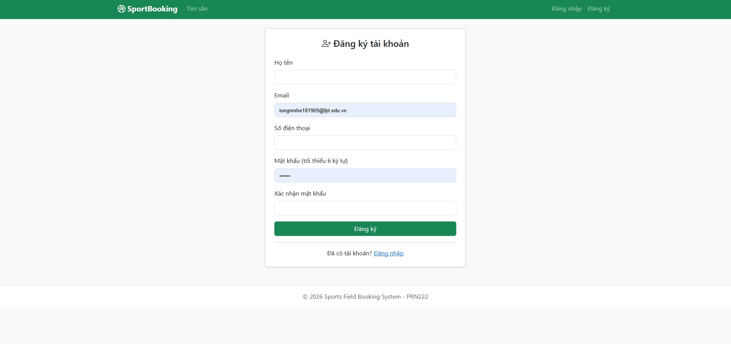

Field Name | Field Type | Description
Họ tên (Full name) | Text Box | New customer's display name.
E-mail | Text Box | Login e-mail; must be unique in the system.
Số điện thoại (Phone) | Text Box | Contact phone number.
Mật khẩu (Password) | Password Box | Account password.
Đăng ký (Register) | Button | Creates a Customer account and redirects to Login.

2. Login
URL: /Account/Login — Roles: Guest
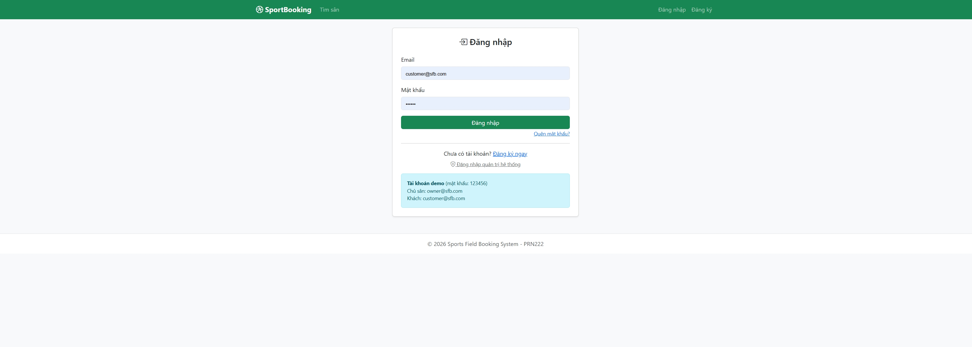

Field Name | Field Type | Description
E-mail | Text Box | User enters the registered e-mail address.
Password | Password Box | User enters the password (stored as SHA-256 hash).
Đăng nhập (Login) | Button | Authenticates the user; on success a cookie session (8 hours) is created and the user is redirected to the page he came from (returnUrl) or to his role's landing page.
Đăng ký (Register) | Link | Navigates to the Register page.
Quên mật khẩu (Forgot password) | Link | Starts the OTP password-recovery flow.

3. Forgot Password – OTP – Reset Password
URL: /Account/ForgotPassword → /Account/VerifyOtp → /Account/ResetPassword — Roles: Guest
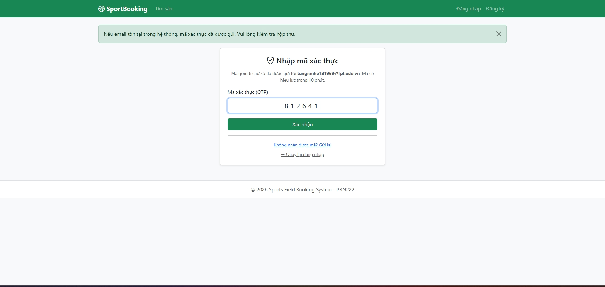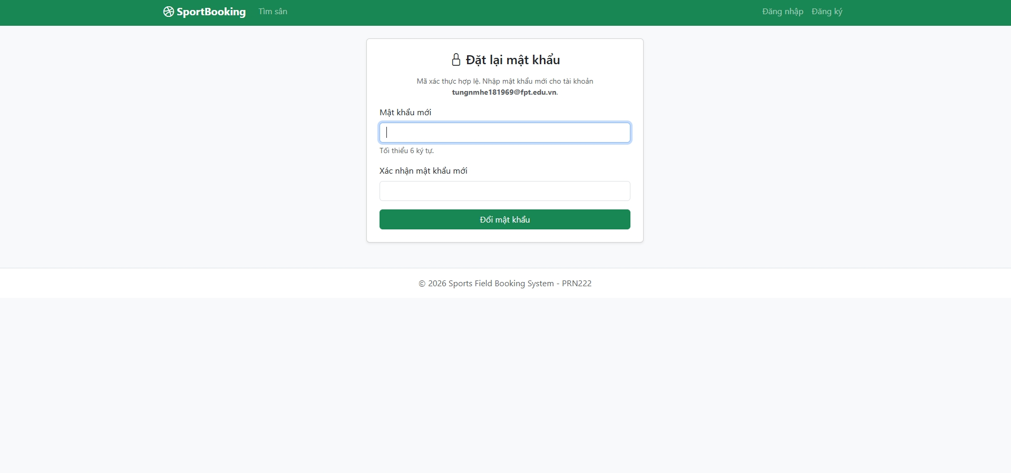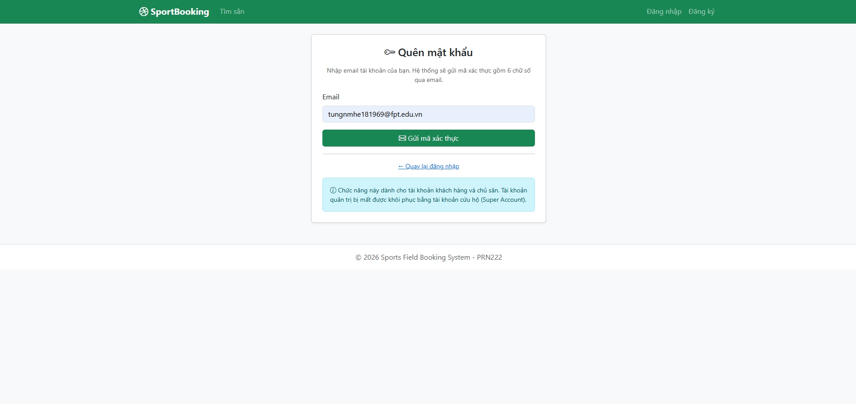

Field Name | Field Type | Description
E-mail | Text Box | E-mail of the account to recover; a 6-digit OTP is sent to it.
Gửi mã (Send OTP) | Button | Sends the OTP e-mail (10-minute expiry).
Mã OTP (OTP code) | Text Box | 6-digit code from the e-mail; at most 5 wrong attempts.
Xác nhận (Verify) | Button | Validates the OTP and opens the reset form.
Mật khẩu mới / Nhập lại (New password / Confirm) | Password Box | New password entered twice.
Đặt lại mật khẩu (Reset) | Button | Saves the new password and returns to Login.

4. Admin Login
URL: /Account/AdminLogin — Roles: Admin, Super Account
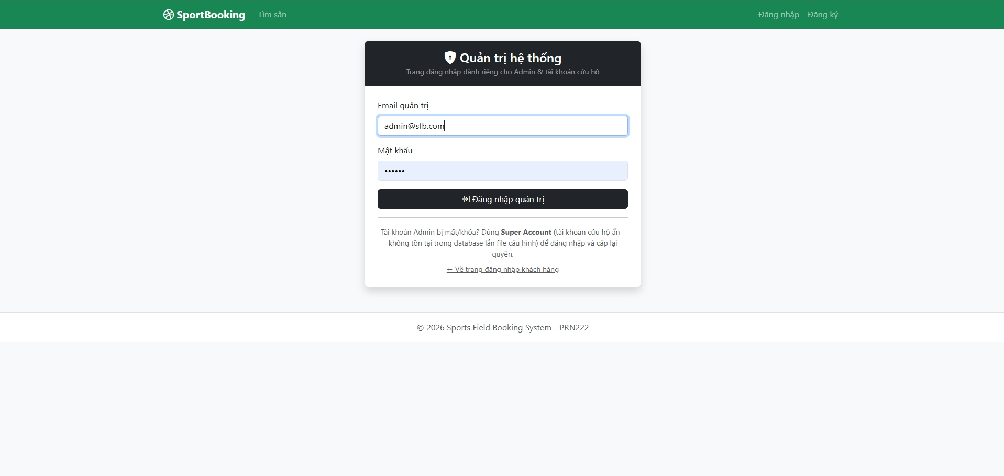

Field Name | Field Type | Description
E-mail | Text Box | Admin e-mail — or the secret Super Account e-mail (checked against a SHA-256 hash in code before any DB query).
Password | Password Box | Password of the administrative account.
Đăng nhập (Login) | Button | Authenticates and lands on the system-wide Reports page (Admin) or Users page (Super Account).

5. Home Page – Search Fields
URL: /Home/Index — Roles: Guest, Customer, Owner, Admin
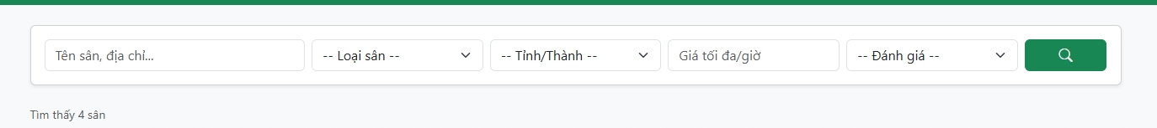
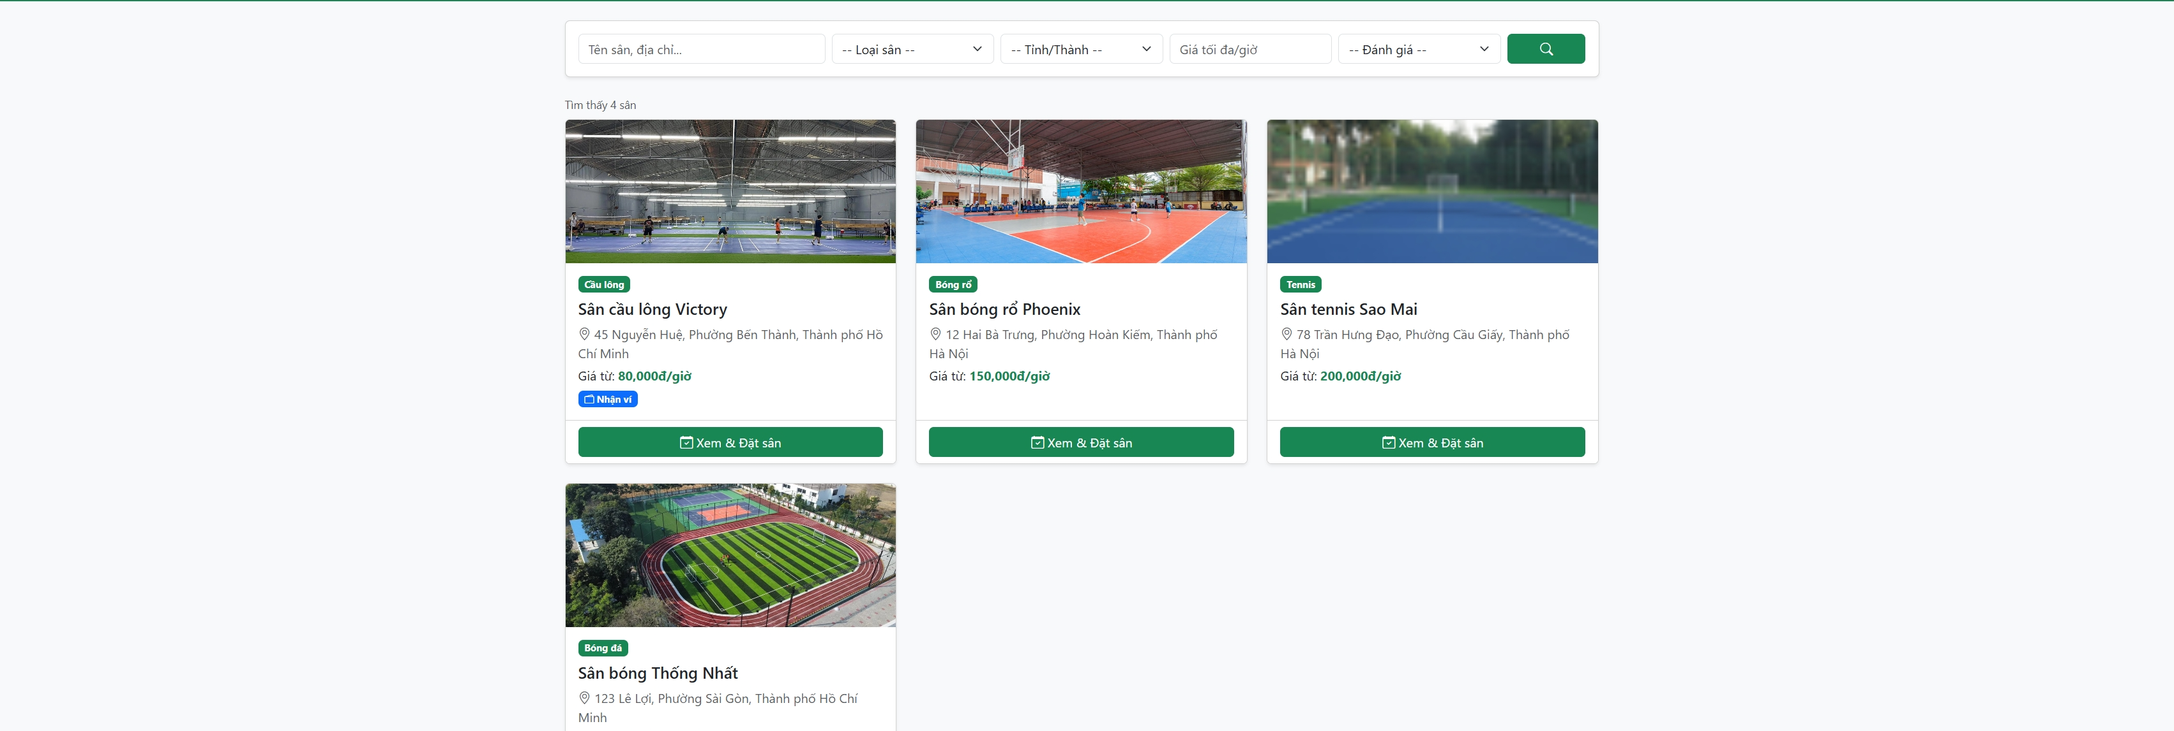

Field Name | Field Type | Description
Loại sân (Sport type) | Dropdown | Filters fields by sport type (Football, Badminton, Tennis, Basketball).
Tỉnh/Thành (Province) | Dropdown | Filters by province/city, populated from the Vietnam administrative-units API.
Giá tối đa (Max price) | Number Input | Shows only fields whose base price is below the entered value.
Số sao (Min rating) | Dropdown | Filters by minimum average review rating.
Lọc (Filter) | Button | Applies the selected filters.
Field card | Card / Link | Shows photo, name, type, address, base price and rating; click opens the Field Detail page.

6. Field Detail & Booking
URL: /Field/Detail/{id} — Roles: Guest xem / đặt cần đăng nhập
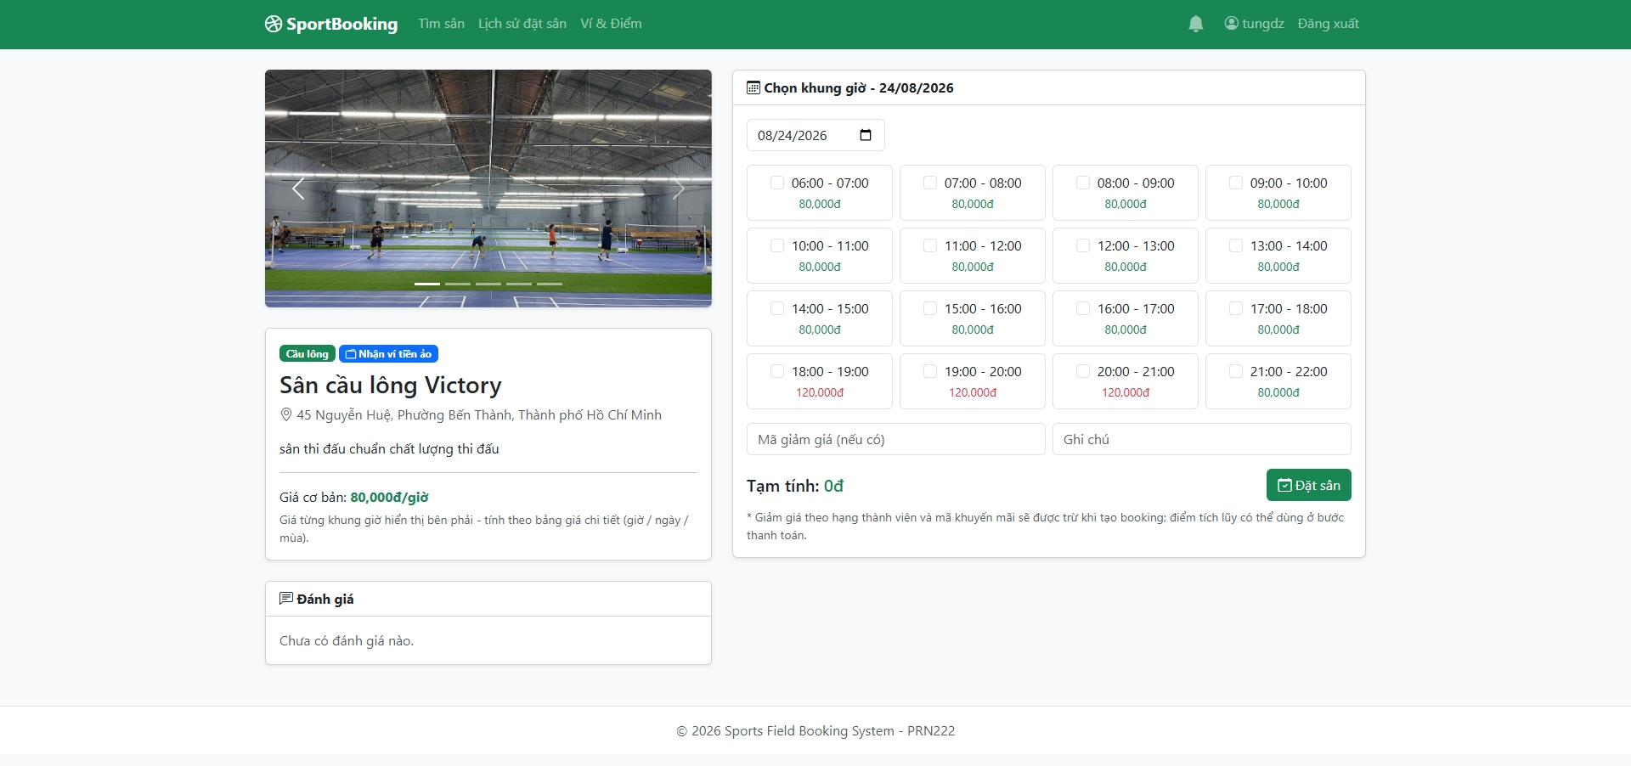

Field Name | Field Type | Description
Image gallery | Images | Photos of the field.
Ngày đá (Date) | Date Picker | Selects the playing date; the slot price table reloads for this date.
Bảng khung giờ (Slot table) | Checkbox List | Every time slot with its price for the chosen date (multi-level pricing rules + golden-day multiplier); booked/past slots are disabled. Each checked slot becomes one booking.
Mã khuyến mãi (Promo code) | Text Box | Optional discount code (system-wide or of this field's owner).
Ghi chú (Note) | Text Area | Optional note sent with the booking.
Đặt sân (Book) | Button | Creates the bookings inside a transaction (double-booking blocked by unique index); guests are redirected to Login first.
Đánh giá (Reviews) | List | 1-5 star reviews with comments from customers who played.

7. Payment Page
URL: /Booking/Pay/{id} — Roles: Customer, Owner, Admin
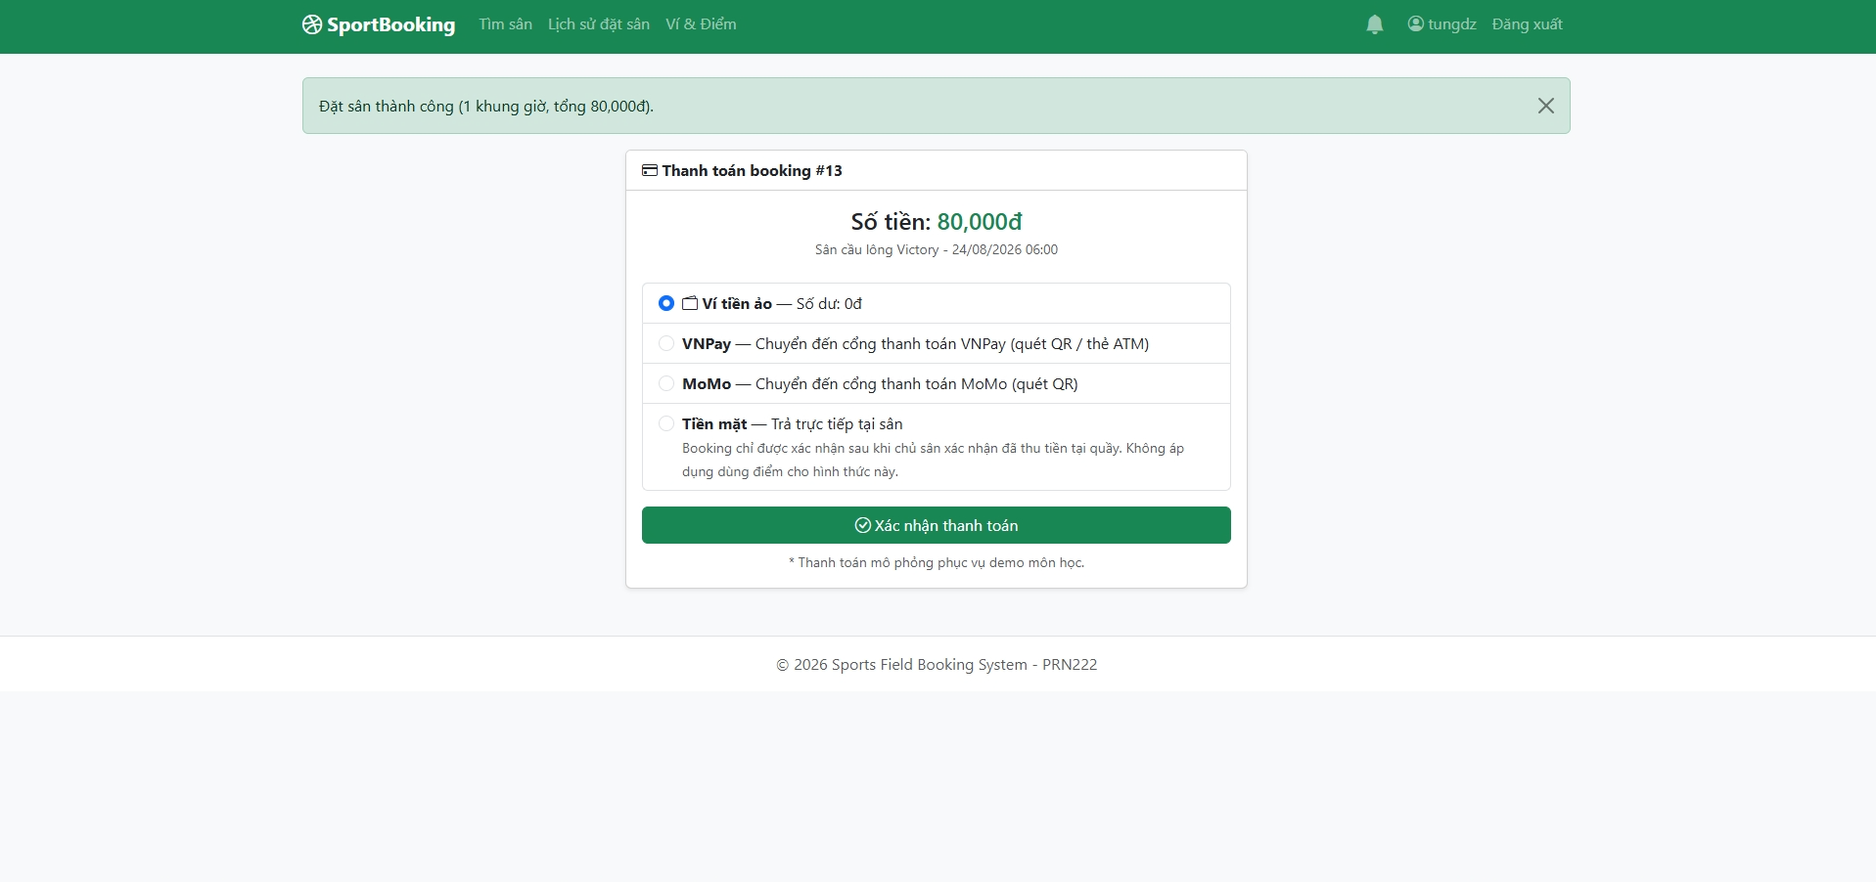

Field Name | Field Type | Description
Thông tin booking (Summary) | Text | Field, date, time slot and the amount to pay (always recalculated on the server).
Dùng điểm (Points to use) | Number Input | Points to redeem (1 point = 100đ, max 50% of the amount; the maximum is displayed).
Phương thức (Method) | Radio Buttons | Wallet (shows balance; hidden when the field does not accept wallet), VNPay, MoMo, or Cash at the field.
Thanh toán (Pay) | Button | Wallet/Cash are settled immediately; VNPay/MoMo redirect to the payment gateway.

8. Payment Gateway (VNPay sandbox / internal demo)
URL: /PaymentGateway/Checkout, /PaymentGateway/Demo — Roles: Customer, Owner, Admin
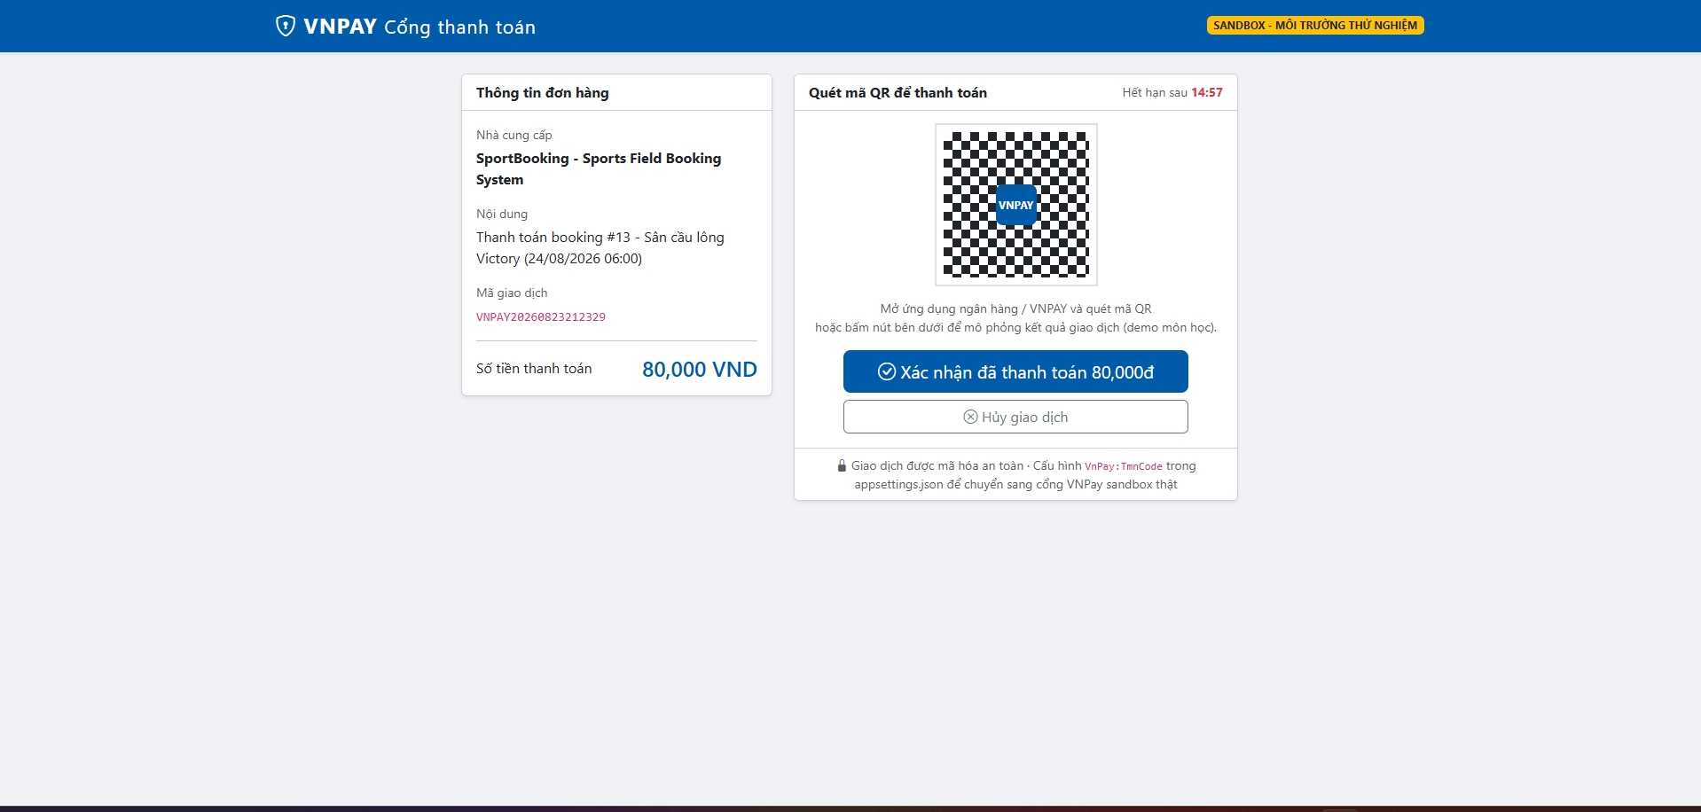

Field Name | Field Type | Description
Thông tin đơn hàng (Order info) | Text | Order code, description and amount.
QR code | Image | Simulated payment QR (demo gateway).
Đồng hồ đếm ngược (Countdown) | Timer | 15-minute payment window.
Xác nhận thanh toán (Confirm) | Button | Simulates a successful gateway payment; the system records the payment and confirms the booking (with the real VNPay sandbox this step happens on vnpayment.vn and the return is signature-verified).
Hủy (Cancel) | Button | Aborts the gateway transaction; the booking stays unpaid.

9. Booking History & Booking Detail
URL: /Booking/Index, /Booking/Detail/{id} — Roles: Customer, Owner, Admin
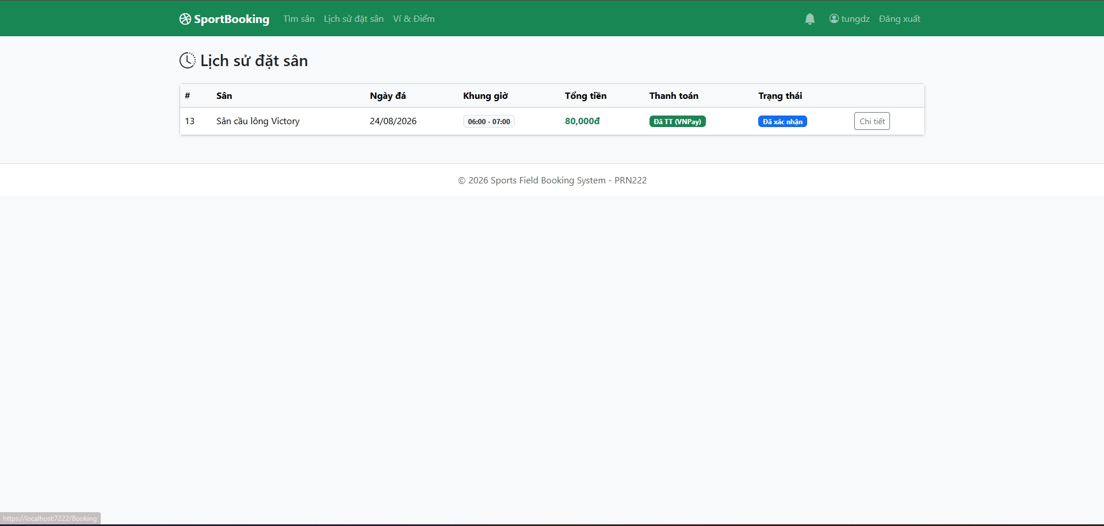

Field Name | Field Type | Description
Danh sách booking (Booking list) | Table | The user's bookings with status badges (Pending / Confirmed / Completed / Cancelled).
Chi tiết (Detail) | Link | Opens the booking's full information: price breakdown, payments, refund status.
Thanh toán (Pay) | Button | Shown for unpaid bookings; opens the Payment Page.
Hủy booking (Cancel) | Button | Allowed at least 2 hours before start; returns promo usage & points and refunds automatically.
Đánh giá (Review form) | Stars + Text Area | After completion, rate 1-5 stars with a comment; grants bonus points.

10. Wallet & Points
URL: /Wallet/Index — Roles: Customer, Owner, Admin
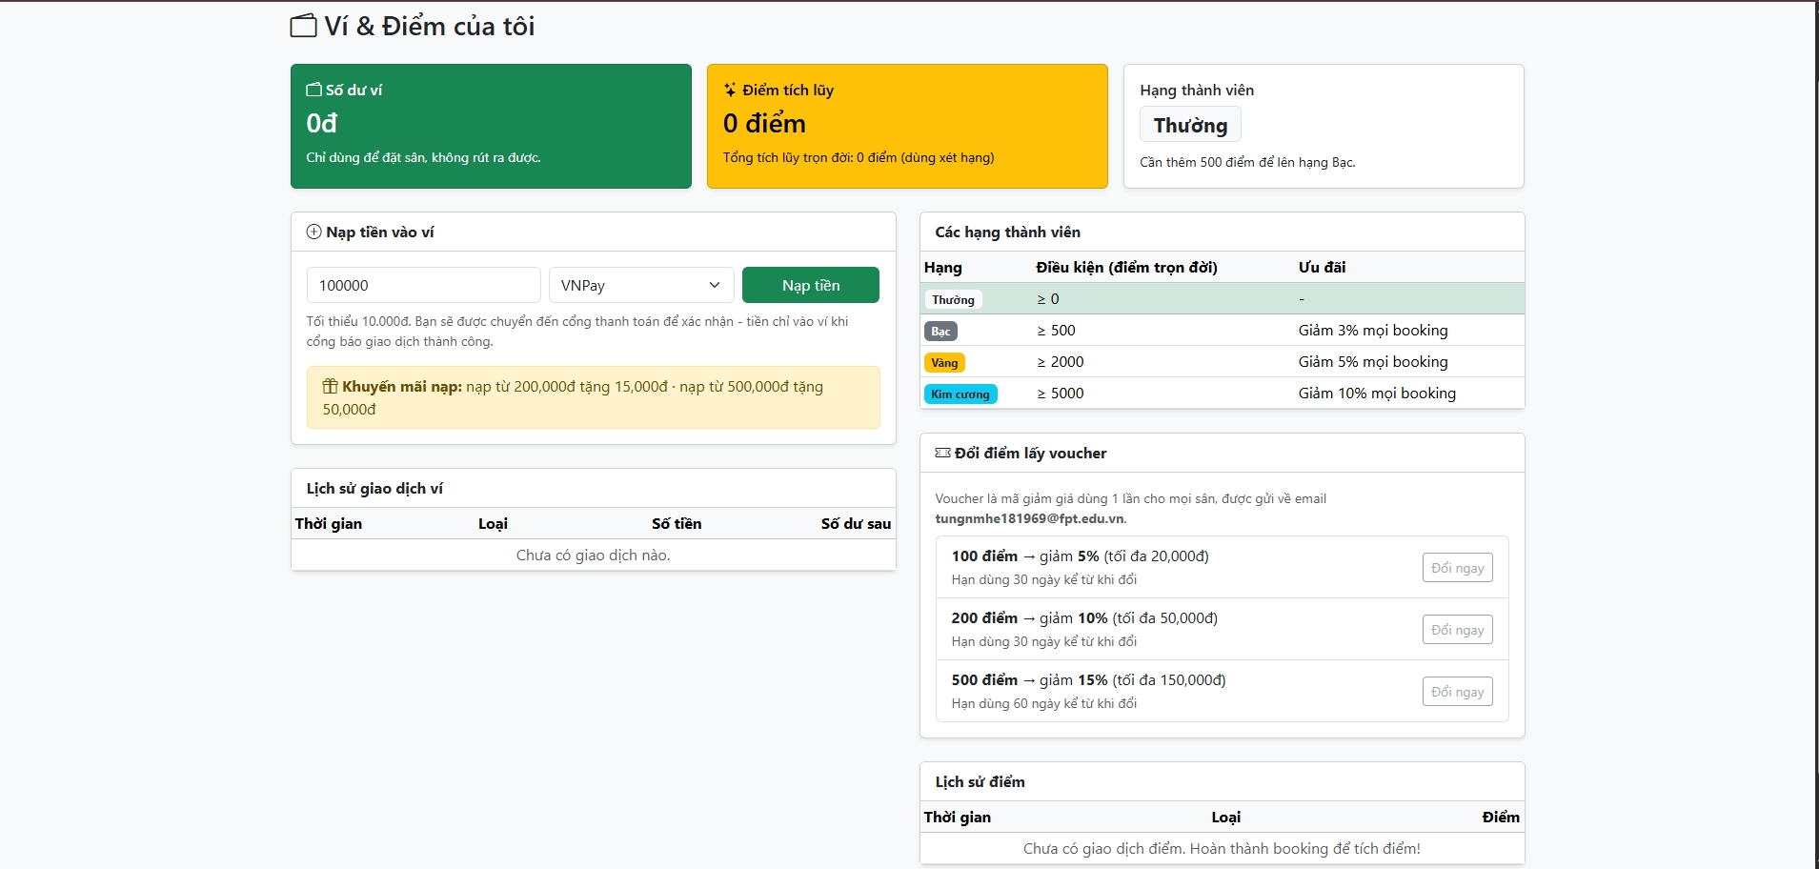

Field Name | Field Type | Description
Số dư ví (Balance) | Card | Current wallet balance; wallet money cannot be withdrawn.
Nạp tiền (Deposit) | Number Input + Button | Deposit via the payment gateway (min 10,000đ; bonus: from 200k +15k, from 500k +50k).
Lịch sử giao dịch (Transactions) | Table | Every wallet movement with type (Deposit/Payment/Refund/Cashback/Bonus/Adjust) and balance after.
Điểm & hạng (Points & tier) | Card | Point balance, lifetime points and membership tier (Silver/Gold/Diamond → 3/5/10% discount).
Đổi voucher (Redeem voucher) | Buttons | Exchanges 100/200/500 points for a one-time discount code sent by e-mail.
Lịch sử điểm (Point history) | Table | Point transactions (Earn/Redeem/ReviewBonus/Revoke/Adjust).

11. Profile
URL: /Profile/Index — Roles: Customer, Owner, Admin
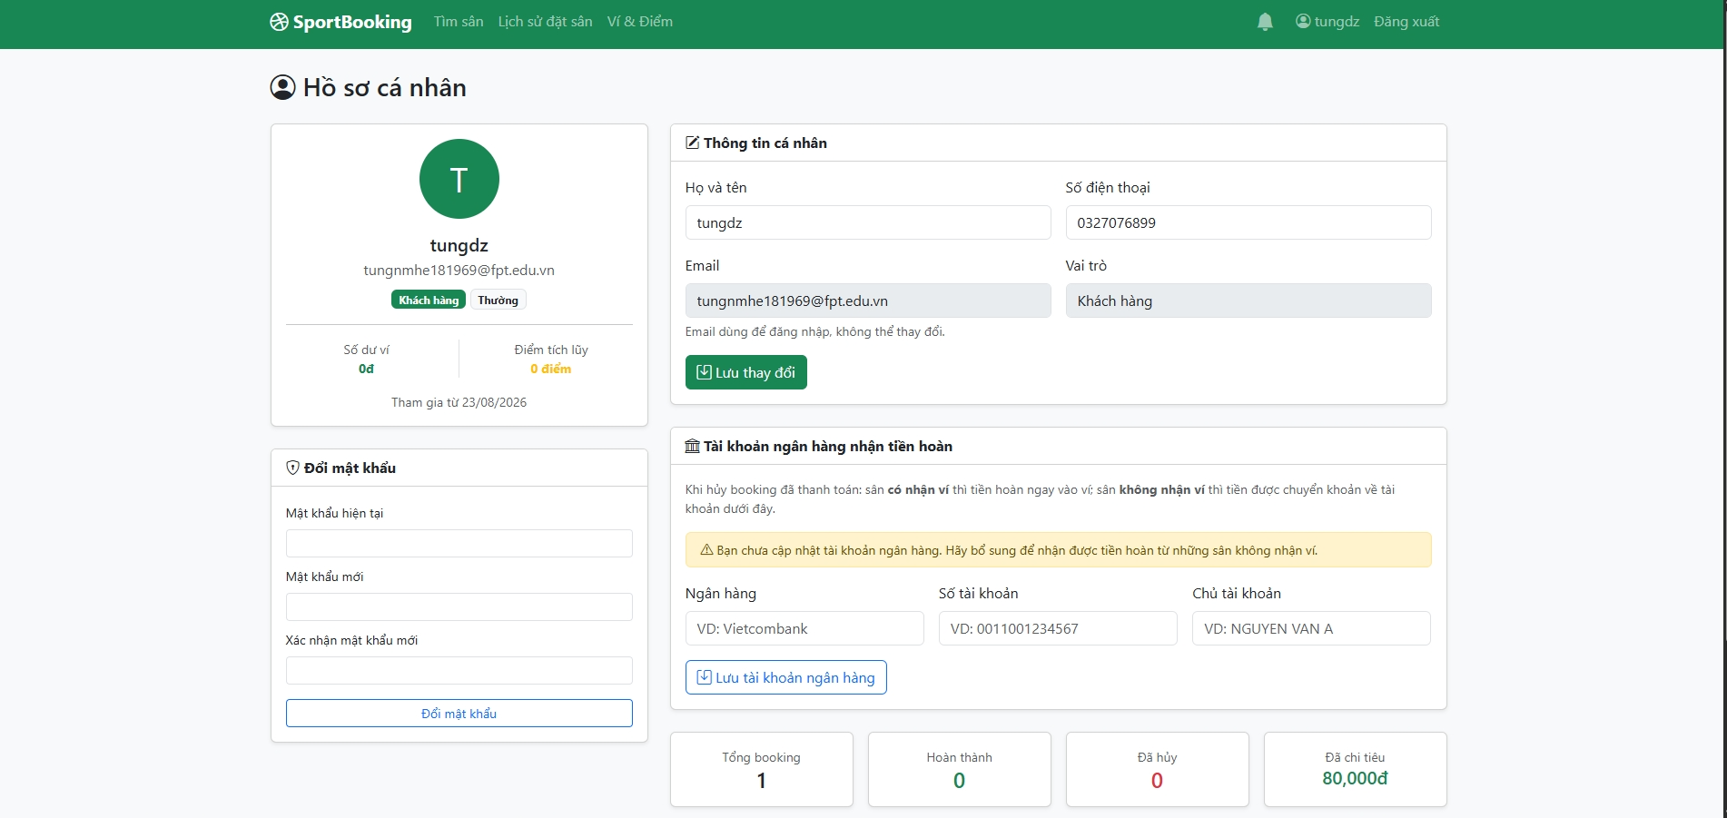
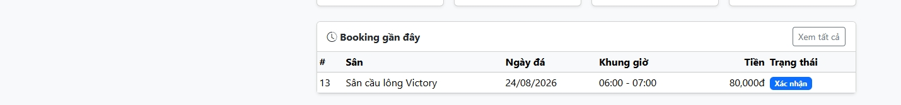

Field Name | Field Type | Description
Họ tên / SĐT (Name / Phone) | Text Boxes | Editable personal information.
Tài khoản ngân hàng (Bank account) | Text Boxes | Account number, bank name, holder — used for bank-transfer refunds when a field does not accept wallet.
Đổi mật khẩu (Change password) | Password Boxes | Current + new password.
Lưu (Save) | Button | Saves the profile changes.

12. Notifications (bell)
URL: mọi trang (navbar) — Roles: Customer, Owner, Admin
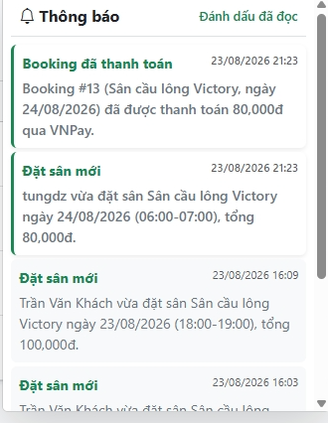

Field Name | Field Type | Description
Chuông + badge (Bell + badge) | Icon | Unread notification count; updates real-time via SignalR without refreshing.
Dropdown | List | Latest notifications (new booking, payment, cancellation, maintenance, wallet/points, refunds, reviews); click opens the related page and marks it read.
Đánh dấu đã đọc (Mark all read) | Button | Marks every notification as read.
Toast | Popup | Sliding popup shown the moment a new notification arrives.

13. Fields Management
URL: /FieldsManage + Create/Edit — Roles: Owner, Admin
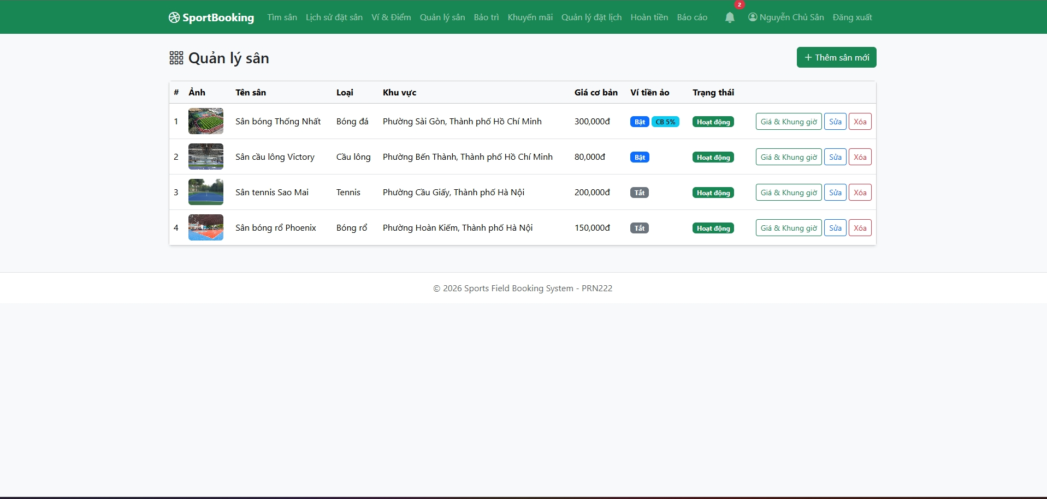
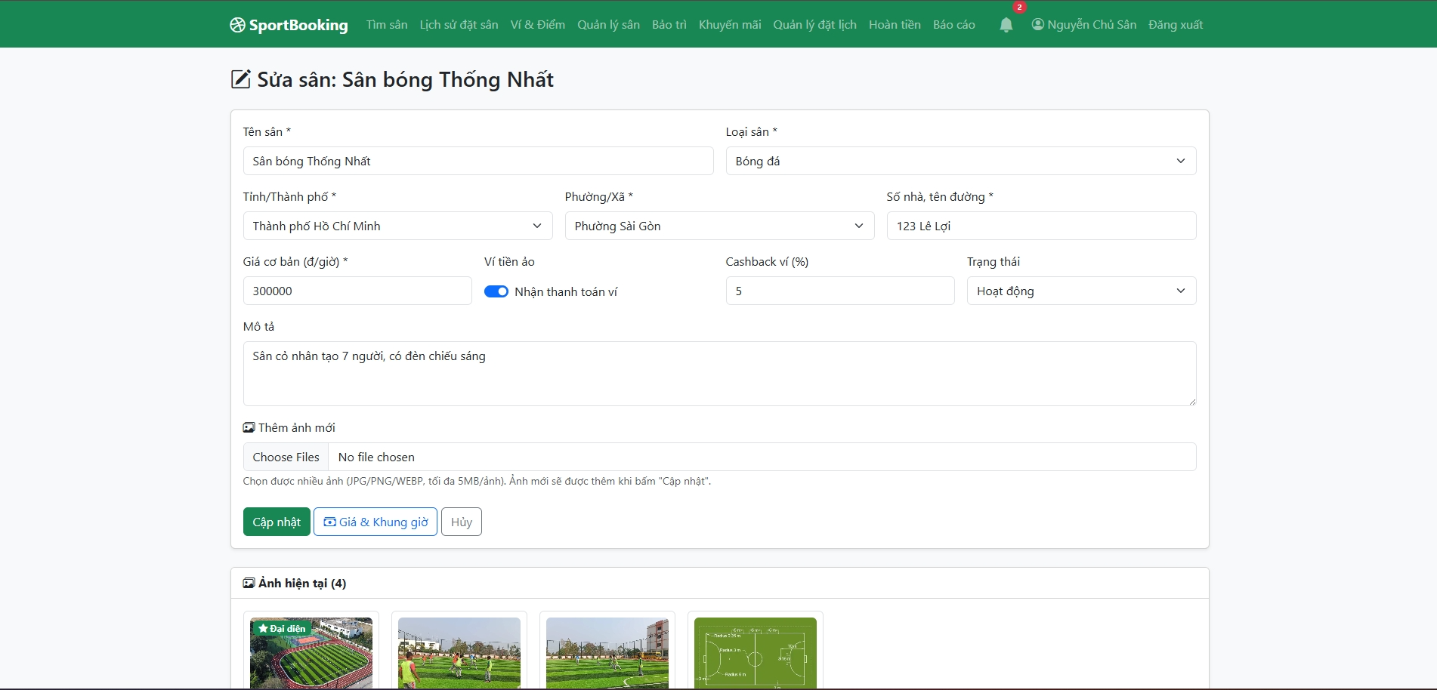
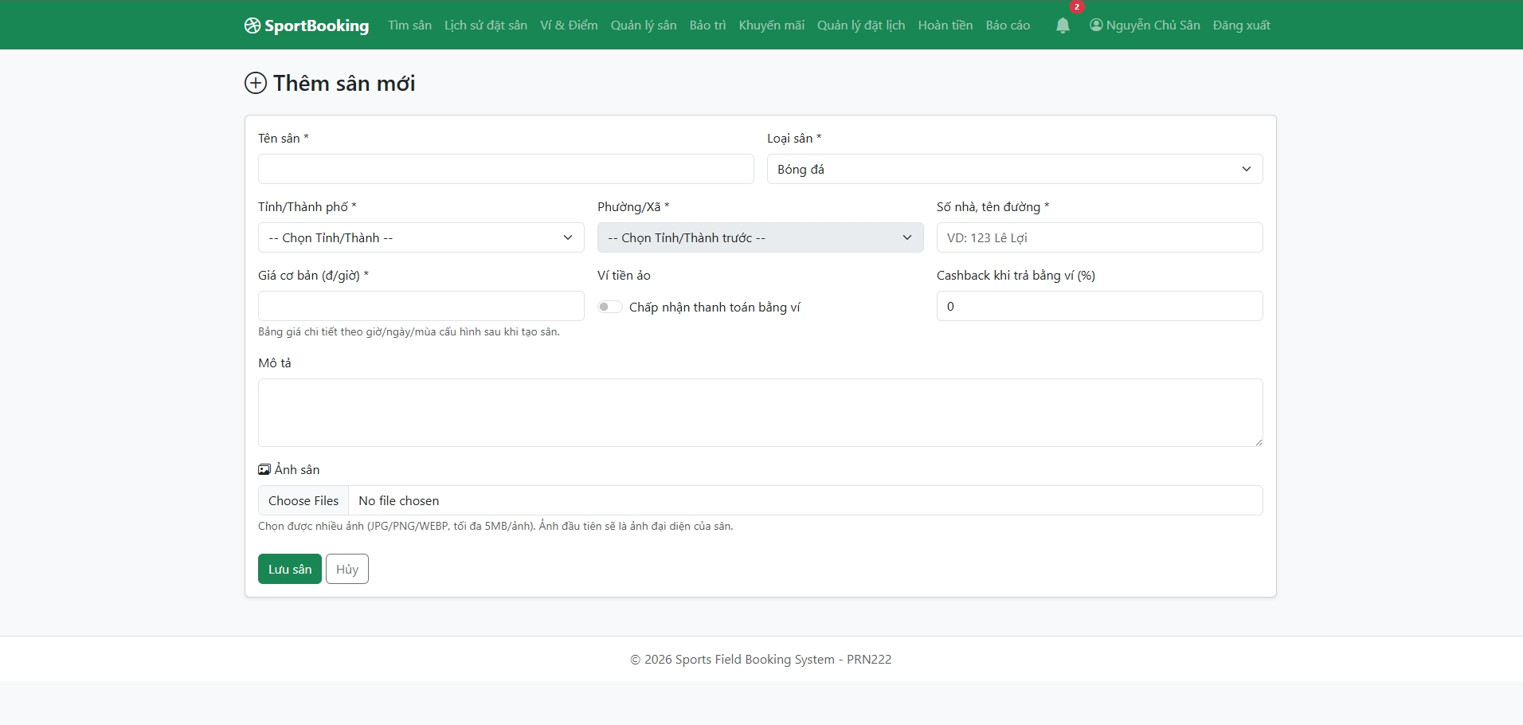

Field Name | Field Type | Description
Danh sách sân (Field list) | Table | Owner's fields with photo, type, area, base price, wallet flag and status.
Tên sân / Loại (Name / Type) | Text Box / Dropdown | Basic field information.
Tỉnh/Thành – Phường/Xã (Province – Ward) | Dropdowns | Address levels loaded from the administrative-units API (no free typing).
Địa chỉ (Street address) | Text Box | House number and street.
Giá cơ bản (Base price) | Number Input | Fallback price per hour when no pricing rule matches.
Nhận ví ảo + Cashback % (Wallet toggle + cashback) | Switch + Number | Enables wallet payment for this field and the cashback percent.
Ảnh sân (Images) | File Upload | Field photos; one is primary.
Lưu / Xóa (Save / Delete) | Buttons | Deleting a field with bookings switches it to Inactive instead.

14. Pricing & Time Slots
URL: /FieldPricing/Index — Roles: Owner, Admin
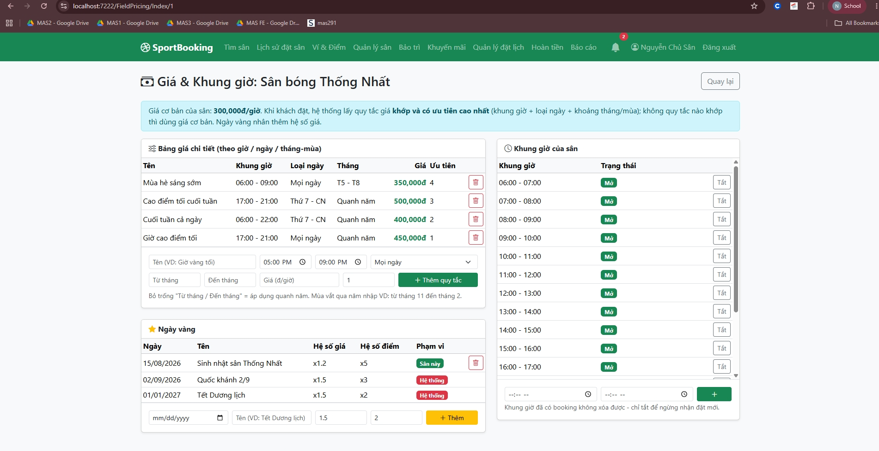

Field Name | Field Type | Description
Khung giờ (Time slots) | Form + List | Adds slots (start – end) per field; slots can be deactivated.
Bảng giá (Pricing rules) | Form + Table | Rule = time range + day type (All/Weekday/Weekend) + month range (season, may wrap year) + price + priority; highest-priority matching rule wins.
Ngày vàng của sân (Field golden days) | Form + Table | Special dates of this field with price multiplier and point multiplier.

15. Promotions & Send E-mail
URL: /Promotions + SendEmail — Roles: Owner, Admin
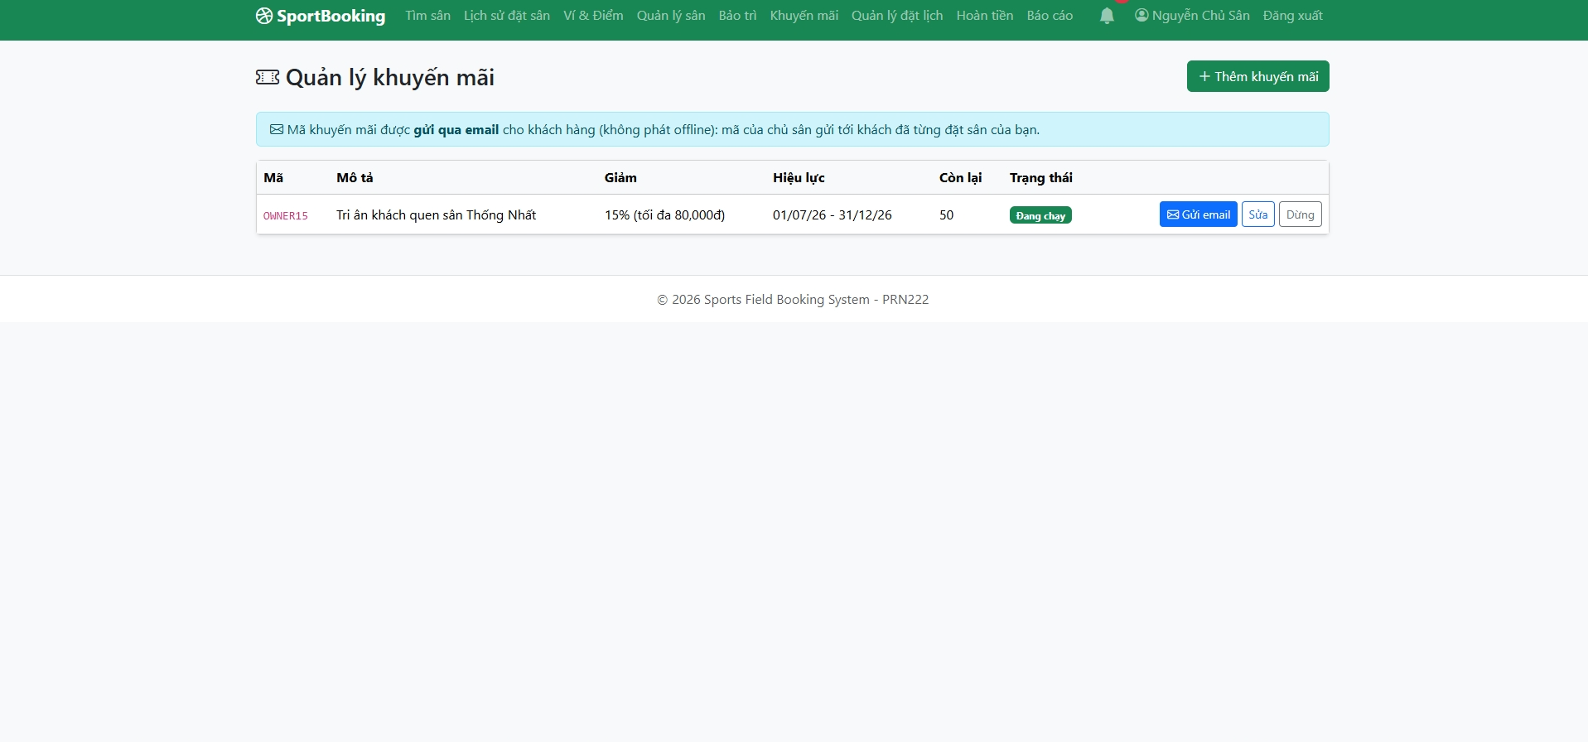
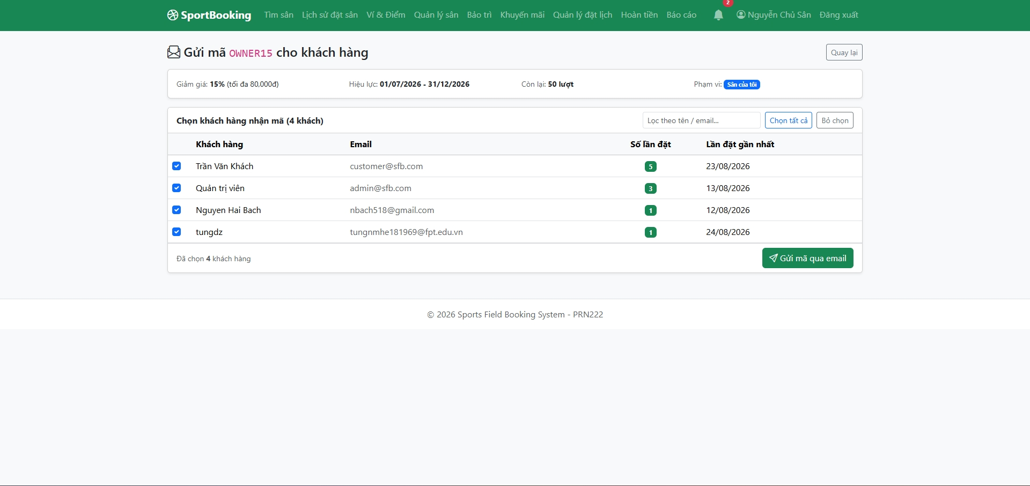

Field Name | Field Type | Description
Danh sách mã (Code list) | Table | Discount codes with usage left and validity; Owner sees own codes, Admin system codes.
Mã / % giảm / Giảm tối đa (Code / % / Max discount) | Text + Numbers | Discount definition.
Hiệu lực / Số lượng (Validity / Quantity) | Date Range + Number | Usage window and number of uses.
Gửi e-mail (Send e-mail) | Button | Owner sends the code to customers who booked his fields; Admin sends system codes to every customer.

16. Booking Management & Book for Customer
URL: /StaffBookings + Create — Roles: Owner, Admin
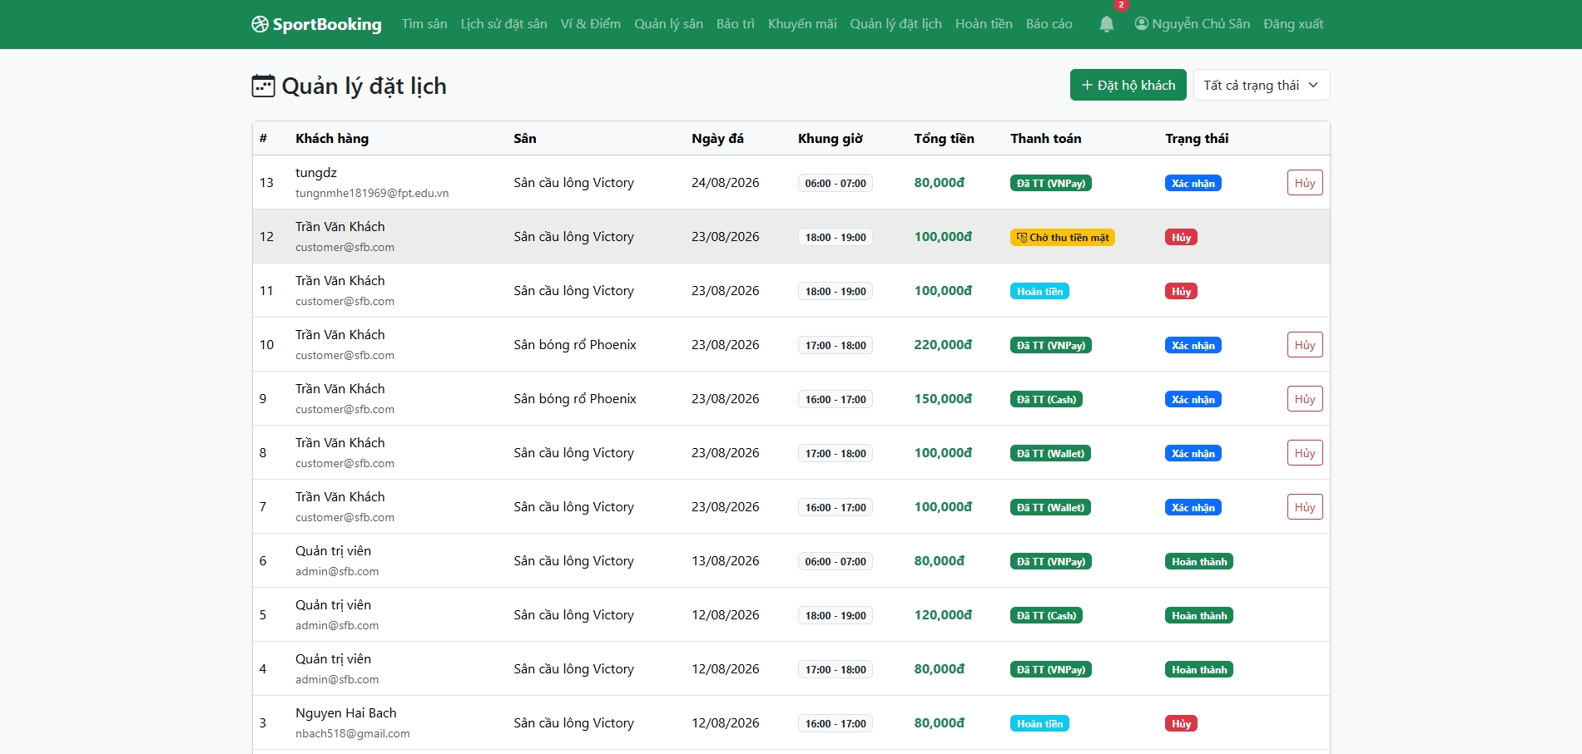
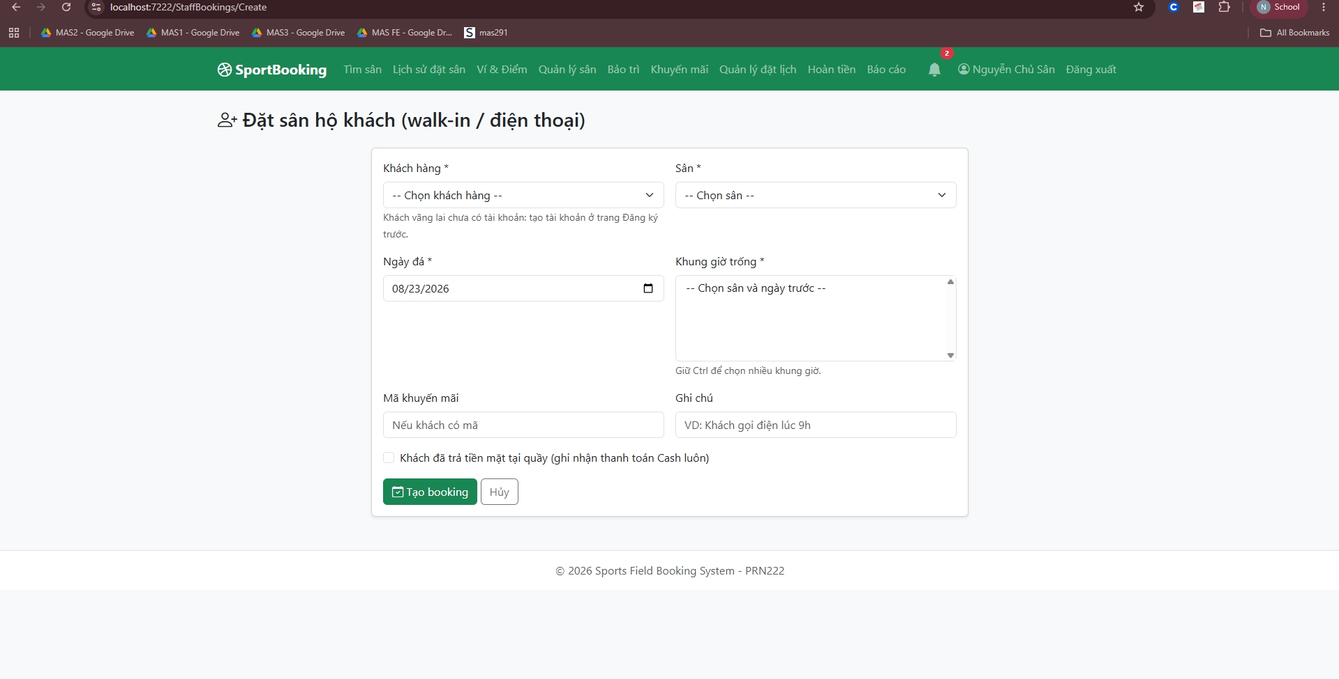

Field Name | Field Type | Description
Bộ lọc trạng thái (Status filter) | Dropdown | Filters bookings by status; Owner sees only his fields' bookings.
Xác nhận / Hủy (Confirm / Cancel) | Buttons | Confirms a pending booking or cancels it (auto refund + notification to the customer).
Xác nhận tiền mặt (Confirm cash) | Button | Marks a cash payment as collected at the counter; the booking becomes Confirmed.
Đặt hộ khách (Book for customer) | Form | Walk-in/phone booking: pick customer, field, date, free slots; optional "paid cash" checkbox records the payment immediately; the booking stores CreatedById for tracing.

17. Maintenance
URL: /Maintenance — Roles: Owner (gửi), Admin (duyệt)
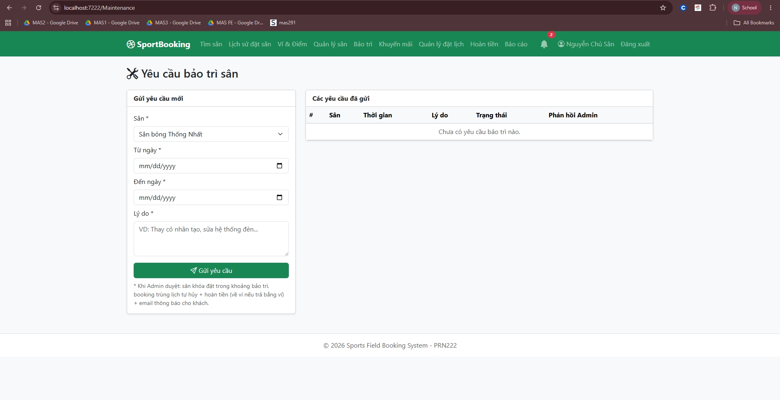

Field Name | Field Type | Description
Sân / Lý do / Khoảng ngày (Field / Reason / Date range) | Form | Owner's maintenance request; one pending request per field.
Danh sách yêu cầu (Request list) | Table | Requests with status Pending / Approved / Rejected and the admin's note.
Duyệt (Approve) | Button | Admin approves: the field switches to Maintenance, overlapping bookings are auto-cancelled, refunded and the customers are e-mailed + notified.
Từ chối (Reject) | Button + Note | Admin rejects with a reason shown to the owner.

18. Refunds
URL: /Refunds/Index — Roles: Owner, Admin
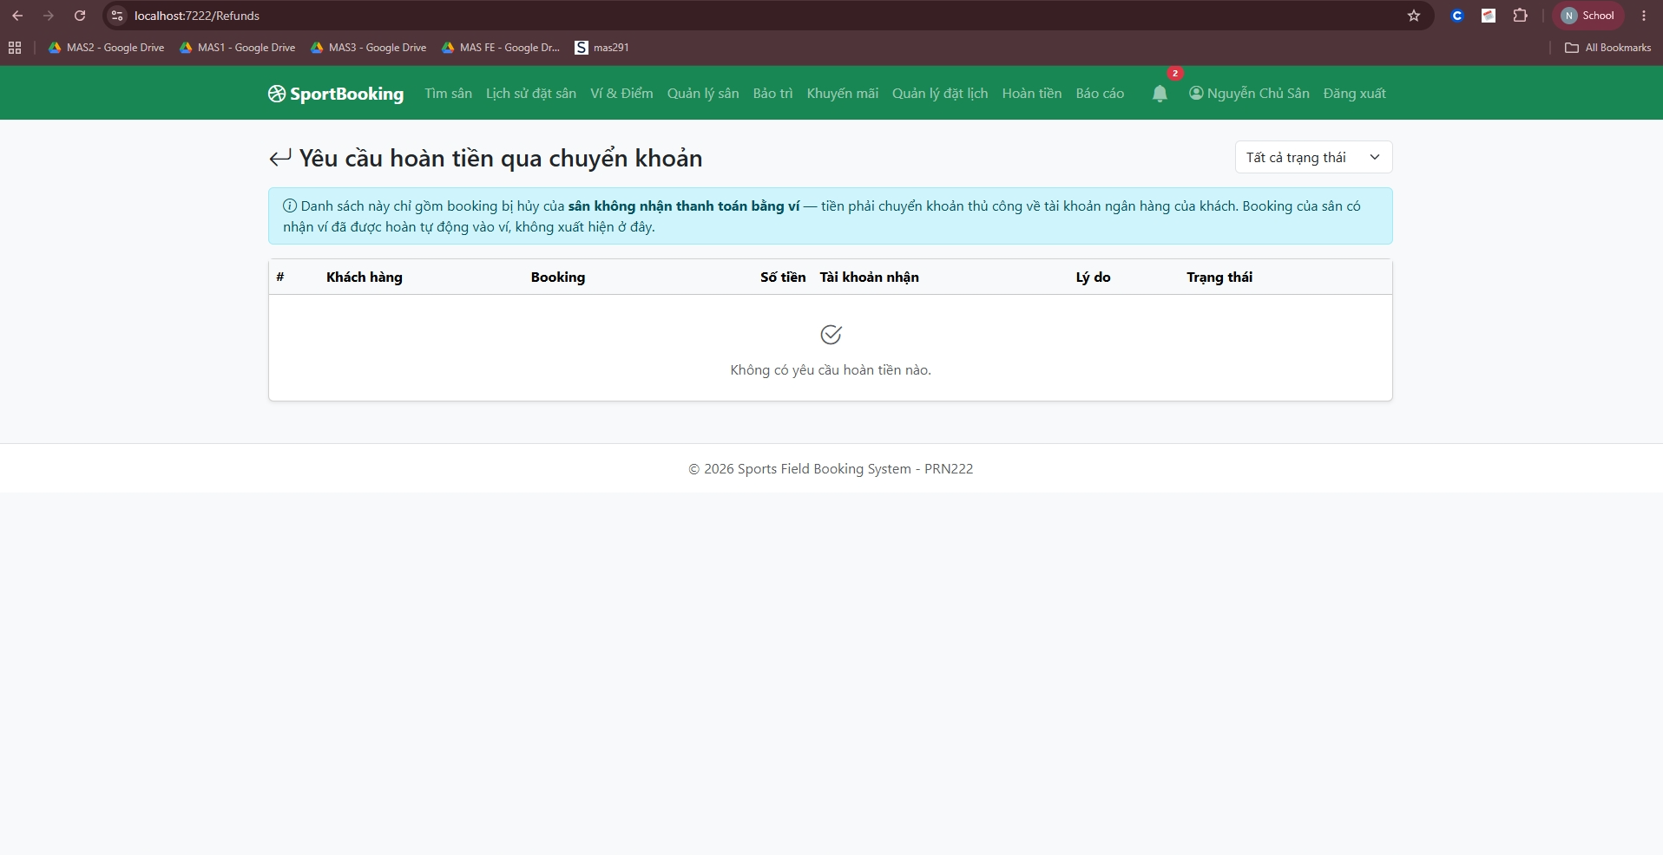

Field Name | Field Type | Description
Bộ lọc trạng thái (Status filter) | Dropdown | Pending / Completed / Rejected bank-transfer refund requests.
Danh sách yêu cầu (Request list) | Table | Customer, amount, booking, snapshot of the customer's bank account.
Đã chuyển khoản (Mark transferred) | Button + Note | Records the manual bank transfer and e-mails + notifies the customer.
Từ chối (Reject) | Button + Note | Rejects the request with a mandatory reason.

19. Reports
URL: /Reports/Index — Roles: Owner (sân mình), Admin (toàn hệ thống)
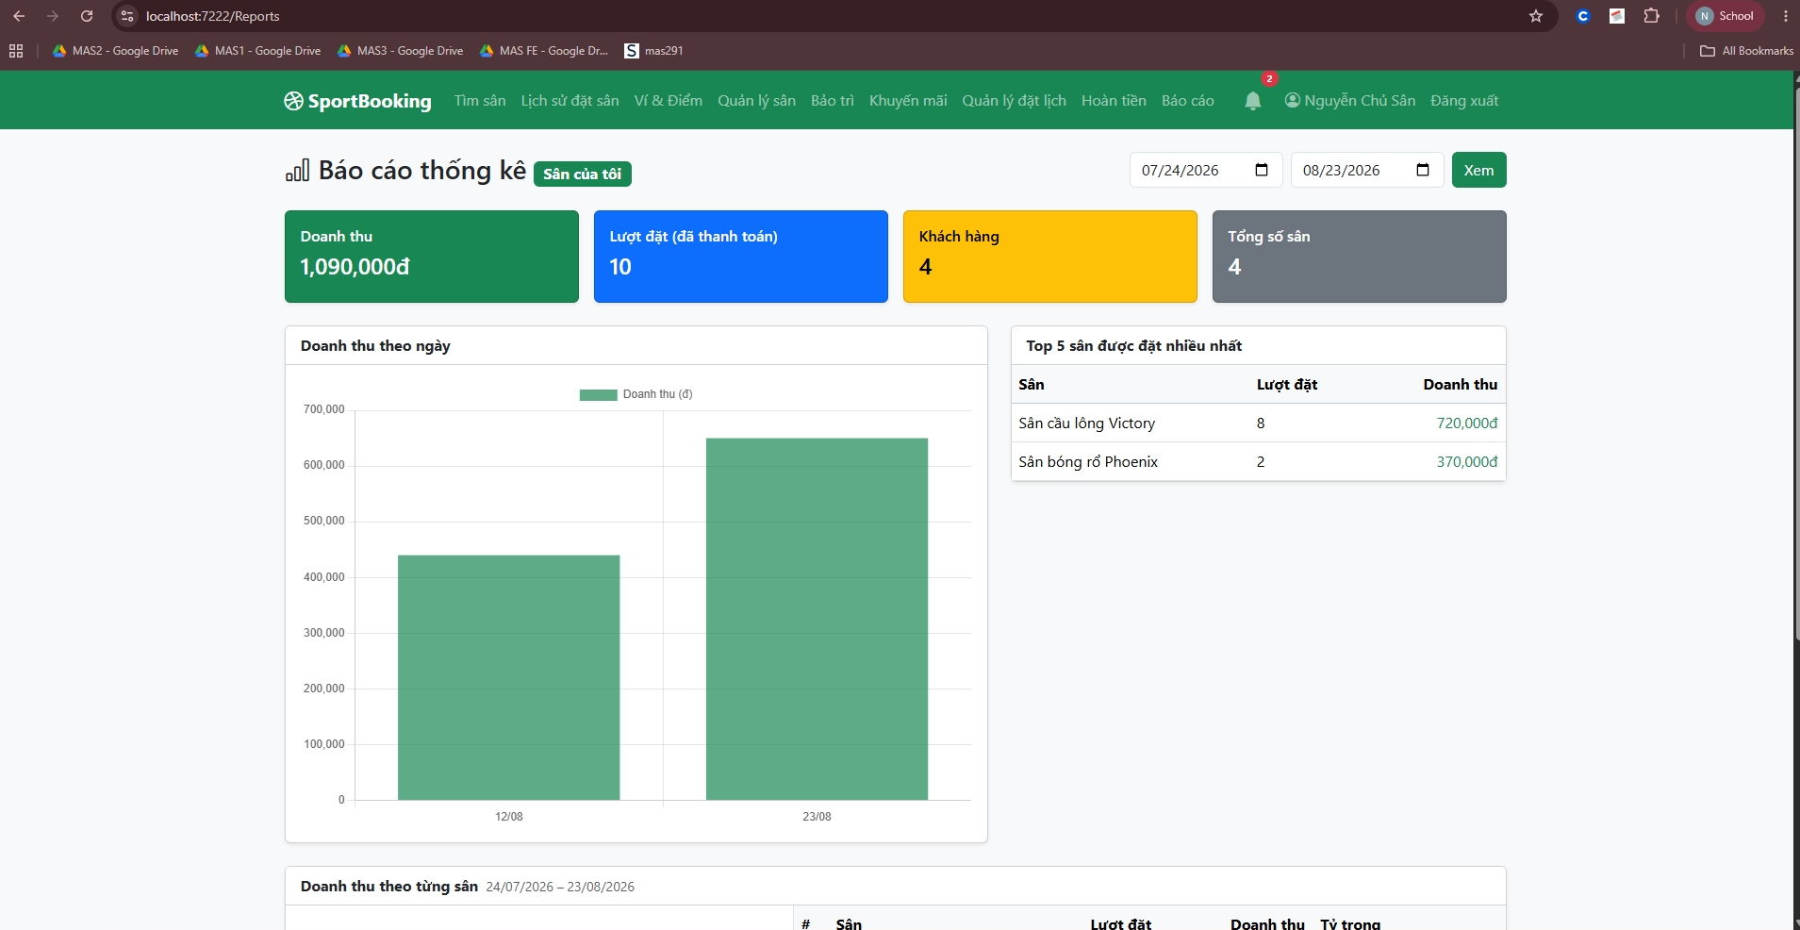
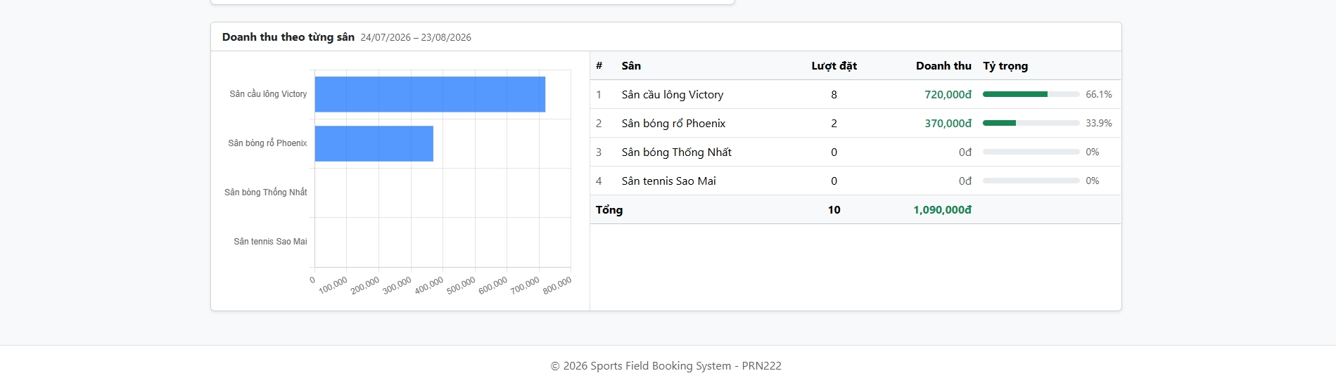

Field Name | Field Type | Description
Khoảng ngày (Date range) | Date Pickers + Button | Filters every figure on the page.
Thẻ tổng quan (Summary cards) | Cards | Revenue, paid bookings, customers, total fields.
Doanh thu theo ngày (Revenue by day) | Bar Chart | Chart.js column chart of daily revenue.
Top 5 sân (Top 5 fields) | Table | Most-booked fields with revenue.
Doanh thu theo từng sân (Revenue per field) | Table + Bar Chart | Every field (including 0đ ones) with bookings, revenue, share % and a horizontal comparison chart.

20. Wallet Management
URL: /Wallet/Manage — Roles: Admin
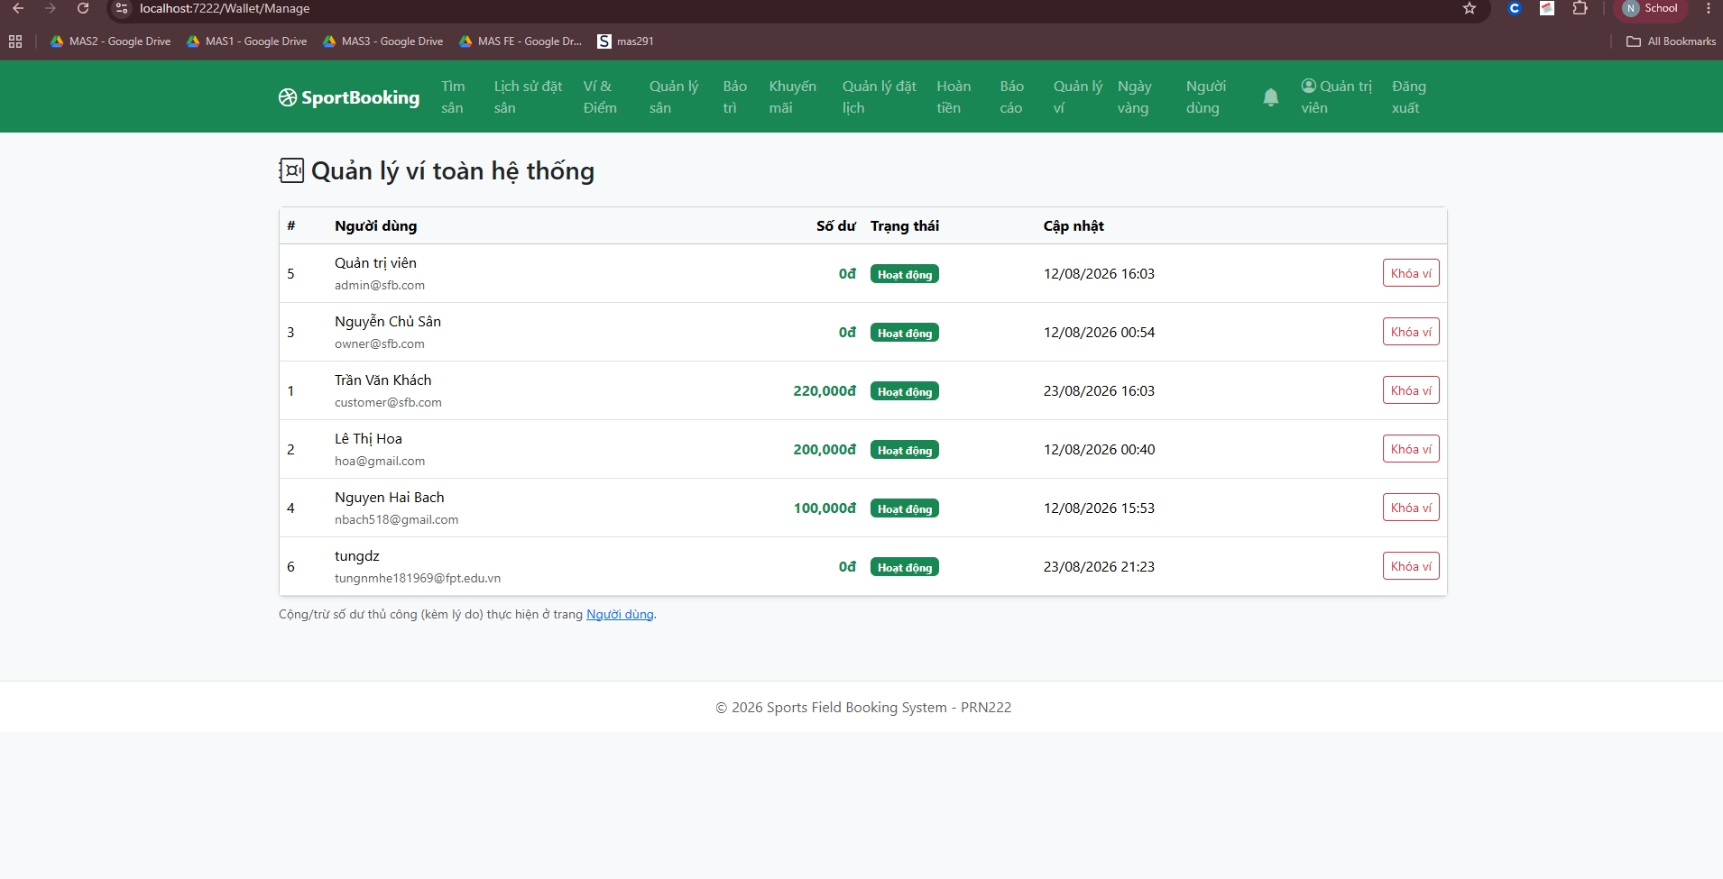

Field Name | Field Type | Description
Danh sách ví (Wallet list) | Table | Every user's wallet with balance and lock state.
Khóa / Mở ví (Lock / Unlock) | Button | A locked wallet cannot deposit or pay (the customer is notified).
Điều chỉnh (Adjust) | Form | Manual +/- adjustment with a mandatory reason; logged as an Adjust transaction.

21. Golden Days (system-wide)
URL: /GoldenDays/Index — Roles: Admin
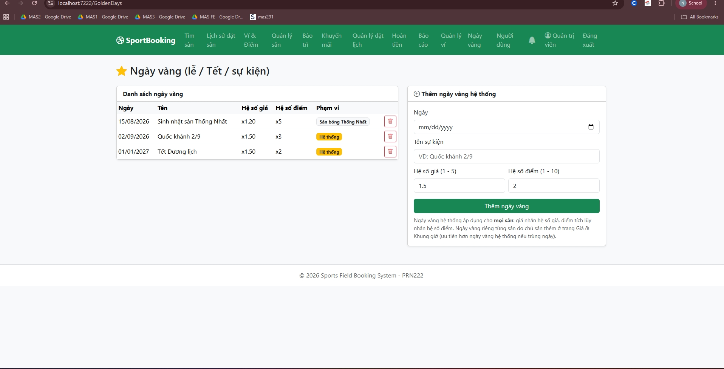

Field Name | Field Type | Description
Ngày / Tên (Date / Name) | Date Picker + Text | Holiday or event date applied to every field.
Hệ số giá / Hệ số điểm (Price / Point multiplier) | Numbers | Multiplies slot prices and earned points on that date.
Danh sách + Xóa (List + Delete) | Table + Button | Manages existing system golden days.

22. Users Management
URL: /Users/Index — Roles: Admin, Super Account
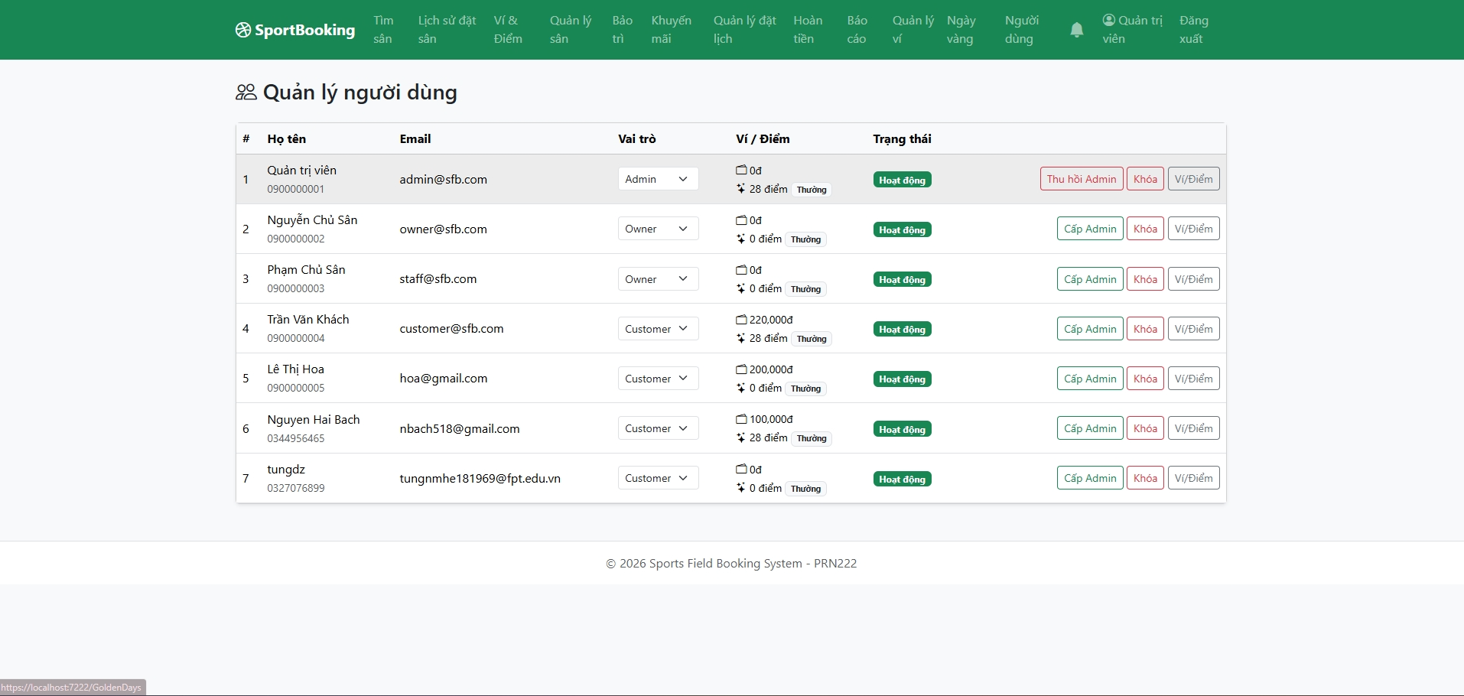

Field Name | Field Type | Description
Danh sách người dùng (User list) | Table | All accounts with role, status, wallet balance and points.
Khóa / Mở (Lock / Unlock) | Button | Locked users cannot log in; open sessions are invalidated on the next request.
Đổi role / Cấp–thu hồi Admin (Role / Grant–revoke Admin) | Dropdown / Buttons | Admin changes roles; Super Account uses grant/revoke Admin as the rescue mechanism.
Cộng/trừ ví & điểm (Adjust wallet & points) | Form | Manual adjustment with mandatory reason (Admin only).

III. Students Contribution

StudentNumber | FullName | Works | Percentage
HE19XXXX | Full name | Design DB | 50%
HE19XXXX | Full name | Code Login function | 50%

IV. Apendix

4.1. Assumptions & Dependencies

AS-1: The system will be used within the organization's internal network.
DE-1: Users have basic knowledge of using Windows applications.

4.2. Limitations & Exclusions
L-E: The system will not support mobile platforms in the current version.

4.3. Business Rules

BR- 1: Default admin account: MemberID is “Admin” and password is “@admin123”.
BR- 2: Default staff account: MemberID is “Staff” and password is “@staff123”.

