SOFTWARE DESIGN SPECIFICATION
SPORTS FIELD BOOKING SYSTEM
Sports Field Booking System (SE1960)

– Ha Noi, Jul 2026 –

Table of Contents
Table of Contents 2
I. Record of Changes 3
II. Software Design Document 4
1. High Level Design 4
1.1 Software Architecture 4
1.2 Package Diagram 5
1.3 Database Design 5
2. State Diagrams 10
2.1 Booking & Payment State 10
3. Detailed Design 11
3.1 Login 11
3.2 Book Field 12
3.3 Payment by Wallet 12
3.4 Deposit via Payment Gateway 13
3.5 Approve Maintenance 14
4. Design Patterns Applied 15

I. Record of Changes
Date | A*M, D | In charge | Change Description
29/07/2026 | A | BachNH | Add 1.1 Software Architecture, 1.2 Package Diagram
29/07/2026 | A | BachNH | Add 1.3 Database Design (16 tables + constraints + indexes)
29/07/2026 | A | BachNH | Add 2. State Diagrams (Booking, Payment, Maintenance, Field)
29/07/2026 | A | BachNH | Add 3. Detailed Design (sequence diagrams: Login, Book, Pay, Deposit, Maintenance)
29/07/2026 | A | BachNH | Add 4. Design Patterns applied
*A - Added M - Modified D - Deleted

II. Software Design Document

1. High Level Design

1.1 Software Architecture
He thong duoc xay dung theo kien truc 3 tang (3-layer) tren nen ASP.NET Core 8 MVC, tach biet ro trach nhiem giua tang giao dien, tang nghiep vu va tang truy cap du lieu. Cac tang giao tiep mot chieu tu tren xuong thong qua Dependency Injection: Web -> Business -> DataAccess -> SQL Server.
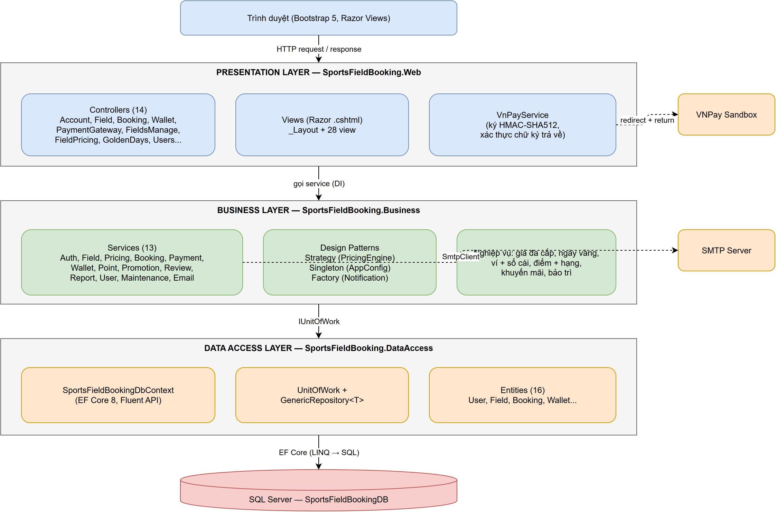
Hinh 1.1 - Software Architecture (3-layer)
Layer | Project | Responsibility
Presentation | SportsFieldBooking.Web | 14 Controller + Razor Views (Bootstrap 5), cookie authentication, VnPayService (ky/xac thuc chu ky HMAC-SHA512).
Business | SportsFieldBooking.Business | 13 Service chua toan bo nghiep vu: tinh gia da cap, vi + so cai, tich diem + hang, khuyen mai, bao tri, email. Ap dung Strategy/Singleton/Factory.
Data Access | SportsFieldBooking.DataAccess | EF Core 8 DbContext (Fluent API), Repository + UnitOfWork, 16 entity.
Database | SQL Server | SportsFieldBookingDB - thiet ke theo huong Database First (script SQL + seed data).

1.2 Package Diagram
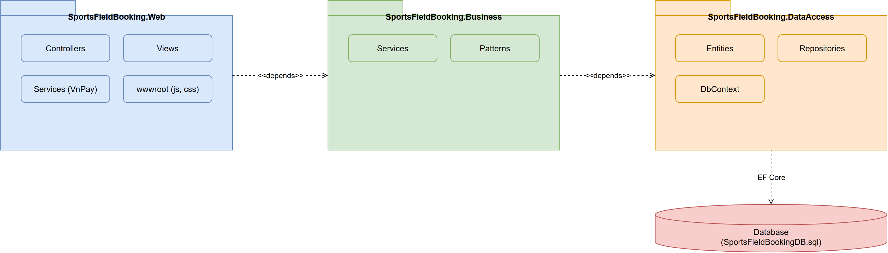
Hinh 1.2 - Package Diagram

1.3 Database Design
1.3.1 Entity Relationship Diagram
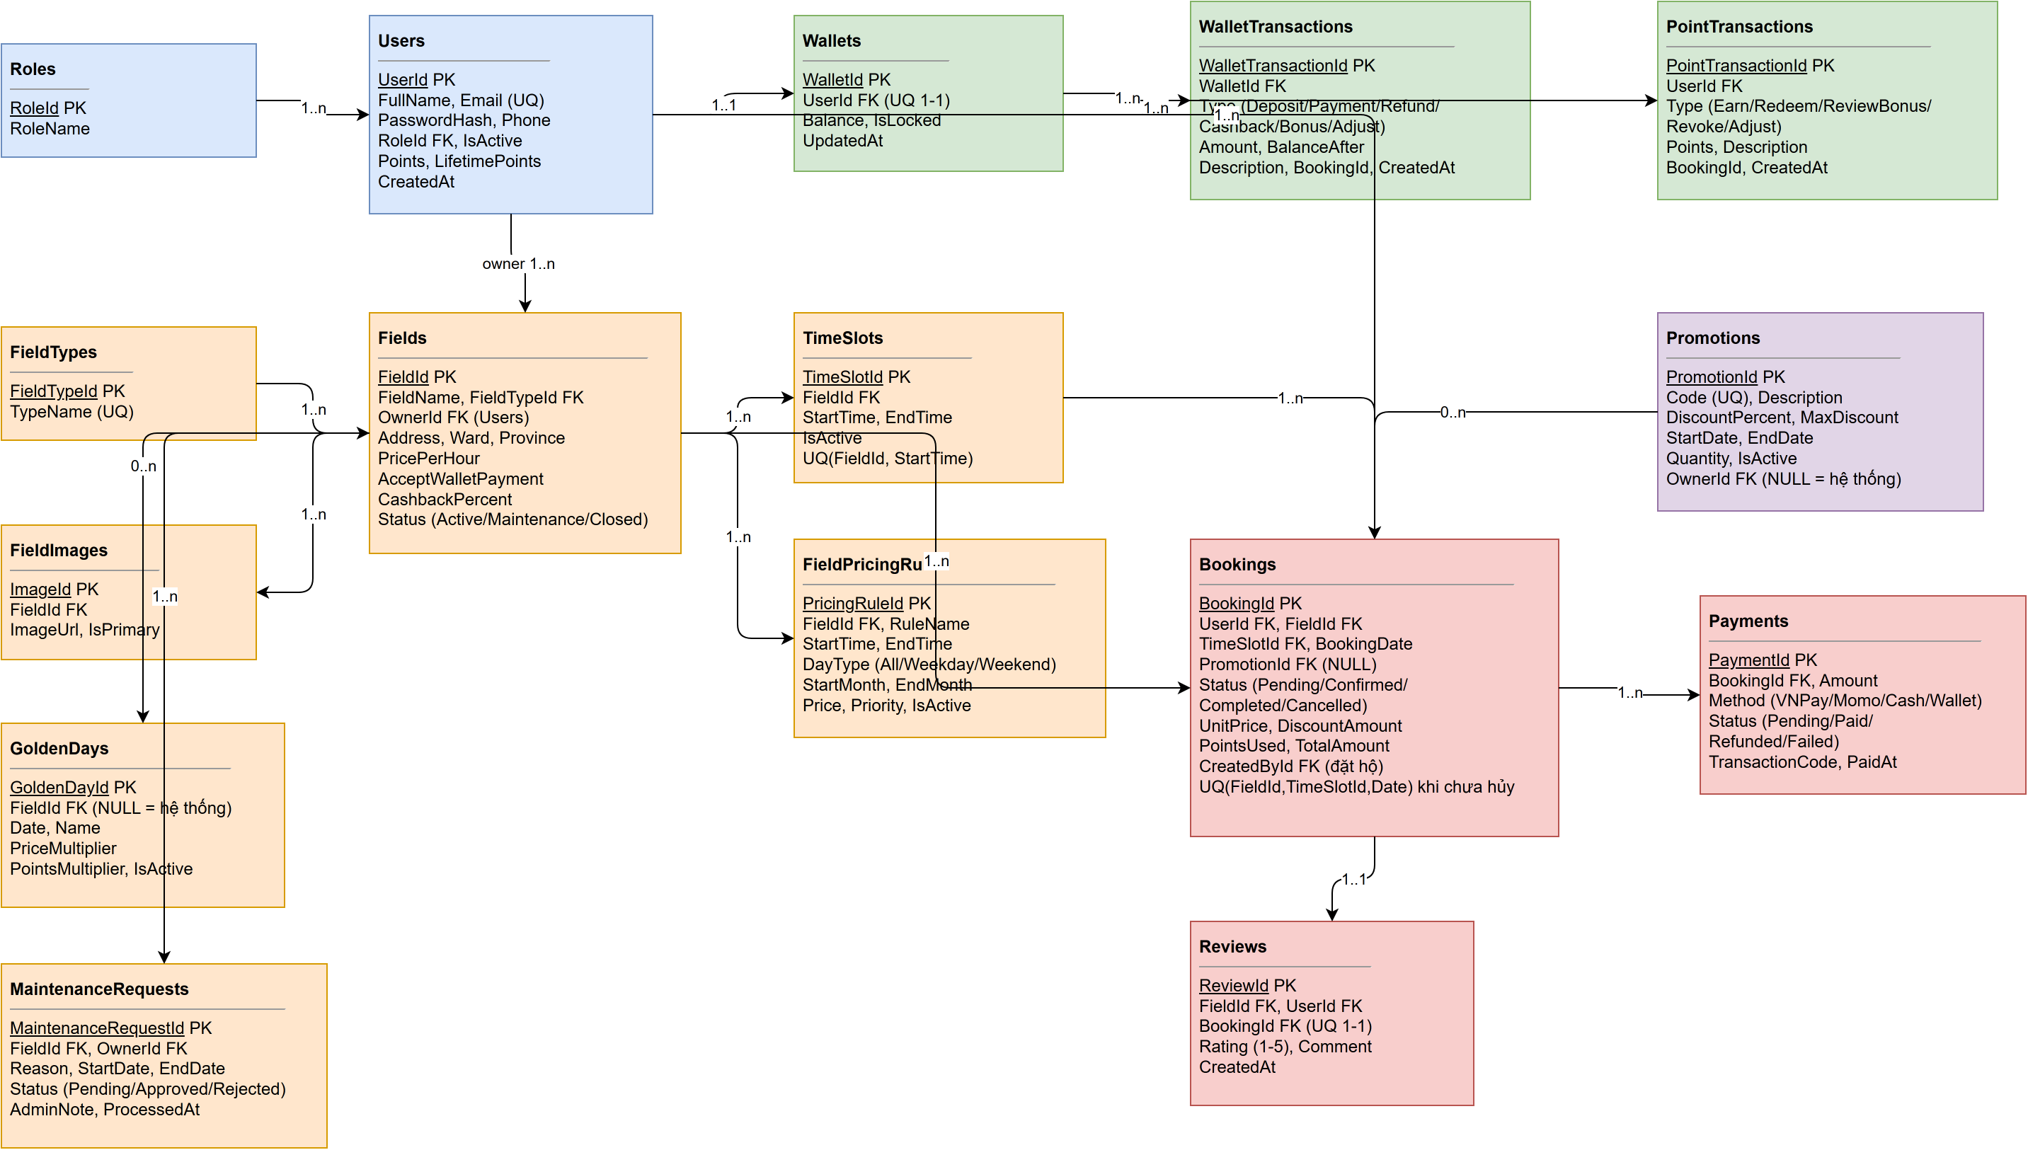
Hinh 1.3.1 - ERD
1.3.2 Table Specifications
Table: Roles
Vai tro he thong (Admin / Owner / Customer).
Column | Data Type | Constraint | Description
RoleId | INT | PK, IDENTITY | Khoa chinh
RoleName | NVARCHAR(50) | NOT NULL, UNIQUE | Ten vai tro

Table: Users
Nguoi dung he thong (moi role dung chung 1 bang).
Column | Data Type | Constraint | Description
UserId | INT | PK, IDENTITY | Khoa chinh
FullName | NVARCHAR(100) | NOT NULL | Ho ten
Email | NVARCHAR(100) | NOT NULL, UNIQUE | Email dang nhap
PasswordHash | NVARCHAR(256) | NOT NULL | Mat khau bam SHA-256
Phone | NVARCHAR(20) | NULL | So dien thoai
RoleId | INT | FK -> Roles | Vai tro
IsActive | BIT | DEFAULT 1 | Trang thai tai khoan (0 = bi khoa)
Points | INT | DEFAULT 0 | So du diem hien tai (tieu duoc)
LifetimePoints | INT | DEFAULT 0 | Diem tich luy tron doi (xet hang thanh vien)
CreatedAt | DATETIME | DEFAULT GETDATE() | Ngay tao

Table: Fields
San the thao thuoc so huu cua mot chu san.
Column | Data Type | Constraint | Description
FieldId | INT | PK, IDENTITY | Khoa chinh
FieldName | NVARCHAR(100) | NOT NULL | Ten san
FieldTypeId | INT | FK -> FieldTypes | Loai san
OwnerId | INT | FK -> Users | Chu san
Address / Ward / Province | NVARCHAR | NOT NULL | Dia chi chi tiet (Phuong/Xa, Tinh/Thanh lay tu API hanh chinh)
PricePerHour | DECIMAL(12,0) | NOT NULL | Gia co ban - dung khi khong co rule nao khop
AcceptWalletPayment | BIT | DEFAULT 0 | Chu san bat/tat nhan thanh toan bang vi
CashbackPercent | INT | DEFAULT 0 | % hoan vi khi khach tra bang vi
Status | NVARCHAR(20) | DEFAULT 'Active' | Active / Maintenance / Closed

Table: TimeSlots
Khung gio kinh doanh cua tung san.
Column | Data Type | Constraint | Description
TimeSlotId | INT | PK, IDENTITY | Khoa chinh
FieldId | INT | FK -> Fields, CASCADE | San
StartTime / EndTime | TIME | NOT NULL | Gio bat dau / ket thuc
IsActive | BIT | DEFAULT 1 | Tat khung gio de ngung nhan dat moi
- | - | UNIQUE(FieldId, StartTime) | Khong trung khung gio tren cung 1 san

Table: FieldPricingRules
Bang gia da cap: moi san mot bang gia rieng theo gio / loai ngay / mua.
Column | Data Type | Constraint | Description
PricingRuleId | INT | PK, IDENTITY | Khoa chinh
FieldId | INT | FK -> Fields, CASCADE | San ap dung
StartTime / EndTime | TIME | NOT NULL | Khung gio ap dung
DayType | NVARCHAR(10) | DEFAULT 'All' | All / Weekday / Weekend
StartMonth / EndMonth | INT | NULL | Khoang thang (mua); ho tro vat qua nam (11 -> 2)
Price | DECIMAL(12,0) | NOT NULL | Gia ap dung
Priority | INT | DEFAULT 1 | Rule khop co Priority cao nhat thang

Table: GoldenDays
Ngay vang (le/Tet/su kien) nhan he so gia va he so tich diem.
Column | Data Type | Constraint | Description
GoldenDayId | INT | PK, IDENTITY | Khoa chinh
FieldId | INT | FK -> Fields, NULL | NULL = ngay vang toan he thong (Admin tao)
Date | DATE | NOT NULL | Ngay ap dung
PriceMultiplier | DECIMAL(4,2) | DEFAULT 1 | He so nhan gia (1 - 5)
PointsMultiplier | INT | DEFAULT 2 | He so nhan diem (1 - 10)

Table: Bookings
Don dat san. 1 booking = 1 san + 1 khung gio + 1 ngay (da bo bang BookingDetails).
Column | Data Type | Constraint | Description
BookingId | INT | PK, IDENTITY | Khoa chinh
UserId | INT | FK -> Users | Khach dat san
FieldId / TimeSlotId | INT | FK | San + khung gio
BookingDate | DATE | NOT NULL | Ngay da
PromotionId | INT | FK, NULL | Ma khuyen mai da ap dung
Status | NVARCHAR(20) | DEFAULT 'Pending' | Pending / Confirmed / Completed / Cancelled
UnitPrice | DECIMAL(12,0) | NOT NULL | Gia goc khung gio (sau rule + ngay vang)
DiscountAmount | DECIMAL(12,0) | DEFAULT 0 | Tong giam gia (ma KM + hang + diem)
PointsUsed | INT | DEFAULT 0 | So diem da dung
TotalAmount | DECIMAL(12,0) | NOT NULL | So tien phai tra
CreatedById | INT | FK -> Users, NULL | Nguoi thao tac khi dat ho khach
- | - | UNIQUE INDEX | (FieldId, TimeSlotId, BookingDate) WHERE Status <> 'Cancelled' - chong dat trung

Table: Payments
Giao dich thanh toan cua booking.
Column | Data Type | Constraint | Description
PaymentId | INT | PK, IDENTITY | Khoa chinh
BookingId | INT | FK -> Bookings | Booking tuong ung
Amount | DECIMAL(12,0) | NOT NULL | So tien
Method | NVARCHAR(20) | NOT NULL | VNPay / Momo / Cash / Wallet
Status | NVARCHAR(20) | DEFAULT 'Pending' | Pending / Paid / Refunded / Failed
TransactionCode | NVARCHAR(50) | NULL | Ma giao dich cong thanh toan
PaidAt | DATETIME | NULL | Thoi diem thanh toan

Table: Wallets / WalletTransactions
Vi tien ao (1-1 voi Users) va so cai moi bien dong so du.
Column | Data Type | Constraint | Description
WalletId | INT | PK | Khoa chinh vi
UserId | INT | FK, UNIQUE | Quan he 1-1 voi Users
Balance | DECIMAL(12,0) | DEFAULT 0 | So du (khong rut ra duoc)
IsLocked | BIT | DEFAULT 0 | Admin khoa vi
WalletTransactionId | INT | PK | Khoa chinh giao dich
Type | NVARCHAR(20) | NOT NULL | Deposit / Payment / Refund / Cashback / Bonus / Adjust
Amount | DECIMAL(12,0) | NOT NULL | So tien (co dau)
BalanceAfter | DECIMAL(12,0) | NOT NULL | So du sau giao dich - phuc vu doi soat

Table: PointTransactions
So cai diem thuong; moi bien dong diem deu di qua bang nay.
Column | Data Type | Constraint | Description
PointTransactionId | INT | PK, IDENTITY | Khoa chinh
UserId | INT | FK -> Users | Nguoi dung
Type | NVARCHAR(20) | NOT NULL | Earn / Redeem / ReviewBonus / Revoke / Adjust
Points | INT | NOT NULL | So diem (co dau)
BookingId | INT | NULL | Booking lien quan (neu co)

Table: Promotions
Ma khuyen mai cua he thong hoac cua tung chu san; voucher doi diem cung luu o day.
Column | Data Type | Constraint | Description
PromotionId | INT | PK, IDENTITY | Khoa chinh
Code | NVARCHAR(30) | NOT NULL, UNIQUE | Ma nhap khi dat san
DiscountPercent | INT | CHECK 1..100 | % giam
MaxDiscount | DECIMAL(12,0) | DEFAULT 0 | Tran giam (0 = khong gioi han)
StartDate / EndDate | DATE | NOT NULL | Han su dung
Quantity | INT | DEFAULT 0 | So luot con lai
OwnerId | INT | FK, NULL | NULL = ma he thong; co gia tri = ma cua chu san

Table: Reviews / MaintenanceRequests
Danh gia san (1-1 voi booking) va yeu cau bao tri cua chu san.
Column | Data Type | Constraint | Description
ReviewId | INT | PK | Khoa chinh danh gia
BookingId | INT | FK, UNIQUE | Moi booking chi danh gia 1 lan
Rating | INT | CHECK 1..5 | So sao
MaintenanceRequestId | INT | PK | Khoa chinh yeu cau bao tri
FieldId / OwnerId | INT | FK | San + chu san gui yeu cau
StartDate / EndDate | DATE | NOT NULL | Khoang thoi gian bao tri
Status | NVARCHAR(20) | DEFAULT 'Pending' | Pending / Approved / Rejected

2. State Diagrams

2.1 Booking & Payment State
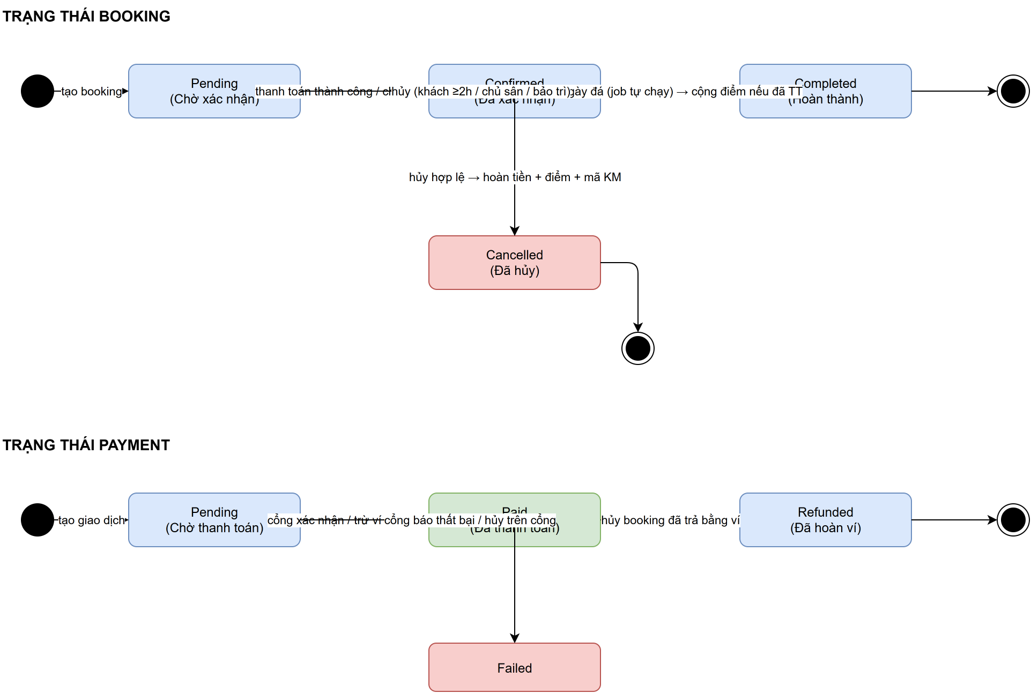
Hinh 2.1 - State Diagram: Booking va Payment
Booking khoi tao o trang thai Pending. Khi thanh toan thanh cong (hoac chu san xac nhan tien mat) chuyen sang Confirmed. Sau ngay da, tien trinh CompletePastBookingsAsync chuyen sang Completed va cong diem neu booking da duoc thanh toan. Booking co the bi huy o Pending/Confirmed boi khach (truoc gio da >= 2 tieng), boi chu san/Admin, hoac tu dong khi Admin duyet bao tri.

3. Detailed Design

3.1 Login
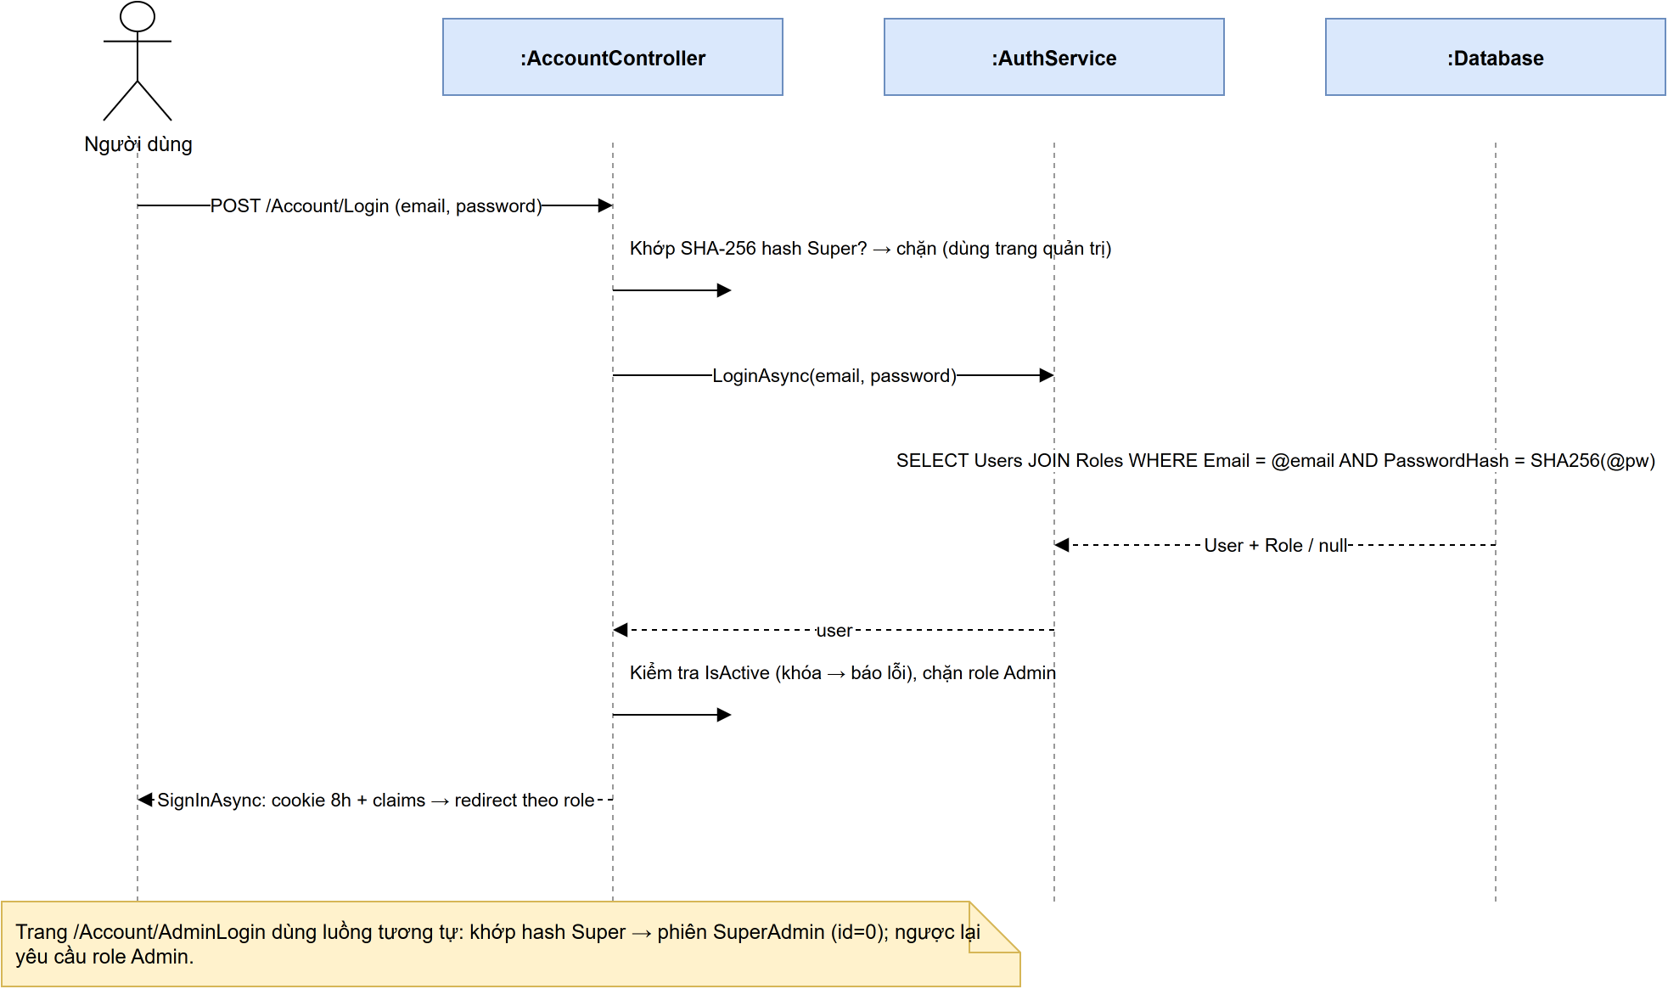
Hinh 3.1 - Sequence Diagram: Dang nhap
Class / Method | Description
AccountController.Login(email, password, returnUrl) | Nhan POST tu trang khach; chan hash Super Account va tai khoan role Admin.
AccountController.AdminLogin(email, password) | Trang quan tri rieng: doi chieu SHA-256 hash Super truoc khi query DB, sau do yeu cau role Admin.
AuthService.LoginAsync(email, password) | Bam SHA-256 mat khau va truy van Users JOIN Roles.
Program.cs - OnValidatePrincipal | Moi request kiem tra lai IsActive; tai khoan bi khoa se bi dang xuat ngay.

3.2 Book Field
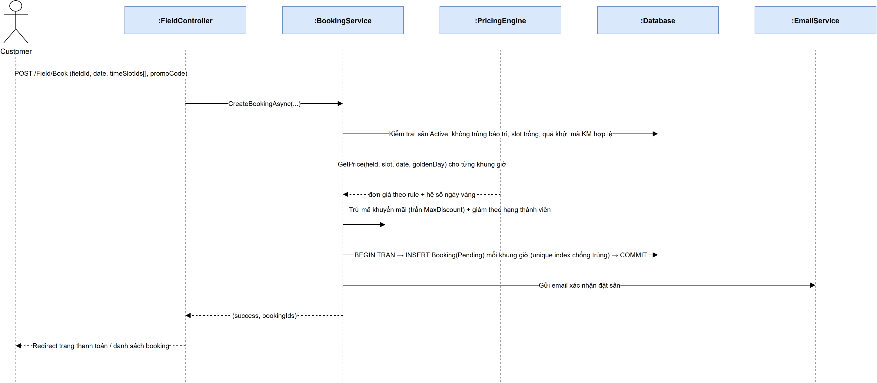
Hinh 3.2 - Sequence Diagram: Dat san
Class / Method | Description
FieldController.Book(fieldId, date, timeSlotIds, promoCode, note) | Nhan POST dat san; yeu cau da dang nhap.
BookingService.CreateBookingAsync(...) | Kiem tra rang buoc, mo transaction, tao 1 booking cho moi khung gio, tru luot ma KM, gui email.
PricingEngine.GetPrice(field, slot, date, goldenDay) | Chon rule khop co Priority cao nhat (Strategy Pattern), nhan he so ngay vang.
MembershipTiers.GetTier(lifetimePoints) | Xac dinh hang thanh vien de tinh % giam gia.

3.3 Payment by Wallet
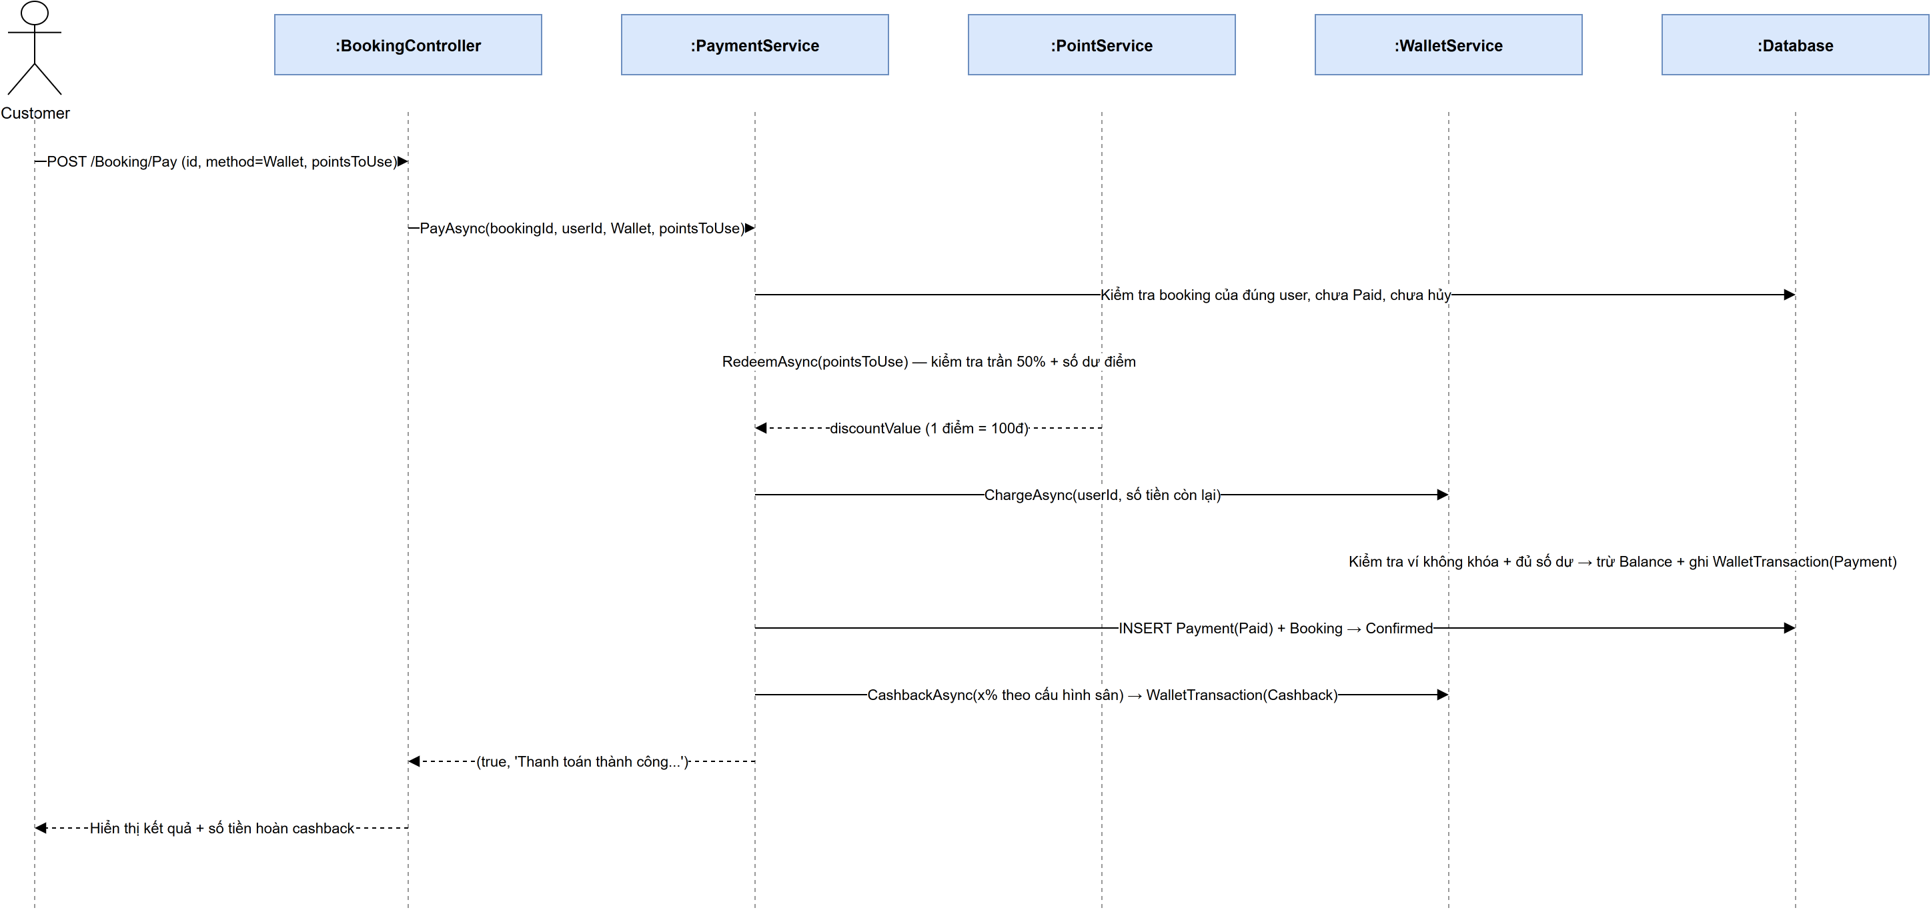
Hinh 3.3 - Sequence Diagram: Thanh toan bang vi
Class / Method | Description
BookingController.Pay(id, method, pointsToUse) | Nhan POST thanh toan tu man hinh Pay.
PaymentService.PayAsync(bookingId, userId, method, pointsToUse) | Mo transaction, tru diem, tru vi, ghi Payment(Paid), chuyen booking sang Confirmed, cong cashback.
PointService.RedeemAsync(userId, points, bookingId) | Kiem tra tran 50% + so du diem, ghi PointTransaction(Redeem).
WalletService.ChargeAsync / CashbackAsync | Tru vi va cong cashback; moi lan deu ghi WalletTransaction kem BalanceAfter.

3.4 Deposit via Payment Gateway
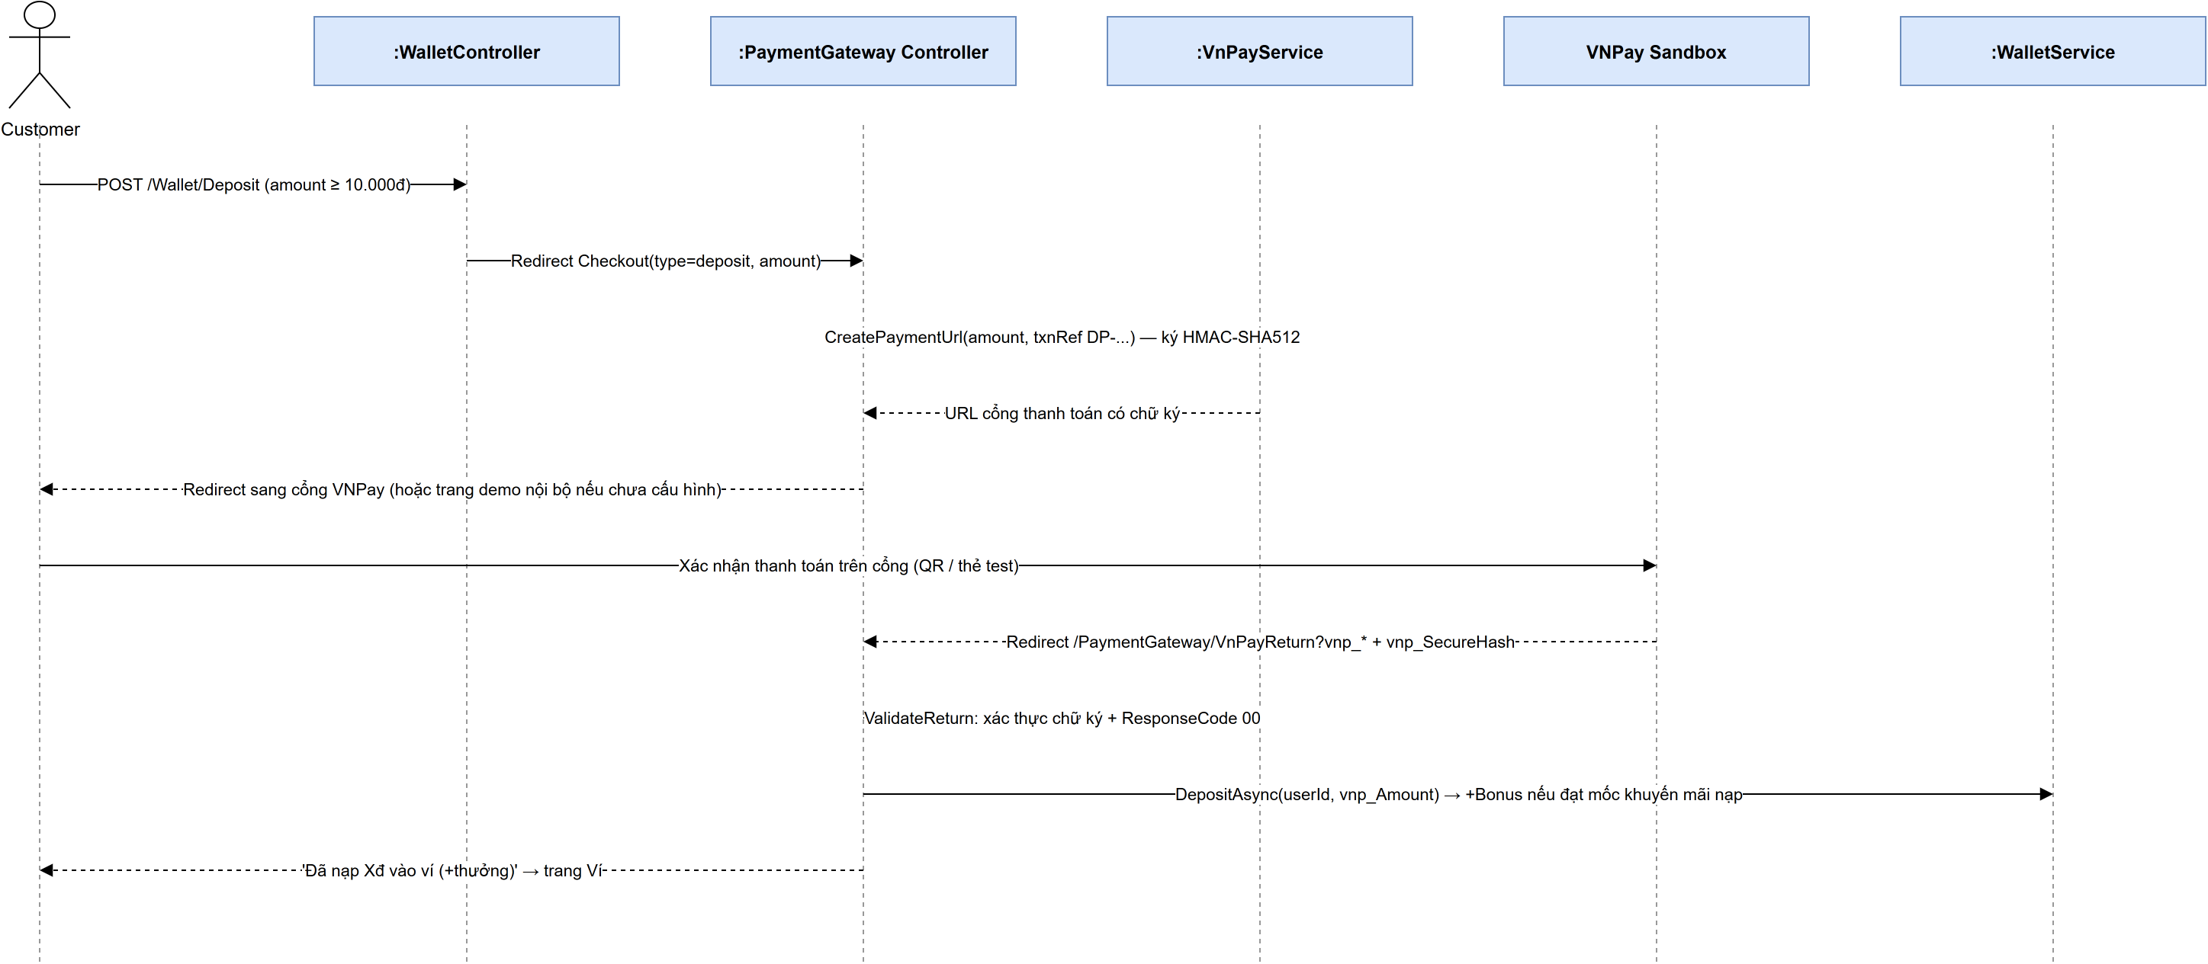
Hinh 3.4 - Sequence Diagram: Nap vi qua VNPay
Class / Method | Description
WalletController.Deposit(amount, method) | Chuyen huong sang PaymentGateway/Checkout.
VnPayService.CreatePaymentUrl(...) | Tao URL thanh toan chuan vnp_ v2.1.0, ky HMAC-SHA512.
PaymentGatewayController.VnPayReturn() | Xac thuc chu ky + ma phan hoi truoc khi ghi nhan tien.
WalletService.DepositAsync(userId, amount) | Cong vi (Deposit) va cong thuong nap (Bonus) neu dat moc.

3.5 Approve Maintenance
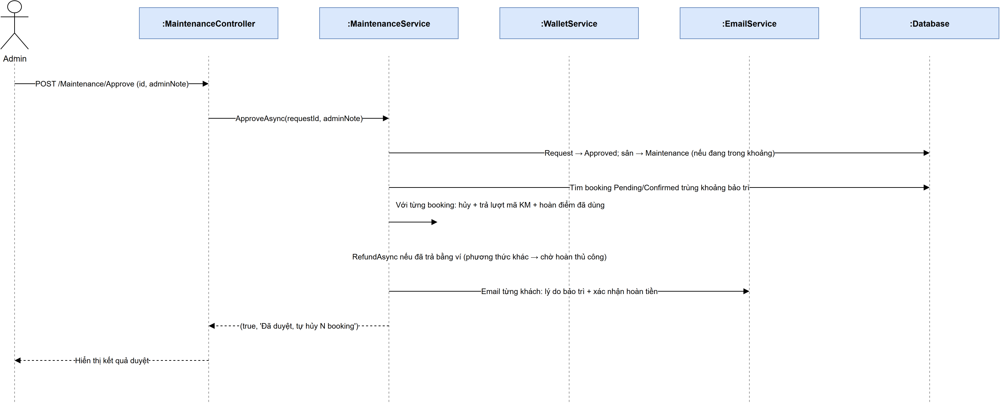
Hinh 3.5 - Sequence Diagram: Duyet bao tri
Class / Method | Description
MaintenanceController.Approve(id, adminNote) | Admin duyet yeu cau bao tri.
MaintenanceService.ApproveAsync(requestId, adminNote) | Doi trang thai san, tim booking trung khoang, huy + hoan tien + gui email.
WalletService.RefundAsync(...) | Hoan tien vao vi neu booking da tra bang vi.
EmailService.SendAsync(...) | Gui email thong bao ly do bao tri va xac nhan hoan tien.

4. Design Patterns Applied
Pattern | Location | Purpose
Strategy | Business/Patterns/PricingStrategy.cs (IPricingStrategy, RuleBasedPricingStrategy, BasePricingStrategy, PricingEngine) | Cho phep thay doi cach tinh gia theo tung tinh huong (co rule khop / khong co rule) ma khong sua code goi.
Singleton | Business/Patterns/AppConfigSingleton.cs | Mot the hien duy nhat luu tham so he thong: gio huy toi thieu, ty le diem, muc thuong nap, goi voucher.
Factory | Business/Patterns/NotificationFactory.cs | Tao doi tuong gui thong bao (Email/SMS) theo loai yeu cau.
Repository + Unit of Work | DataAccess/Repositories/ | Truu tuong hoa truy cap du lieu, gom nhieu thao tac vao mot transaction.
Dependency Injection | Program.cs | Dang ky toan bo service theo vong doi Scoped, giup de test va thay the cai dat.

