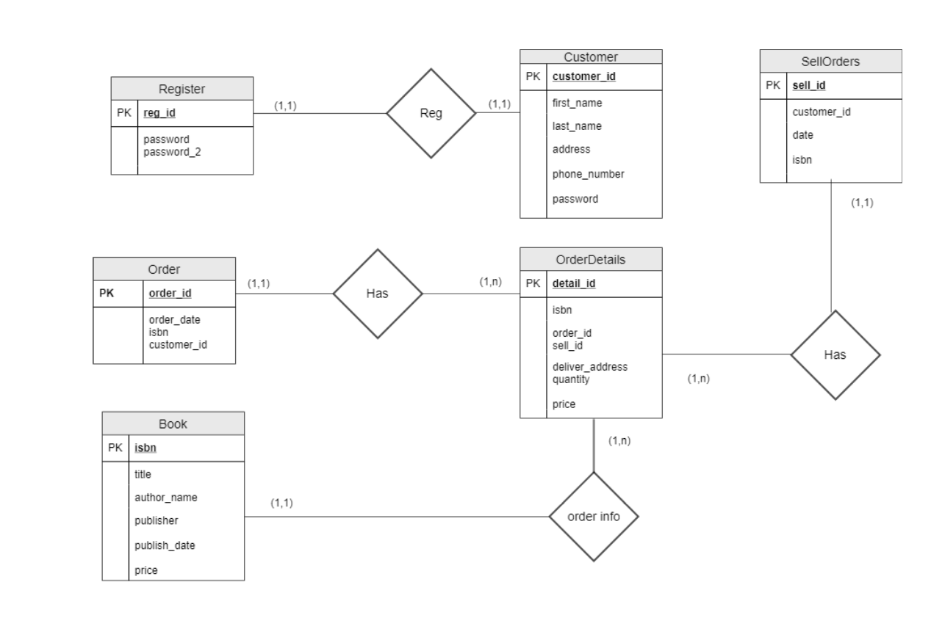**ACCOUNT/BUYING AND SELLING BOOKS**

Register = (**reg_id**, password,password_2)

Customer = (**customer_id**,password,first_name,last_name,email,address,phone_number)

From Customer.customer_id *to* Register.reg_id

From Customer.password *to* Register.password

Book = (**isbn**, title, author_name,publisher, publish_date,price)

Order = (**order_id**, customer_id, isbn,quantity)

From Order.customer_id *to* Customer.customer_id

From Order.isbn to Book,isbn

Sell = (**sell_id**, customer_id, isbn,quantity)

From Sell.customer_id *to* Customer.customer_id

From Sell.isbn to Book,isbn

OrderDetails = (**detail_id**, ibsn, price,quantity,order_status,order_id)

From OrderDetails.order_id to Order.order_id

From OrderDetails.order_id to Sell.sell_id

From OrderDetails.price to Book.price