GDD

HI-Concept – I want to make a fast pace 3d and 2d pong game with 2 modes, one where you can aim the ball in different directions with your paddle, and the other where you can play with a friend where it’s like a platformer hitting the ball to the other side.

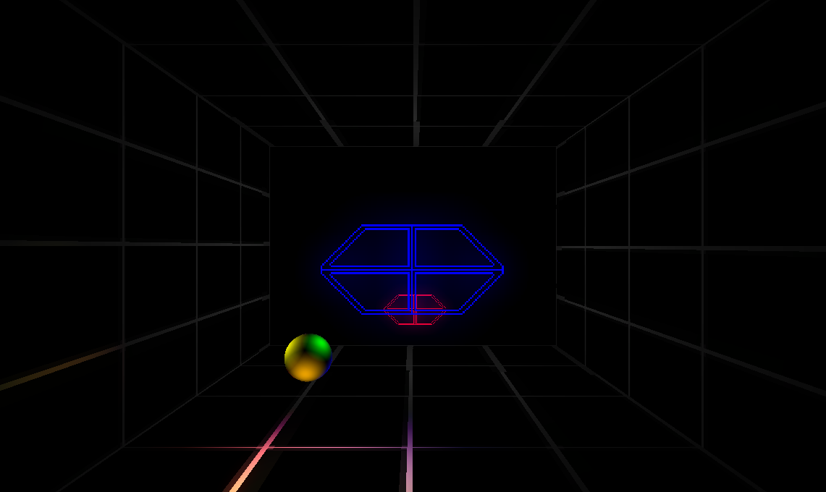

Competitive Product Analysis -
- Product name: Poverty Pong
- Product platform(s): Pong, Platformer
- Development company: Tritavision
- Publisher: Tung Nguyen
- Release date: Feb, 20, 2015
- The game is going to have features of lethal league like the ability to hit/bunt the ball, walking around, and a character select screen. The game will also have features of many other 3d pong games like a 3d wall that can change a ball’s angle and 2 paddles trying to hit the ball to the other side. What makes this game different is a story line that goes with the game, 2 different modes, and a platformer pong game.

Product Development Overview – The game is a 2d/3d fast pace pong game featuring 2 different modes. One of the modes is a 3d pong game featuring 2 paddles where you are trying to fight an AI and get the ball to the other side to score points, Scoring 8 points wins you the match and if the AI scores 8 points then you lose. The second mode is a 2d platformer pong game where you can select from 6 different character and fight your friend on different maps. The objective is to hit the ball to the other player’s side and to intercept incoming balls from the other player. Just like the first mode, the first to score 8 points wins.

Target Demographic – The targeted audience is teens around the age of 13+ because it contains violence.

Detailed Storyline – It is the year 2150, you are in an alley way playing a 3d pong game on your PT-9000 phone, then all of a sudden a group of Pongsters approaches you then challenges you to a game of Poverty Pong, a highly illegal street sport tournament where you use your state of the art Esper Gear and try to hit the hover ball to the opponent’s side. The game was banned in the past due to the result of death, and serious injuries that may occur while being played. But you are one of the Pong kings and must defend your title. You must win before the police comes!

Main Character(s) - Tung, Austin, Sedrick, Tre, Peyton, Julio

Characters – Tung, Austin, Sedrick, Tre, Peyton, Julio

Game Objects – the game is going to have a ball, paddles, different backgrounds, and walls.

Level Overview – When you start the game the first level you see is the splash screen where it shows the title of the game and the DigiPen logo. The game then sends you to the main menu, in the main menu the player can press on a couple buttons that can lead them to the Storyline, About, Credits, Exit, Play mode 1, and play mode 2. If you press on mode one it then sends you to the difficulty select screen and you choose from Easy, Medium, and Hard. It then sends you to the 3d pong game where you fight an enemy AI and you have to score 8 points to win, if the enemy scores 8 points then you lose. The lose screen lasts for a few seconds and then goes back to the main menu. If you picked the second mode you will be sent to the character select screen where player 1 and player 2 selects their characters, after selecting character the map select screen will pop up asking you which map you would like to play on. After you picked your map you fight against player 2 by trying to hit the ball to the other side while protecting your own side. Whoever scores 8 points first wins and will be displayed on the win screen, after a few seconds they get sent back to the character select screen.

Other Game Elements – In the HUD there will be score text boxes, one for player 1 and one for player 2/Enemy AI. The HUD will also have a ball speed counter, a countdown timer, and icons of player 1 and player 2.

Game Flow - On the start of the game it will first enter the splash screen, then go to the main menu after a few seconds, while on the main menu there will be buttons you can press to go to the about screen, tutorial, credits, Story, exit, play mode 1 and mode 2. On mode 1 you will be sent to a screen to select the difficulty of the AI, after you picked the difficulty you play the game and either win or lose. On mode 2 you will be sent to the character select screen where player 1 and player 2 pick their characters, after characters are picked you choose a map to play on, when you’re on the map player 1 and player 2 try to score points by hitting the ball to the other side’s screen edge and whoever wins will be showed at the end then returned back to the character select screen.

Game Controls – For the first mode of the game the controls will just be moving your mouse to where the ball is to move your paddle. The second mode of the game if your player 1 you will use A, S, D to move the character left, kneel, right, Space will let player 1 jump, T will swing the weapon, Y will bunt using the weapon. For Player 2 you will use Left Arrow, Down Arrow, Right Arrow to move left, kneel, right, Up Arrow will let the character jump, NumPad4 will swing weapon, NumPad5 will bunt weapon.

Development Risks – In this project we are fighting against time. There is lots of art and animation to create the character sprites especially for the attack animations such as swinging a weapon or using a weapon to bunt. The music will also be a risk because it takes a while to create music.

Target Estimates – I estimate my game’s content memory will be around 100 Mbs.

Tool Use – Zero Engine, Paint.net, Calculator, Mixcraft, lots of love, sweat, and tears.

