Name: Doan Cao Thanh Long

Student ID: 20162513

Class: ICT.02-K61

**LAB WORK**

**CHAPTER1: INTRODUCTION**

**Question 1:**

The path of the html file that contains the content of the default website apache is

“/var/www/html/index.html”

**Question 2:**

The default port that the webserver is listening is 80

**Question 3:**

Permission 755 means that everyone can read and execute access, but only root has the write access

**Question 4:**

We can see the content of the 2 html files rendered on the browser because these 2 sites are enabled in the apache webserver.

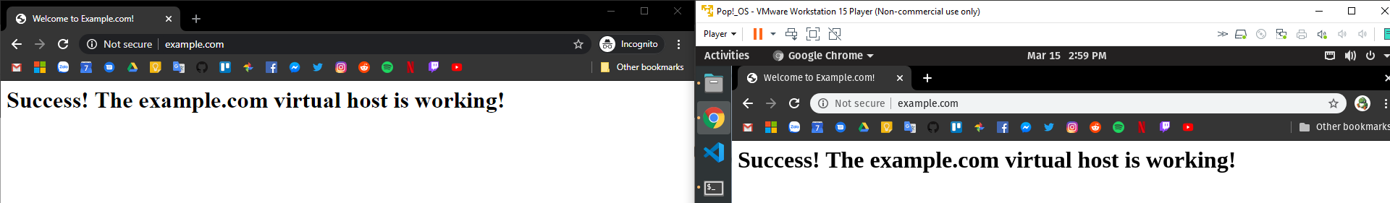

**Question 5:**

In order to make other machines in the same LAN access to these 2 websites, we need to add to that machine host file the ip of the webserver machine and the URL of the website.

Example:

2.2.2.2 example.com

3.3.3.3 test.com

**Question 6:**

Code of the while loop:

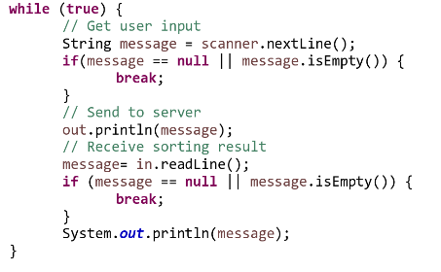

This while loop serves the purpose of listening to the message of the client and send it to the server and listen to server message until the client input nothing.

**Question 7:**

The role of method run is to receive and to process client’s request. It is called whenever client send a line to server.