Student's name: Nguyễn Thanh Tùng

Class: ICT04-K62

**LABWORK**

**COURSE: DISTRIBUTED SYSTEMS**

**CHAPTER 4: SYNCHRONIZATION**

**Question 1:**

We can see that if we apply the join() function for all three workers, the result of the rsc variable will be guaranteed to be 3000. This is because the join() function will act as a lock to make sure that the worker 2 only run after the worker 1 has finished its job, same as for the worker 3 and worker 2.

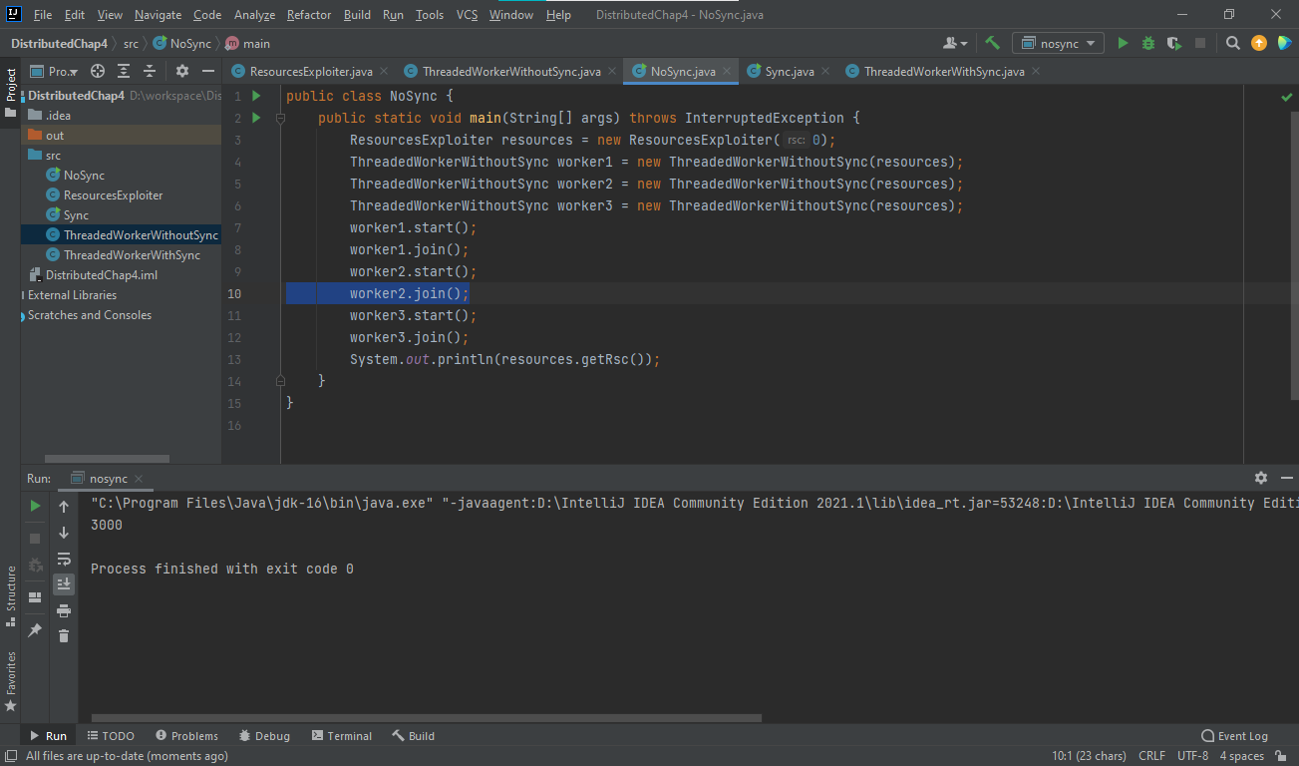

However, if we only make worker 3 join() so that the System.out.println() function get the final result of the rsc variable, it’s not guaranteed that the result we get will be 3000 as expected, this value may varies from time to time depending on each run. 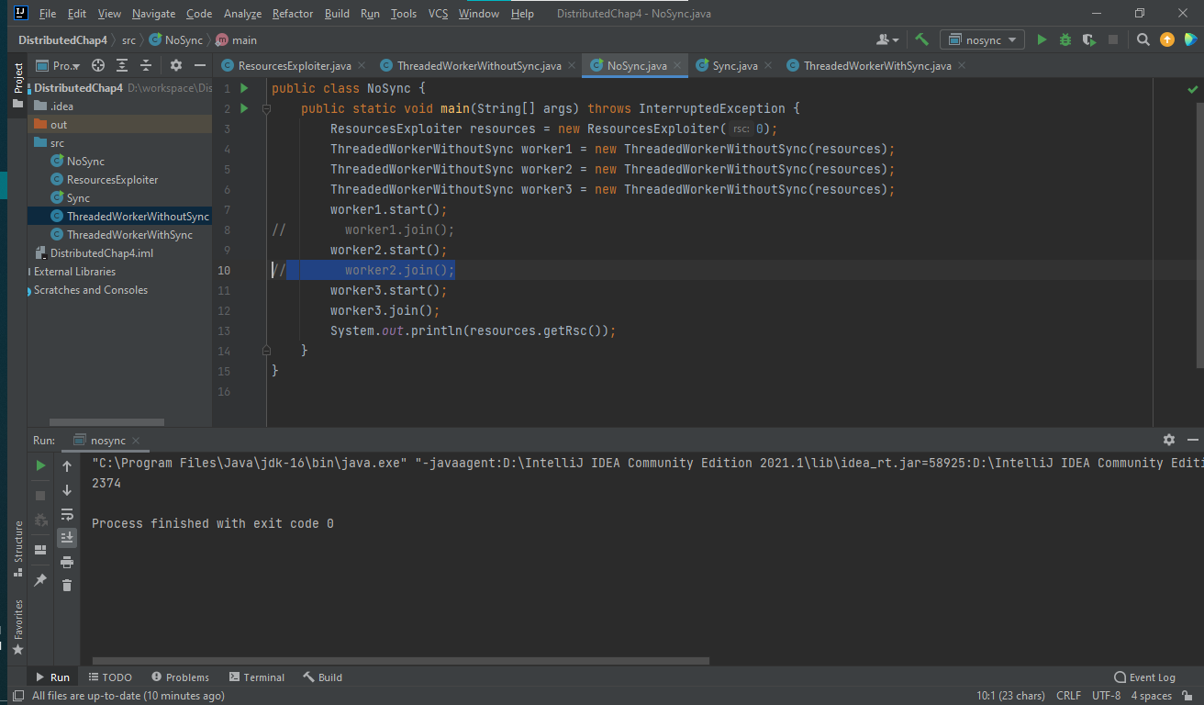

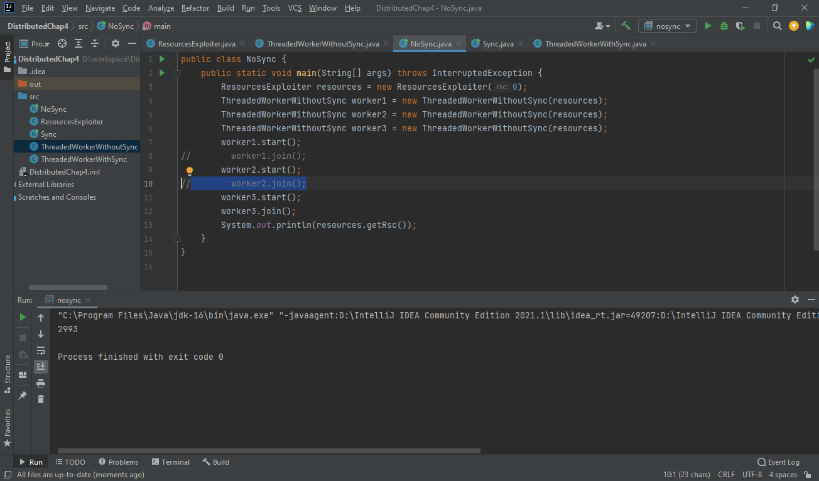

This is because the rsc is changed by 3 workers as the same time, there are no locking mechanism to protect the rsc to make sure it’s working as expected.

**Question 2:**

By applying the synchronization mechanism to the program, we can assure that the result we get will be 3000 because now the Resource Exploiter will be access synchronously, this means that even without the join() function, no 2 workers can access the rsc at the same time, each worker will have to wait for other until they can change the rsc.

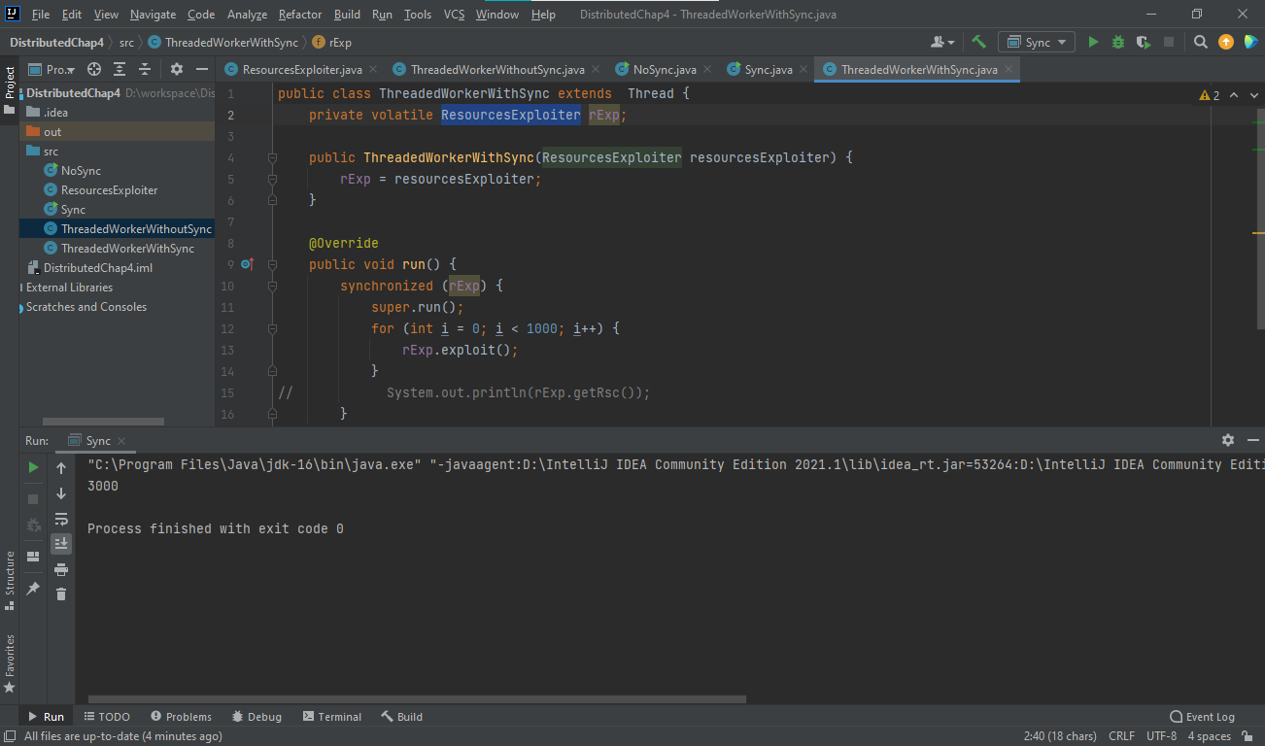

**Question 3:**

The ReentrantLock class implements the Lock interface and provides synchronization to methods while accessing shared resources. As the name says, ReentrantLock allows threads to enter into the lock on a resource more than once. When the thread first enters into the lock, a hold count is set to one. Before unlocking the thread can re-enter into lock again and every time hold count is incremented by one. For every unlocks request, hold count is decremented by one and when hold count is 0, the resource is unlocked.

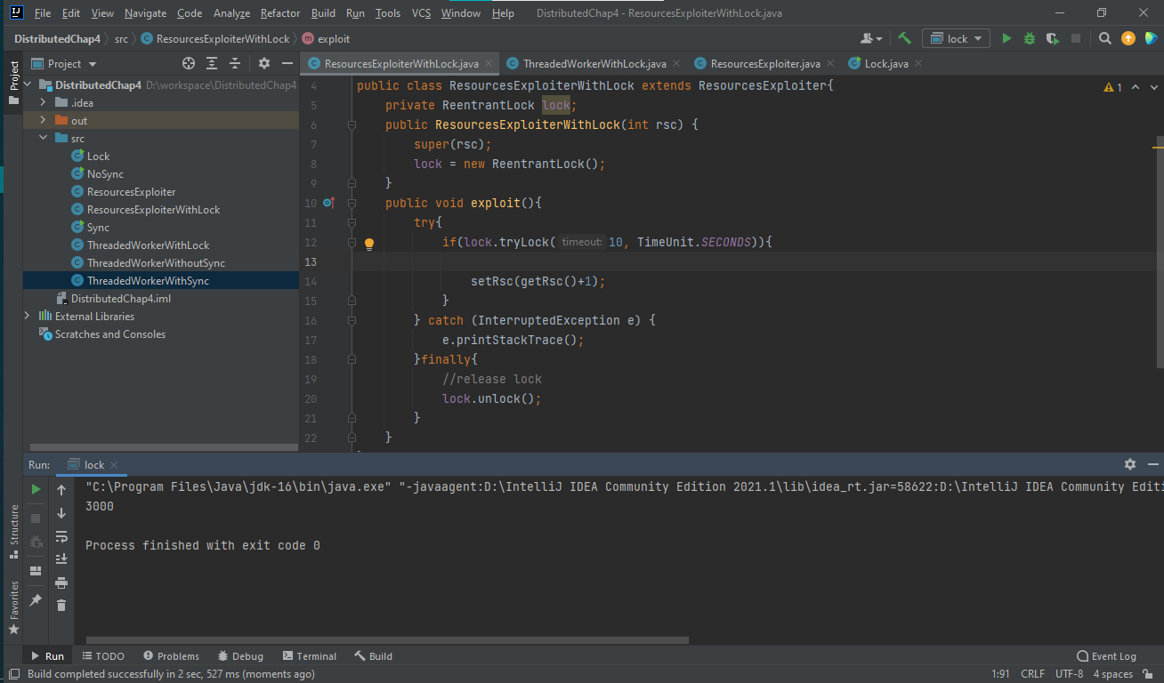

tryLock(long timeout, TimeUnit unit): As per the method, the thread waits for a certain time period as defined by arguments of the method to acquire the lock on the resource before exiting. This method helps protecting the rsg of concurrent access from the workers. Because of this locking mechanism, the result we get is guaranteed to be 3000.

Question 4:

**Question 5:**

Without increase the number of threads and value of NUM_TRANS, I can already see the different between balance and the equation INIT_BALANCE + credits – debits. This occurrence happened because some of the loop function in our 5 threads access the same resource balance or debits, credits concurrently without waiting for other thread to finish its execution on the so-called resources.

**Question 6:**

We use lock variable with the hope to identify that only 1 specific thread can access to resources, in this case, shared variable, but the difference still occurred since there will be a time that 2 or more thread that accessed to lock variable when its value equals to 0 and increase shared at the same time, continue the loop, so that the shared cannot exceed number of loop multiply with 100, the difference happened at line shared++ which is shared = shared + 1, the shared on the right hand side will be, for example 2 concurrence equation shared = shared + 1 and shared = shared + 1, if it happened at the same time, shared on the right hand side of the 2 line of code will have the same value thus assign the same value to the new shared, then 2 equations this time will only have effect as 1 equation 🡪 shared variable is 9956 when it is expected to be 10000.

**Question 7:**

After using mutex for locking critical sections, the experiments show no difference between balance and its expected value 🡪 The improvement can be seen.

**Question 8:**

Without experiment on large resources of code, we can predict that fine locking strategy give a faster runtime since its decrease waiting time of other thread when access to a specific amount of resource. But in the example code, since there are only 2 type of resources which is balance and credits versus balance and debits, the runtime of fine locking is slightly slower than coarse due to the lock and unlock operations.

**Question 9:**

In the experiment we cannot see the output since the two thread are blocking each other by the mutex lock_a and mutex lock_b, thread 1 lock mutex a and thread 2 lock mutex b cause the other thread cannot keep its operation going since thread 1 need mutex b of thread 2 is locking and thread 2 need mutex a of thread 1 is locking 🡪 deadlock.