Student’s name:

Class: TT.CNTT.ICT 04 K62

**Theoretical Exercises**

**Module: Distributed Systems**

**Chapter 5: Replication and Consistency**

***Question 1:*** *What are the benefits of deploying replication in distributed systems?*

* Higher Availability: To ensure the availability of the distributed system( System keeps on working even if one or fewer nodes fail)
* Reduced Latency: Replication assists in reducing the latency of data queries (By keeping data geographically closer to a user. For example, CDN(Content Delivery Networks) keeps a copy of replicated data closer to the user. Ever thought how Netflix streams videos with such short latencies!)
* Read Scalability: Read queries can be served from replicated copies of the same data (this increase overall throughput of queries)
* Network Interruption: System works even under network faults

***Question 2:***Consider a distributed data store that consists of 5 processes: P1-P5. Each process can perform read and write operations only on data item x of its local copy. The operations are described as follows:

* *t1: P1 writes the value a*
* *t2: P3 reads the value a*
* *t3: P2 writes the value b and P3 writes the value c*
* *t4: P5 reads the value b*
* *t5: P4 and P5 read the value a*
* *t6: P4 reads the value b*
* *t7: P4 and P5 read the value c (ti < ti + 1 for all i = 0..6)*

*a) Does this model satisfy the causal consistency model? Explain it.*

*b) Does this model satisfy the sequential consistency model? Explain it*

|  |  |  |  |  |  |  |  |
| --- | --- | --- | --- | --- | --- | --- | --- |
| **P1** | *W(x)a* |  |  |  |  |  |  |
| **P2** |  |  | *W(x)b* |  |  |  |  |
| **P3** |  | *R(x)a* | *W(x)c* |  |  |  |  |
| **P4** |  |  |  |  | *R(x)a* | *R(x)b* | *R(x)c* |
| **P5** |  |  |  | *R(x)b* | *R(x)a* |  | *R(x)c* |

a) We have *W2(x)b* is potentially dependent on *W1(x)a* as *b* may be a result of computation involving the value read by *R3(x)a*. The two writes of *a* and *b* are causally related, and all processes must see them in the same order. However, in P5, *R5(x)b* comes before *R5(x)a*. Thus, this model does not satisfy the causal consistency model.

b) The reads in P4: a 🡪 b 🡪 c

The reads in P5: b 🡪 a 🡪 c

🡺 The reads in P4 and P5 are not in the same order. 🡺 This model does not satisfy the sequential consistency model.

***Question 3:*** *What is the conit? What is the consequence if the conit’s size is too big? Relatively, what is the consequence if the conit’s size is too small?*

A consistency unit, abbreviated to Conit. A conit specifies the unit over which consistency is to be measured

If a conit is too big (represents a lot of data), such as a complete database, then updates are aggregated for all the data in the conit. As a consequence, this may bring replicas sooner in an inconsistent state.

Unfortunately, making conits very small is not a good idea:

- The total number of conits that need to be managed grows as well.

- This overhead, in turn, may adversely affect overall performance.

***Question 4:*** *A system aimed at ensuring the continuous consistency model, the administrator use Conit to monitor 3 variables x, y, and z. Suppose that there are 2 replica servers (replica) A and B with update operations as shown below. Gray operations are the committed ones. There was an update operation in B that was propagated to A, and vice versa there was an operation from A to B. What are the deviation on numerical values, deviation on order, and deviation of time?*

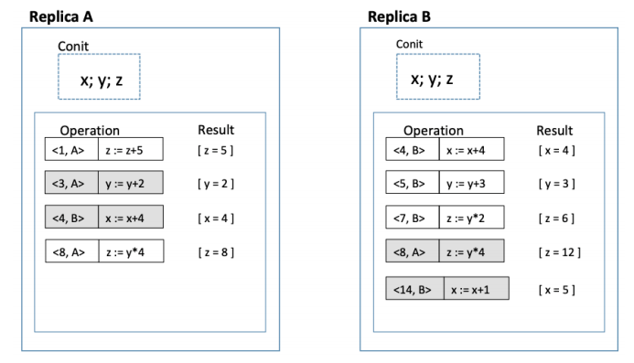

Replica A: Vector clock A = (9, 4)

Order deviation = 3

Numerical deviation = (3, 12)

Replica B: Vector clock B = (8, 15)

Order deviation = 4

Numerical deviation = (2, 12)

***Question 5:*** *A system aimed to guarantee the client-centric consistency. A client moves between 4 local copies and performs some read/write operations like the figure below. Which consistency model this system does not satisfy? Explain it.*

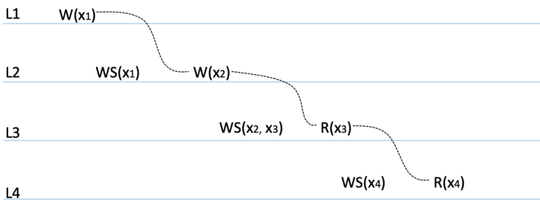

After the client has read *x3* in *L3*, it later performs the read operation *R(x4)* at *L4*. However, only the write operation in *WS(x4)* have been performed in *L4*, so no guarantees are given that this set also contains all operations contained in *WS(x2, x3)*. Thus, this system violates the monotonic-read consistency model.

***Question 6:*** *Concerning the content distribution, which solution for updating data is appropriate for:*

*a) DNS service?*

*b) WWW service?*

a) For DNS service, the solution for updating data is server-based protocols (push-based) with multicasting, as this service needs the server to keep track of all client updates with their name and IP address.

b) For WWW service, the solution for updating data is client-based protocols (pull-based) with unicasting, since the client in this service requests the web server to check and update the cached data items, and the server does not need to take care of the client.

***Question 7:*** *Concerning Primary-based protocols, compare remote-write protocol and local-write protocol.*

|  |  |
| --- | --- |
| **Remote-write protocol (Fixed-primary)** | **Local-write protocol (Local-primary)** |
| In both protocol, there are multiple copies of an item x (replication) | |
| Primary-based remote-write protocol with a fixed server to which all read and write operation are forwarded | Primary-based local-write protocol in which a single copy is migrated between processes |
| Writes go through a primary copy and are forwarded to bakups, reads may work locally (also well-suited for sequential consistency, since primary serializes updates) | Writes are performed after migrating primary to local server, updates are forwarded to other backups locations. Reads may proceed locally |

* Remote-write:

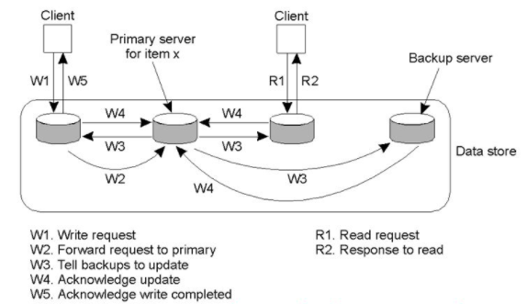

* Local-write:

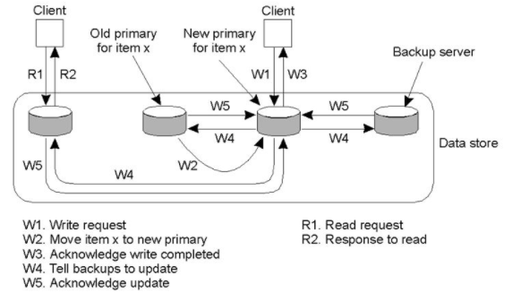

***Question 8:*** *Garena company is managing the game League of Legends (LoL) which is a very attractive game with a huge number of gamers in the world. Managing a huge number of gamers makes Garena decide to register for Akamai's CDN service. Concretely, Garena asks Akamai to deploy 3 services as follows:*

*- Downloading game: allows gamers to download the installation version to the computer*

*- Updating game: allows updating the latest installation*

*- Chatting (messenger): allows users to manage their own received and sent messages.*

*a) For each of the 3 services above, Akamai should choose data-centric consistency model or client-centric consistency model?*

*b) Akamai deploys 10000 replicas and chooses the quorum-based consistency protocol with Nw = 9800 and Nr = 3000 where Nr and Nw are the quorum read and quorum write, respectively. Could this system avoid the read-write conflict and write-write conflict?*

a) - Downloading game: Data-centric consistency

- Updating game: Data-centric consistency

- Chatting: Client-centric consistency

b) 🡪 No read-write conflict.

🡪 No write-write conflict.

🡺 This system can avoid the read-write and write-write conflicts