

**SELLING ONLINE COURSE SYSTEM**

Software Requirements Specification

Version 1

Nguyễn Trung Kiên

Lead Software Engineer

– Hanoi, Summer 2023 –

# Revision History

|  |  |  |  |
| --- | --- | --- | --- |
| **Date** | **Description** | **Author** | **Comments** |
| 8/06/2023 | Version 1 | Nguyễn Trung Kiên |  |
| 10/06/2023 | Version 1.1 | Nguyễn Hoàng Kiên |  |
| 16/06/2023 | Version 2 | Nguyễn Hoàng Kiên |  |

# Document Approval

The following Software Requirements Specification has been accepted and approved by the following:

|  |  |  |  |
| --- | --- | --- | --- |
| **Signature** | **Printed Name** | **Title** | **Date** |
|  | Nguyen Thanh Y | Instructor, SWP 391 |  |
|  | Nguyen Trung Kien | Leader |  |
|  | Pham Ha Ngoc Mai | Team member |  |
|  | Luu Duc Tung | Team member |  |
|  | Nguyen Hoang Kien | Team member |  |
|  | Pham Minh Duc | Team member |  |

# Table of content

Revision History ii

Document Approval ii

Table of content iii

1. Introduction 1

1.1 Overview *1*

1.2 Purpose *2*

1.3 Scope *2*

1.4 Definitions, Acronyms, and Abbreviations *3*

2. General Description *3*

2.1 Product Perspective *3*

2.2 Product Functions *3*

2.3 User Characteristics *4*

2.4 General Constraints *4*

3. Specific Requirements *4*

3.1 External Interface Requirements *4*

3.1.1 User Interfaces 4

3.1.2 Hardware Interfaces 4

3.1.3 Software Interfaces 4

3.1.4 Communications Interfaces 4

3.2 Functional Requirements 5

3.2.1 System Functional Overview 5

3.2.2 Create customer account 10

3.2.3 Create mentor account 11

3.2.4 Register Account 12

3.2.5 Login 13

3.2.6 Logout 14

3.2.7 Forgot Password 15

3.2.8 Update profile 16

3.2.9 View List Customer 17

3.2.10 Add news 18

3.2.11 Change status News 19

3.2.12 Add course type 20

3.2.13 Add courses 21

3.2.14 View list course in client site 22

3.2.15 Default payment 23

3.2.16 Show all News and News detail 24

3.2.17 Online payment 25

3.2.18 Add modules Course 26

3.2.19 List mentor 27

3.2.20 Smart Search Bar 28

3.2.21 Change status Customer and mentor 29

3.2.22 Update course type 30

3.2.23 Change status course type 31

3.2.24 View Course type 32

3.2.25 Add news type 33

3.2.26 Update news type 34

3.2.27 Change status news type 35

3.2.28 View News type 36

3.2.29 Update news 37

3.2.30 Change status news 38

3.2.31View News 39

3.2.32 Views Course 40

3.2.33 Change status course 41

3.2.34 Add flash card 42

3.2.35 Show List flash card 43

3.2.36 Show flash card detail 44

3.2.37 Chat box 45

3.2.38 Update Account status 46

3.2.39 Login with username and password 47

3.3 Use Cases 47

3.2.1 Use Case Overview 48

3.2.2 Use Case Admin 49

3.2.3 Use Case Mentor 50

3.2.4 Use Case Guest 51

3.2.5 Use Case Customer 52

3.4 Non-Functional Requirements 52

3.4.1 Performance 52

3.4.2 Availability 53

3.4.3 Security 53

3.5 Inverse Requirements *53*

3.6 Design Constraints *53*

3.7 Logical Database Requirements *53*

3.8 Other Requirements *54*

A. Appendices *54*

A.1 Business Rule *54*

A.2 References 54

# 1. Introduction

## 1.1 Overview

* Selling Online Course System is a web platform designed to provide users with a convenient and efficient way to access and purchase online courses. The platform aims to revolutionize traditional methods of course registration by providing a user-friendly interface and a host of features that enhance the learning experience.
* The main goal of Selling Online Course System is to facilitate the discovery and selection of courses. Users can easily browse through available courses, view detailed course descriptions. The platform incorporates a powerful search function that allows users to quickly find specific courses based on their interests or requirements.
* Users can choose to sign in with their Google account or by providing a username and password. This ensures a seamless and secure login process.
* One notable feature of Selling Online Course System is the ability to add flashcards. Users can create and manage flashcards to support learning for the courses they've signed up for. These flashcards can contain important concepts, key terms, or any other relevant information that helps with the learning process.
* Selling Online Course System supports various online payment methods, providing users with a secure and convenient way to complete their transactions. This streamlined checkout process ensures a hassle-free experience for users.
* Users can access a list of available advisors for each course, view their profile, and choose the one that best suits their needs. This mentoring feature enhances the overall learning experience and fosters interaction between learners and experts in their respective fields.
* To further enhance customer support, the platform incorporates a chat function that allows users to communicate directly with employees. This feature ensures timely support and resolves any questions or problems users may encounter during their course registration or study.

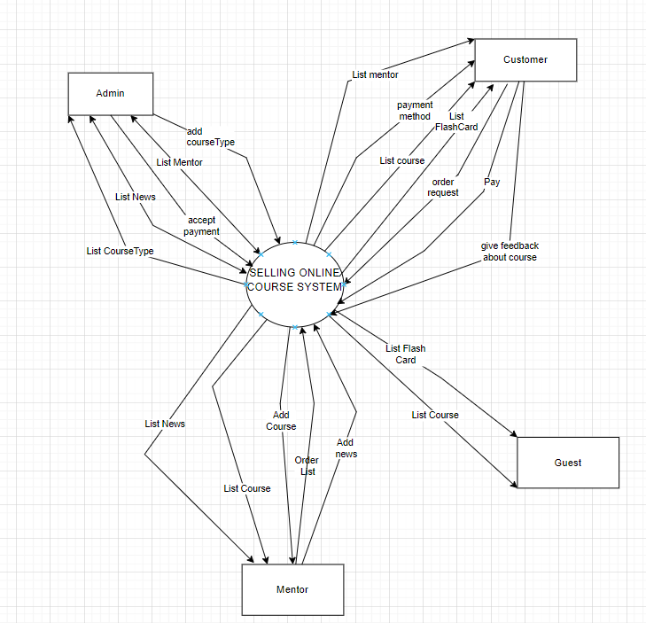

## 1.2 Purpose

The purpose of the project is to develop an Online Course Sale system that capitalizes on the increasing demand for online courses. This system will provide a convenient and accessible way for learners to access educational content through an online learning platform

## 1.3 Scope

The scope of the system is to empower course creators by offering them a user-friendly platform to showcase and monetize their expertise. It will provide robust tools and features for course creation, management, and effective marketing.

The Online Course Sale system will enable businesses, organizations, and individuals to generate substantial income at a low cost while demonstrating the quality of their products. The coding conventions for the system will adhere to Google Standards for Java, HTML/CSS, JavaScript, and other relevant programming languages.

## 1.4 Definitions, Acronyms, and Abbreviations

|  |  |
| --- | --- |
| SRS | Software Requirements Specifications |
| BR | Business Rule |
| UI | User Interface |
| N/A | Not applicable, not available |
| Use Case(s) | Diagram describe system requirements |

# 2. General Description

## 2.1 Product Perspective

* The system consists of Guest, Customer and Administrator agents.
* Customers is a user who logged in to the system, allowed buy course
* Guest is a user who is not logged in to the system.
* The administrator has the role of administering the operation of the system.

## 2.2 Product Functions

**Admin**

* Account Management
* Manage Course type
* Statistical
* News manager

**Mentor**

* Course Management
* Order management
* News management

**Client**

* View the course
* Course search
* Login with google account or with username and password
* Add flash card
* View Flash Card details
* Buy the course
* Choose online payment method
* View the list of mentors
* Update profile.
* Chat with staff.
* Feedback about the course for the mentor.

## 2.3 User Characteristics

Members and administrators operating the system are users of the system. Users are those who have a need for course search*.*

## 2.4 General Constraints

* Model-View-Controller architecture was employed during coding.
* Words are combined without spaces and are lowercased starting with the first letter when using camelCase variables.
* Methods and functions must have comments so that maintenance programmers can readily comprehend the code. Comments should come before methods, before loops, and before lengthy sections of code.
* The Oracle Java code convention must be followed when writing code.
* Designing with Web Standards requires that HTML and CSS be coded in a specific way (read about them in reference).

# 3. Specific Requirements

## 3.1 External Interface Requirements

### 3.1.1 User Interfaces

* UI-1: The website header will include the website's logo, address, phone number, and main categories; The middle of the page displays the products, the bottom of the page is divided into newsgroups (warranty policy, promotions...)
* UI-2: The interface is suitable for display on computers and phones.
* UI-3: Use icons to provide more detail to users.
* UI-4: The main color of the website is red, white in one, and sometimes black.

### 3.1.2 Hardware Interfaces

* *No hardware interfaces have been identified.*

### 3.1.3 Software Interfaces

* *The website does not integrate other commercial software*

### 3.1.4 Communications Interfaces

* The web browser will automatically log out if the user does not use the system within 10 seconds

## 3.2 Functional Requirements

### 3.2.1 System Functional Overview

#### 3.2.1.1 Screens Flow

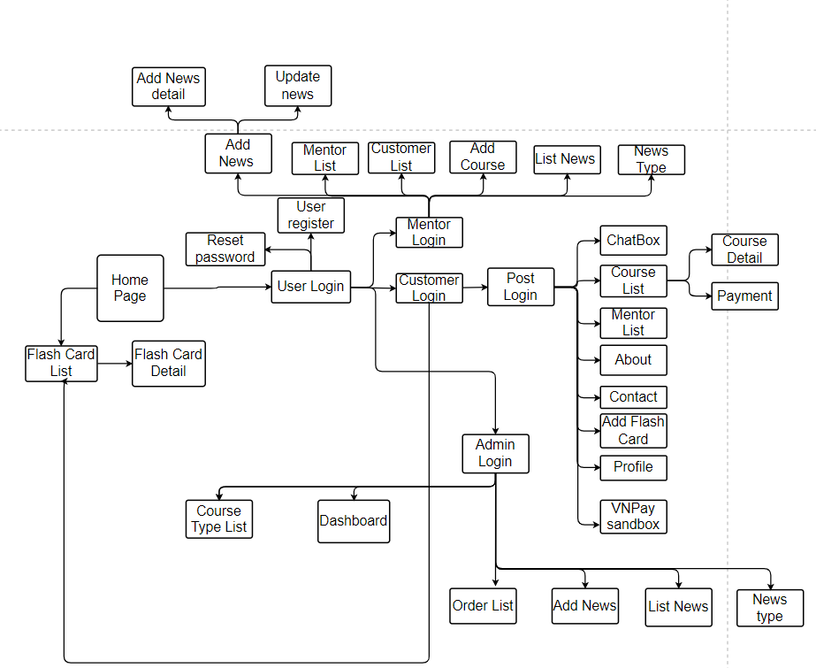

#### 3.2.1.2 Screen Descriptions

|  |  |  |  |
| --- | --- | --- | --- |
| **#** | **Feature** | **Screen** | **Description** |
| 1 | Add course | Add Course | Mentor adds a course to the list |
| 2 | Add News | Add News | Admin add News to the admin added a news to the News board |
| 3 | Update News | Update News | Update news on News board |
| 4 | Login | User login | User login with username and password or login with email |
| 5 | Add Flash Card | Add Flash Card | Customer add Flash Card to be able to study easily |
| 6 | Chat box | Chat Box |  |
| 7 | Payment | Payment | Customers pay for the course |
| 8 | Add Course Type | Add Course Type | Admin add course Type |
| 9 | Update Course Type | Update Course Type |  |
| 10 | Forgot password | Reset Password if user forgot | User change password |
| 11 | Show List order | Order List | show the list of courses that customers order |
| 12 | show List Course | Course List | Show list course for customer |
| 13 | Show list mentor | Mentor list | Show list mentor |
| 14 | Show list news | List news | Show list news in screen |
| 15 | Add and update news type | news type | Add and update News type |
| 16 | Show customer List | customer list | Show customer List |
| 17 | Add and update news | Add news | Add and update news |
| 18 | Update profile | Profile | Update profile Customer |

#### 3.2.1.3 Screen Authorization

|  |  |  |  |
| --- | --- | --- | --- |
| **Screen** | **Admin** | **Mentor** | **Customer** |
| Course type list | X |  |  |
| Add Course type |  |  |  |
| Update Course type |  |  |  |
| Order List | X | X |  |
| Query all list order | X |  |  |
| Accept order | X |  |  |
| Add news | X | X |  |
| Update News | X | X |  |
| List News | X | X |  |
| Flash Card |  |  | X |
| Login | X | X | X |
| Add flash Card |  |  | X |
| Course | X | X |  |
| Add Course |  | X |  |
| Update Course |  | X |  |
| View Course manager site | X | X |  |
| Forgot Password | X | X | X |
| View Course |  |  | X |
| News Type | X | X |  |
| Add News Type | X |  |  |
| Update News Type | X |  |  |
| View Mentor List manager site | X |  |  |
| View Mentor List in Home page |  |  | X |
| Update profile |  |  | X |
| Payment |  |  | X |
|  |  |  |  |

#### 3.2.1.4 Non-Screen Functions

|  |  |  |  |
| --- | --- | --- | --- |
| **#** | **Feature** | **System Function** | **Description** |
| 1 | Send mail |  | Send email users when they pay, forgot password |
| 2 | MD5 encrypt |  | Encrypt the password |
| 3 | Upload file |  | process files from personal computers, then upload to the system |
| 4 | Create random code and disable this code |  | Create a code and send it to the user's email when forgot the password and can cancel the code after 60 seconds |
| 5 | Authentication |  | Authenticate user |
| 6 | Process order when paying with VNpay |  | After successful payment, the course is saved to Order List |
| 7 |  |  |  |

#### 3.2.1.5 Entity Relationship Diagram

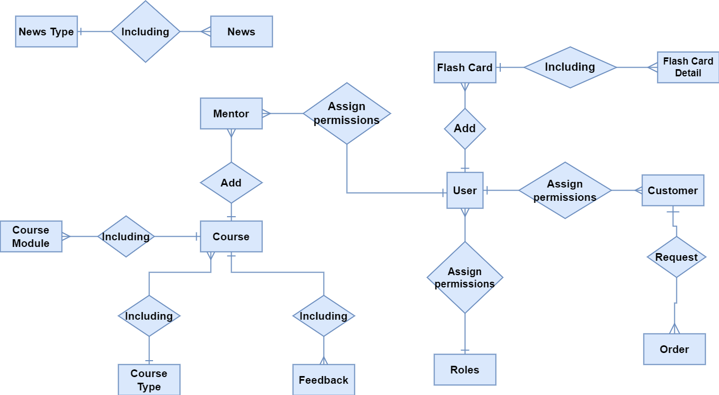

#### 3.2.1.6 Entities Description

|  |  |  |
| --- | --- | --- |
| **#** | **Entity** | **Description** |
| 1 | User |  |
| 2 | NewsType | Divide the News into different types |
| 3 | News |  |
| 4 | Role | divide User into different object groups |
| 5 | Customer | use the site to buy courses and learn |
| 6 | Order | order course |
| 7 | FlashCard | items containing different flash cards |
| 8 | FlashCardDetail |  |
| 9 | Feedback | User feedback about the course |
| 10 | Course |  |
| 11 | CourseModule | Create modules and include the link of the course video |
| 12 | CourseType | Divide the Course into different types |
| 13 | Mentor | Post and manage courses and news |

### 3.2.2 Create customer account

|  |  |  |  |
| --- | --- | --- | --- |
| UC ID and Name: | Create customer account | | |
| Created By: | KienNT | Date Created: | 15/5/2023 |
| Primary Actor: | Guest | Other  Actors: |  |
| Trigger: | Guest click “Register now” button | | |
| Description: | Guests can create accounts for customers about building materials. | | |
| Preconditions: |  | | |
| Postconditions: | Create a new customer account can be active | | |
| Normal Flow: | 1. Guest Select Register function 2. The system displays the registration interface 3. Guest Enter account information 4. Guest Requires registration 5. System Check if guest entered required fields   enter or not   1. System Check if guest email address is valid 2. System Check the re-entered password and the password is the same as each other or not? 3. System Check password is enough level of security 4. System Saves account information and registration notice as success | | |
| Alternative Flows: | N/A | | |
| Exceptions: | 1. If account is existed in database, show an error message and don’t allow add | | |
| Priority: | Normal | | |
| Frequency of Use: | Usually | | |
| Business Rules: | BR-01, BR-04, BR-05, BR-06, BR-10, BR-13, BR-16, BR-18 | | |
| Other Information: | N/A | | |
| Assumptions: | N/A | | |

### 3.2.3 Create staff account

|  |  |  |  |
| --- | --- | --- | --- |
| UC ID and Name: | Create mentor account | | |
| Created By: | KienNT | Date Created: | 15/5/2023 |
| Primary Actor: | Guest | Other  Actors: | N/A |
| Trigger: | Guest click Register now button | | |
| Description: | Guest can create account for mentor about building materials. | | |
| Preconditions: | | | |
| Postconditions: | Create a new customer account can be active | | |
| Normal Flow: | 1. Guest Select Register function 2. The system displays the registration interface 3. Guest Enter account information 4. Guest Requires registration 5. System Check if guest entered required fields 6. enter or not 7. System Check if guest email address is valid 8. System Check the re-entered password and the password is the same each other or not? 9. System Check password is enough level of security 10. System Saves account information and registration notice as success | | |
| Alternative Flows: | N/A | | |
| Exceptions: | 6a. If account is existed in database, show an error message and don’t allow add | | |
| Priority: | Normal | | |
| Frequency of Use: | Usually | | |
| Business Rules: | BR-01, BR-04, BR-05, BR-06, BR-10, BR-13, BR-16, BR-18 | | |
| Other Information: | N/A | | |
| Assumptions: | N/A | | |

### 3.2.4 Register account

|  |  |  |  |
| --- | --- | --- | --- |
| UC ID and Name: | Login with Username/Email and Password | | |
| Created By: | TungLD | Date Created: | 15/5/2023 |
| Primary Actor: | Guest | Others actor: | Admin, Customer, Mentor |
| Trigger: | Click on the login button in the head of the website interface | | |
| Description: | The actor logs into the system to use system functions | | |
| Preconditions: | Account does not exist in database | | |
| Postconditions: | The actor can log in to system | | |
| Normal Flow: | 1. Type url of website on Internet brower and enter  2. Software: Display Login screen with the following fields: User name, Password, Login button  3. Actor enter username and password then click login button   1. Software: Validate username and password | | |
| Alternative Flows: | N/A | | |
| Exceptions: | 4a. Error message: Required fields need to be entered if the customer is missing  4b. Error message: Invalid email and/or password if the email and password are not found in the system | | |
| Priority: | Normal | | |
| Frequency of Use: | Usually | | |
| Business Rules: | BR-01, BR-04, BR-05, BR-06, BR-08, BR-09, BR-11 | | |
| Other Information: | N/A | | |
| Assumptions: | N/A | | |

### 3.2.5 Login with google

|  |  |  |  |
| --- | --- | --- | --- |
| UC ID and Name: | Login with Google | | |
| Created By: | TungLD | Date Created: | 15/5/2023 |
| Primary Actor: | Guest | Secondary Actors: | User, mentor |
| Trigger: | Click on the login button in the head of the website interface | | |
| Description: | User login with google account instead of using username and password | | |
| Preconditions: | User must have a google account | | |
| Postconditions: | The program redirects to the homepage when successfully logged in | | |
| Normal Flow: | 1. Click Google logo in Login site 2. Choose Google account 3. Software: register new account with email if email not exist in DB and navigate to home page | | |
| Alternative Flows: | N/A | | |
| Exceptions: | 2a User does not have a google account | | |
| Priority: | Normal | | |
| Frequency of Use: | Usually | | |
| Business Rules: | N/A | | |
| Other Information: | If you log in with your google account, you don't need to register for an account before | | |
| Assumptions: | N/A | | |

### 3.2.6 Logout

|  |  |  |  |
| --- | --- | --- | --- |
| UC ID and Name: | 3-Logout | | |
| Created By: | KienNT | Date Created: | 15/5/2023 |
| Primary Actor: | User | Secondary Actors: | Staff, customer |
| Trigger: | Click on the logout button in the head of the website interface | | |
| Description: | Click on the sign out. Admin, User, Customer will be signed out the page. | | |
| Preconditions: | After customer, admin have account and login successfully | | |
| Postconditions: | The actor can log out of system | | |
| Normal Flow: | 1. User Clicks the logout button 2. Software Displays Home Screen after system logout | | |
| Alternative Flows: | N/A | | |
| Exception Flow: | N/A | | |
| Priority: | Normal | | |
| Frequency of Use: | Usually | | |
| Business Rules: | N/A | | |
| Other Information: | N/A | | |
| Assumptions: | N/A | | |

### 3.2.7 Forgot password

|  |  |  |  |
| --- | --- | --- | --- |
| UC ID and Name: | Forgot password | | |
| Created By: | TungLD | Date Created: | 16/5/2023 |
| Primary Actor: | Customer, Mentor | Other  Actors: | N/A |
| Trigger: | Click on the Forgot password button on the Login screen | | |
| Description: | The actor will receive random code in email register and redirect to Forgot password page to enter Email of account | | |
| Preconditions: | The user must enter the correct email registered account | | |
| Postconditions: | Actor can log in system | | |
| Normal Flow: | 1. Actor click on Forgot password button Software: Display enter mail screen 2. Software: Display Forgot password screen with the following fields: + Email 3. Actor enter the account & email into Forgot password screen then click on "Get code" button 4. Software: Validate the entered account & email, then send a code to customer’s email and redirect to new screen to get new password (code, new password) 5. Actor get code and enter code and a new password then click on “Change password” button 6. Software: Validate the entered code, then update new password for customer in to database. Code exist in 30s. | | |
| Alternative Flows: | N/A | | |
| Exceptions: | 4a. When the actor enter a wrong mail, the system will show message “Email not exist”  6a. When the actor enter a wrong code, the system shall not update new password | | |
| Priority: | Normal | | |
| Frequency of Use: | Usually | | |
| Business Rules: | BR-10, BR-11 | | |
| Other Information: | N/A | | |
| Assumptions: | N/A | | |

### 3.2.8 Update profile

|  |  |  |  |
| --- | --- | --- | --- |
| UC ID and Name: | Update profile | | |
| Created By: | KienNH | Date Created: | 20/5/2023 |
| Primary Actor: | Customer | Secondary Actors: | N/A |
| Trigger: | Click on “Profile” in the head | | |
| Description: | Actor change personal information | | |
| Preconditions: | After actor have account and login successfully | | |
| Postconditions: | Information have been updated and save in system | | |
| Normal Flow: | 1. After successful login, Click on “Profile” in the head 2. Display the interface to update personal information 3. Fill in the information you need to update and request to change  * User name * Address * Phone * Date of birth * Avatar  1. Click “Update profile” button 2. Update information and notify actor | | |
| Alternative Flows: | 3a. When the user type a wrong format, the system shall display an error message if the system cannot update information on the screen. | | |
| Exception Flow: | N/A | | |
| Priority: | Normal | | |
| Frequency of Use: | Usually | | |
| Business Rules: | BR-13, BR-14 | | |
| Other Information: | N/A | | |
| Assumptions: | N/A | | |

### 3.2.9 View list customer

|  |  |  |  |
| --- | --- | --- | --- |
| UC ID and Name: | View list user in system | | |
| Created By: | KienNT | Date Created: | 20/5/2023 |
| Primary Actor: | Admin | Others Actors: |  |
| Trigger: | Admin Login with admin account to accept into Admin Site | | |
| Description: | Admin can view read information | | |
| Preconditions: | After admin have account and login successfully | | |
| Postconditions: | Information have been updated and save in system | | |
| Normal Flow: | 1. Admin Login with admin account 2. Software: show Admin site 3. Request view list account 4. Show list accounts | | |
| Alternative Flows: | 1. Login admin site 2. Scroll down to see table user in system | | |
| Exception Flow: |  | | |
| Priority: | Normal | | |
| Frequency of Use: | Usually | | |
| Business Rules: | N/A | | |
| Other Information: | N/A | | |
| Assumptions: | N/A | | |

### 3.2.10 Add News

|  |  |  |  |
| --- | --- | --- | --- |
| UC ID and Name: | Add News | | |
| Created By: | MaiPHN | Date Created: |  |
| Primary Actor: | Admin | Others Actors: | Mentor |
| Trigger: | Admin and mentor can add News after successful login | | |
| Description: | Add News to the News list | | |
| Preconditions: | Mentor and Admin login successfully | | |
| Postconditions: | News is stored in the database | | |
| Normal Flow: | 1. After successful login 2. Actor select Add news function 3. The system display all fields need to add of News 4. Fill all information into all fields 5. Click “Add News” | | |
| Alternative Flows: | N/A | | |
| Exception Flow: | BR-16 | | |
| Priority: | Normal | | |
| Frequency of Use: | Usually | | |
| Business Rules: | N/A | | |
| Other Information: | N/A | | |
| Assumptions: | N/A | | |

### 3.2.11 Change status News

|  |  |  |  |
| --- | --- | --- | --- |
| UC ID and Name: | Change Status News | | |
| Created By: | MaiPHN | Date Created: |  |
| Primary Actor: | Admin | Others Actors: | Mentor |
| Trigger: | Actor clicks on view list news | | |
| Description: | Admin can view all news status | | |
| Preconditions: | News must exist in data | | |
| Postconditions: | Display news list with updated status | | |
| Normal Flow: | 1. Admin click button ”News” 2. Software: Show News list 3. Admin select change status NEWS 4. Software : Change status from block to unblock (or vice versa) | | |
| Alternative Flows: | N/A | | |
| Exception Flow: | N/A | | |
| Priority: | Normal | | |
| Frequency of Use: | Usually | | |
| Business Rules: | N/A | | |
| Other Information: | N/A | | |
| Assumptions: | N/A | | |

### 3.2.12 Add Course Type

|  |  |  |  |
| --- | --- | --- | --- |
| UC ID and Name: | Add Course Type | | |
| Created By: | KienNH | Date Created: | 29/5/2023 |
| Primary Actor: | Admin | Others Actors: | Mentor |
| Trigger: | Actor clicks on Add Course Type | | |
| Description: | Actor add new course type into system | | |
| Preconditions: | The course type does not exist in the data | | |
| Postconditions: | the course type is added to data | | |
| Normal Flow: | 1. Actor click on Course Type 2. The system displays all type and form add type 3. Actor enter information of course Type 4. Actor clicks on “Add type” button 5. System validation all information that are entered 6. Display a pop-up message: “Add type successful .” | | |
| Alternative Flows: |  | | |
| Exception Flow: | 5a. System Error Message: Type name exist in System | | |
| Priority: | Normal | | |
| Frequency of Use: | Usually | | |
| Business Rules: | BR-01, BR-04, BR-05, BR-06 | | |
| Other Information: | N/A | | |
| Assumptions: | N/A | | |

### 3.2.13 Add Course

|  |  |  |  |
| --- | --- | --- | --- |
| UC ID and Name: | Add Course | | |
| Created By: | DucPM | Date Created: | 29/5/2023 |
| Primary Actor: | Mentor | Others Actors: |  |
| Trigger: | Admin clicks Add course | | |
| Description: | Admin can add new course into system | | |
| Preconditions: | After admin have account and login successfully | | |
| Postconditions: | Information have been updated and save in system | | |
| Normal Flow: | 1. Actor click to the Course page in Admin site after Login successfully 2. Fill all information of Course 3. Click “Add course” | | |
| Alternative Flows: |  | | |
| Exception Flow: | 5a. System Error Message: Course name exist in System | | |
| Priority: | Normal | | |
| Frequency of Use: | Usually | | |
| Business Rules: | N/A | | |
| Other Information: | N/A | | |
| Assumptions: | N/A | | |

### 3.2.14 View list Course in Client site

|  |  |  |  |
| --- | --- | --- | --- |
| UC ID and Name: | View list Course | | |
| Created By: | DucPm | Date Created: | 12/6/2023 |
| Primary Actor: | Guest | Others Actors: | Mentor, Admin |
| Trigger: | Actor view home page | | |
| Description: | Admin can view read course information | | |
| Preconditions: | Course exists in data | | |
| Postconditions: | Display Course list | | |
| Normal Flow: | 1. Actor view page home 2. System will show list Course | | |
| Alternative Flows: |  | | |
| Exception Flow: | N/A | | |
| Priority: | Normal | | |
| Frequency of Use: | Usually | | |
| Business Rules: | N/A | | |
| Other Information: | N/A | | |
| Assumptions: | N/A | | |

### 3.3.15 Default Payment

|  |  |  |  |
| --- | --- | --- | --- |
| UC ID and Name: | Show Modal to payment | | |
| Created By: | KIENNH | Date Created: | 15/6/2023 |
| Primary Actor: | Developer | Other  Actors: | member |
| Trigger: | Create Modal to show pay detail when click "Enroll this course" button | | |
| Description: |  | | |
| Preconditions: | the course exists and the customer ordered it | | |
| Postconditions: | show payment details to paying customers | | |
| Normal Flow: | 1. Enter your account and password in the login screen to log in 2. Software: Display home screen 3. Users click on the course item to find the account 4. Software: Show courses 5. Users click on the course they want to join 6. Software: Show this course details 7. User clicks "enroll test course" button to join the course 8. Software: Show payment details | | |
| Alternative Flows: | N/A | | |
| Exceptions: |  | | |
| Priority: | Normal | | |
| Frequency of Use: | Usually | | |
| Business Rules: | N/A | | |
| Other Information: | N/A | | |
| Assumptions: | N/A | | |

### 3.3.16 Show all news and News details

|  |  |  |  |
| --- | --- | --- | --- |
| UC ID and Name: | Show all news and News details | | |
| Created By: | MaiPHN | Date Created: | 15/6/2023 |
| Primary Actor: | admin | Other  Actors: | member |
| Trigger: | Admin click “List news” button | | |
| Description: | Admin can see the list of recently added news | | |
| Preconditions: | News is available in the database | | |
| Postconditions: | Display list News | | |
| Normal Flow: | 1. After Admin login successfully 2. Software: Display admin site 3. Admin Click “List NEWS” button 4. Software : display all News | | |
| Alternative Flows: | N/A | | |
| Exceptions: |  | | |
| Priority: | Normal | | |
| Frequency of Use: | Usually | | |
| Business Rules: | N/A | | |
| Other Information: | N/A | | |
| Assumptions: | N/A | | |

### 3.3.17 Online payment

|  |  |  |  |
| --- | --- | --- | --- |
| UC ID and Name: | Embed Online payment method into system | | |
| Created By: | TungLD | Date Created: | 15/6/2023 |
| Primary Actor: | Customer | Other  Actors: | member |
| Trigger: | User chooses to buy the course and clicks the "enroll" button | | |
| Description: | The system will display different online payment methods when the user clicks the "enroll" button. | | |
| Preconditions: | Select the course they want to buy | | |
| Postconditions: |  | | |
| Normal Flow: | 1. After user successfully login, click "Course" to buy the course 2. Software : show list of courses 3. Select the course to purchase and click "Enroll this course" 4. Software : Display two online payment methods, VNPay or TPbank 5. User chooses one of two payment methods | | |
| Alternative Flows: | N/A | | |
| Exceptions: |  | | |
| Priority: | Normal | | |
| Frequency of Use: | Usually | | |
| Business Rules: | N/A | | |
| Other Information: | N/A | | |
| Assumptions: | N/A | | |

### 3.3.18 Add module Course

|  |  |  |  |
| --- | --- | --- | --- |
| UC ID and Name: | Add Module Course | | |
| Created By: | DucPM | Date Created: | 15/6/2023 |
| Primary Actor: | Mentor | Other  Actors: | member |
| Trigger: | Mentor Click “add Course” | | |
| Description: | Mentor adds course modules and adds video links to each module | | |
| Preconditions: | Paste the corresponding video link | | |
| Postconditions: |  | | |
| Normal Flow: | 1. After Mentor login Successfully, Click “Add Course” Button 2. Fill in the information in the fields 3. In the add Module section, click "More modules" to add other modules 4. Click "ADD Course" to complete | | |
| Alternative Flows: | N/A | | |
| Exceptions: |  | | |
| Priority: | Normal | | |
| Frequency of Use: | Usually | | |
| Business Rules: | BR-15 | | |
| Other Information: | N/A | | |
| Assumptions: | N/A | | |

### 3.3.19 List Mentor

|  |  |  |  |
| --- | --- | --- | --- |
| UC ID and Name: | Show List Mentor | | |
| Created By: | KienNT | Date Created: | 15/6/2023 |
| Primary Actor: | Guest | Other  Actors: | member |
| Trigger: |  | | |
| Description: | Show list of mentors and their information | | |
| Preconditions: | The mentor account must be available with data | | |
| Postconditions: | Display mentor list | | |
| Normal Flow: | 1. User logs into the system 2. Scrolling down will show a list of mentors | | |
| Alternative Flows: | N/A | | |
| Exceptions: |  | | |
| Priority: | Normal | | |
| Frequency of Use: | Usually | | |
| Business Rules: |  | | |
| Other Information: | N/A | | |
| Assumptions: | N/A | | |

### 3.3.20 Smart Search Bar

|  |  |  |  |
| --- | --- | --- | --- |
| UC ID and Name: | Smart Search Bar | | |
| Created By: | KienNT | Date Created: | 15/6/2023 |
| Primary Actor: | Guest | Other  Actors: |  |
| Trigger: |  | | |
| Description: | Display suggestions courses according to the keyword entered by actor | | |
| Preconditions: | Course data must be stored in the database | | |
| Postconditions: | show search results under taskbar | | |
| Normal Flow: | 1. In the search bar, customers search for a course by typing all or part of the name of the course, 2. The program will display suggestions related to the courses they are looking for. | | |
| Alternative Flows: | N/A | | |
| Exceptions: | N/A | | |
| Priority: | Normal | | |
| Frequency of Use: | Usually | | |
| Business Rules: |  | | |
| Other Information: | N/A | | |
| Assumptions: | N/A | | |

### 3.3.21 Change status Customer and mentor

|  |  |  |  |
| --- | --- | --- | --- |
| UC ID and Name: | Change status Customer and mentor | | |
| Created By: | MaiPHN | Date Created: | 15/6/2023 |
| Primary Actor: | admin | Other  Actors: |  |
| Trigger: | Admin login successful | | |
| Description: | Change status from blocked to unblocked (or vice versa) of customer and mentor | | |
| Preconditions: | The Mentor and customer must be available with data | | |
| Postconditions: | Status of mentor and client is changed | | |
| Normal Flow: | 1. After successful login, the system will display a list of customers and mentors right on the Dashboard page 2. admin will be able to block or unblock any user | | |
| Alternative Flows: | N/A | | |
| Exceptions: | N/A | | |
| Priority: | Normal | | |
| Frequency of Use: | Usually | | |
| Business Rules: |  | | |
| Other Information: | N/A | | |
| Assumptions: | N/A | | |

### 3.3.22 Update Course Type

|  |  |  |  |
| --- | --- | --- | --- |
| UC ID and Name: | Update Course Type | | |
| Created By: | KienNH | Date Created: | 15/6/2023 |
| Primary Actor: | Admin | Other  Actors: |  |
| Trigger: | Admin login successful | | |
| Description: | Update Course Type in admin site | | |
| Preconditions: | The Course Type must be available with data | | |
| Postconditions: |  | | |
| Normal Flow: | 1. After admin successfully login, select item “Course Type” 2. Software: show the course type 3. Select the course type you want to update 4. Software: display its title and description 5. Admin enter the course type name and description and click update button to finish | | |
| Alternative Flows: | N/A | | |
| Exceptions: | N/A | | |
| Priority: | Normal | | |
| Frequency of Use: | Usually | | |
| Business Rules: | BR-16 | | |
| Other Information: | N/A | | |
| Assumptions: | N/A | | |

### 3.3.23 Change status Course Type

|  |  |  |  |
| --- | --- | --- | --- |
| UC ID and Name: | Change Course Type | | |
| Created By: | KienNH | Date Created: | 15/6/2023 |
| Primary Actor: | admin | Other  Actors: |  |
| Trigger: | Select button ”Course Type” | | |
| Description: | Change Course Type in admin site | | |
| Preconditions: | The Course Type must be available with data | | |
| Postconditions: | Display News Type list with updated status | | |
| Normal Flow: | 1. After admin successfully login, select item “Course Type” 2. Software: show list Course Type List and their status 3. Admin will be able to block or unblock | | |
| Alternative Flows: | N/A | | |
| Exceptions: | N/A | | |
| Priority: | Normal | | |
| Frequency of Use: | Usually | | |
| Business Rules: | BR-16 | | |
| Other Information: | N/A | | |
| Assumptions: | N/A | | |

### 3.3.24 View Course Type

|  |  |  |  |
| --- | --- | --- | --- |
| UC ID and Name: | Show List course type | | |
| Created By: | KienNH | Date Created: | 9/6/2023 |
| Primary Actor: | Admin | Other  Actors: |  |
| Trigger: | Click button “ Course type” | | |
| Description: | Show Course Type in admin site | | |
| Preconditions: | The News Type must be available with data | | |
| Postconditions: | Dislay list News Type | | |
| Normal Flow: | 1. After admin successfully login, select item “Course Type” 2. Software: Show list Course Type | | |
| Alternative Flows: | N/A | | |
| Exceptions: | N/A | | |
| Priority | Normal | | |
| Frequency of Use: | Usually | | |
| Business Rules: | BR-16 | | |
| Other Information: | N/A | | |
| Assumptions: | N/A | | |

### 3.3.25 Add news type

|  |  |  |  |
| --- | --- | --- | --- |
| UC ID and Name: | Add news type | | |
| Created By: | MaiPHN | Date Created: | 15/6/2023 |
| Primary Actor: | Admin | Other  Actors: |  |
| Trigger: | Click button “ news type” | | |
| Description: | Add News Type in admin site | | |
| Preconditions: | News Types does not exist in data | | |
| Postconditions: | Save News Type to data | | |
| Normal Flow: | 1. After admin successfully login, select item “News Type” 2. Software: Two boxes will appear to enter title and description 3. Admin enter name and description and press "add type" to finish | | |
| Alternative Flows: | N/A | | |
| Exceptions: | N/A | | |
| Priority: | Normal | | |
| Frequency of Use: | Usually | | |
| Business Rules: | BR-16 | | |
| Other Information: | N/A | | |
| Assumptions: | N/A | | |

### 3.3.26 Update News Type

|  |  |  |  |
| --- | --- | --- | --- |
| UC ID and Name: | Update News Type | | |
| Created By: | KienNH | Date Created: | 15/6/2023 |
| Primary Actor: | admin | Other  Actors: |  |
| Trigger: | Admin login successful | | |
| Description: | Update News Type in admin site | | |
| Preconditions: | The News Type must be available with data | | |
| Postconditions: | Edit the content of News Type and update it in data | | |
| Normal Flow: | 1. After admin successfully login, select item “News Type” 2. Software: show the course type 3. Select the course type you want to update 4. Software: display its title and description 5. Admin enter the news type name and description and click “update” button to finish | | |
| Alternative Flows: | N/A | | |
| Exceptions: | N/A | | |
| Priority: | Normal | | |
| Frequency of Use: | Usually | | |
| Business Rules: | BR-16 | | |
| Other Information: | N/A | | |
| Assumptions: | N/A | | |

### 3.3.27 Change status News Type

|  |  |  |  |
| --- | --- | --- | --- |
| UC ID and Name: | Change Course Type | | |
| Created By: | MaiPHN | Date Created: | 10/6/2023 |
| Primary Actor: | admin | Other  Actors: |  |
| Trigger: | Select button ”News Type” | | |
| Description: | Change News Type in admin site | | |
| Preconditions: | The News Type must be available with data | | |
| Postconditions: | Display News Type list with updated status | | |
| Normal Flow: | 1. After admin successfully login, select item “News Type” 2. Software: show list News Type List and their status 3. Admin will be able to block or unblock | | |
| Alternative Flows: | N/A | | |
| Exceptions: | N/A | | |
| Priority: | Normal | | |
| Frequency of Use: | Usually | | |
| Business Rules: |  | | |
| Other Information: | N/A | | |
| Assumptions: | N/A | | |

### 3.3.28 View News Type

|  |  |  |  |
| --- | --- | --- | --- |
| UC ID and Name: | Show List news type | | |
| Created By: | MaiPHN | Date Created: | 9/6/2023 |
| Primary Actor: | Admin | Other  Actors: |  |
| Trigger: | Click button “ News type” | | |
| Description: | Show News Type in admin site | | |
| Preconditions: | The News Type must be available with data | | |
| Postconditions: | Dislay list News Type | | |
| Normal Flow: | 1. After admin successfully login, select item “News Type” 2. Software: Show list News Type | | |
| Alternative Flows: | N/A | | |
| Exceptions: | N/A | | |
| Priority: | Normal | | |
| Frequency of Use: | Usually | | |
| Business Rules: | BR-16 | | |
| Other Information: | N/A | | |
| Assumptions: | N/A | | |

### 3.3.29 Update News

|  |  |  |  |
| --- | --- | --- | --- |
| UC ID and Name: | Update News | | |
| Created By: | KienNH | Date Created: | 15/6/2023 |
| Primary Actor: | admin | Other  Actors: |  |
| Trigger: | Click button “ List news” | | |
| Description: | Update News in admin site | | |
| Preconditions: | The News must be available with data | | |
| Postconditions: | Edit the content of News and update it in data | | |
| Normal Flow: | 1. After admin successfully login, select item “List News” 2. Software: show the table News 3. Select the News want to update 4. Software: Show details of News and items to update 5. Admin fill in the information to update and click “update” button to finish | | |
| Alternative Flows: | N/A | | |
| Exceptions: | N/A | | |
| Priority: | Normal | | |
| Frequency of Use: | Usually | | |
| Business Rules: | BR-16 | | |
| Other Information: | N/A | | |
| Assumptions: | N/A | | |

### 3.3.30 Change status News

|  |  |  |  |
| --- | --- | --- | --- |
| UC ID and Name: | Change status News | | |
| Created By: | MaiPHN | Date Created: | 10/6/2023 |
| Primary Actor: | admin | Other  Actors: |  |
| Trigger: | Select button ”List News” | | |
| Description: | Change status News in admin site | | |
| Preconditions: | The News must be available with data | | |
| Postconditions: | Display News list with updated status | | |
| Normal Flow: | 1. After admin successfully login, select item “List News” 2. Software: show list News Type List and their status 3. Admin will be able to block or unblock | | |
| Alternative Flows: | N/A | | |
| Exceptions: | N/A | | |
| Priority: | Normal | | |
| Frequency of Use: | Usually | | |
| Business Rules: |  | | |
| Other Information: | N/A | | |
| Assumptions: | N/A | | |

### 3.3.31 View News

|  |  |  |  |
| --- | --- | --- | --- |
| UC ID and Name: | Show List news | | |
| Created By: | MaiPHN | Date Created: | 9/6/2023 |
| Primary Actor: | Admin | Other  Actors: |  |
| Trigger: | Click button “ List News” | | |
| Description: | Show List News in admin site | | |
| Preconditions: | The News must be available with data | | |
| Postconditions: | Display list News | | |
| Normal Flow: | 1. After admin successfully login, select item “List News” 2. Software: Show list News | | |
| Alternative Flows: | N/A | | |
| Exceptions: | N/A | | |
| Priority: | Normal | | |
| Frequency of Use: | Usually | | |
| Business Rules: | BR-16 | | |
| Other Information: | N/A | | |
| Assumptions: | N/A | | |

### 3.3.32 View Course

|  |  |  |  |
| --- | --- | --- | --- |
| UC ID and Name: | Show Course | | |
| Created By: | MaiPHN | Date Created: | 9/6/2023 |
| Primary Actor: | Admin | Other  Actors: |  |
| Trigger: | Click button “List Course” | | |
| Description: | Show List News in admin site | | |
| Preconditions: | The course must be available with data | | |
| Postconditions: | Display list course | | |
| Normal Flow: | 1. After admin successfully login, select item “List Course” 2. Software: Show list Course | | |
| Alternative Flows: | N/A | | |
| Exceptions: | N/A | | |
| Priority: | Normal | | |
| Frequency of Use: | Usually | | |
| Business Rules: | BR-16 | | |
| Other Information: | N/A | | |
| Assumptions: | N/A | | |

### 3.3.33 Change Status Course

|  |  |  |  |
| --- | --- | --- | --- |
| UC ID and Name: | Change status News | | |
| Created By: | DucPM | Date Created: | 5/6/2023 |
| Primary Actor: | Admin | Other  Actors: | Mentor |
| Trigger: | Select button ”List News” | | |
| Description: | Change status News in admin site | | |
| Preconditions: | The course must be available with data | | |
| Postconditions: | Display Course list with updated status | | |
| Normal Flow: | 1. After admin successfully login, select item “List Course” 2. Software: show list Course and their status 3. Admin will be able to block or unblock | | |
| Alternative Flows: | N/A | | |
| Exceptions: | N/A | | |
| Priority: | Normal | | |
| Frequency of Use: | Usually | | |
| Business Rules: |  | | |
| Other Information: | N/A | | |
| Assumptions: | N/A | | |

### 3.3.34 Add Flash card

|  |  |  |  |
| --- | --- | --- | --- |
| UC ID and Name: | Add Flash Card | | |
| Created By: | KienNH | Date Created: | 30/6/2023 |
| Primary Actor: | Customer | Other  Actors: |  |
| Trigger: | Select button ”Add flash Card” | | |
| Description: | Add Flash Card to learn | | |
| Preconditions: | Flashcard does not exist in data | | |
| Postconditions: | Save FlashCard to data | | |
| Normal Flow: | 1. After customer successfully login, select item “Add Flash Card” 2. Software: displays cells to enter title, question and answer 3. User enter title, questions and answers for flash card | | |
| Alternative Flows: | N/A | | |
| Exceptions: | N/A | | |
| Priority: | Normal | | |
| Frequency of Use: | Usually | | |
| Business Rules: | BR-16 | | |
| Other Information: | N/A | | |
| Assumptions: | N/A | | |

### 3.3.35 Show List Flash Card

|  |  |  |  |
| --- | --- | --- | --- |
| UC ID and Name: | Show List Flash Card | | |
| Created By: | KienNH | Date Created: | 30/6/2023 |
| Primary Actor: | Customer | Other  Actors: | Guest |
| Trigger: | Select button ”Flash Card” | | |
| Description: | Show List Flash Card for customer and guest | | |
| Preconditions: | The list of Flash card types that must be available in the data | | |
| Postconditions: |  | | |
| Normal Flow: | 1. User click button ” Flash card” 2. Software : display Flash cards for User to choose | | |
| Alternative Flows: | N/A | | |
| Exceptions: | N/A | | |
| Priority: | Normal | | |
| Frequency of Use: | Usually | | |
| Business Rules: | BR-16 | | |
| Other Information: | N/A | | |
| Assumptions: | N/A | | |

### 3.3.36 Show Flash Card Detail

|  |  |  |  |
| --- | --- | --- | --- |
| UC ID and Name: | Show List Flash Card | | |
| Created By: | KienNH | Date Created: | 30/6/2023 |
| Primary Actor: | Customer | Other  Actors: | Guest |
| Trigger: | Select button ”Flash Card” | | |
| Description: | Show List Flash Card for customer and guest | | |
| Preconditions: | Flash card must be entered information of the card in advance | | |
| Postconditions: | Show details of the content of Flash Card | | |
| Normal Flow: | 1. User click button ” Flash card” 2. Software : display list Flash Card 3. Users choose which Flash card they want to learn 4. Software: displays the Flash card, in addition, it also displays a list of questions and answers | | |
| Alternative Flows: | N/A | | |
| Exceptions: | N/A | | |
| Priority: | Normal | | |
| Frequency of Use: | Usually | | |
| Business Rules: | BR-16 | | |
| Other Information: | N/A | | |
| Assumptions: | N/A | | |

### 3.3.37 Chat Box

|  |  |  |  |
| --- | --- | --- | --- |
| UC ID and Name: | Chat Box | | |
| Created By: | TungLD | Date Created: | 30/6/2023 |
| Primary Actor: | Customer | Other  Actors: | Guest |
| Trigger: | Select the "message" icon | | |
| Description: | User send messenger to mentor | | |
| Preconditions: | User have account email | | |
| Postconditions: |  | | |
| Normal Flow: | 1. User clicks on messenger icon 2. Software: Shows the box to send the message to the user 3. User enters name, email and message content. Then press "Hoan Tat" to send | | |
| Alternative Flows: | N/A | | |
| Exceptions: | 3a. Guest doesn't have an email account | | |
| Priority: | Normal | | |
| Frequency of Use: | Usually | | |
| Business Rules: | BR-16 | | |
| Other Information: | N/A | | |
| Assumptions: | N/A | | |

### 3.2.38 Update account status

|  |  |  |  |
| --- | --- | --- | --- |
| UC ID and Name: | Update account status | | |
| Created By: | MaiPHN | Date Created: | 20/5/2023 |
| Primary Actor: | Admin | Secondary Actors: | N/A |
| Trigger: | Click on “Block/Unblock” in the account table in admin site | | |
| Description: | Actor change personal status | | |
| Preconditions: | After admin have account and login successfully | | |
| Postconditions: | Information have been updated and save in system | | |
| Normal Flow: | 1. After admin login successfully 2. Select the function to block/unblock 3. Update information and notify actor | | |
| Alternative Flows: | 1. Admin login into admin site 2. Click block button to block user or unblock button to unblock user | | |
| Exception Flow: | N/A | | |
| Priority: | Normal | | |
| Frequency of Use: | Usually | | |
| Business Rules: | N/A | | |
| Other Information: | N/A | | |
| Assumptions: | N/A | | |

### 3.2.39. Login with Username and password

|  |  |  |  |
| --- | --- | --- | --- |
| UC ID and Name: | Login | | |
| Created By: |  | Date Created: | 15/5/2023 |
| Primary Actor: | User | Secondary Actors: | Mentor,admin |
| Trigger: | Any user and mentor who has successfully registered an account can log in | | |
| Description: | Log in with the username and password they registered before | | |
| Preconditions: | Account exists in data | | |
| Postconditions: | The program redirects to the homepage when successfully logged in | | |
| Normal Flow: | 1. The user clicks on the “login” button on the web page corner 2. Software: displays the login page 3. User enters username and password and click button “ Login” 4. Software: navigate to home page or admin site or mentor site | | |
| Alternative Flows: | 1. User directly access the login link 2. User enters username and password and click button “ Login” 3. Software: navigate to home page or admin site or mentor site | | |
| Exception Flow: | The account does not exist in the database | | |
| Priority: | Normal | | |
| Frequency of Use: | Usually | | |
| Business Rules: | N/A | | |
| Other Information: | N/A | | |
| Assumptions: | N/A | | |

## 3.3 Use Cases

**Actor(s)**

This part gives the description of system actors, you can follow the table form as below

|  |  |  |
| --- | --- | --- |
| **#** | **Actor** | **Description** |
| 1 | Administrator | Admin is the site manager |
| 2 | Customer | Use the website to buy courses and refer to courses |
| 3 | Mentor | Is the customer manager, course manager and course posting |
| 4 | Guest | Refer to the course before registering and can use flash cards to study |

### 3.2.1 Use Case Overview

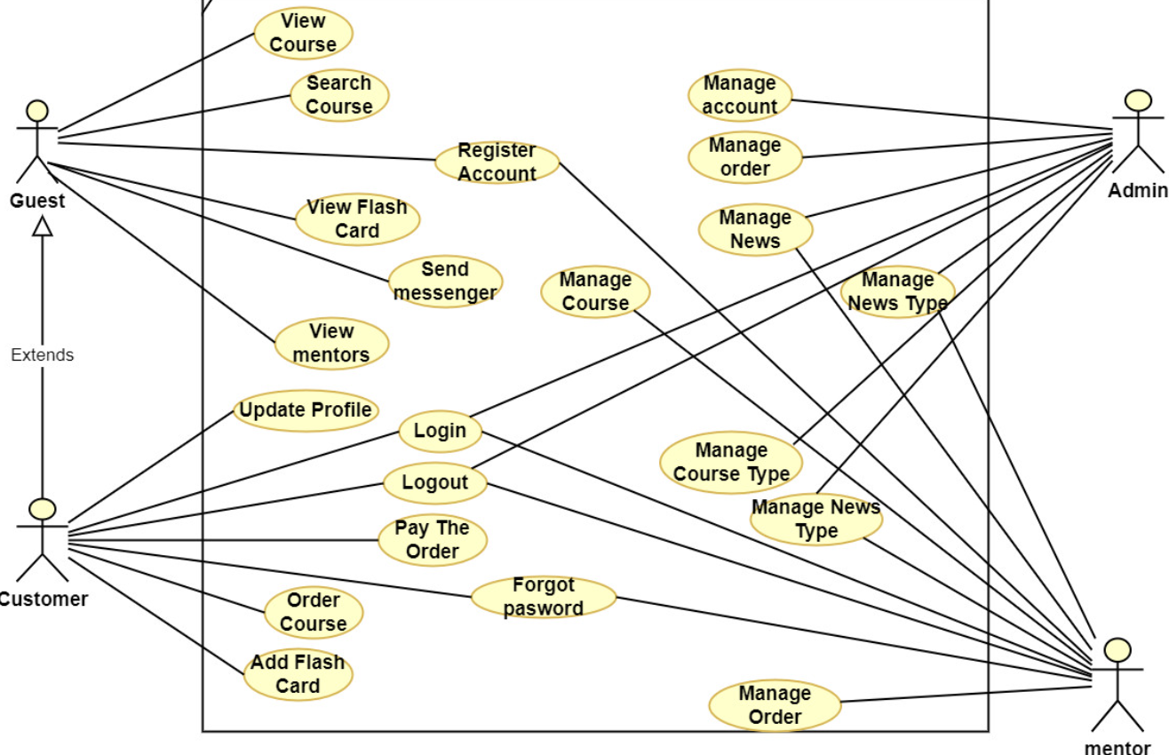

### 3.2.2 Use Case Admin

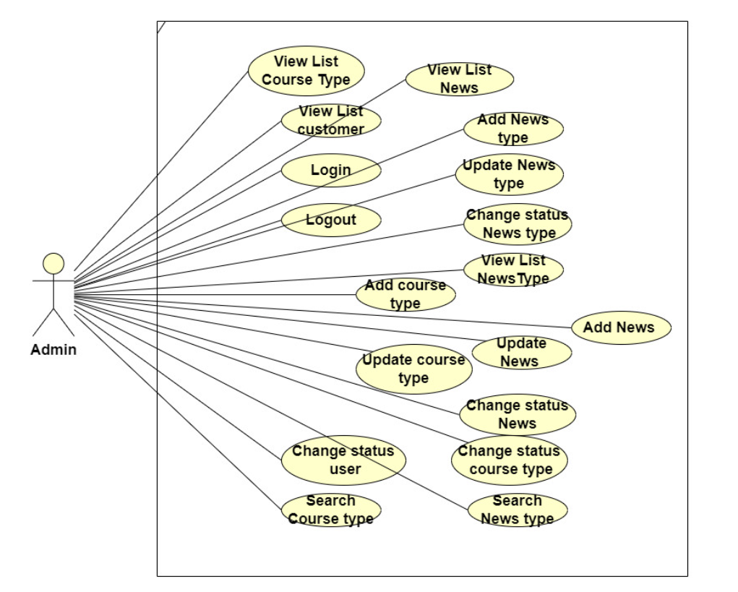

### 3.2.3 Use Case Mentor

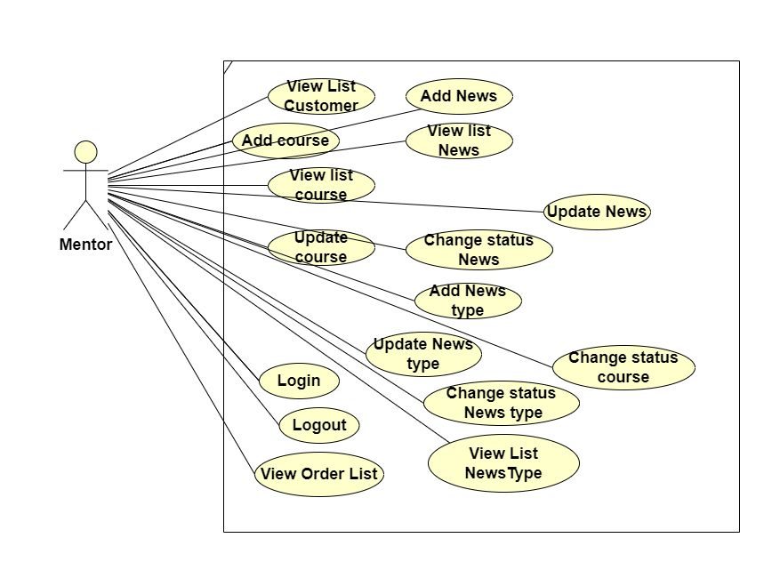

### 3.2.4 Use Case Guest

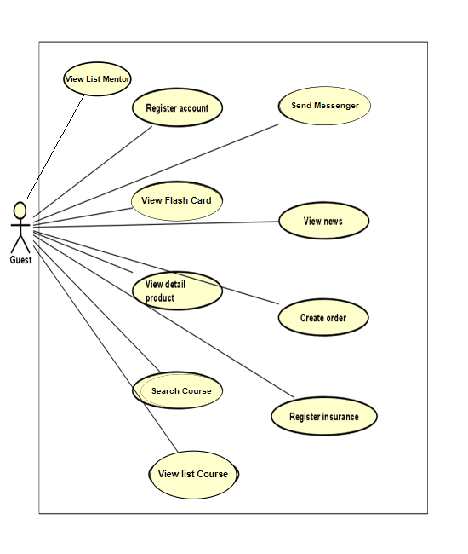

### 3.2.5 Use Case Customer

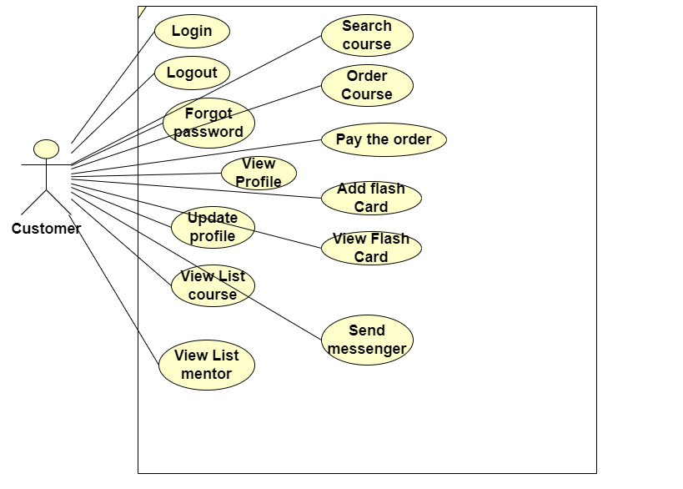

## 3.4 Non-Functional Requirements

Non-functional requirements may exist for the following attributes. Often these requirements must be achieved at a system-wide level rather than at a unit level. State the requirements in the following sections in measurable terms (e.g., 95% of transaction shall be processed in less than a second, system downtime may not exceed 1 minute per day, > 30 day MTBF value, etc).

### 3.4.1 Performance

The interface looks good on a variety of devices.

When visitors use a web browser to access the system, the system will accept access requests from the client side through the browser and reroute them to the browser function menus specific to each user.

In this instance, the visitor can interact with the system through a browser screen window with the following page structure:

* The system name and system login button are provided in the page title section.
* The page's body contains details about the products' list and specifications.

Administrators who access the page through system functions will also see the page's body distributed in a left-to-right way

### 3.4.2 Availability

The system should be available at all times, meaning the user can access it using a web browser, only restricted by the down time of the server on which the system runs

### 3.4.3 Security

* A user can only use functions and access data that are appropriate for that user's role.

## 3.5 Inverse Requirements

## 3.6 Design Constraints

Specify design constrains imposed by other standards, company policies, hardware limitation, etc. that will impact this software project.

## 3.7 Logical Database Requirements

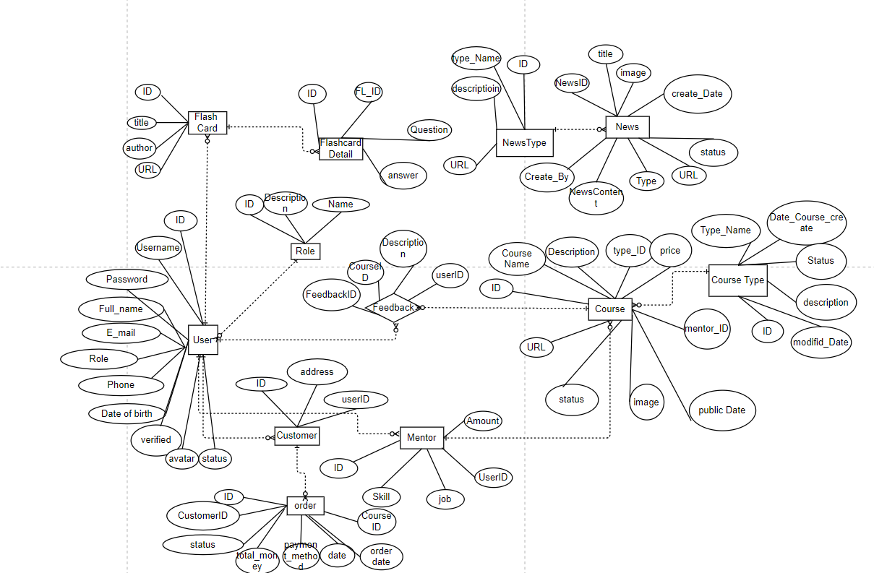

## 3.8 Other Requirements

Catchall section for any additional requirements.

# A. Appendices

## A.1 Business Rule

* BR-01 Full name must be 1-50 characters and contain no special characters.
* BR-02 Users can only access information that belongs to them, except administrator.
* BR-03 Content manager only signs in with the account provided by the administrator.
* BR-04 Each user has exactly one role.
* BR-05 Each email is only registered for an account.
* BR-06 Email must be in the correct format: “abc123@gmail.com”.
* BR-07 Username must be unique.
* BR-08 Username does not contain spaces and special characters.
* BR-09 The length of the username must be between 4-20 characters.
* BR-10 Password must be encrypted.
* BR-11 Password length must be between 4-20 characters and contain no spaces.
* BR-12 When changing the password, the user must enter the old password.
* BR-13 Phone can only contain 10 digits and start with 0.
* BR-14 Date of birth must be before current time.
* BR-15 All managed lists must be displayed with pagination.
* BR-16 Fields marked with an asterisk (*) cannot be left blank.
* BR-17 When reset the password, the user must enter the email so that system can send verify code.
* BR-18 When register account, the user must enter the password twice.

## A.2 References

* IEEE Recommended Practice for Software Requirements Specifications," in IEEE Std 830-1998, vol., no., pp.1-40, 20 Oct. 1998
* IEEE Guide for Developing System Requirements Specifications," in IEEE Std 1233-1996, vol., no., pp.1-30, 22 Dec. 1996.