PT2

User following DB: run file script.sql to create db
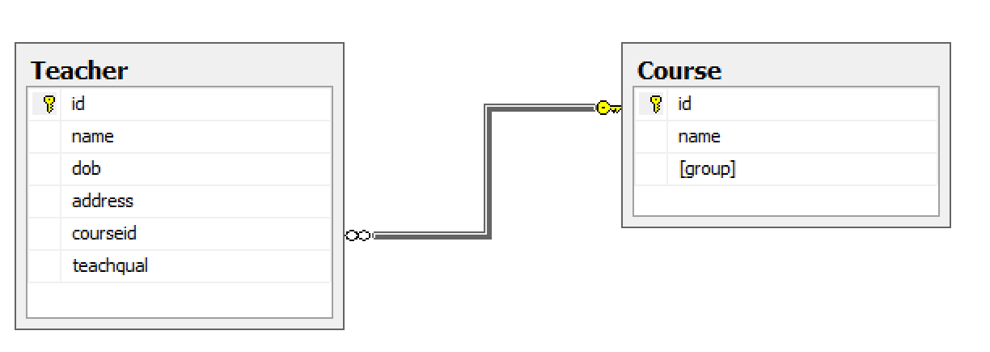
Type url /show to show web page.
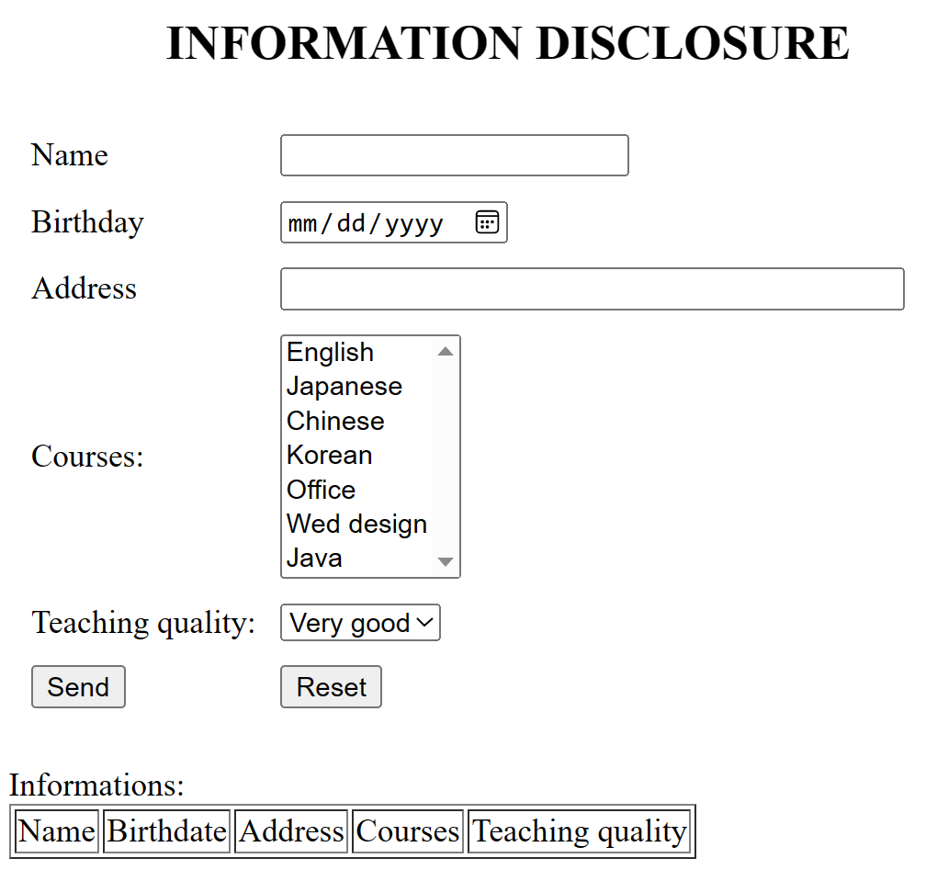
- Course is loaded from [Course] table.
- Click “Send” button then:
a. Browser makes a request to /send using POST method.
b. When servlet receive the request, it will process then displays submitted data of user
- Check validate for input data:
+ Check empty.
+ Check name must contain 5 to 25 characters.
+ Check age <18.
- Check OK then
+ Add information to [Teacher] table.
+ Show information in following table.

