report 1



CAPSTONE PROJECT REPORT
Report 1 – Project Introduction

SmartDroneInspection

AI-powered Infrastructure Inspection-as-a-Service Platform

– Ho Chi Minh City, September 2026 –
Table of Contents
I. Record of Changes 3
II. Project Introduction 4
1. Overview 4
1.1 Project Information 4
1.2 Project Team 4
2. Product Background 4
3. Existing Systems 5
3.1 DroneDeploy Inspection AI 5
3.2 Flyability Inspector 5
4. Business Opportunity 5
5. Software Product Vision 6
6. Project Scope & Limitations 6
6.1 Major Features 6
6.2 Limitations & Exclusions 8

I. Record of Changes
Date | A*  M, D | In charge | Change Description
11 Sep  2026 | A | Team | Version 1.0: complete project-specific content and team information.
12 Sep 2026 | M | Team | Version 1.1: clarified Review 1 target users and scope boundaries.
*A - Added M - Modified D - Deleted

II. Project Introduction

1. Overview

1.1 Project Information
- Project name: SmartDroneInspection: AI-powered Infrastructure Inspection Management Platform
- Project code: GFA26SE139
- Group name: FA26SE112
- Software type: Responsive Web Portal, Flutter Field Application, REST APIs and server-side AI services

1.2 Project Team
Full Name | Role | Email | Mobile
Phạm Minh Trí | Lecturer | tripm14@fpt.edu.vn
Đặng Ngọc Minh Đức | Lecturer | ducdnm2@fpt.edu.vn
Trần Hoàng Trung Hiếu | Leader | hieuthtse184212@fpt.edu.vn | 0963832382
Phùng Trung Quốc | Member | quocptse170027@fpt.edu.vn | 0896986551
Trương Thái Như | Member | nhuttse180082@fpt.edu.vn | 0328416716
Trần Tùng Bách | Member | bachttse180220@fpt.edu.vn | 0378351050

2. Product Background
Organizations that own or manage infrastructure assets need to perform inspections regularly to identify defects, assess asset conditions, and verify repairs. In practice, inspection requests, captured images, findings, approvals, and maintenance updates may be handled through separate tools or manual processes, making it difficult to track the latest condition and resolution status of each defect. This can lead to fragmented information, slower follow-up, and difficulty connecting inspection evidence with the related asset and maintenance activity. SmartDroneInspection is proposed to centralize this process in a shared platform for requesting inspection services, managing inspection evidence, reviewing findings, and tracking defect resolution. The intended customers are organizations that own or manage infrastructure assets and require inspection services.

3. Existing Systems
The following products provide relevant references for inspection evidence, findings and reporting. Their published capabilities inform the design comparison; the scope-fit observations below are project assessments, not claims that the products lack all other capabilities.

3.1 DroneDeploy
Description: DroneDeploy is a cloud-based drone data platform for flight planning, image processing, inspection, analysis, and reporting.
Actors: Organization Owner/Admin, Coordinator, Member, External User, Pilot, Editor/Analyst, Upload-only User, and Viewer.
Main features: Automated flight planning, drone image upload and processing, 2D/3D mapping, measurements, issue tagging, inspection reports, collaboration, and permission management.
Pros: Provides an integrated inspection workflow, strong visualization and analysis tools, flexible access control, and good support for collaboration.
Cons: Advanced features may require higher-tier plans, some inspection tasks are more desktop-oriented, and its workflow focuses more on drone data and inspection management than on service-order processes such as quotations, deposits, provider assignment, and remediation requests.
Reference: DroneDeploy, https://www.dronedeploy.com/

3.2 Flyability Inspector
Description: Flyability Inspector is companion software designed for organizing, reviewing, and reporting inspection data captured by Elios 3 drones.
Actors: Inspection Teams, Engineers, and Asset Owners.
Main features: Asset-based organization, visual review with points of interest (POI), spatial context mapping, historical data comparison over time, structured report generation, and stakeholder collaboration.
Pros: Allows findings to be reviewed with strong visual and spatial context, and supports inspection history comparisons over time.
Cons: Specialized specifically for Elios 3 data rather than general service management or standard uploaded-image workflows, and lacks a built-in 3D digital-twin requirement for this project's scope.
Reference: Flyability, “Inspector”, https://www.flyability.com/inspector (accessed 11 September 2026).

4. Business Opportunity
Infrastructure owners need a more convenient way to purchase, manage, and track occasional or recurring inspection services. When service requests, quotations, inspection evidence, findings, reports, and defect follow-up are handled separately, customers may have difficulty understanding the current status of an inspection or tracing a defect from discovery to resolution. SmartDroneInspection provides a shared platform where customers can define inspection needs, review and confirm service orders, access inspection evidence and reports, and follow defect resolution. For the service provider, the same platform supports resource allocation and maintains a traceable history of inspection activities.
Compared with solutions that primarily focus on drone data capture, mapping, or inspection analysis, SmartDroneInspection focuses on connecting inspection-service ordering with evidence management, AI-assisted defect detection, reporting, and follow-up activities. This makes the proposed system suitable for organizations that need inspection services without operating their own inspection teams or drone infrastructure. The expected benefits are clearer service coordination, easier retrieval of inspection evidence, more consistent defect follow-up, and better visibility of service progress.

5. Software Product Vision
For organizations that need reliable infrastructure inspection services without managing an internal provider workforce, SmartDroneInspection is a B2B web and field application that connects service requests and confirmed prices to manual field inspections, human-verified AI findings, customer-approved reports, and separately ordered remediation.
Unlike fragmented manual communications and generic software lacking complete service workflows, SmartDroneInspection gives customers a clear record of what was purchased, what was observed, who verified the findings, and how defects were resolved. It gives the service provider a consistent way to allocate resources and deliver traceable evidence, prioritizing a demonstrable end-to-end service lifecycle with a limited, validated AI detection scope.

6. Project Scope & Limitations
The project scope covers four main business workflows.
WF1 Asset Registration & Periodic Inspection Schedule Processing.
WF2 Inspection Request Review & Service Assignment.
WF3 Inspection Execution, AI-assisted Finding Verification & Report Approval; and
WF4 Maintenance, Defect Resolution, and Re-inspection. The platform supports five human roles: Administrator, Manager, Inspector, Maintenance Engineer, and Viewer. SmartDroneHub and AI Services are treated as external/system actors.
Within the scope, customer Managers can manage assets, request or schedule inspections, review service information, access inspection evidence, and approve reports. Provider-side staff can be assigned to service requests, perform inspections, verify AI-assisted findings, submit reports, carry out maintenance activities, and update defect resolution status. The platform also supports provider resource assignment based on availability, workload, location, and required skills.
The project may include assembling and configuring a prototype drone using commercially available components for demonstration and system integration. The drone is manually operated using its designated controller and is used to capture inspection evidence for upload to SmartDroneInspection.
The project does not include fully autonomous drone operation, custom flight-control algorithms, commercial-grade drone manufacturing, or a complete 3D digital-twin platform. AI-generated defect candidates must be reviewed by an Inspector and do not replace professional judgment. The capstone release is limited to the defined inspection and maintenance workflows; additional hardware, advanced analytics, or commercial features are outside the current scope unless formally approved as a scope change.

6.1 Major Features
Feature identifiers FE-01 to FE-08 form the scope baseline for requirements, work estimates and acceptance tests. Optional enhancements are scheduled only after the core workflows are stable.
FE-01: Identity & Access Governance. JWT-based authentication and role-/scope-based authorization, the five roles, organization and assignment scope, profile management, and audit logs. API queries and evidence access must enforce scope on the server.
FE-02: Asset Registry & Inspection Schedule. Managers create and manage their organization’s assets, documents, inspection history and recurring schedules. Administrators maintain categories and checklist templates. WF1 generates periodic requests with an Asset + Schedule + Due Cycle idempotency key.
FE-03: Inspection Request & Work Assignment. WF2 unifies PERIODIC and AD_HOC requests. Manager review, scope, priority and deadline lead to a versioned quotation and service-order confirmation. Applicable deposit or credit-term checks are completed before service mobilization or assignment, according to the confirmed service order.
FE-04: Inspection Execution & Evidence Management. The Flutter application supports assignment acceptance, inspection sessions, evidence upload/retry and metadata. Evidence records the inspection, asset, Inspector, capture time and source; GPS or external mission references are retained when available. Manual drone piloting stays outside the platform.

FE-05: YOLO-assisted Defect Detection & Verification. Server-side inference generates candidates with defect label, confidence, bounding box and model version. Inspector Confirm, Modify, Reject and Manual Add actions determine official findings. Unverified candidates are excluded from official defect statistics.
FE-06: Inspection Report & Approval. WF3 combines checklist results, evidence and verified findings into a versioned report. Inspector submission is followed by Manager review, revision/resubmission or approval. Approved versions are immutable; corrections create a new version and preserve approval history.
FE-07: Maintenance & Defect Resolution. WF4 links approved defects to separately confirmed maintenance orders and tickets. The platform supports Engineer assignment after the maintenance order is confirmed and any applicable payment condition is satisfied. The Engineer uploads before/after evidence and marks the work resolved; the Manager requests rework, closes it or requests a new re-inspection through WF2.
FE-08: Dashboard, Analytics & Notifications. Scoped views summarize due and overdue inspections, request and report status, workload, verified defects, maintenance, asset history and service/payment summaries. Notifications support assignments, reviews and deadlines without requiring live telemetry.
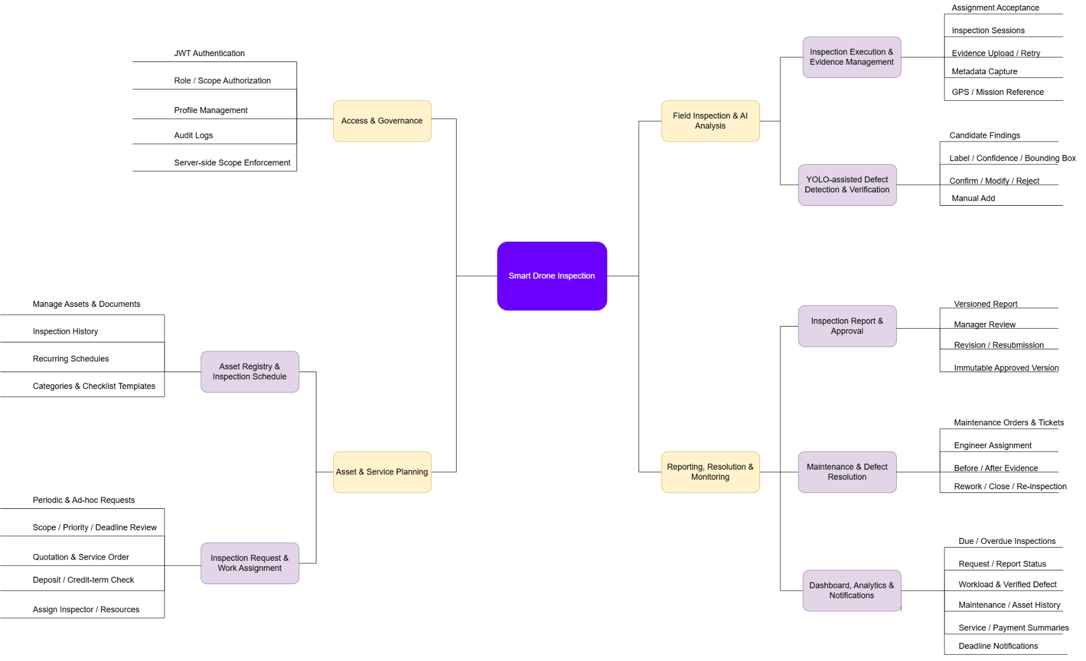
Figure 1. The four service workflows and the re-inspection return to WF2.

6.2 Limitations & Exclusions
The first release is bounded by the following exclusions and dependencies. These limits apply to the software and demonstration, while the service records retain the complete business lifecycle.
LI-1: No custom flight-controller development, autonomous flight, waypoint navigation, automated mission planning, or obstacle-avoidance algorithms are included. Basic configuration and calibration required to operate the prototype drone may be performed using the manufacturer’s or flight-controller’s standard tools.
LI-2: AI detection is limited to one or two defect types supported by the selected dataset and evaluated model. Defect classes, asset domain and evaluation thresholds are finalized after dataset assessment. AI does not certify structural safety or make final technical decisions.
LI-3: Maintenance remains inspection-related remediation follow-up. Inventory, spare-parts procurement, payroll, enterprise-wide maintenance planning and full cost accounting are excluded.
LI-4: SmartDroneHub integration depends on confirmed API access and supported metadata/media contracts. Direct evidence upload and a clearly identified adapter mock support development if live integration is unavailable. Real-time telemetry is not a core acceptance requirement.
LI-5: YOLO-based defect detection and LLM-assisted report generation are required features but may produce inaccurate or incomplete outputs.
LI-6: Payment processing is limited to sandbox gateway integration for the capstone release. The system supports the full payment flow and records transaction status and references, but no real monetary transactions are processed.
LI-7: The release does not include general-purpose photogrammetry, 3D reconstruction, public anonymous consumer use. Approval is an authenticated versioned record, rather than a claim of certified digital signing.

