

Capstone Project Report
Report 3 - Software Requirement Specification

- Ho Chi Minh City, September 2026 -
Table of Contents
I. Record of Changes 3
II. Software Requirement Specification 4
1. Product Overview 4
2. User Requirements 5
2.1 Actors 5
2.2 Use Cases 6
3. Functional Requirements 8
3.1 System Functional Overview 8
3.2 Inspection Service Management 14
3.3 Maintenance Management 16
4. Non-Functional Requirements 18
4.1 External Interfaces 18
4.2 Quality Attributes 18
5. Requirement Appendix 19
5.1 Business Rules 19
5.2 Common Requirements 21
5.3 Application Messages List 21
5.4 Other Requirements 22

I. Project Report

1. Status Report
As of 22 September 2026, SmartDroneInspection has an aligned requirements baseline for the four business workflows: asset registration and periodic scheduling (WF1), inspection request review and assignment (WF2), inspection execution and report release (WF3), and maintenance resolution and re-inspection (WF4). The baseline covers the five current roles: Admin, Client, Service Manager, Inspector, and Maintenance Engineer.
Area | Status | Evidence and next step
Product scope | Baseline aligned | The platform manages the inspection-to-maintenance lifecycle. Drone flight control, online payment processing, and autonomous AI approval remain out of scope.
Requirements | In progress | Report 3 defines actors, use cases, functional requirements, non-functional requirements, business rules, messages, and scope constraints. The team will update the baseline when an approved requirement changes.
Software foundation | In progress | The project uses separate backend, frontend, mobile, and documentation repositories. Authentication and role contracts are aligned; remaining business capabilities are delivered as focused vertical slices.
Verification | Ongoing | Each repository must run its relevant formatting, lint, build, and test checks before a release baseline is accepted. Environment-dependent failures must be recorded separately from code failures.

2. Team Involvements
Member | Role | Main involvement
Trần Hoàng Trung Hiếu | Leader | Coordinates scope, planning, repository integration, document baselines, review preparation, and end-to-end workflow consistency.
Phùng Trung Quốc | Member | Contributes to backend domain implementation, asset and inspection workflow functions, data rules, and related verification.
Trương Thái Như | Member | Contributes to web and mobile workflow screens, report and AI-assisted review experiences, and user-facing validation.
Trần Tùng Bách | Member | Contributes to authentication, authorization, storage and integration concerns, backend implementation, and technical verification.
Phạm Minh Trí | Lecturer | Provides project supervision and academic review.
Đặng Ngọc Minh Đức | Lecturer | Provides project supervision and academic review.

3. Issues and Suggestions
Issue or risk | Suggestion
Requirements, implementation, and report sections can drift when roles or workflow states change. | Keep role names, workflow identifiers, business rules, API contracts, and test evidence aligned in the same change review.
The system spans backend, web, mobile, object storage, and AI services. | Deliver one bounded vertical slice at a time and verify the relevant repository and integration boundaries before expanding scope.
AI output can contain false positives, false negatives, or unsupported conclusions. | Treat AI output as a candidate only; require Inspector verification and preserve the evidence and model version used for each result.
Cross-organization and assignment access errors have high impact. | Test positive and negative authorization cases for organization ownership, assignment, release authority, and separation of duties.
Local infrastructure may not be available on every development machine. | Record blocked environment checks explicitly and rely on CI or an approved integration environment for the missing verification.

II. Software Requirement Specification

1. Overall Description

1.1 Product Overview
SmartDroneInspection is an infrastructure inspection management platform. It coordinates the business lifecycle from customer assets and recurring inspection schedules to inspection requests, service orders, field evidence, verified findings, reports, maintenance tickets, and final resolution. The solution includes a web application for administration, customer operations, and service coordination; a mobile application for assigned field work; and a backend that owns business rules, authorization, transactional data, file access, and integration contracts.
The platform supports five actors: Admin, Service Manager, Inspector, Maintenance Engineer, and Client. A Client acts only within one customer organization. Inspectors and Maintenance Engineers work only on assigned resources. Service Managers coordinate service delivery across customer organizations. Admin manages platform configuration and identities but does not automatically receive permission to perform customer or service workflow actions.
The product does not pilot drones, control flights, own drone telemetry, or replace site safety procedures. Inspection images may be transferred from a drone SD card, computer, web browser, or mobile device. MinIO stores authorized evidence objects. The configured YOLO service may propose defect candidates, but those candidates do not become official findings until an Inspector confirms or corrects them.
The main business flow is:
- WF1: the Client registers an asset and configures periodic inspection scheduling.
- WF2: the Client submits or completes an inspection request; the Service Manager reviews it, prepares a quotation and service order, and assigns an Inspector.
- WF3: the Inspector performs the inspection, uploads evidence, verifies AI candidates, prepares the report, and completes peer review before the Service Manager releases the report to the Client.
- WF4: the Client creates a maintenance ticket from verified findings; the Maintenance Engineer assesses and performs approved work; the Service Manager releases the result; and the Client accepts, requests rework, or requests re-inspection.
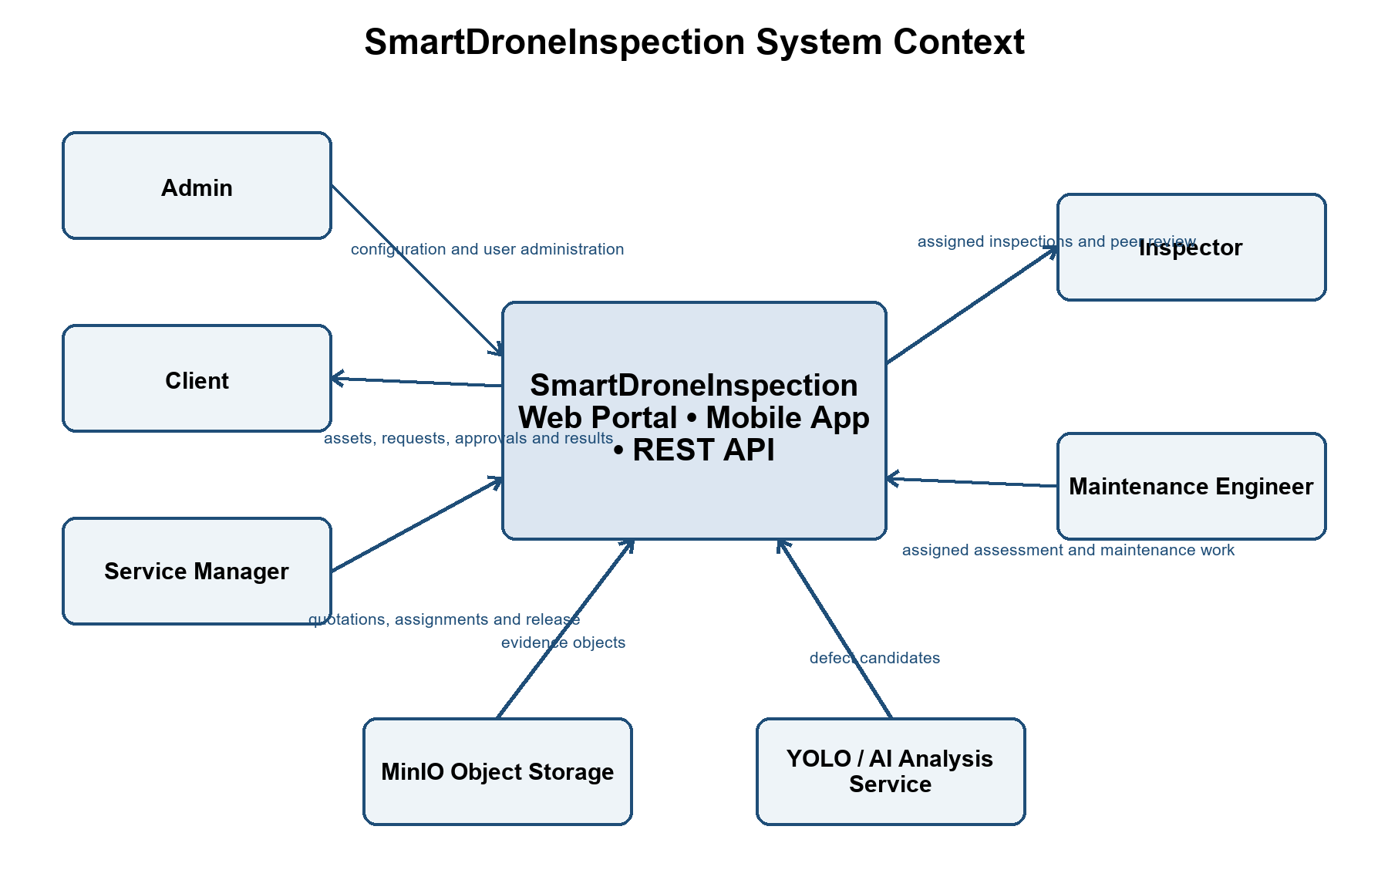

1.2 Business Rules
ID | Rule Definition
BR-01 | Admin, Client, and service-workforce identities use distinct actor zones; Admin and Client roles are exclusive.
BR-02 | A Client can access only data owned by the Client's organization.
BR-03 | An Inspector or Maintenance Engineer can access only work assigned to that user unless another explicit service role grants separate scope.
BR-04 | An asset code is unique within its organization.
BR-05 | An active recurring schedule requires an active asset and an available checklist template.
BR-06 | Only one periodic request may be generated for the same Asset, Schedule, and Due Cycle.
BR-07 | An ad hoc request must reference an asset owned by the Client's organization.
BR-08 | A quotation or order revision creates a new version and preserves earlier versions.
BR-09 | No upfront payment is required for inspection or maintenance work.
BR-10 | An unconfirmed inspection service order cannot proceed to Inspector assignment.
BR-11 | An Inspector assignment must be accepted before inspection status becomes READY_FOR_INSPECTION.
BR-12 | Assignment rejection requires a reason and returns the work to the Service Manager.
BR-13 | Manual drone piloting, flight control, and operational flight safety remain outside SmartDroneInspection.
BR-14 | Each evidence object has a checksum; duplicate content cannot create duplicate evidence in the same work context.
BR-15 | Missing GPS is recorded but does not automatically invalidate otherwise acceptable evidence.
BR-16 | AI candidates remain non-official until an Inspector confirms or modifies them.
BR-17 | Rejected or unverified AI candidates do not enter official defect statistics or reports.
BR-18 | An Inspector may manually add a defect that the AI service did not detect.
BR-19 | A report author cannot peer-review or technically approve the same report.
BR-20 | A report cannot be released before technical approval and deliverable-completeness review.
BR-21 | Internal drafts and peer-review comments are not visible to the Client.
BR-22 | An accepted report version is immutable; corrections require a new linked version.
BR-23 | A maintenance ticket must reference at least one verified finding in an accepted report.
BR-24 | A qualified Maintenance Engineer provides the technical maintenance assessment.
BR-25 | An assessment assignment does not authorize maintenance execution.
BR-26 | An approved maintenance order is required before execution assignment.
BR-27 | Material scope or cost growth requires an approved change-order version before additional work.
BR-28 | Before and after evidence is required before a maintenance ticket can be closed.
BR-29 | Only the Service Manager releases inspection and maintenance results to the Client.
BR-30 | The Client may accept a maintenance result, request rework, or request a linked re-inspection.
BR-31 | Rework preserves the existing ticket and creates a new execution cycle.
BR-32 | Re-inspection creates a linked ad hoc inspection request and returns it to WF2.
BR-33 | Status transitions that affect assignment, approval, release, acceptance, or closure are audited.
BR-34 | File possession or an object-storage path alone does not grant access to evidence.
BR-35 | Password, role, status, and session-revocation changes invalidate affected active sessions.

2. User Requirements

2.1 System Actors
# | Actor | Description
1 | Admin | Manages organizations, user accounts, role assignments, asset categories, checklist templates, platform configuration, and authorized audit views. Admin does not automatically perform Client or service-workforce actions.
2 | Service Manager | Reviews inspection and maintenance requests, prepares quotation and order versions, assigns qualified staff, coordinates peer review, verifies deliverables, and releases customer-visible results.
3 | Inspector | Accesses assigned inspections and assigned peer reviews; completes checklists, evidence, verified findings, and inspection reports. The report author cannot approve the same report as peer reviewer.
4 | Maintenance Engineer | Accesses assigned maintenance assessments and execution work; supplies technical estimates, work logs, change requests, before/after evidence, and completion results.
5 | Client | Acts for one customer organization and manages that organization's assets, inspection requests, commercial approvals, released reports, maintenance tickets, and resolution decisions.

2.2 Use Cases

2.2.1 Diagram(s)
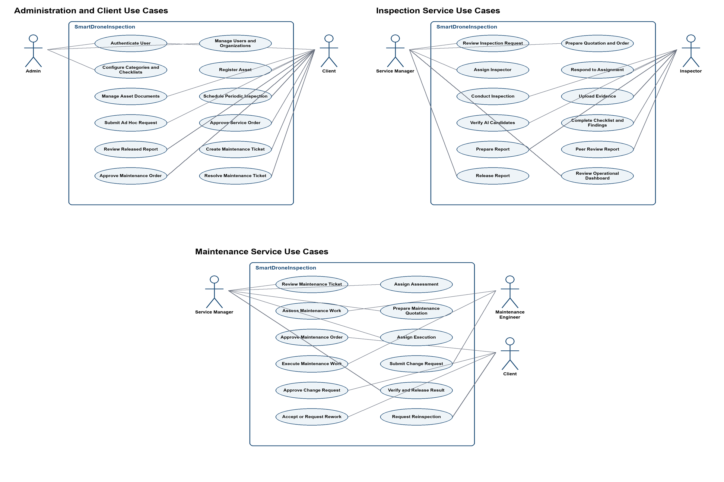

2.2.2 Descriptions
ID | Use Case | Actors | Use Case Description
01 | Authenticate User | All roles | Sign in with an issued account, complete first-password setup when required, refresh the session, change the password, and sign out.
02 | Manage Users and Organizations | Admin | Create organizations and accounts, assign valid roles, reset credentials, change account status, and revoke sessions.
03 | Configure Categories and Checklists | Admin | Maintain asset categories, checklist templates, checklist versions, and platform-level reference data.
04 | Register Asset | Client | Create and update an infrastructure asset owned by the Client's organization.
05 | Manage Asset Documents | Client | Upload and maintain drawings, manuals, previous reports, and maintenance history for an authorized asset.
06 | Schedule Periodic Inspection | Client | Create, activate, pause, or update a recurring inspection schedule for an active asset and checklist template.
07 | Submit Inspection Request | Client | Submit an ad hoc request or complete a system-generated periodic request with scope, priority, deadline, access constraints, contact, and attachments.
08 | Review Inspection Request | Service Manager | Check request completeness, scope feasibility, service capacity, access conditions, and required supporting information.
09 | Prepare Inspection Quotation and Order | Service Manager | Create a versioned quotation and draft service order containing scope, deliverables, estimated price or rates, duration, and post-service payment terms.
10 | Approve Inspection Order | Client | Approve the current quotation and order or request a revised version.
11 | Assign Inspector | Service Manager | Select an available and qualified Inspector without a known conflict of interest.
12 | Respond to Inspection Assignment | Inspector | Accept or reject an assignment; rejection requires a reason and returns the work for reassignment.
13 | Conduct Inspection | Inspector | Start an assigned inspection session and execute the confirmed checklist and service scope.
14 | Upload Evidence | Inspector | Upload images or documents with file validation, checksum, duplicate prevention, provenance, and available metadata.
15 | Verify AI Candidates | Inspector | Confirm, modify, or reject AI-generated candidates and manually add defects missed by the AI service.
16 | Complete Checklist and Findings | Inspector | Complete checklist responses and record location, severity, technical notes, and recommended action for verified findings.
17 | Prepare Inspection Report | Inspector | Review the compiled report content, correct the working version, and submit it for peer review.
18 | Peer Review Report | Inspector | Review another Inspector's report, request changes, or technically approve the report when evidence supports its conclusions.
19 | Release Inspection Report | Service Manager | Verify deliverable completeness and release a technically approved report to the Client.
20 | Accept or Revise Report | Client | Accept the released report or request clarification or revision without editing technical content directly.
21 | Create Maintenance Ticket | Client | Create a maintenance ticket from one or more verified findings in an accepted report.
22 | Assess Maintenance Work | Maintenance Engineer | Review defect evidence, assess remotely or on site, and estimate work, materials, labor, duration, risks, assumptions, and cost range.
23 | Prepare Maintenance Quotation | Service Manager | Create a versioned maintenance quotation and draft order based on the Engineer's technical assessment.
24 | Approve Maintenance Order | Client | Approve the maintenance scope and post-service payment terms or request revision.
25 | Assign Maintenance Execution | Service Manager | Assign a qualified Maintenance Engineer after the maintenance order is approved.
26 | Execute Maintenance Work | Maintenance Engineer | Accept the execution assignment, perform approved work, and record progress, material use, time, evidence, and cost.
27 | Manage Maintenance Change Request | Maintenance Engineer, Service Manager, Client | Stop unapproved additional work, revise the order, and obtain the Client's decision before continuing.
28 | Release Maintenance Result | Service Manager | Verify the completion report, before/after evidence, and final cost against approved order versions before release.
29 | Resolve Maintenance Ticket | Client | Accept the result, request rework, or request a linked re-inspection.
30 | View Dashboard and Audit History | Admin, Service Manager | View authorized operational summaries and material workflow or security history without bypassing resource scope.

3. Functional Requirements

3.1 System Functional Overview

3.1.1 Screens Flow
The browser application provides administration, Client, and Service Manager workflows. The mobile application provides assigned Inspector and Maintenance Engineer workflows. Each route is filtered by authenticated role and resource scope, while the backend remains the authorization authority.
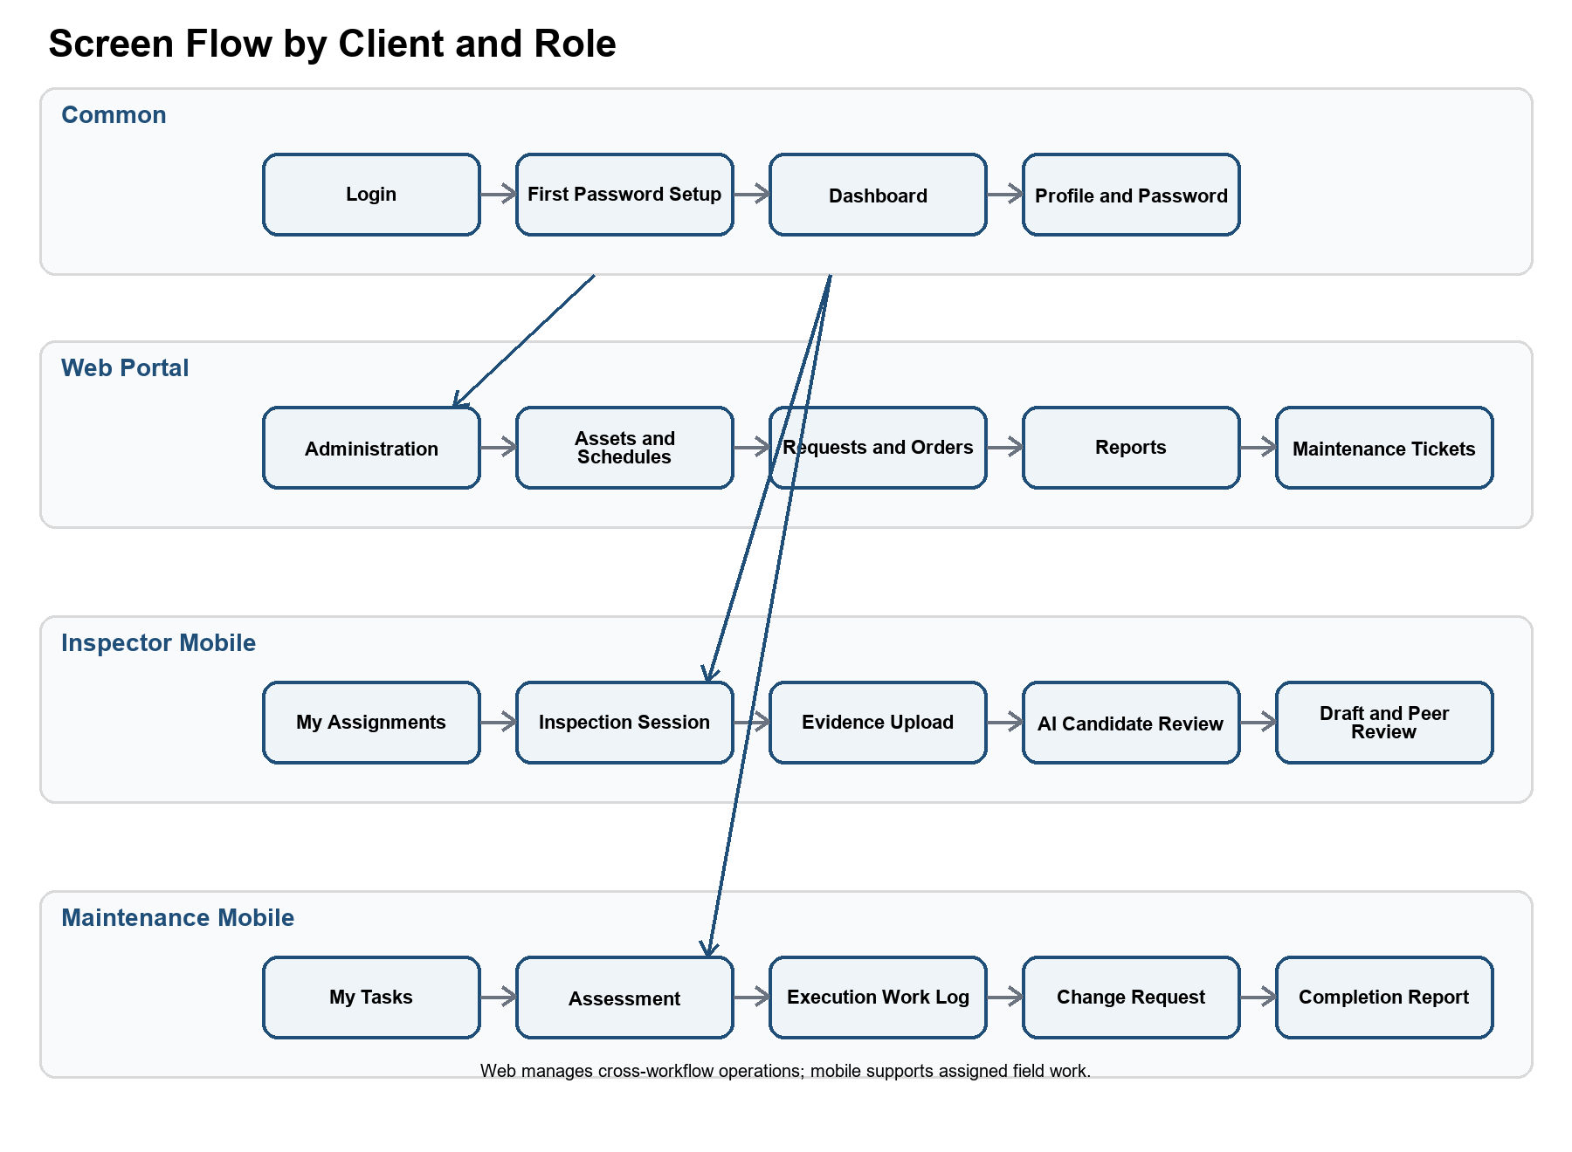

3.1.2 Screen Descriptions
# | Feature | Screen | Description
1 | Authentication | Login | Authenticate an issued account and route the user to the permitted application experience.
2 | Authentication | First Password Setup | Replace the administrator-issued setup password before normal application access.
3 | Common | Dashboard | Show role-scoped work queues, counts, deadlines, and recently released results.
4 | Common | Profile and Password | View account information, change the password, and terminate the current or all sessions.
5 | Administration | Organizations | Create, activate, suspend, and inspect customer organizations.
6 | Administration | Users | Provision accounts, assign valid roles, reset credentials, change status, and revoke sessions.
7 | Administration | Asset Categories | Maintain classifications used by assets and checklist templates.
8 | Administration | Checklist Templates | Create and version checklist templates and checklist items.
9 | Assets | Asset List | Search, filter, and open assets within the user's authorized scope.
10 | Assets | Asset Details | View and update asset data, documents, schedules, requests, reports, findings, and maintenance history.
11 | Planning | Inspection Schedules | Create, activate, pause, and review recurring inspection schedules.
12 | Requests | Inspection Request | Create, complete, review, or reject a periodic or ad hoc inspection request and its attachments.
13 | Commercial | Inspection Quotation and Order | Create versions, review scope and terms, approve, or request revision.
14 | Assignments | Inspector Assignment | Assign an Inspector and record accept or reject responses.
15 | Inspection | My Inspection Assignments | List only inspections assigned to the signed-in Inspector.
16 | Inspection | Inspection Session | Start work, complete the checklist, record progress, and finish the field session.
17 | Inspection | Evidence Upload | Upload images and documents and show validation and processing status.
18 | AI Assistance | AI Candidate Review | Confirm, modify, or reject AI candidates and add manual findings.
19 | Reports | Draft Report | Review generated content, edit a working version, and submit for peer review.
20 | Reports | Peer Review | Review another Inspector's report and request changes or approve technical content.
21 | Reports | Report Release | Check required deliverables and release the final report to the Client.
22 | Reports | Released Report | View, download, accept, or request clarification or revision.
23 | Maintenance | Maintenance Ticket | Create or review a ticket linked to verified findings.
24 | Maintenance | Assessment Assignment | Assign and complete the technical maintenance assessment.
25 | Maintenance | Maintenance Quotation and Order | Prepare, revise, and approve maintenance scope and terms.
26 | Maintenance | Execution Assignment | Assign a Maintenance Engineer and record acceptance or rejection.
27 | Maintenance | Execution Task | Record work progress, materials, time, actual cost, and before/after evidence.
28 | Maintenance | Change Request | Document additional damage or cost and collect the Client decision before additional work.
29 | Maintenance | Completion and Resolution | Verify, release, and accept the result or route it to rework or re-inspection.
30 | Audit | Audit History | Search security and workflow events allowed for the current role and resource scope.

3.1.3 Screen Authorization
The matrix preserves the five-column structure of the supplied template. The combined field-workforce column identifies the applicable role in each row: I means Inspector and M means Maintenance Engineer. M in other cells means Manage; V means View; O means Own organization; A means Assigned resource; and R means Release or coordinate. A blank cell means denied. Backend organization, ownership, assignment, and separation-of-duties checks remain authoritative.
Screen | Admin | Service Manager | Inspector / Maintenance Engineer | Client
Dashboard | V | V | I: V; M: V | V
Organizations and Users | Manage
Categories and Checklists | Manage | V | I: V; M: V | V
Asset List and Details | V |  |  | Manage own organization
Inspection Schedules | V |  |  | Manage own organization
Inspection Requests | V | Manage and review | I: View assigned | Manage own organization
Inspection Quotation and Order | V | Manage and release | I: View assigned | Approve own organization
Inspector Assignment | V | Manage | I: Respond to assigned | View own organization
Inspection Session | V | Coordinate and view | I: Manage assigned | View own organization result
Evidence and AI Review | V | Coordinate and view | I: Manage assigned | View released result
Draft Report | V | Coordinate and view | I: Manage authored version
Peer Review | V | Assign reviewer | I: Manage assigned review
Report Release | V | Manage and release | I: View assigned | Accept own organization report
Maintenance Ticket | V | Manage and review | M: View assigned | Manage own organization
Assessment Assignment | V | Manage | M: Manage assigned | View own organization
Maintenance Quotation | V | Manage and release | M: View assigned | Approve own organization
Execution Assignment and Task | V | Coordinate and view | M: Manage assigned | View own organization result
Change Request | V | Manage and release | M: Manage assigned | Decide for own organization
Completion and Resolution | V | Manage and release | M: Manage assigned | Decide for own organization
Audit History | Manage and view | Authorized view | I: Assigned view; M: Assigned view | Own organization view

3.1.4 Non-Screen Functions
# | Feature | System Function | Description
1 | Authentication | Access-token validation | Validate token signature, issuer, audience, expiry, session, user status, authentication version, role, and applicable resource scope.
2 | Authentication | Refresh-token rotation | Rotate the opaque refresh token and reject an expired, revoked, or reused token.
3 | Planning | Periodic request generation | Create at most one periodic request for each Asset, Schedule, and Due Cycle combination.
4 | Files | Evidence intake | Validate file type and size, calculate checksum, prevent duplicates, and store authorized objects in MinIO.
5 | AI Assistance | Image inference | Submit eligible images to the YOLO service and store model version, label, confidence, and bounding box as non-official candidates.
6 | Reports | Draft compilation | Compile a versioned report draft from checklist responses, evidence, and Inspector-verified findings.
7 | Reports | Immutable acceptance | Preserve an accepted report version and its complete approval and revision history.
8 | Maintenance | Linked re-inspection | Create an ad hoc inspection request from a re-inspection decision and return it to WF2.
9 | Notifications | Workflow notification | Notify the next responsible actor after material assignments, decisions, deadlines, releases, and correction requests.
10 | Audit | Security and workflow audit | Append material security and workflow events without storing passwords, raw tokens, or protected evidence content.
11 | Cleanup | Retention processing | Remove expired token history and apply configured audit and evidence retention rules.

3.1.5 Entity Relationship Diagram
The diagram describes the principal transactional entities. The complete physical PostgreSQL schema, indexes, constraints, and Flyway migrations are maintained in the database design and backend source.
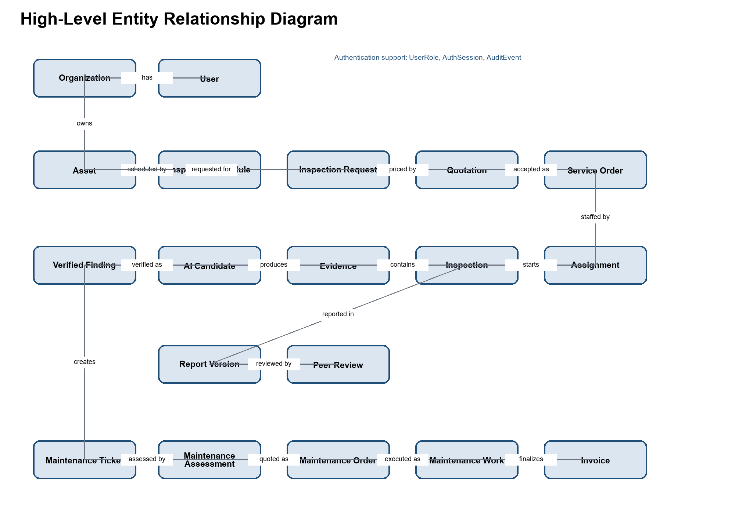
Entities Description
# | Entity | Description
1 | Organization | Customer organization that owns assets and Client accounts.
2 | User | Issued account with status, actor zone, organization scope, password state, and authentication version.
3 | User Role Assignment | Role assignment constrained by the user's actor zone and organization relationship.
4 | Auth Session | Web or mobile login session that can be revoked independently.
5 | Asset Category | Admin-managed classification used by assets and checklist templates.
6 | Checklist Template | Versioned inspection checklist definition.
7 | Asset | Organization-owned infrastructure item subject to inspection and maintenance.
8 | Asset Document | Drawing, manual, previous report, or maintenance document linked to an asset.
9 | Inspection Schedule | Recurring schedule that generates periodic inspection requests.
10 | Inspection Request | Periodic or ad hoc request with scope, priority, deadline, contact, and access constraints.
11 | Quotation | Versioned commercial proposal for inspection or maintenance service.
12 | Service Order | Confirmed inspection scope, deliverables, and post-service payment terms.
13 | Assignment | Accepted or rejected assignment for inspection, peer review, assessment, or execution.
14 | Inspection | Field inspection session governed by an accepted Inspector assignment.
15 | Checklist Response | Recorded answer to a checklist item for an inspection.
16 | Evidence | Stored file with checksum, provenance, metadata, and object-storage reference.
17 | AI Finding Candidate | Non-official model output awaiting Inspector verification.
18 | Verified Finding | Confirmed or manually added defect with location, severity, notes, and recommendation.
19 | Inspection Report | Report aggregate linked to one inspection.
20 | Report Version | Versioned report content and approval state.
21 | Peer Review | Technical review result by an Inspector other than the report author.
22 | Maintenance Ticket | Client request linked to one or more verified findings.
23 | Maintenance Assessment | Engineer-provided technical scope, estimate, risks, and assumptions.
24 | Maintenance Order | Approved maintenance scope and commercial terms.
25 | Maintenance Assignment | Assessment or execution assignment to a Maintenance Engineer.
26 | Maintenance Work Log | Progress, materials, duration, cost, and before/after evidence.
27 | Change Request | Material change in scope or cost that requires a Client decision.
28 | Invoice | Final actual-cost and payment-status record issued after completion.
29 | Notification | Delivery record for a user-facing workflow notification.
30 | Audit Event | Append-only security or material workflow event.

3.2 FE-01 Identity and Access Governance
FE-01 provides Client organization self-registration, authentication, account and profile management, role- and scope-based authorization, session management, and audit logging. A Client registration creates one active organization and its first Client account; it cannot create platform or service-workforce roles. Backend authorization remains authoritative for organization, ownership, assignment, release, and separation-of-duties scope.

3.2.1 Identity, Session and Authorization Rules
All users sign in through the versioned authentication API. The browser keeps access tokens in memory, uses the protected refresh-cookie flow, and does not persist credentials in browser storage.
Mobile authentication uses the mobile token-delivery contract and secure platform storage.
Admin manages platform identities and role assignments. Client self-registration creates only the Client role.
Logout, password change, disable, role change, and session revocation invalidate affected active sessions.
Authentication and authorization events are auditable without storing passwords, raw tokens, or protected evidence content.

3.3 FE-02 Asset Registry and Inspection Schedule

3.3.1 Manage Assets and Periodic Inspection Scheduling
Function trigger: The Client opens Asset Management to register an asset or opens Inspection Schedules for an existing active asset.
Function description:
- The Client enters the asset code, name, category, location, technical description, operational status, and available documents.
- The system verifies that the Client belongs to the asset's organization and that the asset code is unique within that organization.
- The Client selects a checklist template, recurrence rule, next due date, preferred inspection window, and responsible contact.
- The system validates the recurrence rule and activates the schedule only when the asset and checklist template are active.
- On each due cycle, the system creates one periodic inspection request and records the Asset, Schedule, and Due Cycle key.
Validation and exception requirements: Missing required asset data prevents activation. An inactive asset pauses its schedule. An unavailable checklist routes the due request to manual review. Retrying the scheduler cannot create a duplicate request for the same due cycle.
Result: A valid periodic inspection request enters the request-review process.

3.4 FE-03 Inspection Request and Work Assignment
FE-03 manages periodic and ad hoc inspection requests, commercial review, quotation and order versions, Client approval, and Inspector assignment.

3.4.1 Review Request and Assign Inspector
Function trigger: A periodic request is generated or the Client submits an ad hoc inspection request.
Function description:
- The Client completes scope, priority, preferred deadline, site-access constraints, contact information, and supporting documents.
- The system verifies organization ownership, required fields, attachment references, and valid status transitions.
- The Service Manager assesses completeness, feasibility, required checklist, duration, service capacity, and delivery expectations.
- The Service Manager creates a versioned quotation and draft service order. A revision creates a new version and preserves earlier versions.
- The Client approves the current version and accepts post-service payment terms or requests revision.
- After approval, the Service Manager selects a qualified and available Inspector and sends the assignment package.
- The Inspector accepts or rejects. Rejection requires a reason and returns the request to the Service Manager for reassignment.
Validation and exception requirements: An unconfirmed service order cannot be assigned. The system prevents assignment to an inactive user and records known conflict checks. Only an accepted assignment can enter inspection execution.
Result: The service order is confirmed and the inspection is READY_FOR_INSPECTION with an accepted Inspector assignment.

3.5 FE-04 Inspection Execution and Evidence Management
FE-04 provides the assigned Inspector's inspection session, checklist execution, evidence intake, metadata, checksum, duplicate prevention, retry behavior, and authorized MinIO storage.

3.5.1 Execute Inspection and Upload Evidence
Function trigger: The assigned Inspector opens an accepted assignment and starts the inspection session.
Function description:
- The system records the start time, responsible Inspector, asset, confirmed scope, and checklist version.
- The Inspector performs the field inspection according to the confirmed scope. Manual drone piloting remains outside the platform.
- The Inspector uploads images and documents. The backend validates type and size, calculates a checksum, prevents duplicate records, and stores authorized content in MinIO.
- Available capture time, source, GPS, device reference, and external mission reference are stored as metadata. Missing GPS is recorded but does not automatically invalidate evidence.
Validation and exception requirements: Unsupported or corrupted files are rejected. Interrupted uploads retry without duplicate evidence records. An Inspector cannot update another Inspector's assignment without a separate authorized role and scope.
Result: The inspection has a session record, completed checklist responses, and traceable evidence ready for finding verification.

3.6 FE-05 YOLO-Assisted Defect Detection and Verification
FE-05 generates non-official defect candidates from eligible inspection images and requires human verification before findings are used in reports or statistics.

3.6.1 AI Candidate Generation and Review
Function trigger: An eligible evidence image is available after upload validation.
Function description:
The configured YOLO service receives only eligible authorized images and returns a candidate label, confidence, bounding box, and model version.
The Inspector reviews every candidate and chooses Confirm, Modify, or Reject.
The Inspector may manually add a finding that the AI service did not detect.
Only confirmed, modified, or manually added findings enter official statistics and report content.
Validation and exception requirements: AI failure does not discard evidence or prevent manual finding entry. Rejected or unverified candidates remain non-official. An Inspector cannot verify findings outside the assigned inspection scope.
Result: The inspection has traceable, Inspector-verified findings that can be used by FE-06.

3.7 FE-06 Inspection Report and Approval
FE-06 compiles versioned inspection reports from checklist responses, evidence, and Inspector-verified findings, then controls peer review, Service Manager release, and Client acceptance.

3.7.1 Review and Release Inspection Report
Function trigger: The Inspector completes the checklist and required finding details.
Function description:
- The system compiles a report draft from checklist responses, evidence, verified findings, and recommendations.
- The Inspector reviews and corrects the draft and submits a version for peer review.
- The Service Manager assigns another qualified Inspector. The author cannot review or technically approve the same report.
- The peer reviewer verifies evidence support, classification, severity, location, checklist consistency, and conclusions.
- When changes are required, the author creates a revised version and resubmits it. Prior versions and review decisions remain traceable.
- When technically approved, the Service Manager checks deliverable completeness and releases the report to the Client.
- The Client accepts the report or requests clarification or revision without editing technical content directly.
Validation and exception requirements: Internal drafts and peer-review comments are not customer-visible. A released report cannot be silently overwritten. An accepted version is immutable; later corrections create a new linked version.
Result: A technically reviewed, customer-visible, and accepted inspection report is available for maintenance decisions.

3.8 FE-07 Maintenance and Defect Resolution

3.8.1 Create and Assess Maintenance Ticket
FE-07 links verified findings from accepted reports to maintenance assessment, approved work, controlled change requests, completion evidence, release, resolution, rework, and re-inspection.
Function trigger: The Client selects one or more verified findings from an accepted report and creates a maintenance ticket.
Function description:
- The system links the ticket to the Client organization, asset, accepted report, selected findings, and supporting evidence.
- The Client supplies priority, preferred deadline, access constraints, contact information, and additional instructions.
- The Service Manager reviews completeness and decides whether assessment can be remote or requires a site visit.
- The Service Manager assigns a qualified Maintenance Engineer for assessment; this assignment does not authorize execution work.
- The Engineer records the condition, required work, materials, labor, duration, risks, assumptions, and estimated cost range.
Validation and exception requirements: A ticket must reference at least one verified finding. The selected finding must belong to the Client's organization. The Engineer must accept the assessment assignment before submitting the assessment.
Result: A traceable technical assessment is ready for commercial preparation.

3.8.2 Prepare and Approve Maintenance Work
Function trigger: The Maintenance Engineer submits the technical assessment.
Function description:
- The Service Manager creates a versioned maintenance quotation and draft maintenance order from the assessment and approved pricing rules.
- The order identifies scope, deliverables, exclusions, estimated duration, cost or rates, assumptions, and post-service payment terms.
- The Client approves the current version or requests revision.
- After approval, the Service Manager confirms the order and assigns the same or another qualified Maintenance Engineer for execution.
- The Engineer accepts or rejects the execution assignment; rejection requires a reason and returns the work for reassignment.
Validation and exception requirements: The Service Manager cannot replace the Engineer's technical assessment with an unsupported estimate. An unapproved order cannot proceed to execution. No upfront payment is required.
Result: An approved maintenance order and accepted execution assignment are ready for work.

3.8.3 Execute Work and Manage Change
Function trigger: The assigned Maintenance Engineer opens an accepted execution assignment.
Function description:
- The Engineer records start time, work progress, materials, labor time, and approved tasks.
- Before and after evidence is uploaded through the authorized file flow and linked to the work log.
- If additional damage or material cost growth is discovered, the Engineer stops the additional work and submits a change request.
- The Service Manager creates a revised order version from the technical change information.
- The Client approves or rejects the change before additional work continues.
- The Engineer completes the approved scope and submits actual duration, materials, final cost, evidence, and completion notes.
Validation and exception requirements: Work outside the approved scope is prohibited until the change is approved. Rejected changes remain in history and do not alter the current approved order. Completion requires before/after evidence and a complete work log.
Result: A maintenance completion report is ready for internal verification.

3.8.4 Release and Resolve Maintenance Result
Function trigger: The Maintenance Engineer submits completion information.
Function description:
- The Service Manager compares completion evidence and final cost with the approved order and approved change versions.
- When complete, the Service Manager releases the maintenance result to the Client.
- The Client chooses Accept Resolution, Request Rework, or Request Re-inspection.
- Accept Resolution closes the ticket and linked defect and allows invoice and payment status tracking.
- Request Rework returns the ticket to execution with a documented reason and a new work cycle.
- Request Re-inspection creates a linked ad hoc inspection request and returns it to WF2.
Validation and exception requirements: Only a released result can receive a Client decision. Closing a ticket preserves the assessment, order versions, assignments, work logs, evidence, decisions, and audit history.
Result: The ticket is closed, returned for rework, or linked to a new inspection request.

3.9 FE-08 Dashboard, Analytics and Notifications
FE-08 provides role- and scope-filtered dashboards, operational summaries, defect and service analytics, asset history, workload visibility, and workflow notifications. The feature does not expose data outside the authenticated user's organization, ownership, assignment, or release scope.

3.9.1 Scoped Dashboard and Analytics
Admin views platform-level operational and audit summaries allowed by the platform policy.
Service Manager views request, assignment, review, deadline, report, maintenance, and payment-status summaries for authorized service operations.
Client views the organization's assets, requests, released reports, maintenance tickets, and invoice or payment status.
Inspector and Maintenance Engineer view assigned work queues, deadlines, evidence status, and relevant history.

3.9.2 Workflow Notifications
The system notifies the next responsible actor after material assignments, review decisions, releases, correction requests, deadlines, and Client decisions.
Notifications do not grant access; every linked page and API request applies the normal authorization and resource-scope checks.

4. Non-Functional Requirements

4.1 External Interfaces
- Web browser: The React web application communicates with the backend over HTTPS and supports current Chrome, Edge, and Firefox versions used by the project.
- Mobile application: The Flutter application communicates with the same versioned backend contract over HTTPS and stores mobile credentials only in platform secure storage.
- REST API: JSON endpoints are versioned under /api/v1. OpenAPI is available for development and protected appropriately in production.
- PostgreSQL: PostgreSQL is the source of truth for transactional state, authorization data, audit metadata, and workflow history.
- MinIO: S3-compatible object storage stores evidence and generated files; access is mediated by backend authorization rather than public object paths.
- YOLO service: Eligible images may be sent for inference; responses contain the model version, predicted label, confidence, and bounding box.

4.2 Quality Attributes

4.2.1 Usability
- A trained user can complete the main workflow for the assigned role without developer tools.
- Validation errors identify the affected field and provide a corrective message.
- Web and mobile use consistent role names, workflow statuses, date and time formats, and action labels.
- Implemented web screens support keyboard navigation, visible focus, text alternatives, and sufficient contrast consistent with WCAG 2.1 AA targets.

4.2.2 Reliability
- Committed transactional records are not lost after application restart, and multi-record workflow transitions are atomic.
- Periodic request generation is idempotent for the Asset, Schedule, and Due Cycle key.
- AI-service failure does not discard uploaded evidence or block manual finding entry.
- Report and order revisions preserve prior versions and approval decisions.
- Database and object-storage backups require a documented and tested restore procedure before production release.

4.2.3 Performance
- Under the agreed project test load, 95 percent of standard JSON API requests complete within 2 seconds, excluding file-transfer time and third-party latency.
- List endpoints use server-side filtering, stable sorting, and bounded pagination.
- Evidence upload shows progress and can retry an interrupted transfer without creating a duplicate database record.
- Long-running AI processing is tracked independently from the original upload request so users can continue other work.

4.2.4 Security, Privacy, Maintainability, and Compatibility
- All non-public endpoints require authentication and deny access unless role and resource-scope checks pass.
- Authorization enforces organization, ownership, assignment, release authority, and separation of duties as applicable.
- Passwords are hashed with the configured Spring Security password encoder and are never logged or returned.
- Browser refresh tokens use Secure, HttpOnly, SameSite=Strict cookies; browser access tokens remain in memory.
- Mobile tokens are returned only by the mobile authentication contract and are stored in secure platform storage.
- Passwords, raw tokens, credentials, private keys, protected evidence content, and unnecessary personal data are excluded from logs and JWT claims.
- Backend business capabilities remain separated by Spring Modulith boundaries, and schema changes use sequential forward Flyway migrations.
- Web and mobile clients consume the same versioned API while using the token-delivery profile appropriate to each client.
- Material security and workflow events include event type, outcome, timestamp, and trace identifier without exposing secrets.

5. Other Requirements

5.1 Appendix 1 - Application Messages List
# | Message code | Message Type | Context | Content
1 | MSG01 | In line | A search returns no authorized records | No results found.
2 | MSG02 | Under field | A required field is empty | This field is required.
3 | MSG03 | Under field | An input exceeds the configured length | Must not exceed {maxLength} characters.
4 | MSG04 | Under field | An email address is invalid | Enter a valid email address.
5 | MSG05 | Toast | A record is created successfully | Created successfully.
6 | MSG06 | Toast | A record is updated successfully | Updated successfully.
7 | MSG07 | Dialog | The user starts a destructive or irreversible action | Are you sure you want to continue?
8 | MSG08 | In line | Authentication fails | Email or password is incorrect.
9 | MSG09 | In line | The account is suspended or disabled | Unable to sign in. Contact an administrator.
10 | MSG10 | In line | The session is expired or revoked | Your session has expired. Sign in again.
11 | MSG11 | Under field | A password does not meet the configured policy | Password does not meet the security requirements.
12 | MSG12 | Toast | An inspection request is submitted | Inspection request submitted successfully.
13 | MSG13 | In line | The quotation or order version is stale | A newer version is available. Refresh and review it before continuing.
14 | MSG14 | Toast | An assignment is accepted | Assignment accepted successfully.
15 | MSG15 | Under field | Assignment rejection has no reason | Enter a reason for rejecting the assignment.
16 | MSG16 | In line | An evidence file is unsupported or too large | This file cannot be uploaded. Check its type and size.
17 | MSG17 | In line | Duplicate evidence is detected | This evidence has already been uploaded.
18 | MSG18 | Toast | Evidence upload completes | Evidence uploaded successfully.
19 | MSG19 | In line | The AI service is temporarily unavailable | AI analysis is unavailable. The evidence is saved for manual review or later processing.
20 | MSG20 | Toast | A report is submitted for peer review | Report submitted for peer review.
21 | MSG21 | In line | The report author attempts self-review | The report author cannot review the same report.
22 | MSG22 | Toast | A report is released | Report released to the Client successfully.
23 | MSG23 | Toast | A maintenance change request is submitted | Change request submitted for Client review.
24 | MSG24 | In line | Additional work is attempted without approval | Additional work requires an approved change request.
25 | MSG25 | Toast | A maintenance ticket is resolved | Maintenance ticket closed successfully.

5.2 Appendix 2 - Common Requirements
- Every create or update request validates required fields, identifier format, length, allowed values, and current workflow state.
- Search screens provide authorized filtering, stable sorting, pagination, empty-result behavior, and clear loading or error states.
- Dates and times are stored as UTC instants when they represent events and are displayed using the configured user or organization time zone.
- Monetary values use decimal storage with an explicit currency and are not calculated with binary floating-point types.
- APIs use RFC 7807 Problem Details with a stable application code and trace identifier for errors.
- Authentication failures use a generic message and do not reveal whether an email address exists.
- File upload validates type, size, checksum, ownership, and workflow context before the object becomes available.
- Important workflow commands are idempotent or protected by state and uniqueness constraints against duplicate execution.
- All list and detail queries apply organization, ownership, assignment, or release scope before returning data.
- Audit records are append-only from normal application workflows and do not contain passwords, raw tokens, or protected file contents.

5.3 Appendix 3 - Scope and Technology Constraints
- The solution does not provide public self-registration, online payment processing, procurement, inventory accounting, or autonomous approval of AI findings in this release.
- Web access tokens remain in memory. Browser refresh credentials are delivered only through the protected cookie flow. Mobile credentials use platform secure storage.
- PostgreSQL is the transactional source of truth. MinIO stores evidence objects. The backend mediates authorized file access.
- Use cases use the template's two-digit IDs. Business rules and application messages retain BR and MSG prefixes. Workflow steps retain WF1 through WF4 identifiers in the business-flow reference.

