**CS591 Mobile App Development_Assignment 1**

**Chih-Wei Tung (Judy)**

**U17550453**

**tu0803ng@bu.edu**

**Part 1. Setup and install Android Studio**

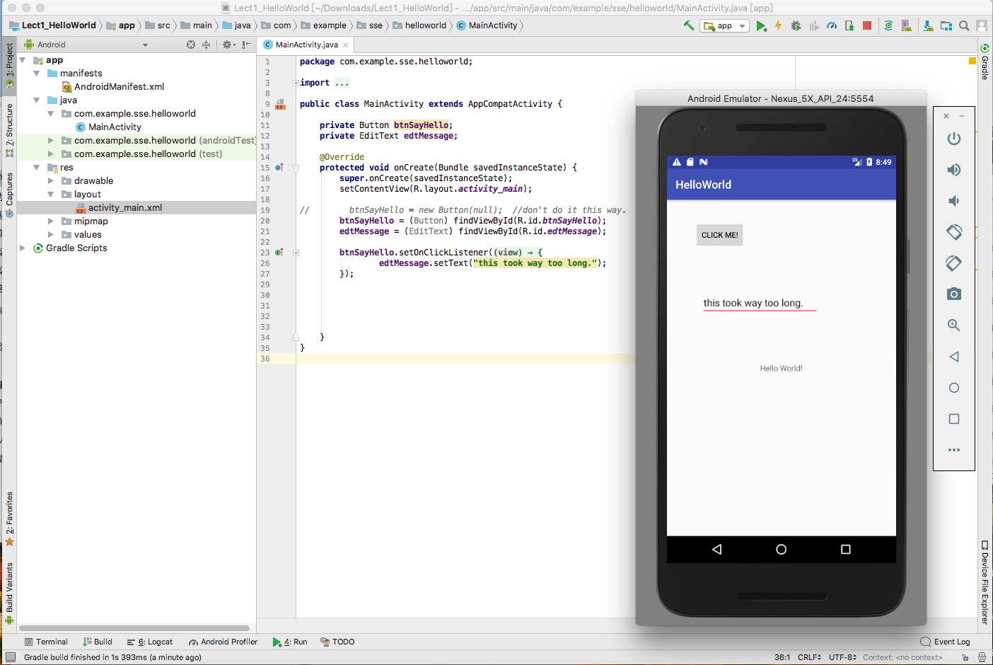

Change the *edtMessage* from “This is way too long.” to “Hello Mobile App Development!”. Screenshot is shown as below.

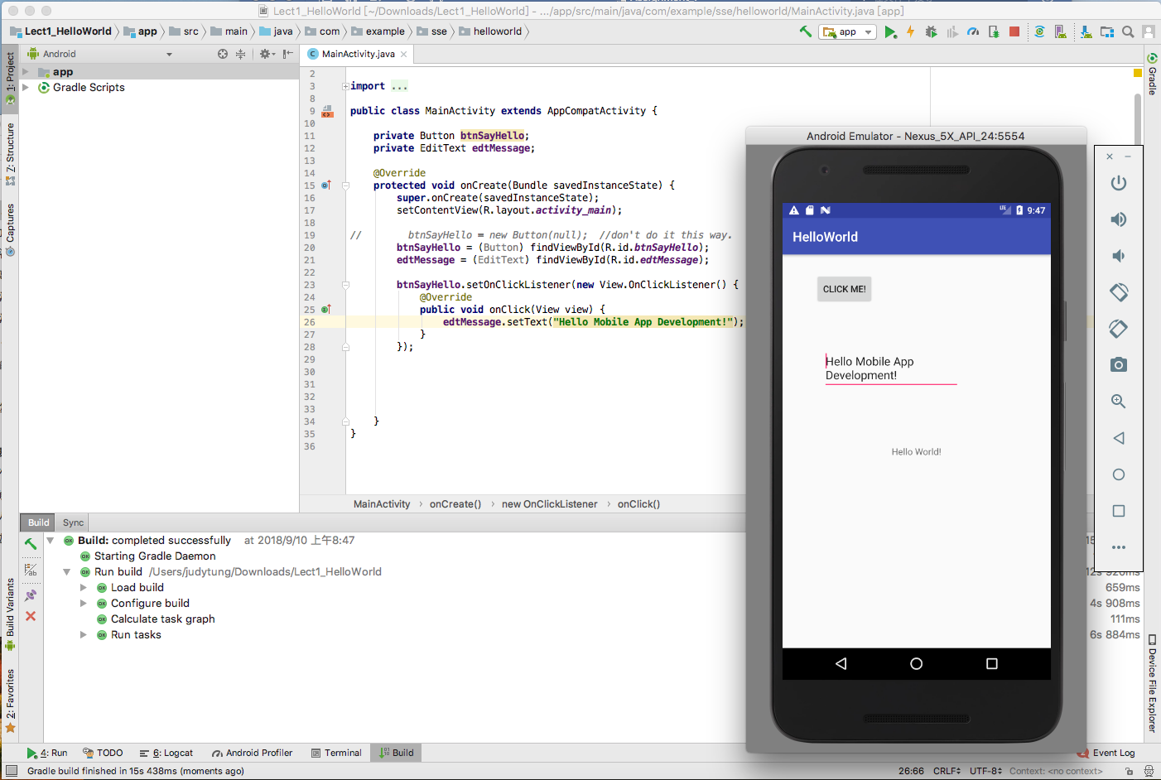

There are three .java file in *Lect1_HelloWorld*.

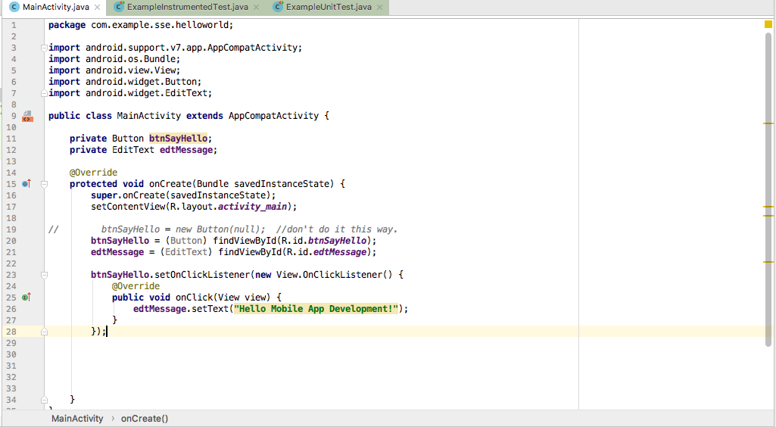

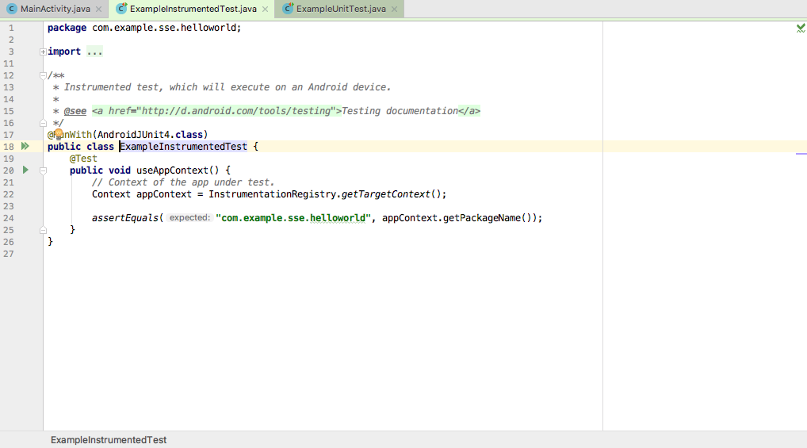

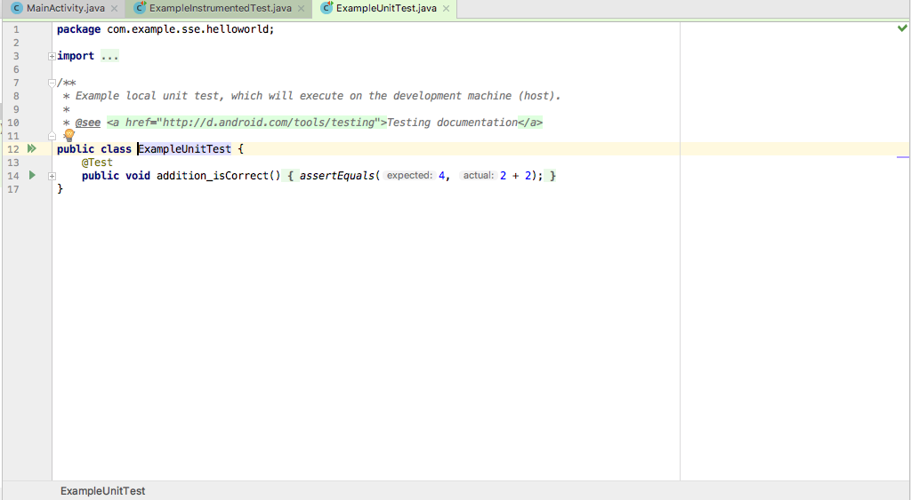

**Part 2.**

1. **List the various sensors and devices on typical Mobile Phones**

Wi-Fi, Bluetooth, GPS, button, touch screen, microphone, GPU/CPU, battery, speaker, camera, light and so on.

1. **List five favorite Apps**

Instagram – Check others’ life and keep connecting with friends.

Netflix – Bunch of dramas and movies that I can watch.

YouTube – Lots of funny videos and great youtubers.

Spotify – The music recommend system is really great.

Venmo – Check splitting by using this app is really convenient and it won’t charge extra money.

1. **3 ideas for apps**

People reviewer – review other people on it can help strangers know each other easier.

AR notes – Use AR to take notes in different place, and can make it online to let others check it, such as taking notes and put it in a class room then other classmate can also see it through the camera.

AI Decision app – An app that can help users make decisions that base on their own personality.

1. **Could you do it better?**

Venmo – should add a function for ledger. And the ledger between each friend. And the social connection on Venmo is not strong enough.

**App Design Challenges**

1. **Emergency Response App**

On this app there should have a few buttons such as “I need help”, “emergency” and “show me the way”. The function of these buttons is shown as below:

1. “I need help”: After pressing this button, it will show all the police station, hospital, fire department, BU police department and BU safety department that around user on the map and will show the information such as phone number on the screen, and can call through the app.
2. “emergency”: Whenever a user feels any danger, press this button. After pressing this button this app will start to track user’s location and upload it to the database every second. And if something bad happen on the user, police can download the user’s last track to find clues.
3. “show me the way”: After pressing this button, user will enter the address of the destination and this app will show the safest way and safest route to get there.

Also, this app should have voice recorder and camera to let user record their voice, filming and take pictures.

1. **Contractor for You**

For this app, the security is very important cause there will be lots of personal information be stored in the app and in the database.

On this app, there will show the reviews, rating, experience and some other details of each contractor. And the user can choose which contractor they want to hire and do their work through this app. To achieve this goal, there are some functions that need to be done.

1. Texting: Users and contractor can send message and documents to each other through the app.
2. Calling: Users and contractor can also call to each other through the app.
3. Scanning: User and contractor can scan their paper work by using camera in this app.
4. **Scenario 1: “Dial a Sentence”**

On this app, user can add others as friend and can send text message and voice chat with friends through this app. And can invite maximum 5 friends to start a competition or randomly match and play with other users online. During the game, the app should have natural-language user interface to recognize if the user says the right word, and users will get bonus point if they say a sentence instead of a word. After a competition, the system will grade the user and the level of user. So, next time, the system will match user to play with other users that are in the same level, and the words that appear in the game will also depends on the level of user.