**CS542 Machine Learning**

**Homework 2**

**Chih Wei Tung (U17550453)**

**3.3**

$ED\left(w\right)=\frac{1}{2}\sum_{n=1}^{N}{{r_{n}\{t_{n}-w^{T}ϕ(x_{n})\}}^{2}}$

$∇E_{D}\left(w\right)=\sum_{n=1}^{N}{r_{n}\{t_{n}-w^{T}ϕ(x_{n})\}ϕ{(x_{n})}^{T}}$

$0=\sum_{n=1}^{N}{r_{n}t_{n}ϕ{(x_{n})}^{T}}-\sum_{n=1}^{N}{w^{T}ϕ(x_{n})ϕ{(x_{n})}^{T}}$

$⇒\sum_{n=1}^{N}{w^{T}ϕ(x_{n})ϕ{(x_{n})}^{T}}=\sum_{n=1}^{N}{r_{n}t_{n}ϕ{(x_{n})}^{T}}$

$ϕ={(ϕ_{0}, ϕ_{1}⋯, ϕ_{m-1})}^{T}$

$⇒\sum_{n=1}^{N}{w^{T}(ϕ_{0}, ϕ_{1}⋯, ϕ_{m-1}){({(ϕ_{0}, ϕ_{1}⋯, ϕ_{m-1})}^{T})}^{T}}=\sum_{n=1}^{N}{r_{n}t_{n}ϕ{(x_{n})}^{T}}$

$r_{1},⋯, r_{n}$ $⇒$ represented by a diagonal matrix

Use the summing from 1 to N ${({(ϕ_{0}, ϕ_{1}⋯, ϕ_{m-1})}^{T})}^{T}⇒Φ$

${w^{T}Φ}^{T}RΦ =\sum_{n=1}^{N}{r_{n}t_{n}ϕ{(x_{n})}^{T}}$

$=\sum_{n=1}^{N}{r_{n}t_{n}ϕ{({(ϕ_{0}, ϕ_{1}⋯, ϕ_{m-1})}^{T})}^{T}}$

$w^{T}=Φ^{T}Rt$

$=Φ^{-1}R^{-1}{(Φ^{T})}^{-1}Φ^{T}Rt$

$={(RΦ)}^{-1}{(Φ^{T})}^{-1}Φ^{T}Rt$

$w^{*}={(Φ^{T}RΦ)}^{-1}Φ^{T}Rt$

(i) Data dependent noise variation $r_{n}$ can be seen as an inverse variance parameter to a data point $(x_{n}, t_{n})$ which modifies the precision matrix

(ii) $r_{n}$ can be seen as an effective number of replicated observation of a data point $(x_{n}, t_{n})$

**3.11**

(3.59): $σ_{N}^{2}\left(x\right)=\frac{1}{β}+ϕ{\left(x\right)}^{T}S_{N}ϕ(x)$

$S_{N}^{-1} =S_{0}^{-1}+βΦ^{T}Φ$

$=S_{0}^{-1}+β\sum_{n=1}^{N}{ϕ(x_{n}){ϕ(x_{n})}^{T}}$

$⇒S_{N+1}^{-1}= S_{0}^{-1}+β\sum_{n=1}^{N}{ϕ(x_{n}){ϕ(x_{n})}^{T}}$

$=S_{N}^{-1}+βϕ(x_{N+1}){ϕ(x_{N+1})}^{T}$

From (3.59)

$⇒σ_{N+1}^{2}\left(x\right) =\frac{1}{β}+ϕ{\left(x\right)}^{T}S_{N+1}ϕ(x)$

$=σ_{N}^{2}(x)+ϕ{\left(x\right)}^{T}(S_{N+1}-S_{N})ϕ(x)$

Set $M=S_{N}^{-1}$ and $\sqrt{β}ϕ(x_{N+1})$

$⇒S_{N+1} =S_{N}-\frac{βS_{N}ϕ(x_{N+1})ϕ{(x_{N+1})}^{T}(S_{N})}{1+βϕ{(x_{N+1})}^{T}S_{N}ϕ(x_{N+1})}$

$⇒σ_{N+1}^{2}\left(x\right)=σ_{N}^{2}\left(x\right)-\frac{β{ϕ\left(x\right)}^{T}S_{N}ϕ(x_{N+1})ϕ{\left(x_{N+1}\right)}^{T}S_{N}ϕ(x)}{1+βϕ{(x_{N+1})}^{T}S_{N}ϕ(x_{N+1})}$

$S_{N}$: positive definite

$S_{N}ϕ(x_{N+1})ϕ{(x_{N+1})}^{T}S_{N}$: positive semidefinite, nonnegative

$⇒σ_{N+1}^{2}\left(x\right)≤σ_{N}^{2}\left(x\right)$

**3.14**

$α=0$, $k\left(x, x^{'}\right)=ψ{\left(x\right)}^{T}ψ(x^{'})$

When $α=0$, ${S_{N}}^{-1}=βϕ^{T}Φ$

Since $ψ_{j}(x)$ is new orthonormal basis passing the same space

$⇒ψ\left(x\right)=Vϕ(x)$

V, matrix that represents the function that transforms original basis to the new one

(V has an inverse)

First, transform $Φ$ to the new orthonormal basis

$⇒ΦV^{T}=Ψ$

$⇒Φ=Ψ{{(V}^{T})}^{-1}$

$⇒{S_{N}}^{-1}=βϕ^{T}Φ$

$⇒S_{N}={(βϕ^{T}Φ)}^{-1}$

$={β^{-1}(ϕ^{T}Φ)}^{-1}$

$=β^{-1}{({\left(Ψ{{(V}^{T})}^{-1}\right)}^{T}\left(Ψ{{(V}^{T})}^{-1}\right))}^{-1}$

$=β^{-1}{\left(Ψ{{(V}^{T})}^{-1}\right)}^{-1}{{(\left(Ψ{{(V}^{T})}^{-1}\right)}^{T})}^{-1}$

$=β^{-1}({\left({{(V}^{T})}^{-1}\right)}^{-1}Ψ^{-1}){({\left({{(V}^{T})}^{-1}\right)}^{T}Ψ^{T})}^{-1}$

$=β^{-1}((V^{T}Ψ^{-1}){{(Ψ}^{T})}^{-1}V)$

${=β}^{-1}(V^{T}V)$

$⇒ K\left(x, x^{'}\right)=βϕ{\left(x\right)}^{T}S_{N}ϕ(x^{'})$

$=βϕ{\left(x\right)}^{T}β^{-1}(V^{T}V)ϕ(x^{'})$

$=ϕ{(x)}^{T}(V^{T}V)ϕ(x^{'})$

Apply $ϕ$ to linear transformation $V$ and $V^{T}$

$⇒ K\left(x, x^{'}\right)=ψ{(x)}^{T}ψ(x^{'})$

$⇒\sum_{n=1}^{N}{k(x,}x_{n})=\sum_{n=1}^{N}{ψ{(x)}^{T}ψ(x_{n})}$

$=\sum_{n=1}^{N}{\sum_{i=1}^{M}{ψ_{i}{(x)}^{T}ψ_{i}}(x_{n})}$

Use 3.115

$⇒\sum_{n=1}^{N}{k(x,}x_{n})= \sum_{i=1}^{M}{ψ_{i}(x_{n})ψ_{i}(x_{n})}=1$

**3.21**

Let $A$ be real, symmetric matrix $A$

The transformation of $A$ can be recreated by multiplying the original vector by

constant $λ_{i}$

Let $\{u_{i}\}$ be the set of orthonormal vectors

$⇒Au_{i}=λ_{i}u_{i}$

$⇒\ln\left|A\right|=\ln{\prod_{i=1}^{M}{ λ_{i}}}$

$=\sum_{i=1}^{M}{\ln{λ_{i}}}$

$α$: random optimized value

$⇒\frac{δ\ln\left|A\right|}{δα}=\sum_{i=1}^{M}{\frac{1}{λ_{i}}\frac{δλ_{i}}{δα}}$

Recreate matrixes and their inverse with their eigenvalues

$A=\sum_{i=1}^{M}{λ_{i}u_{i}{u_{i}}^{T}}$

$A^{-1}=\sum_{i=1}^{M}{\frac{1}{λ_{i}}u_{i}{u_{i}}^{T}}$

$⇒\frac{δ}{δα}A=\sum_{i=1}^{M}{\frac{δλ_{i}}{δα}}u_{i}{u_{i}}^{T}+λ_{i}(\frac{δu_{i}}{δα}{u_{i}}^{T}+u_{i}{\frac{δu_{i}}{δα}}^{T})$

If length of $u_{i}$ is always constant

$⇒$ the derivative of a vector is orthogonal to the vector

$⇒u_{i}\left(\frac{δu_{i}}{δα}\right)=0$

$⇒\frac{δ}{δα}A=\sum_{i=1}^{M}{\frac{δλ_{i}}{δα}}u_{i}{u_{i}}^{T}$

$⇒Tr\left(A^{-1}\frac{δ}{δα}A\right)=Tr(\sum_{i=1}^{M}{\frac{1}{λ_{i}}u_{i}{u_{i}}^{T}}\sum_{j=1}^{M}{\frac{δλ_{j}}{δα}}u_{j}{u_{j}}^{T})$

$=tr(\sum_{i=1}^{M}{\sum_{j=1}^{M}{\frac{1}{λ_{i}}\frac{δλ_{j}}{δα}u_{i}{u_{i}}^{T}u_{j}{u_{j}}^{T}}})$

Multiplication of orthogonal vectors = 0, $\sum_{i=1}^{M}{u_{i}{u_{i}}^{T}=I}$

$⇒Tr\left(\frac{1}{λ_{i}}\frac{δλ_{j}}{δα}\right)=\sum_{i=1}^{M}{\frac{1}{λ_{i}}\frac{δλ_{j}}{δα}}$

$\ln\left(t | α, β\right)=\frac{M}{2}\ln{α}+\frac{N}{2}\ln{β}-Ε\left(m_{N}\right)-\frac{1}{2}\ln\left|A\right|-\frac{N}{2}\ln{(2π)}$

$⇒\frac{d\ln\left(t | α, β\right)}{α}=\frac{M}{2}\frac{1}{α}-\frac{1}{2}m_{N}^{T}m_{N}-\frac{1}{2}Tr(A^{-1}\frac{d}{dα}A)$

$=\frac{1}{2}(\frac{M}{α}-m_{N}^{T}m_{N}-Tr(A^{-1}\frac{d}{dα}A))$

${A=S}_{N}^{-1}$

$⇒\frac{d}{dα}A=1$

$⇒\frac{d\ln\left(t | α, β\right)}{α}=\frac{1}{2}(\frac{M}{α}-m_{N}^{T}m_{N}-Tr(A^{-1}))$

$=\frac{1}{2}(\frac{M}{α}-m_{N}^{T}m_{N}-\sum{\frac{1}{λ_{i}+α}})$

$⇒$ 3.117 can be used to derive 3.92

**2(a)**

Before finding the third variable in determining HOM, we must to create a matrix with size of 1*13 that fill it with 1 and combine it with FTP and WE $⇒$ [1, FTP, WE] (Matrix1)

The way to find the third variable in determining HOM is shown as below:

1. Combine the matrix of targeted variable with Matrix1 $⇒$ [1, FTP, WE, variable] (Matrix2)
2. Get the lowest error for each variable:
3. Get the sum of (Matrix2*((((Matrix2')*Matrix2)^(-1))*(Matrix2')*HOM))-HOM
4. Lowest error will be “sum/(2*13)”
5. Find the index of the minimum value from Step 2
6. The minimum of those lowest error is LIC, so **LIC is the third variable in determining HOM**.

The errors of each variables can be seen as below:

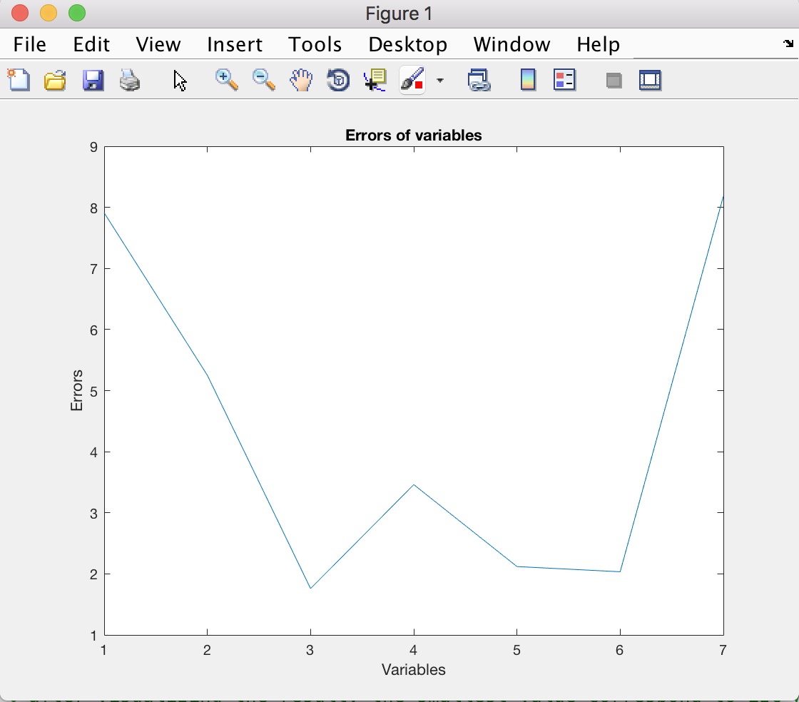

**2(b)**

1. The unknown non-number features are replaced by the median value of all the other features. And the unknown number features are replaced by label-conditioned mean (sum of the feature of “+” or “-“ / number of ”+” or “-“).
2. Accuracy Table

|  |  |  |
| --- | --- | --- |
| K value | Lenses | CRX |
| 1 | 5/6 = 83.33% | 114/138 = 82.6% |
| 2 | 4/6 = 66.66% | 113/138 = 81.88% |
| 3 | 5/6 = 83.33% | 113/138 = 81.88% |
| 5 | 3/6 = 50% | 117/138 = 84.78% |
| 10 | 3/6 = 50% | 119/138 = 86.23% |
| 100 | 3/6 = 50% | 108/138 = 78.26% |
| 300 | 3/6 = 50% | 97/138 = 70.28% |
| 500 | 3/6 = 50% | 83/138 = 60.14% |

PS. I couldn’t generate executable file for both of the program of problem 2. But the first one works on MATLAB app, and the second one works with standard commands (python xxx.py ….)