**CS542 Machine Learning**

**Homework 5**

**Chih Wei Tung (U17550453)**

**8.3**

$p(a, b)≠p\left(a\right)p(b)$

But $p\left(a, b\left|c\right.\right)=p\left(a\left|c\right.\right)p\left(b\left|c\right.\right)$ for $c=0$ and $c=1$

By the summation rule: $p\left(a, b\right)=\sum_{c∈\{0, 1\}}{p(a, b, c)}$

$⇒p\left(a\right)=\sum_{b∈\{0, 1\}}{\sum_{c∈\{0, 1\}}{p(a, b, c)}}$, $p\left(b\right)=\sum_{a∈\{0, 1\}}{\sum_{c∈\{0, 1\}}{p(a, b, c)}}$

The rule of conditional probability applying the product: $p\left(c, a, b\right)=p\left(a, b\left|c\right.\right)p(c)$

$⇒p\left(a, b\left|c\right.\right)=\frac{p(a, b, c)}{\sum_{a∈\{0, 1\}}{\sum_{b∈\{0, 1\}}{p(a, b, c)}}}$

Use similar technique:

$p\left(a\left|c\right.\right)=\frac{\sum_{b∈\{0, 1\}}{p(a, b, c)}}{\sum_{a∈\{0, 1\}}{\sum_{b∈\{0, 1\}}{p(a, b, c)}}}$ and $p\left(b\left|c\right.\right)=\frac{\sum_{a∈\{0, 1\}}{p(a, b, c)}}{\sum_{a∈\{0, 1\}}{\sum_{b∈\{0, 1\}}{p(a, b, c)}}}$

**8.4**

$p\left(a, b, c\right)=p(a)p\left(c\left|a\right.\right)p\left(b\left|c\right.\right)$

The value of $p(a)$ and $p\left(b\left|c\right.\right)$ were computed as follow:

|  |  |
| --- | --- |
| $$a$$ | $$p(a)$$ |
| 0 | 0.600 |
| 1 | 0.400 |

|  |  |  |
| --- | --- | --- |
|  |  |  |
| 0 | 0 | 0.800 |
| 0 | 1 | 0.400 |
| 1 | 0 | 0.200 |
| 1 | 1 | 0.600 |

Use the rule of product:

|  |  |  |
| --- | --- | --- |
|  |  |  |
| 0 | 0 | 0.400 |
| 0 | 1 | 0.600 |
| 1 | 0 | 0.600 |
| 1 | 1 | 0.400 |

$⇒$ $⇒$ Multiply all the value

$⇒$ $p\left(a, b, c\right)=p(a)p\left(c\left|a\right.\right)p\left(b\left|c\right.\right)$

$⇒$ Corresponding directed graph:

b

c

a

**8.11**

$P\left(D=1\left|G=1\right.\right)=0.900$ and $P\left(D=0\left|G=0\right.\right)$

Use Bayse Theorem and marginalizing:

$P\left(F=0\left|D=0\right.\right)=\frac{P\left(D=0\left|F=0\right.\right)P(F=0)}{P(D=0)}$

$P\left(D=0\left|F=0\right.\right)=\sum_{B, G}{P\left(D=0\left|G\right.\right)P\left(G\left|B, F=0\right.\right)P(B)}$

$=0.748 (74.8\%)$

$P\left(D=0\right)=\sum_{B, G, F}{P\left(D=0\left|G\right.\right)P\left(G\left|B, F\right.\right)P(B)P(F)}$

$=0.352 (35.2\%)$

$⇒P\left(F=0\left|D=0\right.\right)=0.213 (21.3\%)$

$⇒P\left(F=0\left|D=0, B=0\right.\right)=0.11 (11\%)$

**8.14**

The energy function is $E\left(x, y\right)=h\sum_{i}{x_{i}}-β\sum_{ij}{x_{i}x_{j}}-v\sum_{i}{x_{i}y_{i}}$ where $n, h, β≥0$ and $x_{i}, y_{i}∈\{-1, 1\}$

Set $h= β=0$ $⇒$ $E\left(x, y\right)=-N\sum_{i}{x_{i}y_{i}}$

When the energy is the lowest, the probable configuration will be the most.

When the negative sign in form of $N$ stays, can only happen if $x_{i}$ and $y_{i}$ are both 1 or both negative.

$⇒$ $x_{i}=y_{i}$ for all $i$

**Programming**

1. First change the image to gray scale, then do the calculation.

**Before: After:**

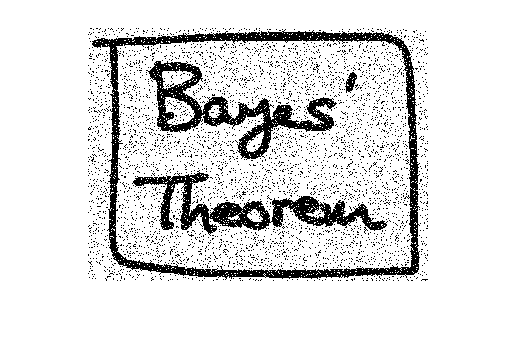 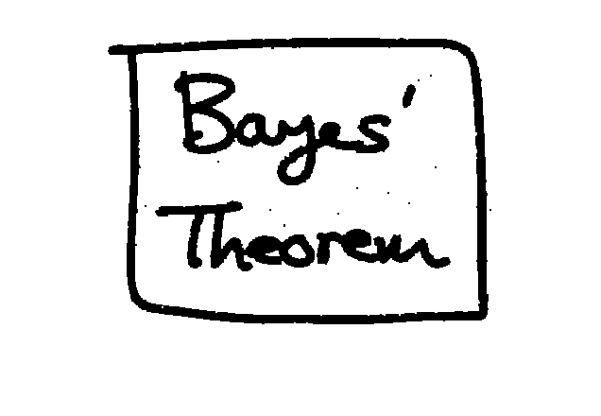

When $h=-.01$, $β=5$ and $η=3$, the accuracy I got is 99.38%

1. For this part, I incremented the pixel, decremented the pixel, or left the pixel the same. And from the pictures below, it’s obvious that the picture of the after one is much more better.

**Before: After:**

