**CS542 Machine Learning**

**Homework 5**

**Chih Wei Tung (U17550453)**

**Programming**

1. First change the image to gray scale, then do the calculation.

**Before: After:**

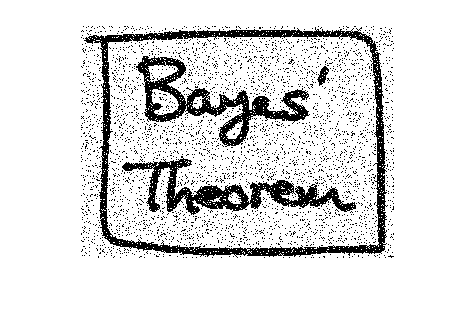 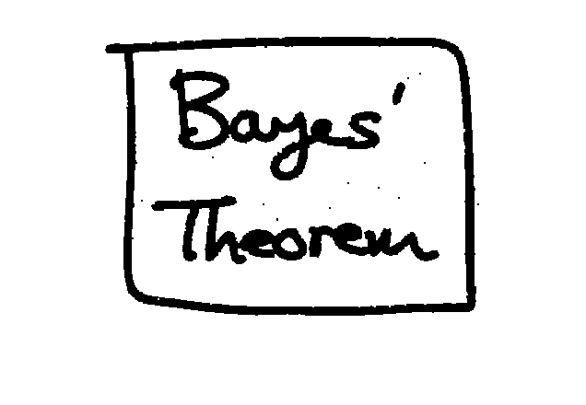

When $h=-.01$, $β=5$ and $η=3$, the accuracy I got is 99.38%

1. For this part, I incremented the pixel, decremented the pixel, or left the pixel the same. And from the pictures below, it’s obvious that the picture of the after one is much more better.

**Before: After:**

