**Question 1**

(**6 points**)

You are asked to write a window form application which allow user manage corporations.

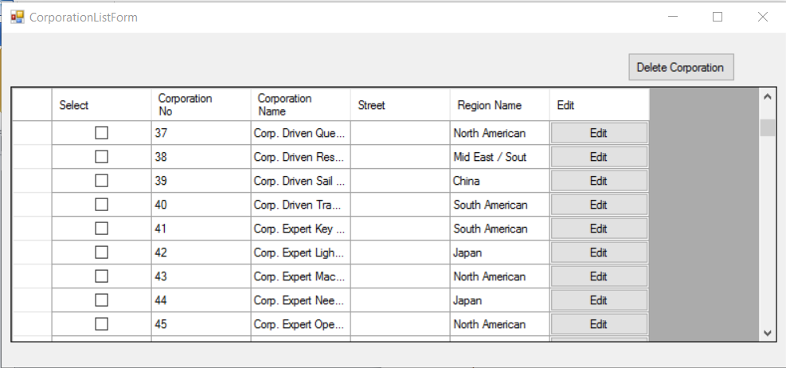

Figure 1: List Corporation Screen

Your tasks include several of following steps:

* The first form like above picture **(0.5 point).**
* List of corporation was loaded from database and show on the datagridview **(1 point).**
* In the datagridview, you must add one DatagridviewCheckboxColumn and one DatagridviewButtonColumn like the picture. **(0.5 point)**
* User will delete corporations by select check box in the first column and then click on Delete button. If no corporation is selected, show the MessageBox to tell to user message “You must select one corporation at least”. **(0.5 point)**
* If user select at least one corporation, delete these from database. **(0.5 point).**
* If delete successful, please show Message Box with message “Deleted x corporation(s).” with x is the number of deleted corporations. **(1 point).**
* When user click on the Edit button in the last column, the new form was loaded for editing information of corporation. The edit form must like below picture **(0.5 point).**

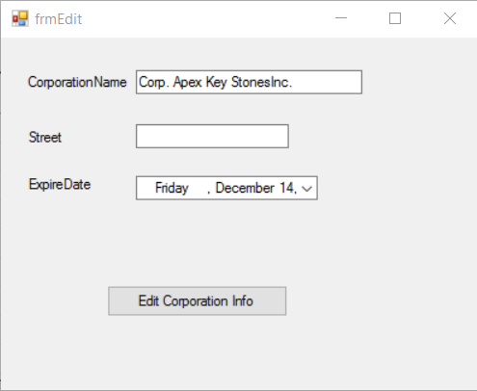

Figure 2: Edit Corporation Info Screen

* The current information of corporation that user want to edit must was loaded into the form. **(0.5 point).**
* If Corporation Name are satisfied, edit information for this corporation and show the MessageBox to tell user about success **(0.5 point).**
* After edit successful, close this form and refresh data on list corporation form. **(0.5 point).**

**Note:** (**0 will be given to the work that not using database connection string in App.config)**

**Question 2**

(**4 points**)

You are asked to write a Webform application which allow user filter the corporations according the selected region and then add new member information into database . (**0 will be given to the work that not using database connection string in Web.config)**

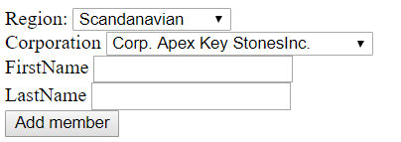

Figure 2: Add Member Screen

* The page has two DropdownList. The data of first dropdown list will be loaded from region values in Region table in database. The first item was selected by default. (**1 point**)
* According the region selected in first dropdown list by the user, the corporations of this region will be loaded in the second DropdownList. **(0.5 point)**
* Every time the region selected changes, list corporation changes accordingly. **(0.5 point).**
* After select region, corporation, fill firstname and lastname, user can click on “Add member” to add information of new member into database. **(1 point)**.
* The issue date of new member must be the next day from the day of present moment and the expiration date must be 6 months later than issue date. **(0.5 point).**
* If add member successful, please show the message “Added successful” below “Add member” button. **(0.5 point)**