**INSTRUCTIONS**

**Please read the instructions carefully before doing the questions.**

* You can use materials in your computer, notebook and text book.
* You are **NOT allowed** to use any device to share data with others.

Beside the above conditions, students must follow the following requirements**:**

1. **The work must complete by using Visual Studio 2019**
2. **The .NET Framework must be 3.5**
3. Create a folder named **RollNo_Name_PRN292 (1) ,** e.g.01245_LongNT_PRN292.
4. **THIS PART IS VERY IMPORTANT, PLEASE READ IT CAREFULLY AND FOLLOW THE INSTRUCTIONS.**

* **For each question create an individual Visual Studio Solution with corresponding name to the question. For example: Question 1 – you will have to create Solution named Q1 (sln file) that contains project Q1 (csprj file)**
* **You are given a database script (.sql file) in Zip file. Execute the script before doing these questions**
* **For Question related to webform, you have to create Web Application instead of Website.**
* **You are not allowed to use SqlDataSource.**
* **Just one of above requirements is violated, your work will be considered as invalid.**

On completion, submit the **whole folder** (1).

**Question 1:**[ac7463ef-1397-45e8-bb00-6f7ed230bb16]

(**4.5 points**)

You are asked to write a window form application that has only one form. **(0 will be given to the work that not using database connection string in App.config file)**

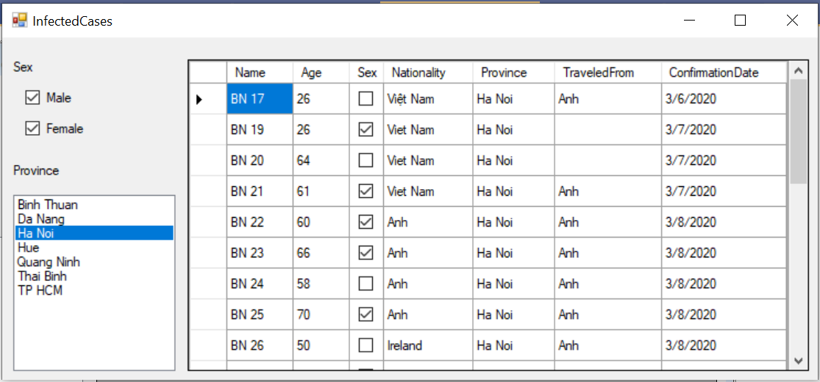

Figure 1 – The design of requirement form.

Your tasks include several of following steps:

* The form must like Figure 1 above, that has: two CheckBox, one ListBox and one DataGridView controls. (**0.5 point**)

The ListBox must enable multiselect mode. **(0.5 point)**

* In the ListBox, show all **distinct** provinces that appear in InfectedCases table in database. (**1 point**)
* By default, both CheckBoxes are checked, the item ‘**Ha Noi**’ of ListBox is selected. (**0.5 point**)
* In DataGridView, list all data about infected cases of nCov-2019 in selected provinces of selected gender. (Only show properties like in the Figure 1.) (**1 point)**

Note: In database, the Sex property get true if the person is male, otherwise female.

* Whenever user changes the checked state of two CheckBoxes or selected items in the ListBox, data in the DataGridView changes accordingly. (**1 point**)

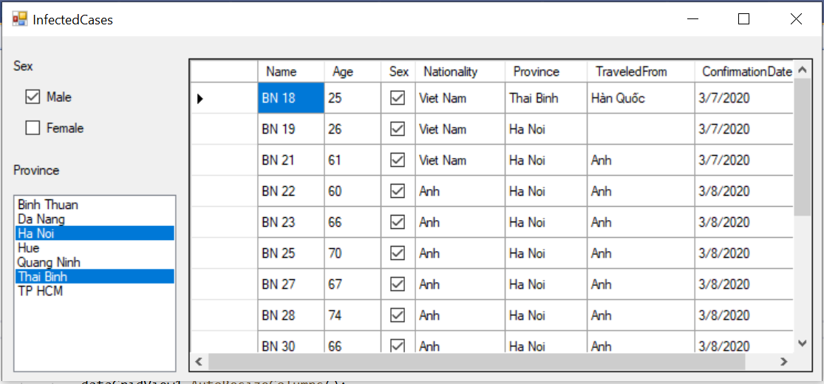

Figure 2 – Data in the DataGridView changes according to selection value of controls.

**Question 2:**[13cce5c7-2388-41d7-89fb-93cceb26902b]

(**5.5 points**)

You are asked to write a Webform application that allows users to enter information about new nCov-19 infected case in VietNam.

In this question, only work with **InfectedCases** table in database.

(**0 will be given to the work that not using database connection string in Web.config file)**

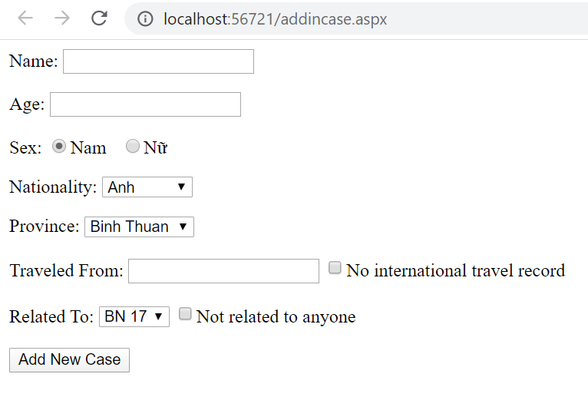

Figure 1 – Required webform

* The page is designed as shown in Figure 1 (**0.5 point**).
* List all **distinct** nationalities in InfectedCase table into the first DropdownList. The first item of this list was selected by default. (**0.5 point**)
* List all **distinct** provinces in InfectedCase table into the second DropdownList. The first item of this list was selected by default. (**0. 5 point**).
* List names of all current infected cases into the third DropdownList. The first item of this list was selected by default. **(0.5 point)**
* If “No international travel record” CheckBox is checked, please disable the TextBox to enter “Traveled From” and vice versa. (**0.5 point**)
* Similarly, if “Not related to anyone” is checked, please disable the “Related To” DropdownList and vice versa. (**0.5 point**)

See Figure 2 below for a better understanding.

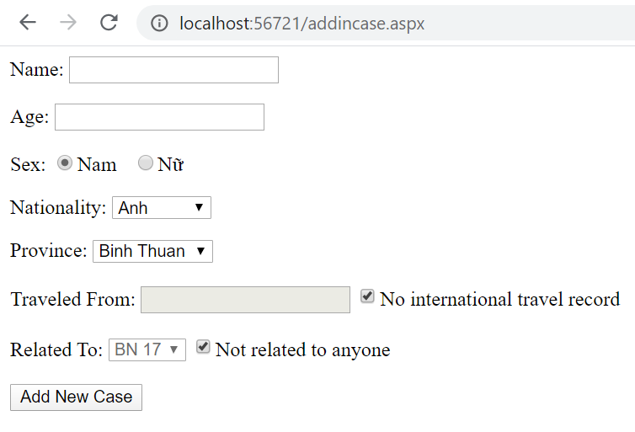

Figure 2 – Form in case two Checkboxes is checked.

* When user click on “Add New Case” Button, please check:
  + Name of infected case must not be blank.
  + Age of must be between 0 and 120.

by using validator controls. Show notification if user entered incorrect data like Figure below (1 point):

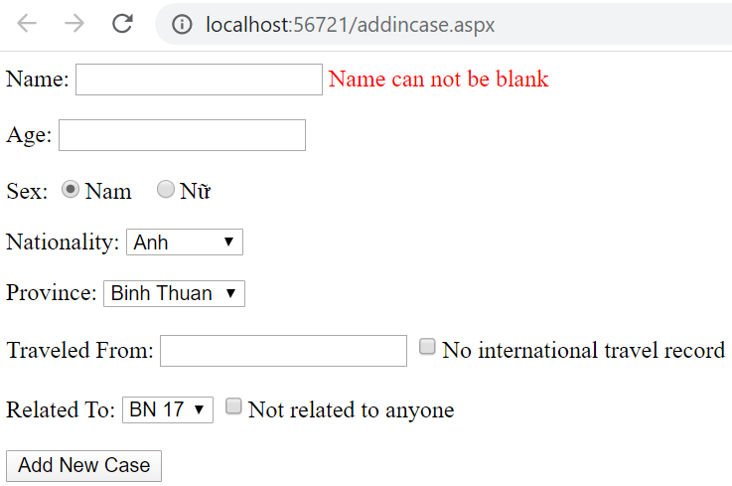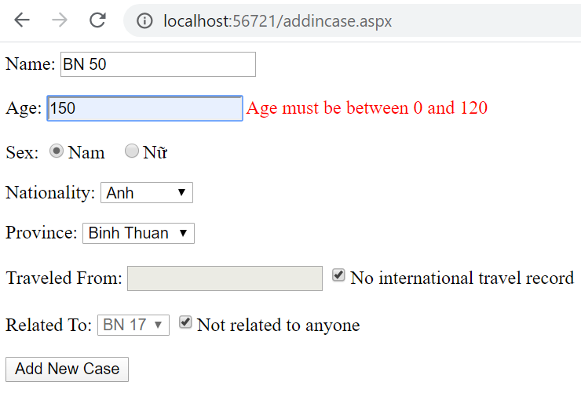

Figure 3 – Notification when user entered data not satisfied

* If all data satisfies the requirements, insert all of them into InfectedCases table in database. (**1 point**).

Note that:

* If “No international travel record” CheckBox is checked, use the NULL value for TraveledFrom property in table**. (0.5 point)**
* If “Not related to anyone” CheckBox is checked, use the NULL value for RelatedTo property.
* In database, the Sex property get true if the person is male, otherwise female.