(4 points)
You are given a database. Figure 1 describe the database structure.
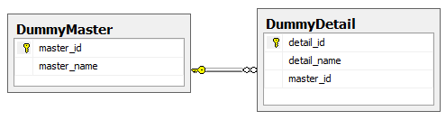
Figure 1: Dummy Database Schema
You are asked to write a Web form application which allow user filter the dummies. (0 will be given to the work that not using database connection string in Web.config)
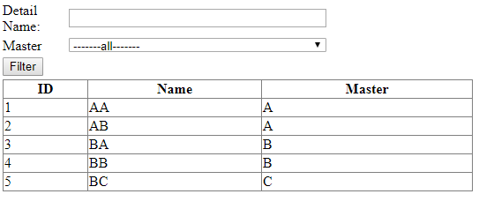
Figure 2: Search Screen
- Master is a Dropdown list, and its data will be loaded from [DummyMaster] Table. (1 point)
Note : -----alll------ is not a record in the table. (Reduce 0.5 point if student cannot add [all] as an item of the dropdown list)
- When user clicks on [Filter] button data will be loaded to the GridView such that: (3 point)
- IF Detail Name is blank, means users want to find all of DummyDetail without caring about its name. IF user fill text into Detail Name, means users want to find all of DummyDetail which have name contains value what they fill.
- If [all] is selected on the dropdownlist, means users want to find all of DummyDetail without caring about its master. IF another item is selected on the dropdownlist, means users want to find all of DummyDetail which belong to the corresponding master.
See below picture for more detail:
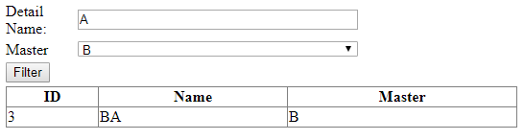
Figure 3: Filter Result
The filter result shows that: User want to find all of DummyDetail that have name contains [A] and belongs to Master [B].
Note: No point is given to this part if any of the condition is not satisfied.

