(3 points)
You are asked to write a window form application which allow user add ‘funny buttons’. The UI should look like below picture. Note that: textboxes are blank at the beginning. No color displayed, no button added to the panel.

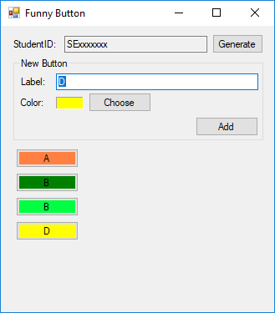
Figure 1: Funny Buttons Screen
Your tasks include several of following steps:
- StudenID field is read only, and its value will be generated when user clicks [Generate] button. The ID is your own student id (0.5 point).
- Following tasks should be done:
  - Label of the button cannot be blank (0.5 point).
  - Color of the button must be selected using build-in Color Dialog (Figure 2). Hint: Below code snippet shows the way to call the Color Dialog (0.5 point).
ColorDialog MyDialog = new ColorDialog();
// Keeps the user from selecting a custom color.
MyDialog.AllowFullOpen = false ;
// Allows the user to get help. (The default is false.)
MyDialog.ShowHelp = true ;
// Sets the initial color select to the current text color.
MyDialog.Color = textBox1.ForeColor ;
// Update the text box color if the user clicks OK
if (MyDialog.ShowDialog() == DialogResult.OK)
textBox1.ForeColor = MyDialog.Color;

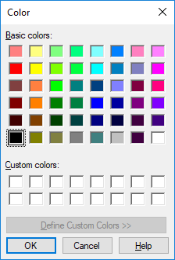
Figure 2: Build-in Color Dialog
  - When user clicks [Add] button in “New Button”, the new button will be added to the below FlowLayoutPanel (0.5 point).
  - The FlowLayoutPanel’s Auto Scroll should be enabled (0.5 point).
- When user clicks Generated button. Display a build-in Message Box Dialog to show the label and RGB color code of the button. (0.5 point)
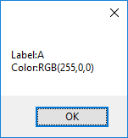
Figure 3: Build-in Message Box to display Button Info

