

Communication Network Analysis

# User Handbook

Version 1.1

Instructor: Dr. Robin Müller-Bady

Due date: February 9th, 2020

Semester: Winter 2019/2020

(This page intentionally left blank)

Table of Contents

1. Introduction 1

2. Overview 2

2.1 Conventions. 2

2.2 System Requirement 2

3. Getting Started 3

3.1 Launch the software. 3

3.2 Input *.graphml file 3

3.3 Accessing the Menu 4

4. Using the System 5

4.1 Graph Summary 5

4.2 Print vertices properties 5

4.3 Print edges properties 7

4.4 Check the connectivity 8

4.5 Print the diameter 8

4.6 Print the shortest path 9

4.7 Print the betweeness centrality 11

4.8 Export new *.graphml file 13

4.9 Exit 14

5. Error Messages 15

5.1 Wrong defined type of input 15

5.2 Error number 16

6. Getting addition support 17

6.1 Support 17

Appendix A: Record of Changes 18

Appendix B: Acronyms 19

Appendix C: References 20

## Introduction

Nowadays, the usage of network has been rapidly increased. In order to fulfill the demand of maintaining the network infrastructure, it is necessary to develop a program, which comprehensively collects and displays the information. This User Handbook is written to provide an overview and a guide for user to use the Communication Network Analysis (CNA) program effectively. Moreover, this is also a requirement for the course “Object Oriented Programming with Java” at the Frankfurt University of Applied Science.

## Overview

The CNA program is written in Java programming language in order to analysis the structure of the network through *.graphml file and output data relate to that network models. Besides, the program also needs to provide additional information such as the nodes, edges, connectivity, diameter, betweenness.

This user handbook includes program’s functions and step-by-step instructions for user to use and run a variety of task through the terminal.

### Conventions.

This document describes how to run the CNA program by providing the print-screen and the corresponding instruction for each step.

When an action is required for the user, it will start with the work “**User**:” at the beginning of that line. For example:

**User**: Enter … to the terminal.

Note: The term “user” is used to refer the person who uses or accesses to the CNA system.

### System Requirement

This program has been tested and run smoothly on Window 10 and MacOS 10.14.

To run this program, users must install Java on their computers, which can be downloaded on <https://www.java.com/en/download/> and Text-Editor which recommended is IntelliJ IDEA:

<https://www.jetbrains.com/idea/download/#section=windows>

It is suggested to download the newest version for both.

To install and run IntelliJ IDEA, the following video on Youtube is recommended:

<https://www.youtube.com/watch?v=2IqfF4WMKGc>

## Getting Started

### Launch the software.

User can start the program from the Command Line Interface (CLI) for processing using the following step:

Click on the Terminal in the IntelliJ IDEA and using the similar interface:



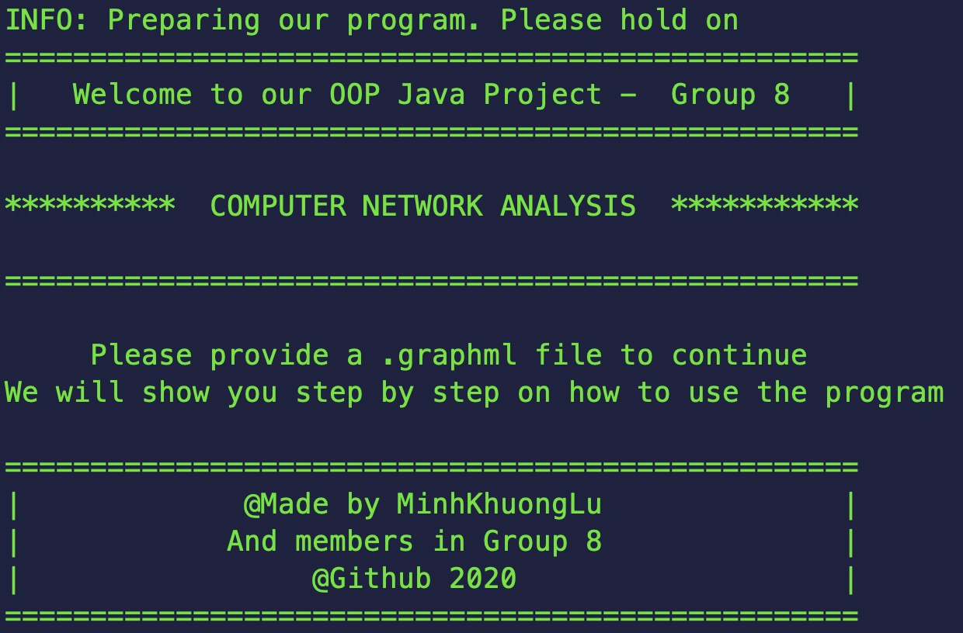

### Input *.graphml file

To insert the *.graphml file, user should follow these step

**User**: Enter “java -jar Final_Java_Project.jar *.graphml” in Terminal

Note: The program supports only *.graphml and *.xml file

*For example: To input the “small_graphl.graphml”*

**

## Using the System

In this section, step-by-step and detailed instructions are given to help users easily control and perform various functions and features of the CNA program through terminal to complete tasks.

### Graph Summary

To print out the number of edges and nodes of the input graph, user has to follow these steps:

**User:** Enter “java -jar Final_Java_Project.jar *.graphml” in Terminal

*For example:*



### Print vertices properties

To print out number of all edges pass an input vertex ID and the path of the edge, user has to follow these steps:

**User**: Enter *.graphml [-v vertex] to the terminal.

*For example:* Choose the vertex which ID is 4 from small_graph.graphml



Then hit “enter”

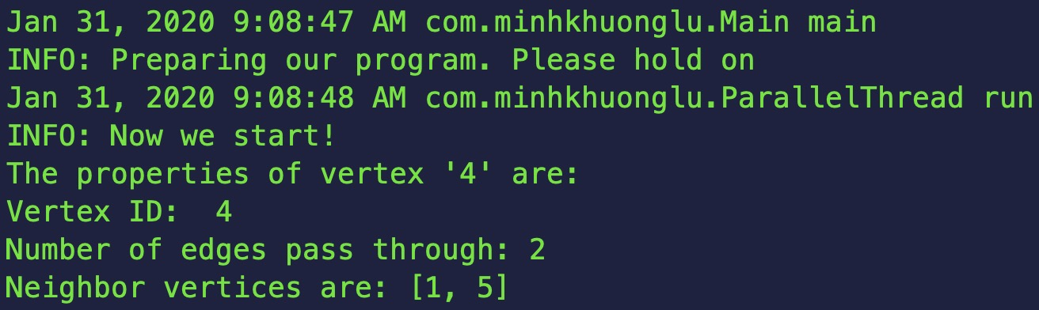

### Print edges properties

User can get edge ID, source, node that passed by, and weight of it through inputted edge by these following steps:

**User:** Enter *.graphml [-e vertex] to the terminal.

*For example: :* Choose the edge which ID is 4 from small_graph.graphml

**

Then click “enter”

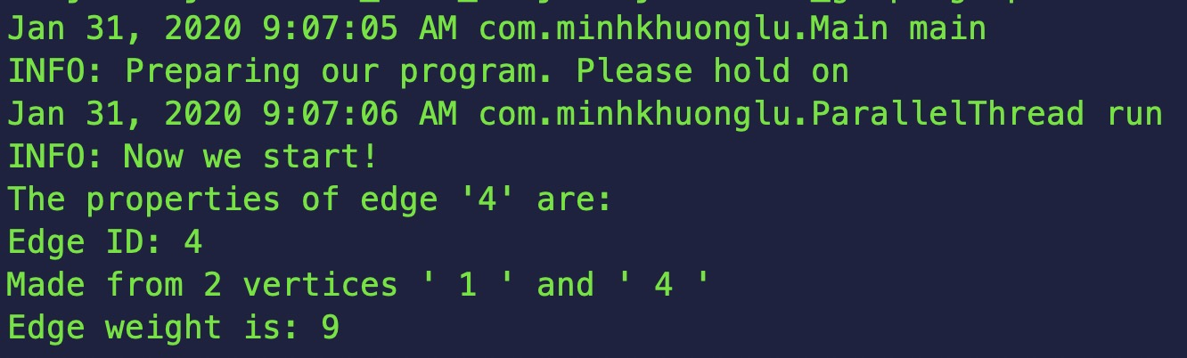

### Check the connectivity

In order to check the connectivity, user should follow these steps:

**User:** Enter “java -jar Final_Java_Project.jar *.graphml” in Terminal

*For example:* with the input graph is small_graph.graphml.xml



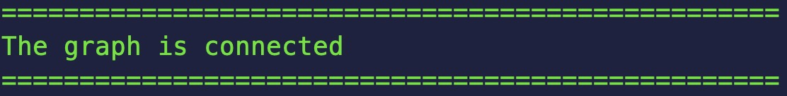

If the graph is not connected, the program will terminate. No further calculate can be calculated, due to lack of information when reading input file.

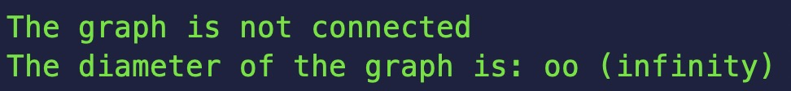

### Print the diameter

To print out the diameter, user should follow these steps:

**User:** Enter “java -jar Final_Java_Project.jar *.graphml” in Terminal

*For example:* with the input graph is small_graph.graphml.xml



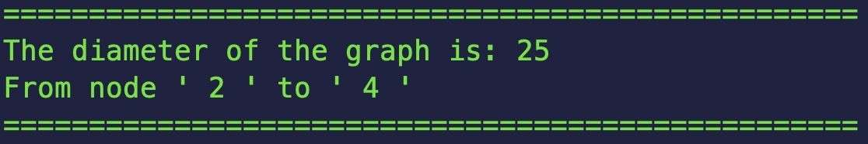

### Print the shortest path

To print out the number of shortest paths between 2 desired nodes, user should follow these steps:

**User:** enter *.graphml [-s vertex vertex] to the terminal.

*For example:* Starting node is: 2 and ending node is: 5



And the result is:

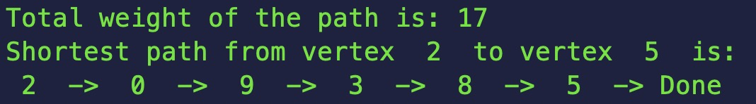

### Print the betweenness centrality

To calculate the betweenness centrality measure with a desired node, user should follow these steps:

**User:** enter *.graphml [-b vertex] to the terminal.

*For example:*

**

Then hit “enter”



### Export new *.graphml file

The software will execute all properties of the input graphml file into a new file, the new file can be saved in a specific folder which user can choose location for the file.

**User:** enter *.graphml [-a *.graphml] to the terminal.

*For example:*



The file is created successfully when you see this line:



### Exit

The program will automatically exit after each command.

## Error Messages

### Wrong defined type of input

If user input character(s) instead of number(s) in the field that requires number only such as vertices or edges, the program will show you how to fix it

When input with characters instead of number stands for vertices or edges. The system will close the option window and users have to input again



Then hit “enter”



### Error number

The input must be a positive number. If user tries to input a negative number, the program will



or user tries to input a number larger than total vertices, the program will



The required input must be positive number and smaller than the total number of vertices.

### Adding too many values or not enough values

For “-s” the user need to add 2 numbers, for “-b”, ”-v”, “-e” the user need to add 1 number, for “-a” the user need to add a *.graphml file.

If one of those requirements are broken, the user will get some help from the program

Example 1:



Example 2:

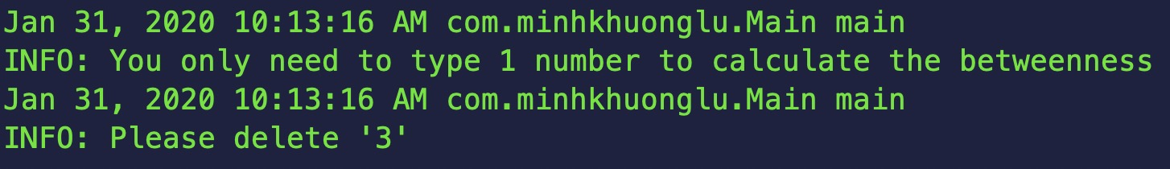

Example 3:

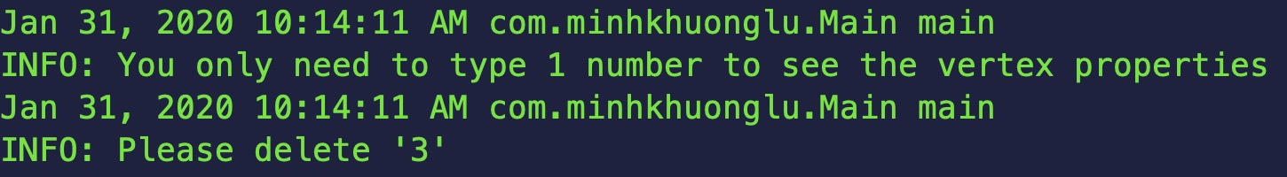

Example 4:

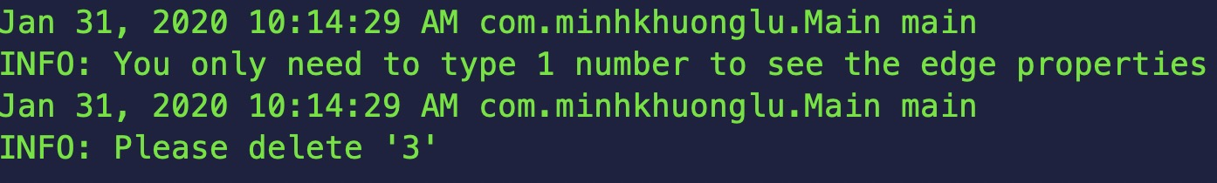

Example 5:

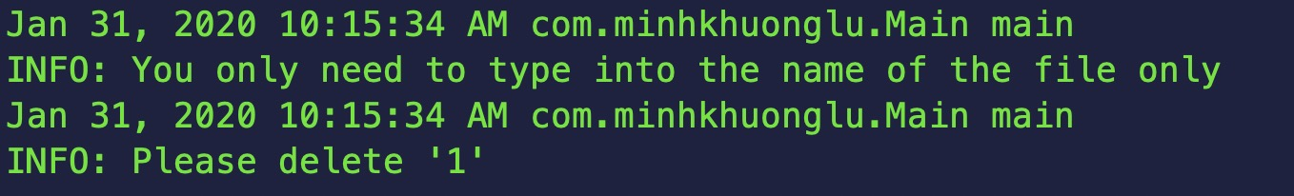

Example 6:



Example 7:



Example 8:

Example 9:



Example 10:



Example 11:



### Additional support

For additional support, please contact through the following info.

| Name | Organization | Email | Responsibility |
| --- | --- | --- | --- |
| Nguyen, Nguyen Tri | VGU | nguyentringuyencool[@gmail.com](mailto:phamgiabao@gmail.com) | Documentation |
| Thinh, Huynh Quang Phuoc | VGU | [yesphuocthinh451999@gmail.com](mailto:yesphuocthinh451999@gmail.com) | Documentation |
| Khuong, Lu Minh | VGU | [quyminhnguyen@gmail.com](mailto:quyminhnguyen@gmail.com) | Source code |
| Cong, Dang Chi | VGU | [cuongphatnguyen@gmail.com](mailto:cuongphatnguyen@gmail.com) | Source code |

Table 1 – Contact info

Appendix A: Record of Changes

| Version Number | Date | Author/Owner | Description of Change |
| --- | --- | --- | --- |
| 1.0 | 21/01/2020 | Nguyen, Nguyen Tri  Thinh, Huynh Quang Phuoc | Structure design |
| 1.1 | 30/01/2020 | Thinh, Huynh Quang Phuoc  Nguyen, Nguyen Tri | Fulfill all contents |

Table 2 - Record of Changes

Appendix B: Acronyms

| Acronym | Translation |
| --- | --- |
| CNA | Communication Network Analysis |
| CLI | Command Line Interface |
| ITJ | IntelliJ IDEA |

Table 3 - Acronyms

Appendix C: References

| Document Name | Document location or URL | Date |
| --- | --- | --- |
| Project Description | Description of Java project | 20/01/2020 |
| User Manual guide | <https://instrktiv.com/en/user-manual-template/> | 20/01/2020 |

Table 4 - Referenced Documents