PROJECT REQUIREMENT SPECIFICATION & DESIGN DOCUMENT
Phone Book Management System
Document Information
Project Name: Phone Book Management System
Document Type: Requirement Specification & Design Document
Version: 1.0
Date: 05/01/2026
Prepared by: Group 06

Revision History
Date | Version | Description | Author
05/01/2026 | 1.0 | Initial version created | Group 06
15/01/2026 | 1.1 | Updated functional requirements and use case descriptions
16/01/2026 | 1.2 | Added DFD Level 0 and DFD Level 1 diagrams | Group 06
17/01/2026 | 1.3 | Completed class diagram and data model design | Group 06
18/01/2026 | 1.4 | Added interface design (CLI) and import/export specification | Group 06
19/01/2026 | 1.5 | Final review, consistency check, and document refinement | Group 06

1. SPECIFIC REQUIREMENTS

1.1 Functional Requirements (FR)
FR-01 View Contact List
Users can view all contacts stored in the system.
• Inputs: None
• Outputs: List of contacts
• Pre-condition: System is running
• Post-condition: Contacts hiển thị trên console
FR-02 View Contact Detail
User can select a contact to view detailed information.
• Inputs: Selected contact
• Outputs: Contact detail console
• Pre-condition: Contact exists
• Post-condition: Contact details hiển thị
FR-03 Add Contact
User can add a new contact with required fields (full name, phone number). Optional: email, address, note, group(s).
• Validation: Phone not empty; unique phone; valid email if provided.
• Outputs: Contact added confirmation
• Pre-condition: System running
• Post-condition: New contact stored
FR-04 Update Contact
User can update an existing contact. Validation same as Add Contact.
• Outputs: Contact updated confirmation
• Pre-condition: Contact exists
• Post-condition: Contact updated in storage
FR-05 Delete Contact
User can delete a contact permanently. System must request confirmation before deleting.
• Outputs: Contact deleted confirmation
• Pre-condition: Contact exists
• Post-condition: Contact removed
FR-06 Mark/Unmark Favorite
User can mark a contact as favorite and remove it from favorite list.
• Outputs: Favorite status updated
• Pre-condition: Contact exists
• Post-condition: Favorite flag updated
FR-07 Search Contact
User can search contacts by keyword (name, phone number, email).
• Inputs: Keyword
• Outputs: Search result list
• Pre-condition: Contacts exist
• Post-condition: Results hiển thị
FR-08 Filter By Group
User can filter contacts by group.
• Inputs: Selected group
• Outputs: Filtered list
• Pre-condition: Group exists
• Post-condition: Filtered results hiển thị
FR-09 Sort Contact List
User can sort contact list by name (A-Z/Z-A), created date, updated date.
• Inputs: Sort option
• Outputs: Sorted list
• Pre-condition: List hiển thị
• Post-condition: List reordered
FR-10 Create Group
User can create a new group. Validation: Group name must be unique.
• Inputs: Group name
• Outputs: Group created confirmation
• Pre-condition: System running
• Post-condition: Group stored
FR-11 Update Group
User can rename or update group description.
• Inputs: Group info
• Outputs: Group updated confirmation
• Pre-condition: Group exists
• Post-condition: Group updated
FR-12 Delete Group
User can delete a group. Contacts remain, only group relation removed.
• Inputs: Selected group
• Outputs: Group deleted confirmation
• Pre-condition: Group exists
• Post-condition: Group removed
FR-13 Assign Contact to Group
User can assign a contact into one or more groups.
• Inputs: Contact + group(s)
• Outputs: Assignment confirmation
• Pre-condition: Contact & group exist
• Post-condition: Relationship stored
FR-14 Remove Contact from Group
User can remove a contact from a group.
• Inputs: Contact + group
• Outputs: Removal confirmation
• Pre-condition: Relationship exists
• Post-condition: Relationship removed
FR-15 Import Contacts
User can import contacts from TXT. System validates each record; invalid records are skipped and reported; duplicates handled by chosen policy.
• Inputs: TXT file
• Outputs: Import summary
• Pre-condition: File provided
• Post-condition: Contacts imported
FR-16 Export Contacts
User can export contacts to TXT. Export scope: all, by group, or by search results.
• Inputs: Format + scope
• Outputs: Export file
• Pre-condition: Contacts exist
• Post-condition: File generated

2. NON-FUNCTIONAL REQUIREMENTS (NFR)
NFR-01 Usability
Console interface (CLI) must be easy to understand for first-time users. CRUD operations must be completed within ≤ 3 steps/commands. Error messages must be clear and user-friendly.
NFR-02 Performance
Searching within 1000 contacts must complete in ≤ 5 seconds. CRUD operations must respond in ≤ 5 second.
NFR-03 Reliability
System must not lose data during normal operations and must ensure consistent storage.
NFR-04 Security
If multi-user login exists: Password stored in hashed form; Users can only access their own contact list.
NFR-05 Maintainability
The system must follow modular architecture (MVC/Layered). Code must be readable and well-documented.
NFR-06 Portability
System should run on Windows at minimum. Dữ liệu được lưu trong file TXT, dễ mang theo giữa các máy.

3. DATA FLOW DIAGRAM (DFD)

3.1 DFD Level 0 (Context Diagram)
Actors: User. System: Phone Book Management System. Data flows: Manage contacts, manage groups, search/filter, import/export.

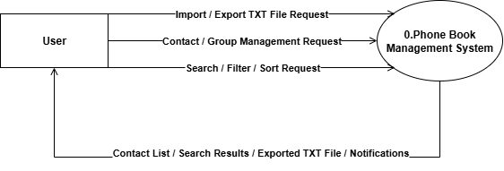

3.2 DFD Level 1
Processes: P1 Manage Contacts, P2 Manage Groups, P3 Search & Filter, P4 Import/Export. Data Stores: D1 Contact TXT file storage, D2 Group TXT file storage.
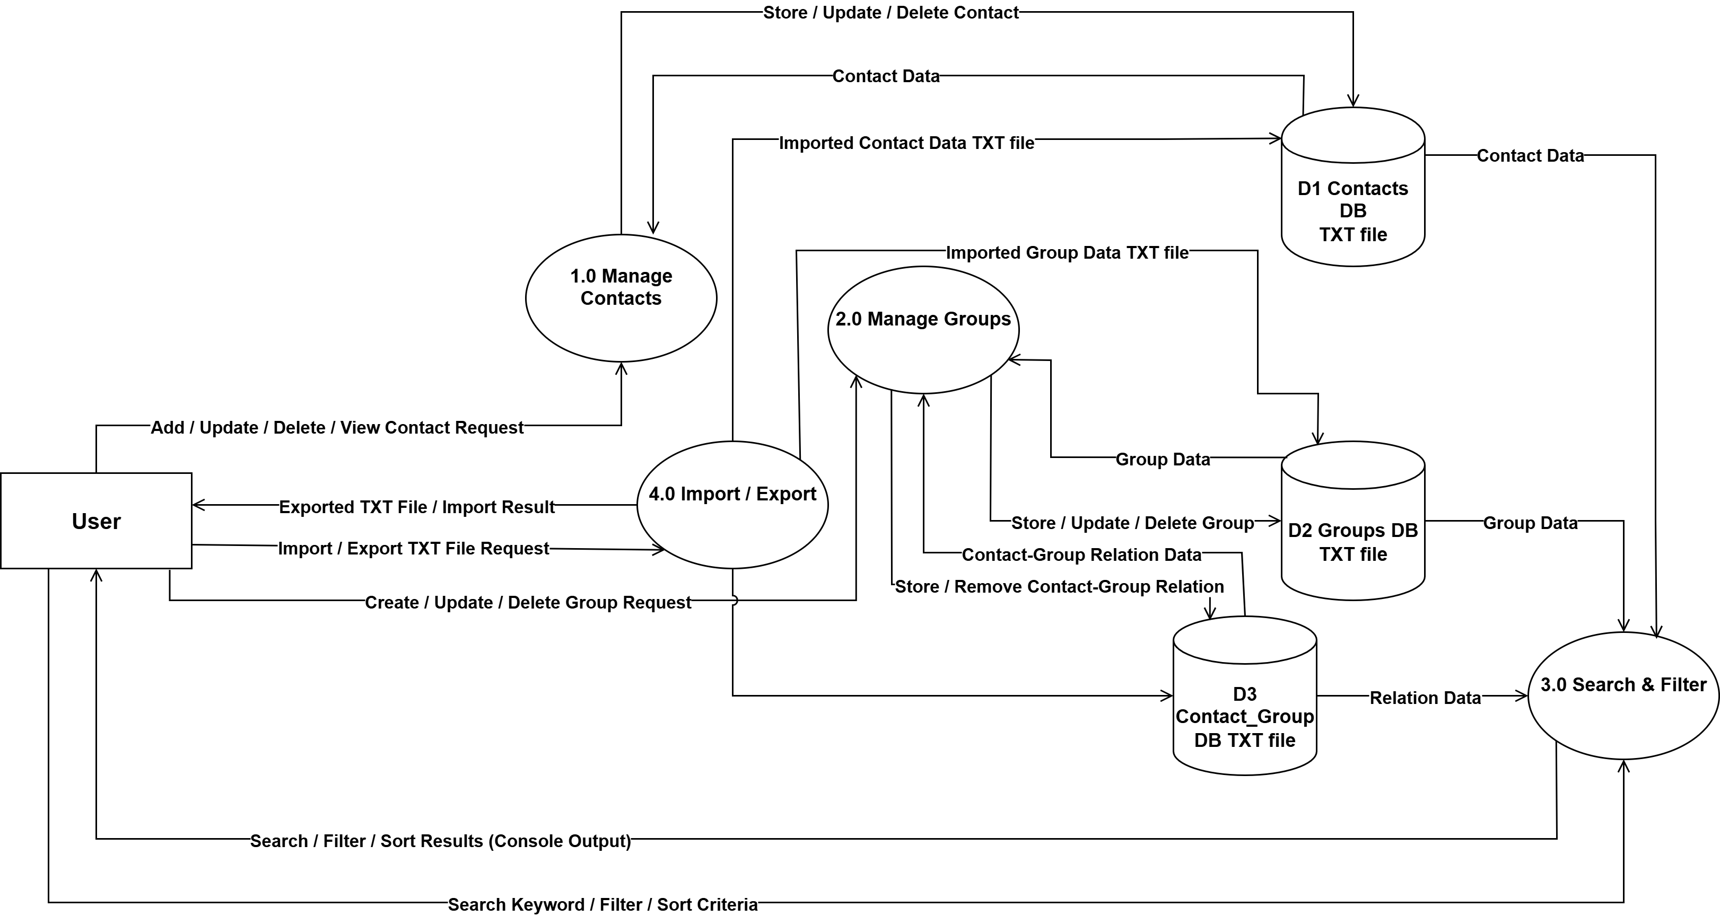

4. USE CASE DIAGRAM
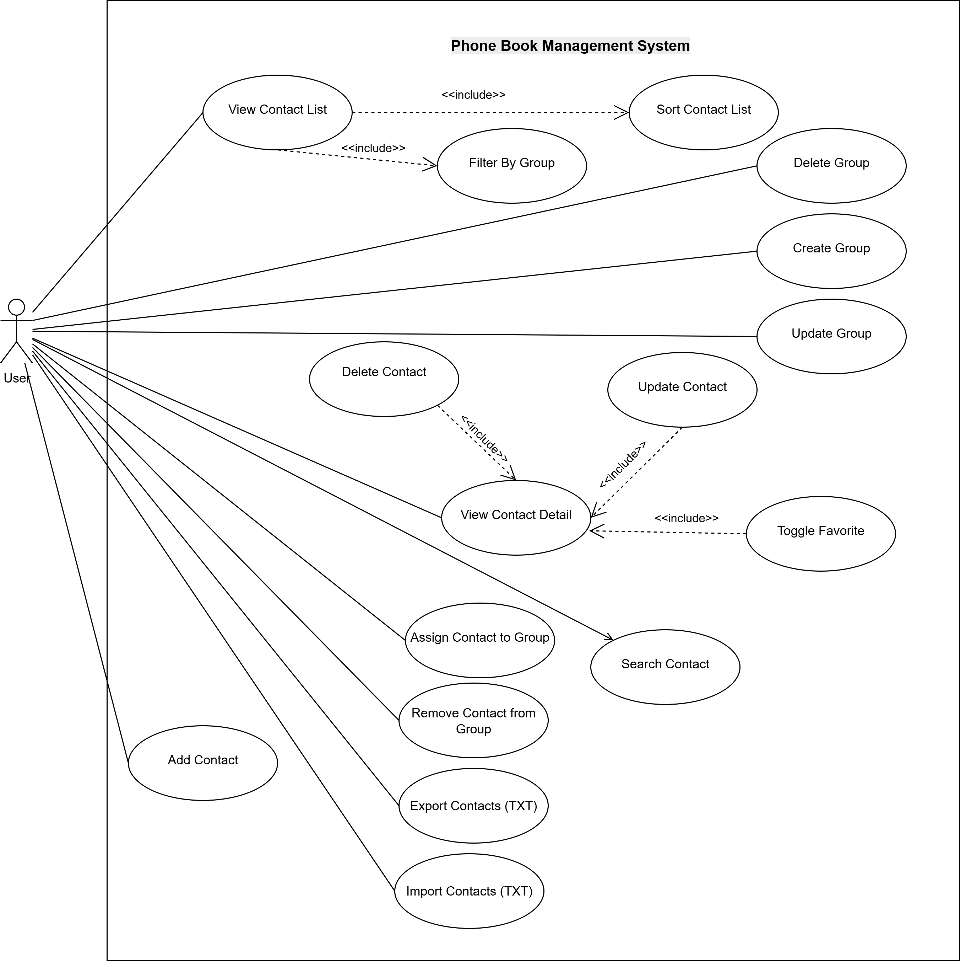
Actor(s):
Number | Use-Case | Meaning
1 | User | The User is the person who interacts with the Phone Book Management System to manage contacts and groups, search/filter/sort data, and import/export contacts.

Use Cases:
No. | Use Case | Meaning
1 | View Contact List | Displays all saved contacts in the system via console output.
2 | View Contact Detail | Shows detailed information of a selected contact via console.
3 | Add Contact | Creates a new contact with required information provided by the user.
4 | Update Contact | Updates information of an existing contact in the system.
5 | Delete Contact | Removes a contact from the system.
6 | Search Contact | Searches for contacts using keywords such as name, phone number, or email and returns matching results.
7 | Filter By Group | Displays contacts that belong to a selected group.
8 | Sort Contact List | Sorts the contact list based on selected criteria (e.g., name or phone number).
9 | Toggle Favorite | Marks or unmarks a contact as a favorite.
10 | Create Group | Creates a new contact group.
11 | Update Group | Updates information of an existing contact group.
12 | Delete Group | Deletes a contact group from the system.
13 | Assign Contact to Group | Assigns a contact to one or more groups.
14 | Remove Contact from Group | Removes a contact from a selected group.
15 | Import Contacts (TXT) | Imports contacts from an external TXT file, parses the data, and stores it in the system.
16 | Export Contacts (TXT) | Exports contacts from the system to an external TXT file in the specified format.

Use Case Specifications – Phone Book Management System

Use Case 1. View Contact List
Summary: Displays all saved contacts in the system via console output.
Main Flow:
1. User selects the function.
2. System processes the request.
3. System displays result via console.
Alternative Flow:
- System displays error message if operation fails.
Pre-condition: None.
Post-condition: Operation completed successfully.

Use Case 2. View Contact Detail
Summary: Shows detailed information of a selected contact via console.
Main Flow:
1. User selects the function.
2. System processes the request.
3. System displays result via console.
Alternative Flow:
- System displays error message if operation fails.
Pre-condition: None.
Post-condition: Operation completed successfully.

Use Case 3. Add Contact
Summary: Creates a new contact with required information provided by the user.
Main Flow:
1. User selects the function.
2. System processes the request.
3. System displays result via console.
Alternative Flow:
- System displays error message if operation fails.
Pre-condition: None.
Post-condition: Operation completed successfully.

Use Case 4. Update Contact
Summary: Updates information of an existing contact in the system.
Main Flow:
1. User selects the function.
2. System processes the request.
3. System displays result via console.
Alternative Flow:
- System displays error message if operation fails.
Pre-condition: None.
Post-condition: Operation completed successfully.

Use Case 5. Delete Contact
Summary: Removes a contact from the system.
Main Flow:
1. User selects the function.
2. System processes the request.
3. System displays result via console.
Alternative Flow:
- System displays error message if operation fails.
Pre-condition: None.
Post-condition: Operation completed successfully.

Use Case 6. Search Contact
Summary: Searches for contacts using keywords such as name, phone number, or email.
Main Flow:
1. User selects the function.
2. System processes the request.
3. System displays result via console.
Alternative Flow:
- System displays error message if operation fails.
Pre-condition: None.
Post-condition: Operation completed successfully.

Use Case 7. Filter By Group
Summary: Displays contacts that belong to a selected group.
Main Flow:
1. User selects the function.
2. System processes the request.
3. System displays result via console.
Alternative Flow:
- System displays error message if operation fails.
Pre-condition: None.
Post-condition: Operation completed successfully.

Use Case 8. Sort Contact List
Summary: Sorts the contact list based on selected criteria.
Main Flow:
1. User selects the function.
2. System processes the request.
3. System displays result via console.
Alternative Flow:
- System displays error message if operation fails.
Pre-condition: None.
Post-condition: Operation completed successfully.

Use Case 9. Toggle Favorite
Summary: Marks or unmarks a contact as favorite.
Main Flow:
1. User selects the function.
2. System processes the request.
3. System displays result via console.
Alternative Flow:
- System displays error message if operation fails.
Pre-condition: None.
Post-condition: Operation completed successfully.

Use Case 10. Create Group
Summary: Creates a new contact group.
Main Flow:
1. User selects the function.
2. System processes the request.
3. System displays result via console.
Alternative Flow:
- System displays error message if operation fails.
Pre-condition: None.
Post-condition: Operation completed successfully.

Use Case 11. Update Group
Summary: Updates information of an existing group.
Main Flow:
1. User selects the function.
2. System processes the request.
3. System displays result via console.
Alternative Flow:
- System displays error message if operation fails.
Pre-condition: None.
Post-condition: Operation completed successfully.

Use Case 12. Delete Group
Summary: Deletes a contact group from the system.
Main Flow:
1. User selects the function.
2. System processes the request.
3. System displays result via console.
Alternative Flow:
- System displays error message if operation fails.
Pre-condition: None.
Post-condition: Operation completed successfully.

Use Case 13. Assign Contact to Group
Summary: Assigns a contact to one or more groups.
Main Flow:
1. User selects the function.
2. System processes the request.
3. System displays result via console.
Alternative Flow:
- System displays error message if operation fails.
Pre-condition: None.
Post-condition: Operation completed successfully.

Use Case 14. Remove Contact from Group
Summary: Removes a contact from a group.
Main Flow:
1. User selects the function.
2. System processes the request.
3. System displays result via console.
Alternative Flow:
- System displays error message if operation fails.
Pre-condition: None.
Post-condition: Operation completed successfully

Use Case 15. Import Contacts (TXT)
Summary: Imports contacts from a TXT file into the system.
Main Flow:
1. User selects the function.
2. System processes the request.
3. System displays result via console.
Alternative Flow:
- System displays error message if operation fails.
Pre-condition: None.
Post-condition: Operation completed successfully.

Use Case 16. Export Contacts (TXT)
Summary: Exports contacts from the system to a TXT file.
Main Flow:
1. User selects the function.
2. System processes the request.
3. System displays result via console.
Alternative Flow:
- System displays error message if operation fails.
Pre-condition: None.
Post-condition: Operation completed successfully.

5. CLASS DIAGRAM
The Class Diagram shows the structure of the system, including key classes, attributes, and relationships.
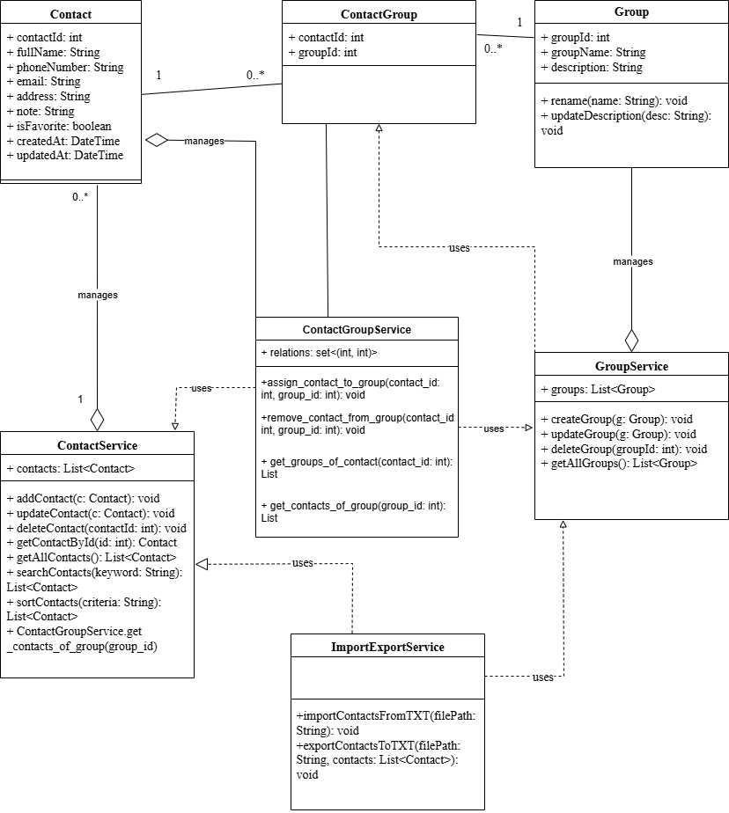

5.1. Overview
This document outlines the technical design for the Contact Management System based on the provided Class Diagram. The system is designed to allow users to store contact information, categorize contacts into groups, manage relationships between contacts and groups, and perform data import/export operations via text files.

5.2. Entity Class Specifications (Data Models)
5.2.1. Class: Contact
Represents a specific contact person or entity.
Attributes:
contactId (int): Primary Key. Unique identifier for the contact.
fullName (String): The full name of the contact. (Required).
phoneNumber (String): The primary phone number. (Required, numeric validation).
email (String): Email address. (Email format validation required).
address (String): Physical address.
note (String): Additional notes or comments regarding the contact.
isFavorite (boolean): Flag to mark the contact as a favorite (True/False).
createdAt (DateTime): Timestamp when the record was created.
updatedAt (DateTime): Timestamp when the record was last updated.
5.2.2. Class: Group
Represents a category for organizing contacts (e.g., Family, Work, Friends).
Attributes:
groupId (int): Primary Key. Unique identifier for the group.
groupName (String): Name of the group. (Required, Unique).
description (String): A description of the group's purpose.
Domain Methods:
rename(name: String): void
updateDescription(desc: String): void
5.2.3. Class: ContactGroup
A junction (association) entity representing the Many-to-Many relationship between Contact and Group.
Attributes:
contactId (int): Foreign Key referencing Contact.
groupId (int): Foreign Key referencing Group.
Constraint: A pair of (contactId, groupId) must be unique.
5.3. Service Layer Specifications
5.3.1. Class: ContactService
Responsible for the business logic regarding Contact management.
Properties:
contacts: List<Contact>
Methods:
addContact(c: Contact): void
updateContact(c: Contact): void
deleteContact(contactId: int): void
getContactById(id: int): Contact
getAllContacts(): List<Contact>
searchContacts(keyword: String): List<Contact>
sortContacts(criteria: String): List<Contact>
5.3.2. Class: GroupService
Properties:
groups: List<Group>
Methods:
createGroup(g: Group): void
updateGroup(g: Group): void
deleteGroup(groupId: int): void
getAllGroups(): List<Group>
5.3.3. Class: ContactGroupService
Properties:
relations: Set<(int, int)>
Methods:
assign_contact_to_group(contact_id: int, group_id: int): void
remove_contact_from_group(contact_id: int, group_id: int): void
get_groups_of_contact(contact_id: int): List
get_contacts_of_group(group_id: int): List
5.3.4. Class: ImportExportService
Methods:
importContactsFromTXT(filePath: String): void
exportContactsToTXT(filePath: String, contacts: List<Contact>): void
5.4. Relationship Analysis
Contact ↔ Group: Many-to-Many
5.5. Implementation Notes
Naming Convention, Exception Handling, Data Format considerations.

6. DATA STORAGE DESIGN (TXT FILE)

6.1 Entity Relationship Overview
Main entities: Contact, Group, Contact_Group (many-to-many relationship).

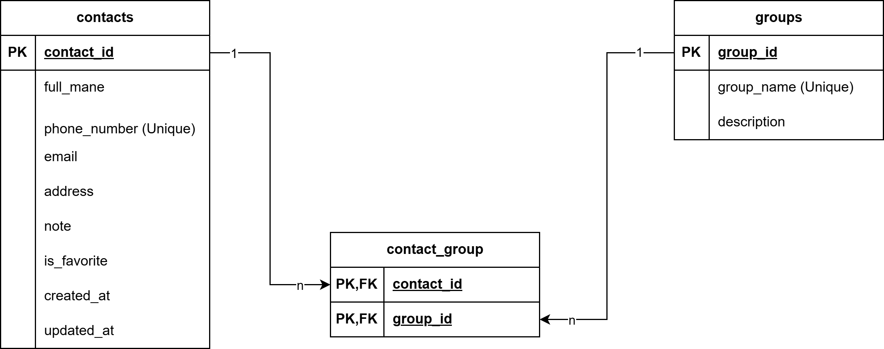

6.2. Data Model Specification – Phone Book Management System

6.2.1. Overview
This document describes the data model specification for the Phone Book Management System. The system is implemented as a console-based application and stores data using TXT files. The data model is presented in a logical relational form to clearly describe entities, attributes, constraints, and relationships.

6.2.2. Data Storage Approach
The system does not use a database management system. Instead, data is persisted in structured TXT files. Despite this, the data model is designed using relational concepts to clearly define entities and relationships, ensure consistency across use cases, class diagrams, and data flow diagrams, and support future migration to a database system.

6.2.3. Entity: Contact
Description:
Stores information about individual contacts.
Attributes:
contact_id : INT (Primary Key)
full_name : STRING
phone_number : STRING (Unique, Not Null)
email : STRING (Optional)
address : STRING (Optional)
note : STRING (Optional)
is_favorite : BOOLEAN
created_at : DATETIME
updated_at : DATETIME
Constraints:
- contact_id uniquely identifies each contact.
- phone_number must be unique.

6.2.4. Entity: Group
Description:
Stores information about contact groups.
Attributes:
group_id : INT (Primary Key)
group_name : STRING (Unique, Not Null)
description : STRING (Optional)
Constraints:
- group_id uniquely identifies each group.
- group_name must be unique.

6.2.5. Entity: Contact_Group
Description:
Represents the many-to-many relationship between Contact and Group.
Attributes:
contact_id : INT (Primary Key, Foreign Key → Contact.contact_id)
group_id : INT (Primary Key, Foreign Key → Group.group_id)
Constraints:
- Composite primary key (contact_id, group_id).
- A contact cannot be assigned to the same group more than once.

6.2.6. Relationships
- One Contact can belong to zero or many Groups.
- One Group can contain zero or many Contacts.
- The many-to-many relationship is implemented using the Contact_Group entity.

6.2.7. Data Consistency Rules
- Deleting a contact removes all related entries in Contact_Group.
- Deleting a groupq group removes all related entries in Contact_Group.
- All updates must preserve referential integrity.

6.2.8. Mapping to TXT Files
contacts.txt stores Contact records.
groups.txt stores Group records.
contact_group.txt stores Contact-Group relationship records.

6.2.9. Purpose of the Data Model
The data model serves as the foundation for system implementation, ensuring consistency between use cases, class diagrams, and file-based storage. It also supports future migration to a database system if required.
- INTERFACE DESIGN DESCRIPTION

7.1. Interface Overview
The system uses a Command Line Interface (CLI) to interact with users.
Interaction style: Menu-driven (users select functions by entering numbers).
Design principles: Simple and easy to understand for first-time users; CRUD operations are completed within a maximum of three command steps.
Display format: ASCII tables are used to clearly present lists of data.

7.2. Navigation Map
The menu structure is organized based on the defined Use Cases:
Main Menu
- Manage Contacts
- Manage Groups
- Search & Filter
- Import/Export
- Exit

7.3. Console Interface Specifications
The following mockups illustrate the main console interfaces based on functional requirements (FR).

7.3.1. Main Menu
=============================================
PHONE BOOK MANAGEMENT SYSTEM
=============================================
[1] View Contact List
[2] Add New Contact
[3] Manage Groups
[4] Search Contact
[5] Import/Export
[0] Exit
=============================================
Enter your choice: _

7.3.2. View Contact List (FR-01)
--- CONTACT LIST ---
ID | Full Name | Phone Number | Groups | Favorite
-----------------------------------------------------------
1 | Nguyen Van A | 0901234567 | Family | [x]
2 | Tran Thi B | 0987654321 | Work | [ ]
3 | Le Van C | 0912345678 | (None) | [ ]
-----------------------------------------------------------
[1] Add Contact [2] Sort [3] View Detail [0] Main Menu
Choose action: _

7.3.3. Add Contact (FR-03)
--- ADD NEW CONTACT ---
Enter Full Name (required): Pham Van D
Enter Phone Number (required): 0999888777
Enter Email (optional): phamvand@example.com
Enter Address (optional): Hanoi
Enter Group Name (optional): Friends
-------------------------------------------
Confirm add contact? (Y/N): Y
>> Success: Contact "Pham Van D" added successfully!

7.3.4. Contact Detail (FR-02)
--- CONTACT DETAIL ---
ID: 1
Full Name: Nguyen Van A
Phone: 0901234567
Email: vana@email.com
Address: Ho Chi Minh City
Groups: Family
Favorite: Yes
Created At: 05/01/2026
----------------------
[1] Update [2] Delete [3] Toggle Favorite [0] Back
Choose action: _

7.3.5. Manage Groups (FR-10 to FR-14)
--- MANAGE GROUPS ---
[1] View All Groups
[2] Create New Group
[3] Edit Group Name
[4] Delete Group
[5] Assign Contact to Group
[6] Remove Contact from Group
[0] Back to Main Menu
=====================
Enter your choice: _

7.3.6. Search Contact (FR-07)
--- SEARCH CONTACT ---
Search by (Name/Phone/Email): 090
------------------------------------------------
Found 1 result(s):
ID | Full Name | Phone Number | Groups
------------------------------------------------
1 | Nguyen Van A | 0901234567 | Family
------------------------------------------------
[1] View Detail [2] New Search [0] Main Menu

7.3.7. Import / Export (FR-15, FR-16)
--- IMPORT / EXPORT ---
[1] Import from TXT file
[2] Export to TXT file
[0] Back
Choice: 1
Enter file path: data/contacts.txt
>> Processing...
>> Summary: 50 contacts imported. 2 duplicates skipped.

7.4. System Feedback
Success Messages:
>> Success: [Action] completed successfully.
Error Messages:
>> Error: Phone number cannot be empty.
>> Error: Group name already exists.
>> Error: Contact not found.
Confirmation Messages:
>> Warning: Are you sure you want to delete this contact? (Y/N)

