

PROJECT: METRIC CONVERSION
GROUP NO:04 BATCH: 01

A. SYSTEM REQUIREMENTS:
Sr. | Item | Description
1. | Operating system | Windows 10, 11, or higher
2. | Hardware | Pentium or better with 4 Gigabytes of RAM or better
3. | Web Browser | Version in later of: Edge 120, Firefox 121, Chrome 120, etc…
4. | Fonts | Standard font Unicode: Segoe UI, Tahoma, Inter, sans-serif, etc…
5. | Other requirement | Has been install node.js v20.9 or higher and have internet connection
Notes: Do not install IDEs (Integrated Development Environment) on the system such as MS Visual Studio, Jbuilder, Dreamweaver, etc.

B. Program Instrallation
Step 1. Copy eProjectSem01_MetricConversion_Group04.rar from USB to your website directory (for example Drive D:\)
Step 2. Extract .rar file into the webroot.
Step 3. Open Command Prompt or Windows PowerShell
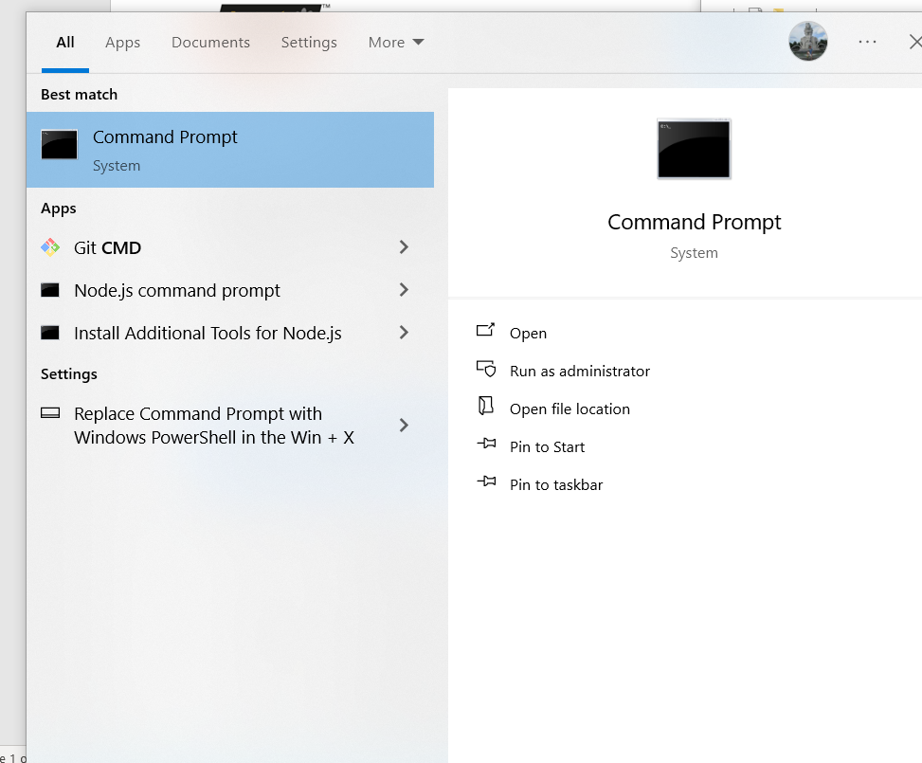
Step 4. Input “cd /D D:\” and press enter
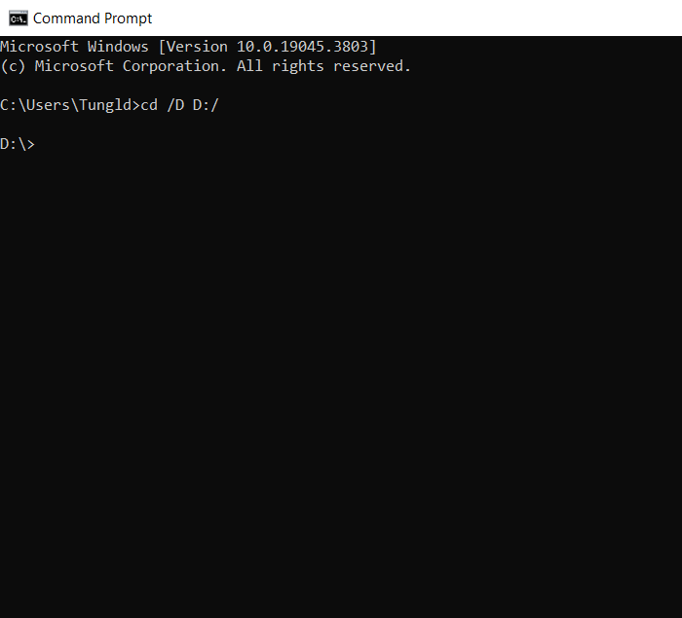
Step 5. Input “ npm install -g create-react-app ” and press enter
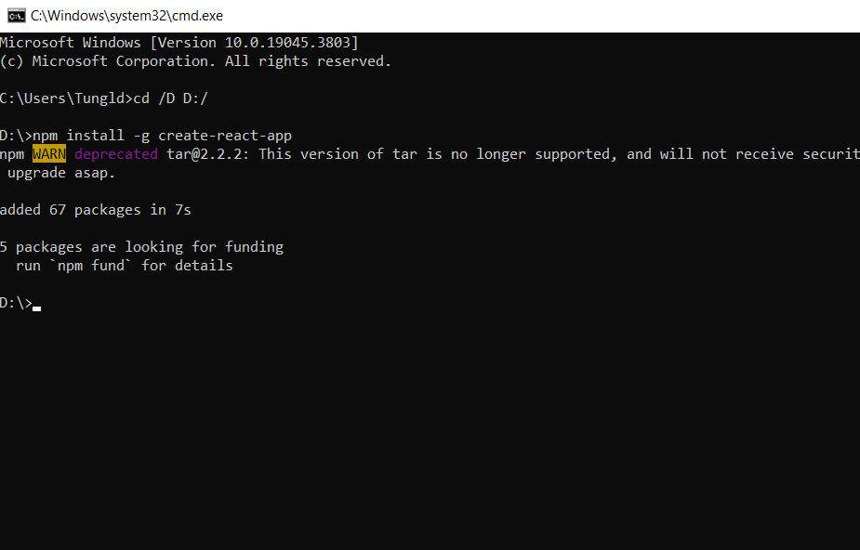
Step 6. Input “ create-react-app metricconversion “ and press enter
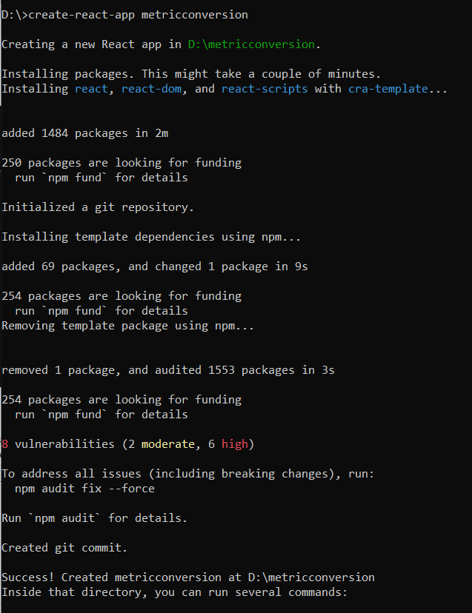
Step 7. Input “ cd metricconversion ” and press enter
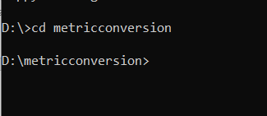
Step 8. Input “ npm install react-router-dom ” and press enter
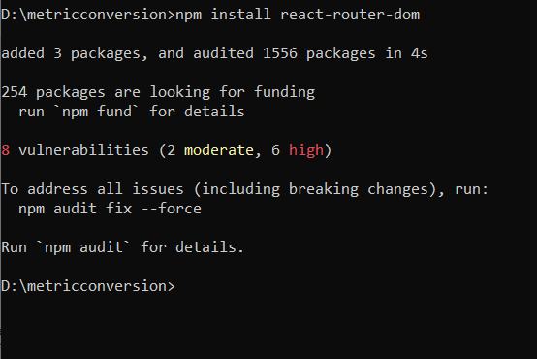
Step 9. Copy folder “public” and “src” has been extracted in step 2 paste to folder metricconversion and choice “replace all” when have alert
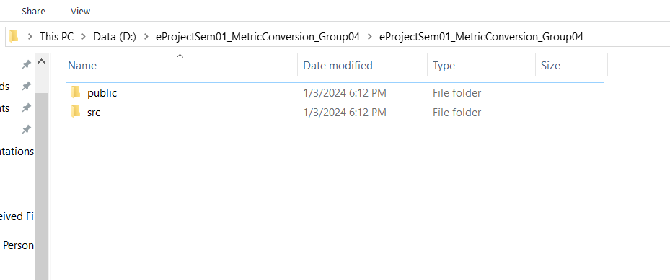
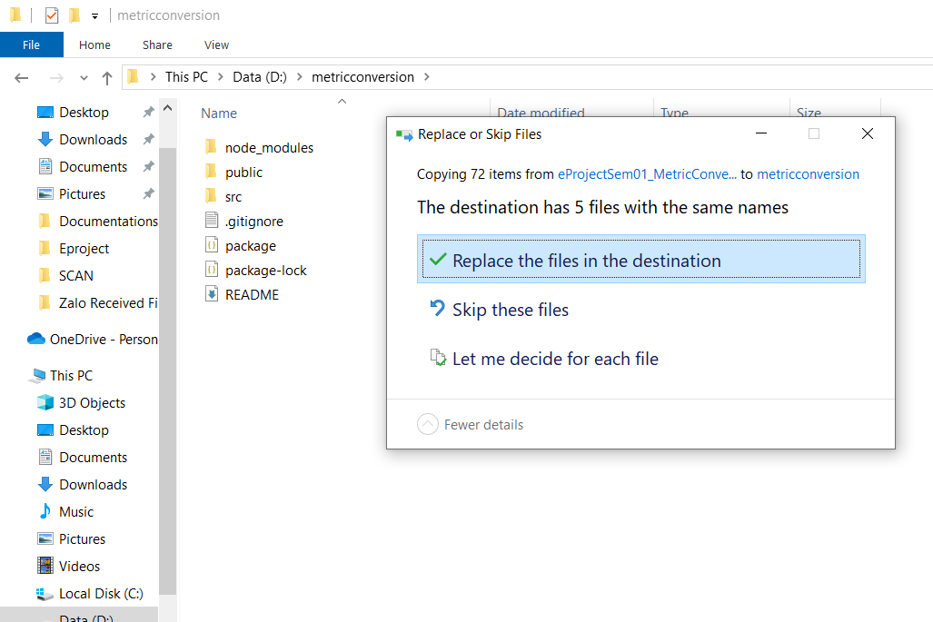
Step 10. Input “npm start” in command prompt or windows powershell is opening and press enter
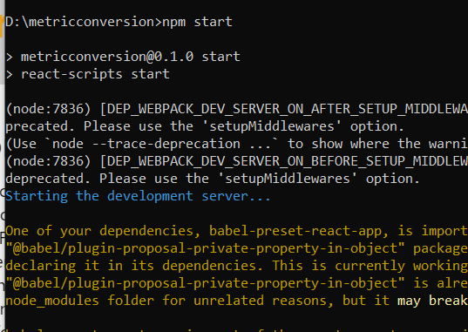

C. Successful test
- The file is loaded successfully
- Homepage should be displayed as described in the documentation.
