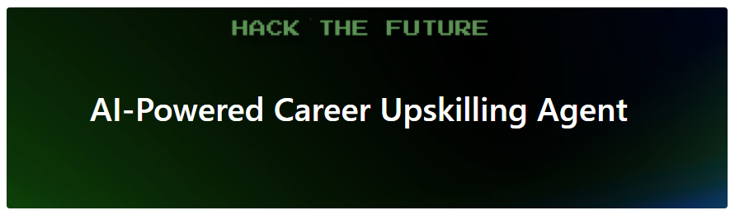

**AI-Powered Career Upskilling Agent**

# Topic HackAIthon #4

Develop an AI-powered personal learning agent that intelligently generates highly customized upskilling pathways. This agent will take an individual's current skills, desired future proficiencies, and learning constraints as input, then curate a structured, actionable learning roadmap utilizing publicly available content and datasets to accelerate career growth.

Context: In today's rapidly evolving technological landscape, particularly with the advent of AI, continuous upskilling is paramount for professionals at FSOFT. Employees frequently find themselves needing to acquire new skills or deepen existing ones to meet project demands and advance their careers. However, navigating the overwhelming abundance of online learning resources, identifying the most relevant content, and structuring an effective, personalized study plan is a significant challenge. Generic training programs often fall short, failing to account for individual learning styles, prior knowledge, or specific career trajectories, leading to inefficient learning and skill gaps.

# Problem Statement

As an FSOFT employee eager to grow, I often feel overwhelmed by the sheer volume of learning resources available (Coursera, Udemy, YouTube, blogs, etc.) and struggle to create a coherent, effective learning plan.

I know my current skills (e.g., "Java - Intermediate," "Git - Beginner") and my desired skills (e.g., "Python - Advanced," "DevOps - Intermediate"), but I don't know the most efficient path to bridge the gap.

It's time-consuming to find high-quality, relevant resources and then organize them into a manageable study schedule within my preferred timeframe (e.g., "3 months" or "10 hours/week").

I need a tool that acts as a personalized career advisor, digesting my goals and existing knowledge to generate a step-by-step learning roadmap, complete with specific resource recommendations. Ideally, this tool should also adapt as I progress and provide a clear way to track my journey.

# Live demo should

|  |  |
| --- | --- |
| **Personalized Input Interface** | A user-friendly web |
| **AI-Generated Learning Roadmap** | Upon submission, the system should instantly display a dynamically generated, structured learning pathway. This pathway should be visually represented (e.g., as a simplified Gantt chart showing weekly modules, a clear timeline, or an interactive mind map of interconnected topics) |
| **Comprehensive Resource Recommendations** | For each module or step in the roadmap, the system must show specific, actionable recommendations with direct links to publicly available content |
| **Progress Tracking & Dynamic Adaptation Simulation** | Triggers the AI to re-evaluate and subtly adjust the remaining learning path |
| **Interactive Dashboard & Export** | Display a concise, interactive dashboard summarizing the learner's progress, skills gained, and upcoming milestones. Demonstrate the ability to download/export the generated learning plan (e.g., as a PDF outline or a JSON file for integration) |

HieuNQ16: Models

LinhHN30: Architecture

DuongPH18, TungND62, ThaoDTP26: Frontend (simple UI with Room chat listed)

HieuBV9, HieuNQ16: Backend (Spring Boot 3, Java17)

SonLT43: Documentation

Tạo git repo

June 13th: Pitching