HA NOI UNIVERSITY OF SCIENCE AND TECHNOLOGY
SHOOL OF INFORMATION AND COMMUNICATION TECHNOLOGY
──────── * ───────



Object-Oriented Language and Theory

PROJECT: Demonstration of Sorting Algorithms on Aray

Instructor: Dr.Nguyễn Thị Thu Trang
Group members:
Nguyễn Thanh Tùng - 20184327
Nguyễn Danh Tiến - 20184311
Nguyễn Thành Trung - 20184318

Hà Nội, 2021
Contents
Contents 2
Project overview 3
Assignment task for each member 4
CHAPTER 1: Mini-Project Description
5
- Describe in detail about mini project requirement.....……………………………5

- Usecase diagram and explanation………………………………………………..5
CHAPTER 2:Design 7
1. General Class Diagram 7
2. Class Diagram for each Package 7
2.1 Class digram for main 8
2.2 Class Diagram for each entity 8
2.3 Class digram for screen 9 2.4 Class digram for sort_visualizer…………….……………………………9 3. Explaination of the design 10

PROJECT OVERVIEW
Array is the most basic structure of computer science. Most operations as well as other data structures are built and performed on array . Sorting on array is important algorithm of programming.
Imagine you need to look up a word in a dictionary, but that dictionary is not arranged in alphabetical order, the words in the dictionary are arranged according to a random rule. Then, all you have to do is turn each page, with each page you have to try to find out if the word you are looking for is on that page or not. And this takes a lot of time and effort. However, with a dictionary arranged in alphabetical order, your work is quite easy.
However, not all sorting algorithms are easy to understand. Understand this problem, my team has come up with idea that visualize sorting algorithm to help people easy to understand it.

ASSIGNMENT FOR EACH MEMBER
Name | Email | Task | Evaluation
Nguyễn Thanh Tùng | tung.nt184327@sis.hust.edu.vn | -SortVisualizer, BubbleSortVisualize class  - Design diagram  -Write report | Work is complete in time
Nguyễn Danh Tiến | tien.nd184311@sis.hust.edu.vn | - Instruction, Bar, Dialog, InsertionSortVisualize class  - Design diagram  - Write report | Work is complete in time
Nguyễn Thành Trung | trung.nt184318@sis.hust.edu.vn | -SortFrame , SortCanvas , QuickSortVisualizer class  - Design diagram  - Design slides | Work is complete in time

CHAPTER 1: MiniProject Description

1.Describe in detail about mini project requirement

- GUI: can freely design your own GUI. However, since the basic aim of the project is to develop an application base on OOP, focus on interface is not required.

- Design:

On the main menu: title of the application, 3 types of sort algorithms for user to choose, helpmenu, quit:
•User must select a sort-type in order to start the demonstration.
•Help menu show the basic usage and aim of the program.
•Quit exits the program. Remember to ask for confirmation.

In the demonstration:
•A button for creating the array: User can choose to randomly create an array or input an array for the program
•A button for starting the algorithm with the created array. Remember to clearly show each step of the sorting.
•A back button for user to return to main menu at any time

2. Usecase diagram and explanation: How the users interact to the software with use cases

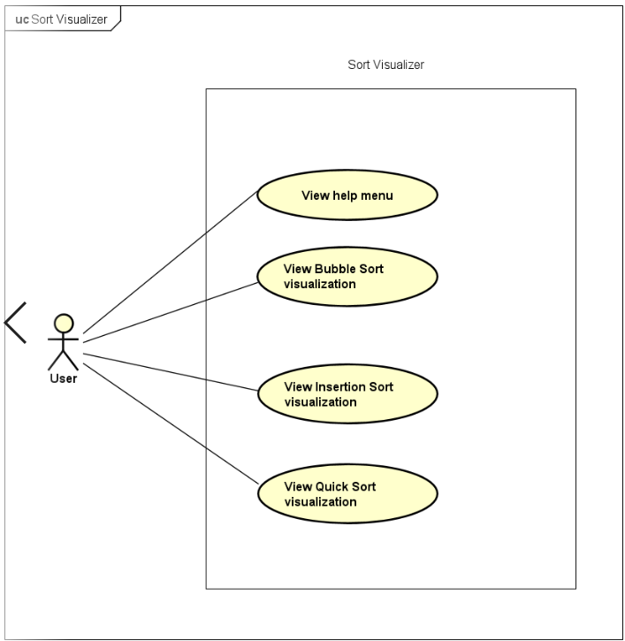

- User can view the help menu by click the button help→usage in the top-left corner of GUI. A screen will be popped up, and user can see some guides to use this application.
- User can view the Bubble Sort Visualization by click the button with the same name (after entering the necessary data).
- User can view the Quick Sort Visualization by click the button with the same name (after entering the necessary data).
- User can view the Insertion Sort Visualization by click the button with the same name (after entering the necessary data).

CHAPTER 2: DESIGN

1.General class diagram

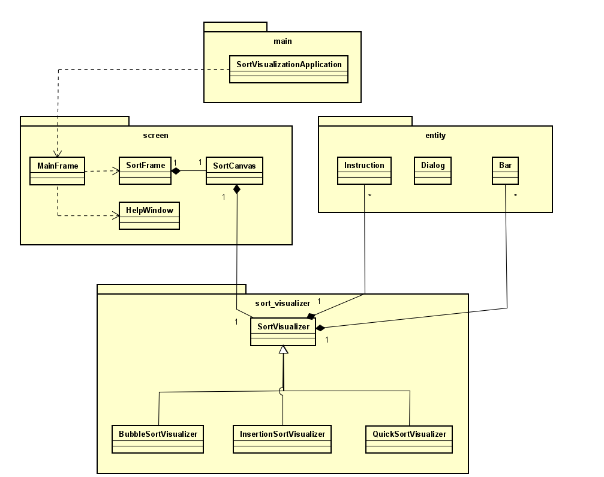

2. Class diagrams for each package

In our project, we divided into 4 packages with several classes inside it.
Below are class diagrams for each package.

2.1 Class diagrams for package main

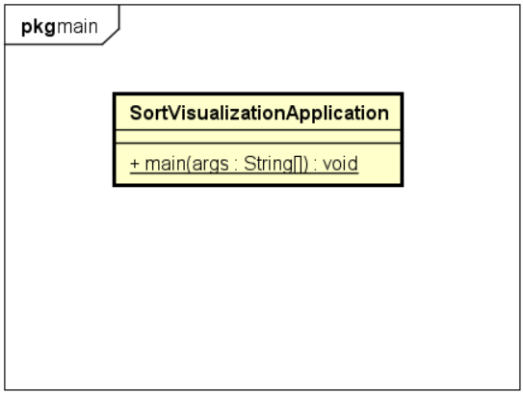

2.2 Class diagrams for package entity

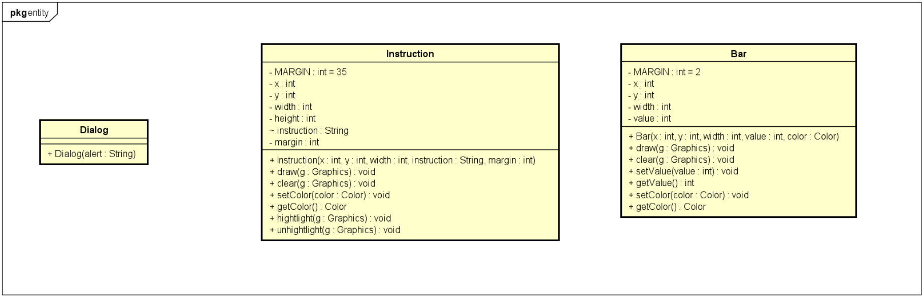

2.3 Class diagrams for package screen

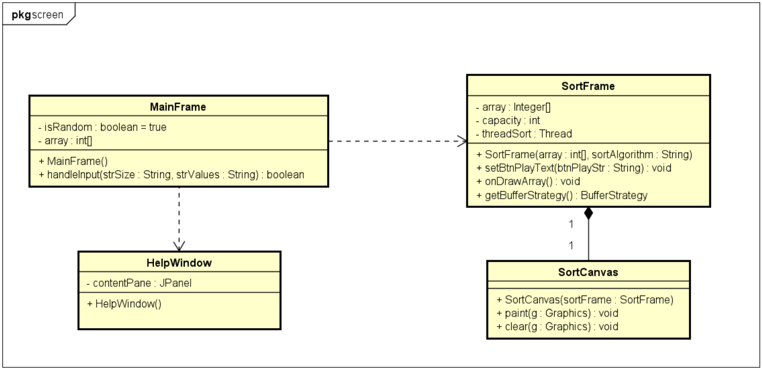

2.4 Class diagrams for package sort_visualizer

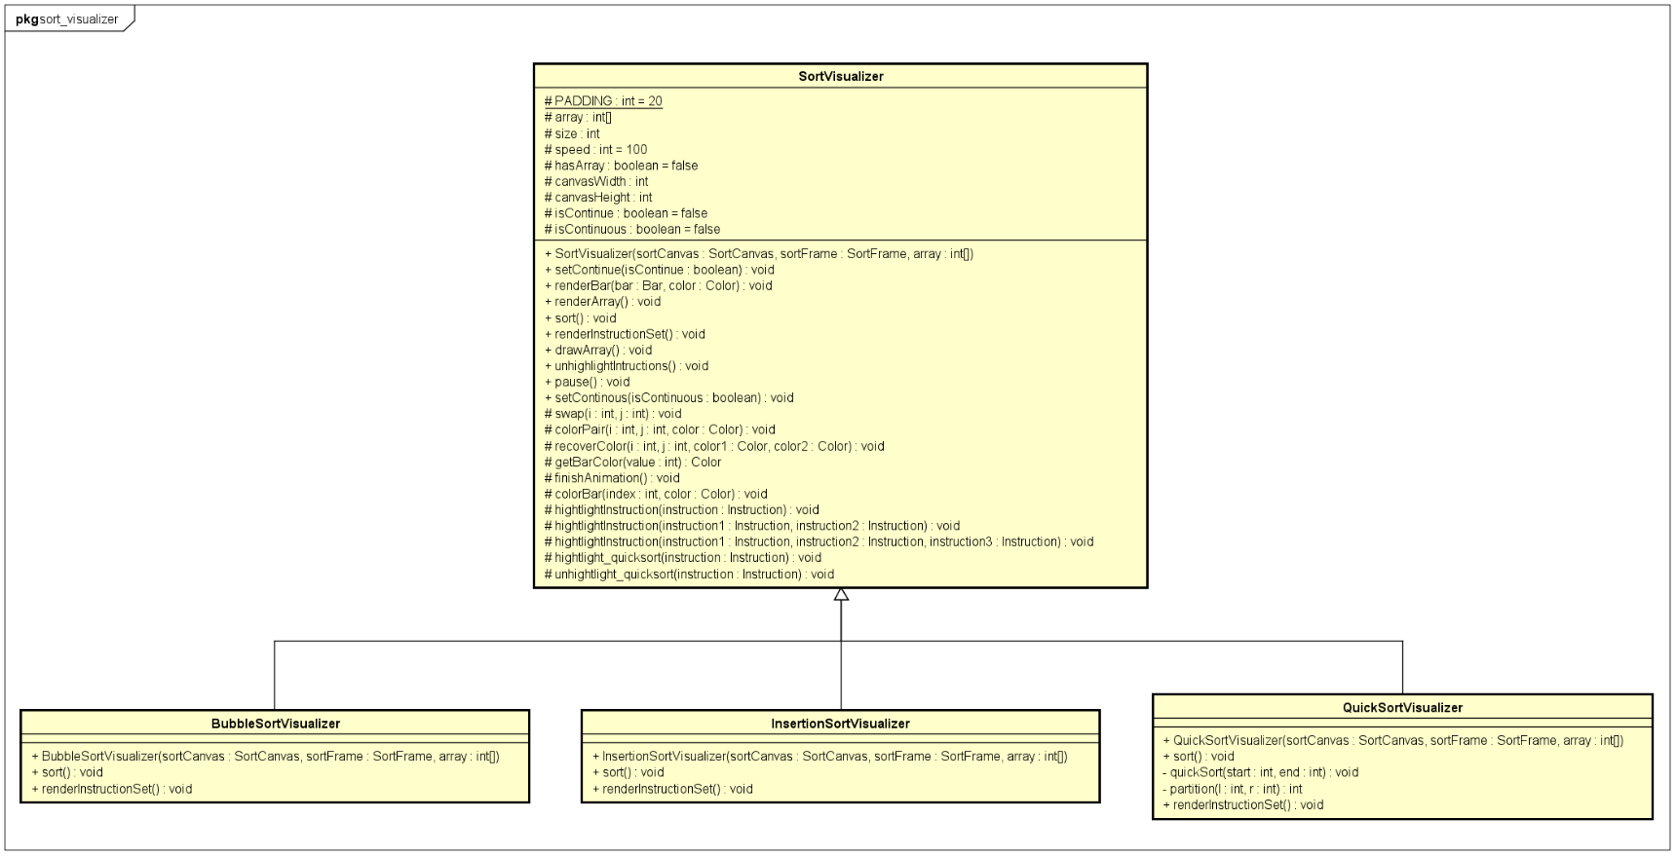

3. Explanation of the design
We create three frames, which all extend JFrame, corresponding to three windows of our application:
- MainFrame class is used to display main menu window, where user can generate an array and choose a sort algorithm to visualize.
- HelpWindow class is used to display help window, where provide instructions for user to use our application properly.
- SortFrame class is used to display sort visualization window, where user can view visualization of a sort algorithm and control it by buttons (Play, Pause, Next).
Object-Oriented Techniques used:
* Association:
- SortFrame – SortCanvas: One-to-one Composition relationship.
Inside SortFrame class, we instantiate a SortCanvas object, which extends Canvas component that represents a blank rectangular area of the screen onto which the application can draw.
Since SortCanvas cannot exists independent of SortFrame, the relationship between them is Composition.
- SortCanvas – SortVisualizer: One-to-one Composition relationship.
In order to visualize sort algorithm, we use bars, which indicate elements in an array, and instruction codes of algorithm. We need to draw these objects and do animations with them on SortCanvas object. These works are implemented in SortVisualizer class.
SortVisulizer cannot exists independent of SortCanvas, the relationship between them is Composition.
- SortVisualizer – Instruction: One-to-many Composition relationship
SortVisualizer uses mulitple Instruction objects to indicate instructions code of algorithm. Thoses instructions cannot exists independent of SortVisualizer, the relationship between them is Composition.
- SortVisualizer – Bar: One-to-many Composition relationship
SortVisualizer uses mulitple Bar objects to indicate elements of an array. Thoses instructions cannot exists independent of SortVisualizer, the relationship between them is Composition.
* Inheritance:
- BubbleSortVisualizer, QuickSortVisualizer, InsertionSortVisualizer inherit SortVisualizer class.
Three sort visualizer corresponding to three sort algorithm share attributes such as: array of instructions, array of bars, speed of animations, etc. They also share methods such as: render initial array, swap bars, highlight instructions, etc.
We put all those common attributes and methods into a parent class: SortVisualizer.
* Polymorphism:
All three sort visualizer need to render array of instructions and do animations while sorting. However, each sort algorithm associated to different set of instructions and mechanism for sorting. We need to override 2 methods renderInstructionSet() and sort() in three child classes.

