­­

**Excellent Coaching**

|  |  |  |
| --- | --- | --- |
| **Supervisor:** | *LÊ THANH NHÂN* | |
| **Semester:** | *01* | |
| **Batch No:** | *T1.2201.E0* | |
| **Group No:** | *03* | |
| **Order:** | **Full name** | **Roll No.** |
| *1.* | *Nguyễn Tấn Lợi* | *Student1359465* |
| *2.* | *Nguyễn Thị Tuyết Nhi* | *Student1359467* |
| *3.* | *Phạm Minh Tùng* | *Student1362609* |
| *4.* | *Phạm Quốc Vinh* | *Student1359473* |

***Month****: 04* ***Year****: 2022*



This is to certify that

|  |  |
| --- | --- |
| **Mr.** | **NGUYỄN TẤN LỢI** |
| **Ms.** | **NGUYỄN THỊ TUYẾT NHI** |
| **Mr.** | **PHẠM MINH TÙNG** |
| **Mr.** | **PHẠM QUỐC VINH** |

Have successfully Designed & Developed

|  |  |  |
| --- | --- | --- |
|  |  |  |
| **EXCELLENT COACHING** | | |

Submitted by:

|  |
| --- |
| **Mr. LE THANH NHAN** |

Date of Issue:

|  |  |
| --- | --- |
|  |  |

Authorized Signature:

|  |  |
| --- | --- |
|  |  |
| **Content** | | | |

Content

Acknowledge

Synposis

Review1 1-4

Review2 5-6

Review3 7-14

Testting Document 15

Final Checklist 16

Tasksheet 17

|  |
| --- |
| **Acknowledge** |

As we understand that the eProject is a step-by-step learning environment that closely simulates the classroom and Lab based learning environment into actual implementation. It is a projectimplementation at your fingertips!! An electronic, live juncture on the machine that allows you to.

* Practice step by step i.e. laddered approach.
* Build a larger more robust application.
* Usage of certain utilities in applications designed by user.
* Single program to unified code leading to a complete application.
* Learn implementation of concepts in a phased manner.
* Enhance skills and add value.
* Work on real life projects.
* Give a real-life scenario and help to create applications more complicated and useful.
* Mentoring through email support.

We would like to send a great thank to our professor and others student for the addorable supports during the time in project.

Beside serveral mistakes we had made in the project, we hope to have more oppotunities to widen our knownledge in web developing world.

We also thank you so much for your infomation and the “demo” project from India APTECH to help us get more reality experience in this project. Since we have gained more experience from this project, we will not stop learning any thing as much as we can to be more successful in the future.

Your Sincerely,

Team Group 03

|  |
| --- |
| **Synposis** |

The Objective of this program we aim is to give a sample project to work on real life projects. These applications help us build a larger more robust application.

The objective is not to teach us HTML/JavaScript but to provide us with a real life scenario and help us create basic applications using the tools.

Hence, we can revise the chapters before we start with the project.

This project is meant for students like us who have completed the module of HTML5. These programs should be done in the Lab sessions with assistance of the faculty if required.

The website (in this project) is a tool for Excellent Coaching to promote the courses that offer to the students who want to achieve the best result for their academic desires.

It is very essential for us that will have a clear understanding of the subject. We think we should go through the project and solve the assignments as per requirements given.

And get back ***eprojects@aptech.ac.in*** as the assigned schedule.

|  |
| --- |
| **Problem Definition** |

Excellent Coaching is into business for more than a decade. They have been advertising about their coaching classes through newspapers, pamphlets, television. Now with changing times, they have decided to go online as most of the students today are frequent users of Internet. They have planned for a website with complete details about the Coaching classes.

We are supposed to create a website for them with the below mentioned requirement specifications.

The website is to be developed for the Windows Platform using HTML5, JavaScript and Geolocation. The site should work well in all leading browsers including Chrome, IE, Firefox etc.

User/member who use the website can find the information (details of teacher, successful stories, prices, etc.) of the courses and classes they would like to participate in. They also can find the email and address on Google Maps to contact Excellent Coaching.

Webmaster of the website can add/edit information of the classes, upload documents of the information and price list on the website for the

|  |  |  |  |  |  |  |  |  |  |  |  |  |  |  |  |
| --- | --- | --- | --- | --- | --- | --- | --- | --- | --- | --- | --- | --- | --- | --- | --- |
| |  | | --- | | **Customer Requirements Specifications** |   Describe the points in the data processing cycle for each user.   |  |  | | --- | --- | | **User:** | | |  | **Input:** | |  | * Member registration data * Course Information * Price information for each course * Teacher Information * Suggestions for admins | |  | **Process:** | |  | * Search course information * Looking for teacher information * Check member registration information * Check the comment information | |  | **Output:** | |  | * Notification of successful/failed member data entry * Notice of success/failure feedback * Course information to be downloaded * Quote information is downloaded | |

|  |  |
| --- | --- |
| **Webmaster:** | |
|  | **Input:** |
|  | * Admin login information * Information about members that need to be added/edited/deleted * Course information to add/edit/delete * Course price information * Information teachers need to add/edit/delete * Reply to member's comments |
|  | **Process:** |
|  | * Add/edit/delete members * Add/edit/delete course information * Add/edit/delete course quotes * Add/edit/delete teacher information * Check feedback information * Delete comments |
|  | **Output:** |
|  | * Login success/failure message * Notice of successful/failed Add/edit/delete members * Notice Add/edit/delete successful/failed course information * Notice Add/edit/delete successful/failed course quotes * Notice Add/edit/delete teacher information on success/failure * Notice of successful/failed comment deletion |

|  |  |
| --- | --- |
| **Hardware / software requirement:** | |
|  | **Hardware:** |
|  | * A minimum computer system that will help you access all the tools in the courses is a Pentium 166 or better * 2 Gigabytes of RAM or better |
|  | **Software:** |
| **Server:** | * Notepad/HTML editor * Dreamweaver * IE 5.0/ Netscape 6.0 |

**Architecture and design of the project**

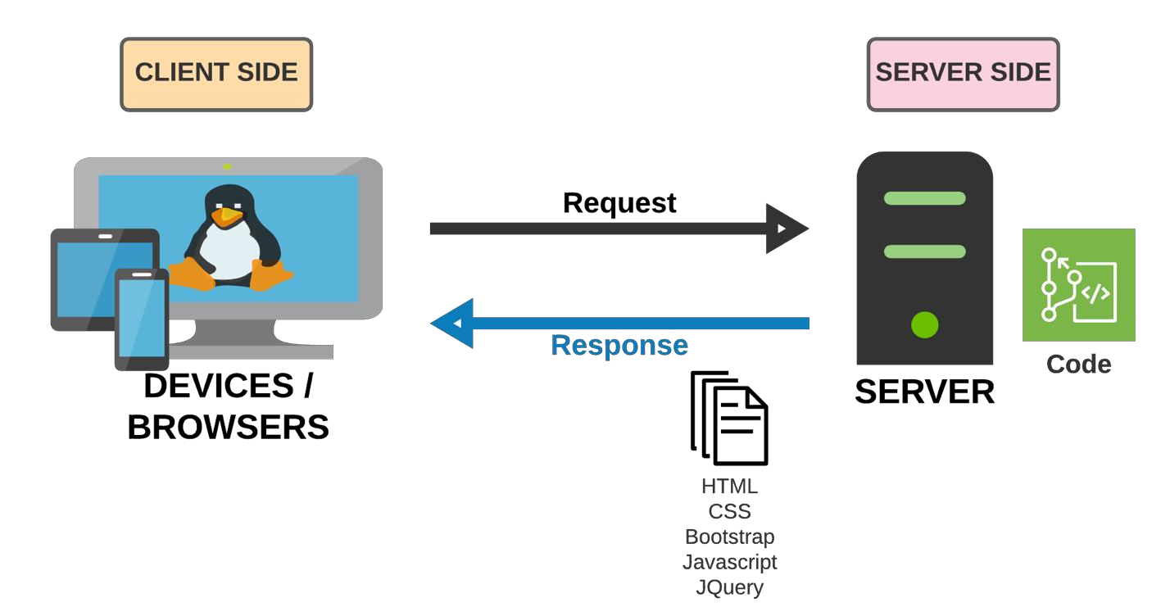

**SiteMap**

Logo

Registration form

Search

Contact

Faculty

Teacher

Information

Successful

story

Mathematic

Languages

Commerce

Courses

Home page

**Screen shots**

**I. Homepage:**

|  |  |  |  |  |  |  |
| --- | --- | --- | --- | --- | --- | --- |
| Logo | Home | Courses | Faculty | Contact | Search | Register |
| < Carousel > | | | | | | |
| Footer | | | | | | |

**Description** : Homepage of the website

**From:** Home

**To :** All other pages

**II. Courses:**

|  |  |  |  |  |  |  |
| --- | --- | --- | --- | --- | --- | --- |
| Logo | Home | Courses | Faculty | Contact | Search | Register |
| Commerce  (Description of Commerce course)  Download link for detailed Commerce course  Mathematic  (Description of Mathematic course)  Download link for detailed Mathematic course  Languages  (Description of Languages course)  Download link for detailed Languages course | | | | | | |
| Footer | | | | | | |

**Description** : Information of all courses

**From:** Courses

**To :** Commerce, Mathematic, Languages

**Commerce course**

|  |  |  |  |  |  |  |
| --- | --- | --- | --- | --- | --- | --- |
| Logo | Home | Courses | Faculty | Contact | Search | Register |
| Commerce  (Description of Commerce course)  Download link for detailed Commerce course  Classes  (List of classes)  Subjects  (List of subjects and tuition fees) | | | | | | |
| Footer | | | | | | |

**Description** : Description of Commerce course and subjects available

**From:** Commerce

**To :** Download file

**Mathematic**

|  |  |  |  |  |  |  |
| --- | --- | --- | --- | --- | --- | --- |
| Logo | Home | Courses | Faculty | Contact | Search | Register |
| Mathematic  (Description of Mathematic course)  Download link for detailed Commerce course  Classes  (List of classes)  Subjects  (List of subjects and tuition fees) | | | | | | |
| Footer | | | | | | |

**Description** : Description of Mathematic course and subjects available

**From:** Mathematic

**To :** Download file

**Lanuguages**

|  |  |  |  |  |  |  |
| --- | --- | --- | --- | --- | --- | --- |
| Logo | Home | Courses | Faculty | Contact | Search | Register |
| Languages  (Description of Languages course)  Download link for detailed Commerce course  Classes  (List of classes)  Subjects  (List of subjects and tuition fees) | | | | | | |
| Footer | | | | | | |

**Description** : Description of Languages course and subjects available

**From:** Languages

**To :** Download file

**III. Faculty:**

|  |  |  |  |  |  |  |
| --- | --- | --- | --- | --- | --- | --- |
| Logo | Home | Courses | Faculty | Contact | Search | Register |
| Commerce faculty  (Description of Commerce faculty)  Mathematic faculty  (Description of Mathematic faculty)  Languages faculty  (Description of Languages faculty) | | | | | | |
| Footer | | | | | | |

**Description** : Desciption of Faculty

**From:** Faculty

**To :**

**Teachers information:**

|  |  |  |  |  |  |  |
| --- | --- | --- | --- | --- | --- | --- |
| Logo | Home | Courses | Faculty | Contact | Search | Register |
| Commerce faculty teachers  (List of Commerce faculty teachers)  Mathematic faculty teachers  (List of Mathematic faculty teachers)  Languages faculty teachers  (List of Languages faculty teachers) | | | | | | |
| Footer | | | | | | |

**Description** : Desciption of Teachers

**From:** Faculty

**To :**

**Successful stories**

|  |  |  |  |  |  |  |
| --- | --- | --- | --- | --- | --- | --- |
| Logo | |  | | Search: | | Register |
| Home | Courses | | Faculty | | Contact |  |
| Successful story 1:  (Desciption of successful Story 1)  Successful story 2:  (Desciption of successful Story 2)  Successful story 3:  (Desciption of successful Story 3) | | | | | | |
| Footer | | | | | | |

**Description** : Desciption of Successful stories

**From:** Faculty

**To :**

**Contact**

|  |  |  |  |  |  |  |
| --- | --- | --- | --- | --- | --- | --- |
| Logo | |  | | Search: | | Register |
| Home | Courses | | Faculty | | Contact |  |
| Contact us  Address:  Hotline phone number:  Email:   |  | | --- | | Google maps geolocation | | | | | | | |
| Footer | | | | | | |

**Description** : Contact page including Google maps geolocation

**From:** Contact

**To :**

**Testing document**

|  |  |  |
| --- | --- | --- |
| **Sr.No** | **Features Tested** | **Remarks** |
| 1 | Website CSS coding |  |
| 2 | Javascript Coding |  |
| 3 | AngularJS Coding |  |
| 4 | Register form (Password, Phone, Email, Name, Address) |  |
| 5 |  |  |
| 6 |  |  |
| 7 |  |  |
| 8 |  |  |
| 9 |  |  |
| 10 |  |  |
| 11 |  |  |
| 12 |  |  |
| 13 |  |  |
| 14 |  |  |
| 15 |  |  |

**Final checklist**

|  |  |  |
| --- | --- | --- |
| **Sr.No** | **Aspected Tested** | **Suggestion/ Remarks** |
| 1 | Are all the users able to view the images and links? |  |
| 2 | Have all the views, modules and controllers been properly  integrated and is the site function as a single page application? |  |
| 3 | Are the GUI content devoid of spelling mistakes? |  |
| 4 | Is the application user-friendly? |  |
| 5 | Is the Website launching correctly in all popular browsers? |  |
| 6 | Are all the forms validated with proper criteria? |  |
| 7 | Do all text links lead to the appropriate website? |  |
| 8 | Do all image links lead to the appropriate website? |  |
| 9 | Are all the images and links clearly visible on the page? |  |
| 10 | Does the Web page work properly in all the tested browsers? |  |
| 11 | Does the Web page take too long to be loaded fully? |  |
| 12 | Is the navigation sequences correct through all the Web pages on the site? |  |
| 13 | Is the JavaScript code working as expected in all click events? |  |
|  |  |  |
|  |  |  |

|  |  |  |  |  |  |  |  |
| --- | --- | --- | --- | --- | --- | --- | --- |
| **No** | **Member** | **Contents** | **Page Name** | **Activity Plan** | **Date of Preparation of Activity Plan** | | |
| **Planed Start Date** | **Actual Start Date** | **Actual Days** | **Status** |
| 1 | Nguyễn Tấn Lợi | Homepage | Homepage.html | 20/04/2022 | 02/05/2022 | 5 | OK |
| 2 | Courses | Courses.html | 20/04/2022 | 02/05/2022 | 5 | OK |
|  | | | | | | | | |
| 1 | Nguyễn Thị Tuyết Nhi | Search | Search.html | 20/04/2022 | 02/05/2022 | 5 | OK |
| 2 | Price List | Price List.html | 20/04/2022 | 02/05/2022 | 5 | OK |
|  | | | | | | | | |
| 1 | Phạm Minh Tùng | Classes registration form | Classes registration form.html | 20/04/2022 | 02/05/2022 | 5 | OK |
| 2 | Faculty | Faculty.html | 20/04/2022 | 02/05/2022 | 5 | OK |
|  |  |  |  |  |  |  |  |
| 1 | Phạm Quốc Vinh | Classes | Classes.html | 20/04/2022 | 02/05/2022 | 5 | OK |
| 2 | Geolocation | Geolocation.html | 20/04/2022 | 02/05/2022 | 5 | OK |