login as: tdv160130
tdv160130@cs1.utdallas.edu's password:
┌────────────────────────────────────────────────────────────────────┐
│ • MobaXterm 10.5 • │
│ (SSH client, X-server and networking tools) │
│ │
│ → SSH session to tdv160130@cslinux1.utdallas.edu │
│ • SSH compression : v │
│ • SSH-browser : v │
│ • X11-forwarding : v (remote display is forwarded through SSH) │
│ • DISPLAY : v (automatically set on remote server) │
│ │
│ → For more info, ctrl+click on help or visit our website │
└────────────────────────────────────────────────────────────────────┘

Department of Computer Science
University of Texas at Dallas

Use of UTD Information Systems is subject to
the UTD Information Security and Acceptable Use Policy.

Pursuant to Texas Administrative Code 202:
(1) Unauthorized use is prohibited;
(2) Usage may be subject to security testing and monitoring;
(3) Misuse is subject to criminal prosecution; and
(4) No expectation of privacy except as otherwise provided by
applicable privacy laws.

If five (5) incorrect passwords are received from your IP address,
this system will ban your IP address access for twenty-four (24) hours.

[[NOTE: If you are a CS Graduate Student, you cannot logon to this server.]]
[[ All CS Graduate Students should use csgrads1.utdallas.edu ]]
Last login: Fri Jan 12 23:11:19 2018 from rrcs-97-77-48-13.sw.biz.rr.com

***---***---***---***---***---***
csgrads1.utdallas.edu - Linux/CentOS 7.3
--All CS Graduate Students should use csgrads1--
cs1.utdallas.edu - Linux/CentOS 7.3
cs2.utdallas.edu - Linux/CentOS 7.3
***---***---***---***---***---***

This system is for use by CS students who need a general purpose Linux system
to complete homework assignments. Computationally or resource intensive
simulations will be throttled automatically.

Thank you,
CS Lab Manager
cs-labs@utdallas.edu

/scratch disk space can be used for temporary files.
All files will be erased on a regular basis (Sunday 0300).

Sourcing /usr/local/etc/skel/global/profile
{cslinux1:~} vim practice
{cslinux1:~} ls
ansda hello hello.c Mail perl5 practice public_html S tunvu workspace
{cslinux1:~} ls practice
practice
{cslinux1:~} ls xxxx
ls: cannot access xxxx: No such file or directory
{cslinux1:~} cat practice
cout << "hello!";
lul
lrl
lel
alvl
bWG
ASD

{cslinux1:~} cp practice practice.copy
{cslinux1:~} rm practice
rm: remove regular file ‘practice’? y
{cslinux1:~} ls practice
ls: cannot access practice: No such file or directory
{cslinux1:~} cat practice
cat: practice: No such file or directory
{cslinux1:~} less /etc/services
{cslinux1:~} less /etc/services
{cslinux1:~} head /etc/services
# /etc/services:
# $Id: services,v 1.55 2013/04/14 ovasik Exp $
#
# Network services, Internet style
# IANA services version: last updated 2013-04-10
#
# Note that it is presently the policy of IANA to assign a single well-known
# port number for both TCP and UDP; hence, most entries here have two entries
# even if the protocol doesn't support UDP operations.
# Updated from RFC 1700, ``Assigned Numbers'' (October 1994). Not all ports
{cslinux1:~} tail /etc/services
3gpp-cbsp 48049/tcp # 3GPP Cell Broadcast Service Protocol
isnetserv 48128/tcp # Image Systems Network Services
isnetserv 48128/udp # Image Systems Network Services
blp5 48129/tcp # Bloomberg locator
blp5 48129/udp # Bloomberg locator
com-bardac-dw 48556/tcp # com-bardac-dw
com-bardac-dw 48556/udp # com-bardac-dw
iqobject 48619/tcp # iqobject
iqobject 48619/udp # iqobject
matahari 49000/tcp # Matahari Broker
{cslinux1:~} hostname
cslinux1.utdallas.edu
{cslinux1:~} mv practice.copy practice1
{cslinux1:~} cat practice1
cout << "hello!";
lul
lrl
lel
alvl
bWG
ASD

{cslinux1:~} grep ' cout'

^Z
[1]+ Stopped grep --color=auto ' cout'
{cslinux1:~} grep 'cout' practice1
cout << "hello!";
{cslinux1:~} vim days
{cslinux1:~} sort days

Friday
Monday
Sartuday
Sunday
Thrusday
Tuesday
Wednesday
{cslinux1:~} edit days
bash: edit: command not found...
{cslinux1:~} vim days
{cslinux1:~} cat days
Monday
Tuesday
Wednesday
Thrusday
Friday
Sartuday
Sunday

{cslinux1:~} sort days

Friday
Monday
Sartuday
Sunday
Thrusday
Tuesday
Wednesday
{cslinux1:~} file days
days: ASCII text
{cslinux1:~} file /etc
/etc: directory
{cslinux1:~} ^C
{cslinux1:~} ls
ansda hello Mail practice1 S workspace
days hello.c perl5 public_html tunvu
{cslinux1:~} cat hello.c
#include <stdio.h>

int
main(int argc, char **argv) {
printf("Hello, World!\n");
}{cslinux1:~} gcc hello.c -o hello
{cslinux1:~} ./hello
Hello, World!
{cslinux1:~} exit
logout
There are stopped jobs.
{cslinux1:~} ^C
{cslinux1:~}

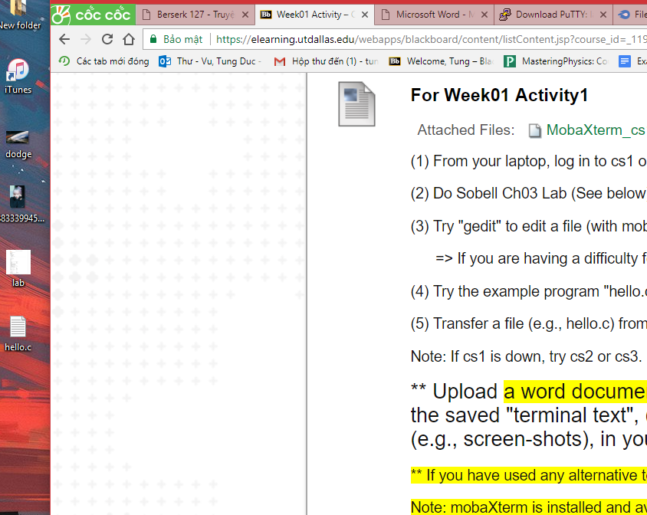
Hello.c transferred to my laptop

