**User manual.**

**Contents:**

1. Role of reporting system.

2. How to use.

3. Exceptions.

**1. Role of reporting system.**

Currently, we are developing a software for  management of school and reporting is an important function in this software. But because demands for the report of each school is different in Vietnam, there are no common standards for all schools, each school has a different reporting format. Therefore, to support the highest and serve many different purposes, we have decided to build the reporting system.

The system allows user create excel template file, upload it to the server, then the server will return result with that template. It is a long time to build a system which can be able to use easily. So, in first phase, we only focus on building the simple reports and mainly for expert users (like programer ...),  then in a second phase,  we will build and design so that the user  can use it more easily.

**2.How to use.**

a) Prepare the excel template file: This image is the most general template for the input file:

. Function is define as #<function>, as in the example #<get_ds_hs()>. This function is defined in definitions.py, which return a list of objects.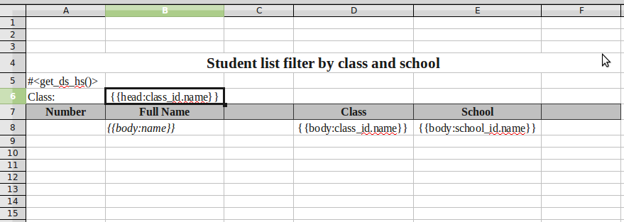

. Header is define as {{head:attribute}}, as in the example {{head:class_id.name}}.

. Body is define as {{body:atribute}}, as in the example {{body:name}}.

. Attribute is an attribute of the objects returned by the function above.

The database design is:

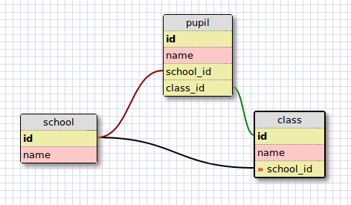

In this example:

. Funtion get_ds_hs() return the list of all pupils

. Each students has attributes: name, class_id, school_id

. class_id has attribute: name

. school_id has attribute: name

The purpose of head and body is for blocking the reports. The head is the attribute for grouping data in the body.

The sample result is as follow:

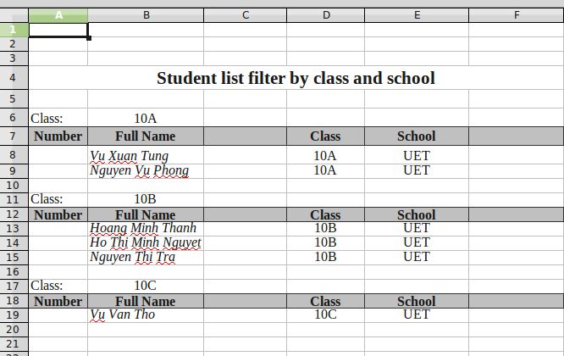

b) Upload the template to the server: User must give the description for the upload file. The description is for clarifying the purpose of the report.

c) After uploading the template, user is redirected to the uploadlist page, in which, user can download the generated reports file. The generated file will be stored temporarily, so user must download it as soon as possible.

1. ***Exceptions:***

All the exceptions are caught and display the error messages for user.