Tên: Phạm Thanh Tú
Lớp: 12_ĐH_CNTT4
MSSV: 1250080220

CREATE USER C##USERMAN IDENTIFIED BY 123;
GRANT ALL PRIVILEGES TO C##USERMAN;
ALTER USER C##USERMAN QUOTA UNLIMITED ON USERS;

CREATE TABLE PHONGBAN (
MAPB VARCHAR2(10) PRIMARY KEY,
TENPB VARCHAR2(50),
TRPHG VARCHAR2(10) -- mã trưởng phòng
);

CREATE TABLE NHANSU (
MANSU VARCHAR2(10) PRIMARY KEY,
HOSU VARCHAR2(20),
TENSU VARCHAR2(20),
PHAI VARCHAR2(5),
NGAYSINH DATE,
DIACHI VARCHAR2(100),
LUONG NUMBER(10),
MAPB VARCHAR2(10),
MAQL VARCHAR2(10), -- mã quản lý
FOREIGN KEY (MAPB) REFERENCES PHONGBAN(MAPB)
);

CREATE TABLE DEAN (
MADA VARCHAR2(10) PRIMARY KEY,
TENDA VARCHAR2(50),
MAPB VARCHAR2(10),
FOREIGN KEY (MAPB) REFERENCES PHONGBAN(MAPB)
);

CREATE TABLE THAMGIA (
MANSU VARCHAR2(10),
MADA VARCHAR2(10),
THOIGIAN NUMBER(5), -- giờ/tuần
PRIMARY KEY (MANSU, MADA),
FOREIGN KEY (MANSU) REFERENCES NHANSU(MANSU),
FOREIGN KEY (MADA) REFERENCES DEAN(MADA)
);

CREATE TABLE NGUOITHAN (
MANSU VARCHAR2(10),
TENNT VARCHAR2(20),
QUANHE VARCHAR2(20),
PRIMARY KEY (MANSU, TENNT),
FOREIGN KEY (MANSU) REFERENCES NHANSU(MANSU)
);

-- INSERT
INSERT INTO PHONGBAN VALUES ('PB01','Hành Chính','NS01');
INSERT INTO PHONGBAN VALUES ('PB02','Tài Vụ','NS02');
INSERT INTO PHONGBAN VALUES ('PB03','Kỹ Thuật','NS03');
INSERT INTO PHONGBAN VALUES ('PB04','Nhân Sự','NS04');
INSERT INTO PHONGBAN VALUES ('PB05','Marketing','NS05');
INSERT INTO PHONGBAN VALUES ('PB06','Kinh Doanh','NS06');
INSERT INTO PHONGBAN VALUES ('PB07','Kho Vận','NS07');
INSERT INTO PHONGBAN VALUES ('PB08','Bảo Vệ','NS08');
INSERT INTO PHONGBAN VALUES ('PB09','Pháp Chế','NS09');
INSERT INTO PHONGBAN VALUES ('PB10','Nghiên Cứu','NS10');

INSERT INTO NHANSU VALUES ('NS01','Phạm','Huynh','Nam',TO_DATE('2000-05-12','YYYY-MM-DD'),'HCM',800000,'PB01',NULL);
INSERT INTO NHANSU VALUES ('NS02','Nguyễn','Lan','Nữ',TO_DATE('2001-07-20','YYYY-MM-DD'),'Hà Nội',750000,'PB02','NS01');
INSERT INTO NHANSU VALUES ('NS03','Trần','Minh','Nam',TO_DATE('2002-03-15','YYYY-MM-DD'),'Đà Nẵng',600000,'PB03','NS01');
INSERT INTO NHANSU VALUES ('NS04','Lê','Huynh','Nam',TO_DATE('2003-11-01','YYYY-MM-DD'),'HCM',450000,'PB04','NS02');
INSERT INTO NHANSU VALUES ('NS05','Phạm','Anh','Nữ',TO_DATE('2004-09-09','YYYY-MM-DD'),'Cần Thơ',500000,'PB05','NS02');
INSERT INTO NHANSU VALUES ('NS06','Hoàng','Mai','Nữ',TO_DATE('2005-01-18','YYYY-MM-DD'),'Hà Nội',650000,'PB06','NS03');
INSERT INTO NHANSU VALUES ('NS07','Vũ','Long','Nam',TO_DATE('2006-06-22','YYYY-MM-DD'),'HCM',700000,'PB07','NS03');
INSERT INTO NHANSU VALUES ('NS08','Đặng','Huy','Nam',TO_DATE('2007-08-30','YYYY-MM-DD'),'Đà Nẵng',720000,'PB08','NS04');
INSERT INTO NHANSU VALUES ('NS09','Ngô','Thảo','Nữ',TO_DATE('2008-12-05','YYYY-MM-DD'),'Huế',680000,'PB09','NS05');
INSERT INTO NHANSU VALUES ('NS10','Bùi','Khanh','Nam',TO_DATE('2009-04-14','YYYY-MM-DD'),'HCM',800000,'PB10','NS06');

INSERT INTO DEAN VALUES ('DA01','Quản lý nhân sự','PB01');
INSERT INTO DEAN VALUES ('DA02','Kế toán tổng hợp','PB02');
INSERT INTO DEAN VALUES ('DA03','Phát triển phần mềm','PB03');
INSERT INTO DEAN VALUES ('DA04','Tuyển dụng nhân sự','PB04');
INSERT INTO DEAN VALUES ('DA05','Chiến dịch quảng cáo','PB05');
INSERT INTO DEAN VALUES ('DA06','Kế hoạch kinh doanh','PB06');
INSERT INTO DEAN VALUES ('DA07','Quản lý kho','PB07');
INSERT INTO DEAN VALUES ('DA08','An ninh công ty','PB08');
INSERT INTO DEAN VALUES ('DA09','Pháp lý hợp đồng','PB09');
INSERT INTO DEAN VALUES ('DA10','Nghiên cứu sản phẩm','PB10');

INSERT INTO THAMGIA VALUES ('NS01','DA01',40);
INSERT INTO THAMGIA VALUES ('NS02','DA02',25);
INSERT INTO THAMGIA VALUES ('NS03','DA03',35);
INSERT INTO THAMGIA VALUES ('NS04','DA04',20);
INSERT INTO THAMGIA VALUES ('NS05','DA05',15);
INSERT INTO THAMGIA VALUES ('NS06','DA06',30);
INSERT INTO THAMGIA VALUES ('NS07','DA07',28);
INSERT INTO THAMGIA VALUES ('NS08','DA08',32);
INSERT INTO THAMGIA VALUES ('NS09','DA09',26);
INSERT INTO THAMGIA VALUES ('NS10','DA10',38);

INSERT INTO NGUOITHAN VALUES ('NS01','Huynh','Con');
INSERT INTO NGUOITHAN VALUES ('NS02','Lan','Chồng');
INSERT INTO NGUOITHAN VALUES ('NS03','Minh','Anh');
INSERT INTO NGUOITHAN VALUES ('NS04','Huynh','Em');
INSERT INTO NGUOITHAN VALUES ('NS05','Anh','Con');
INSERT INTO NGUOITHAN VALUES ('NS06','Mai','Em');
INSERT INTO NGUOITHAN VALUES ('NS07','Long','Anh');
INSERT INTO NGUOITHAN VALUES ('NS08','Huy','Con');
INSERT INTO NGUOITHAN VALUES ('NS09','Thảo','Chị');
INSERT INTO NGUOITHAN VALUES ('NS10','Khanh','Em');

-- cau 1
SELECT * FROM NHANSU WHERE TENSU = 'Huynh';
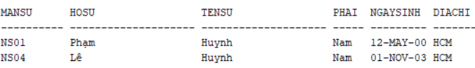
-- cau 2
SELECT MANSU, HOSU || ' ' || TENSU AS HOTEN, DIACHI
FROM NHANSU NS JOIN PHONGBAN PB ON NS.MAPB = PB.MAPB
WHERE PB.TENPB = 'Hành Chính';
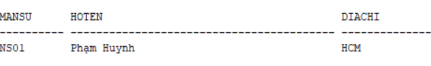
-- cau 3
SELECT MANSU, HOSU || ' ' || TENSU AS HOTEN, DIACHI
FROM NHANSU NS JOIN PHONGBAN PB ON NS.MAPB = PB.MAPB
WHERE PB.TENPB IN ('Hành Chính','Tài Vụ');
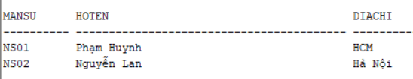

-- cau 4
SELECT NS.MANSU, HOSU || ' ' || TENSU AS HOTEN, DA.TENDA
FROM NHANSU NS JOIN THAMGIA TG ON NS.MANSU = TG.MANSU
JOIN DEAN DA ON TG.MADA = DA.MADA;
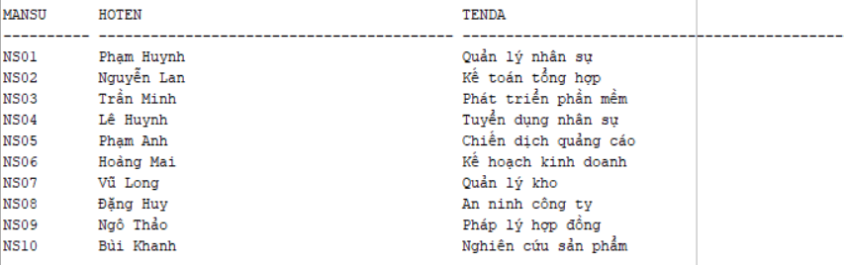
-- cau 5
SELECT DA.MADA, DA.TENDA, PB.TENPB, PB.TRPHG, NS.HOSU || ' ' || NS.TENSU AS TRUONGPHONG
FROM DEAN DA JOIN PHONGBAN PB ON DA.MAPB = PB.MAPB
JOIN NHANSU NS ON PB.TRPHG = NS.MANSU;
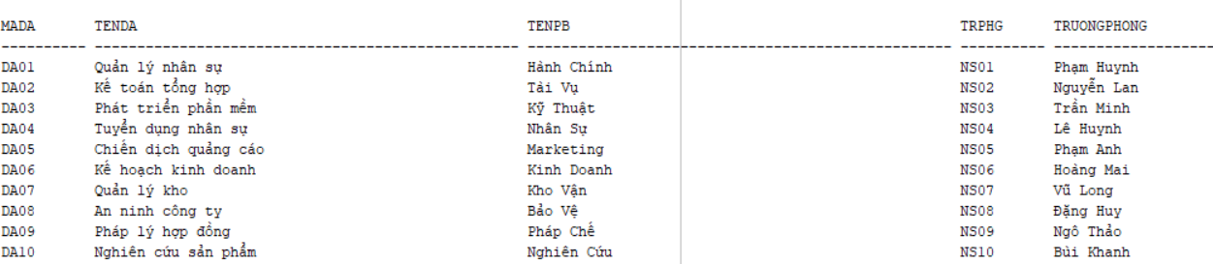
-- cau 6
SELECT NS.MANSU, HOSU || ' ' || TENSU AS HOTEN
FROM NHANSU NS JOIN THAMGIA TG ON NS.MANSU = TG.MANSU
WHERE TG.MADA = 'DA01' AND TG.THOIGIAN > 30;
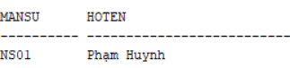
-- cau 7
SELECT DISTINCT NS.MANSU, HOSU || ' ' || TENSU AS HOTEN
FROM NHANSU NS JOIN NGUOITHAN NT ON NS.MANSU = NT.MANSU
WHERE NS.TENSU = NT.TENNT;
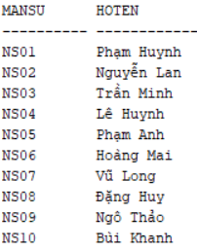
-- cau 8
SELECT NS.MANSU, NS.HOSU || ' ' || NS.TENSU AS HOTEN
FROM NHANSU NS
JOIN PHONGBAN PB ON NS.MAPB = PB.MAPB
JOIN NHANSU TP ON PB.TRPHG = TP.MANSU
WHERE TP.HOSU = 'Phạm' AND TP.TENSU = 'Huynh';
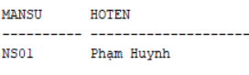
-- cau 9
SELECT NS.MANSU, NS.HOSU || ' ' || NS.TENSU AS HOTEN
FROM NHANSU NS
JOIN NHANSU QL ON NS.MAQL = QL.MANSU
WHERE QL.HOSU = 'Phạm' AND QL.TENSU = 'Huynh';
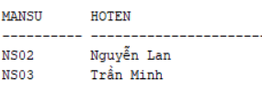
-- cau 10
SELECT NS.MANSU, HOSU || ' ' || TENSU AS HOTEN
FROM NHANSU NS
WHERE NOT EXISTS (
SELECT * FROM DEAN DA
WHERE NOT EXISTS (
SELECT * FROM THAMGIA TG
WHERE TG.MANSU = NS.MANSU AND TG.MADA = DA.MADA
)
);
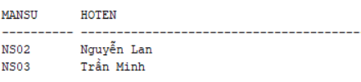
-- cau 11
SELECT NS.MANSU, NS.HOSU || ' ' || NS.TENSU AS HOTEN
FROM NHANSU NS
JOIN PHONGBAN PB ON NS.MAPB = PB.MAPB
JOIN NHANSU TP ON PB.TRPHG = TP.MANSU
WHERE TP.HOSU = 'Phạm' AND TP.TENSU = 'Huynh';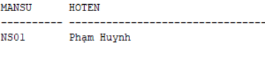
-- cau 12
SELECT AVG(LUONG) AS LUONG_TB FROM NHANSU;
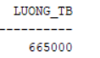
-- cau 13
SELECT AVG(LUONG) AS LUONG_TB_NAM FROM NHANSU WHERE PHAI = 'Nam';
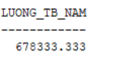
-- cau 14
SELECT COUNT(*) AS TONG_DEAN FROM DEAN;
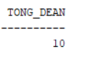
-- cau 15
SELECT MADA, COUNT(DISTINCT MANSU) AS SO_NS
FROM THAMGIA GROUP BY MADA;
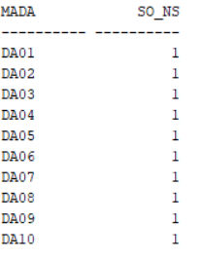
-- cau 16
SELECT TG.MADA, COUNT(DISTINCT NS.MANSU) AS SO_NS_NU
FROM THAMGIA TG JOIN NHANSU NS ON TG.MANSU = NS.MANSU
WHERE NS.PHAI = 'Nữ'
GROUP BY TG.MADA;
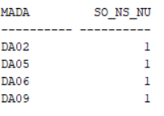
-- cau 17
UPDATE THAMGIA TG
SET TG.THOIGIAN = TG.THOIGIAN + 4
WHERE TG.MANSU IN (SELECT MANSU FROM NHANSU WHERE PHAI = 'Nam');
