Tên: Phạm Thanh Tú
Lớp: 12_ĐH_CNTT4
MSSV: 1250080220
-- Chạy với quyền SYSTEM
CREATE USER C##ADMIN-BANK IDENTIFIED BY 123;
GRANT ALL PRIVILEGES TO C##ADMIN-BANK;
ALTER ADMIN C##ADMIN-BANK QUOTA UNLIMITED ON ADMIN;

CREATE USER C##USER1-BANK IDENTIFIED BY 123;
GRANT ALL PRIVILEGES TO C##USER1-BANK;
ALTER USERS C##USER1-BANK QUOTA UNLIMITED ON USERS;

-- 1. Tạo bảng NganHang (bảng cha)
CREATE TABLE NganHang (
MaNH VARCHAR2(10) PRIMARY KEY,
TenNH NVARCHAR2(100) NOT NULL
);

-- 2. Tạo bảng ChiNhanh
CREATE TABLE ChiNhanh (
MaCN VARCHAR2(10) PRIMARY KEY,
MaNH VARCHAR2(10) NOT NULL,
ThanhPhoCN NVARCHAR2(50) NOT NULL,
TaiSan NUMBER(15,2),
CONSTRAINT FK_ChiNhanh_NganHang
FOREIGN KEY (MaNH) REFERENCES NganHang(MaNH)
ON DELETE CASCADE
);

-- 3. Tạo bảng KhachHang
CREATE TABLE KhachHang (
MaKH VARCHAR2(10) PRIMARY KEY,
TenKH NVARCHAR2(100) NOT NULL,
DiaChi NVARCHAR2(200)
);

-- 4. Tạo bảng TaiKhoanVay
CREATE TABLE TaiKhoanVay (
SoTKV VARCHAR2(20) PRIMARY KEY,
MaKH VARCHAR2(10) NOT NULL,
MaCN VARCHAR2(10) NOT NULL,
SoTienVay NUMBER(15,2) CHECK (SoTienVay >= 0),
CONSTRAINT FK_TKVay_KhachHang
FOREIGN KEY (MaKH) REFERENCES KhachHang(MaKH)
ON DELETE CASCADE,
CONSTRAINT FK_TKVay_ChiNhanh
FOREIGN KEY (MaCN) REFERENCES ChiNhanh(MaCN)
ON DELETE CASCADE
);

-- 5. Tạo bảng TaiKhoanGoi
CREATE TABLE TaiKhoanGoi (
SoTKG VARCHAR2(20) PRIMARY KEY,
MaKH VARCHAR2(10) NOT NULL,
MaCN VARCHAR2(10) NOT NULL,
SoTienGoi NUMBER(15,2) CHECK (SoTienGoi >= 0),
CONSTRAINT FK_TKGoi_KhachHang
FOREIGN KEY (MaKH) REFERENCES KhachHang(MaKH)
ON DELETE CASCADE,
CONSTRAINT FK_TKGoi_ChiNhanh
FOREIGN KEY (MaCN) REFERENCES ChiNhanh(MaCN)
ON DELETE CASCADE
);

-- INSERT DỮ LIỆU BẢNG NGANHANG

INSERT INTO NganHang (MaNH, TenNH) VALUES (1, N'Ngan Hang Cong Thuong');
INSERT INTO NganHang (MaNH, TenNH) VALUES (2, N'Ngan Hang Ngoai Thuong');
INSERT INTO NganHang (MaNH, TenNH) VALUES (3, N'Ngan Hang Nong Nghiep');
INSERT INTO NganHang (MaNH, TenNH) VALUES (4, N'Ngan Hang A Chau');
INSERT INTO NganHang (MaNH, TenNH) VALUES (5, N'Ngan Hang Thuong Tin');

-- INSERT DỮ LIỆU BẢNG CHINHANH

INSERT INTO ChiNhanh (MaNH, MaCN, ThanhPhoCN, TaiSan) VALUES (1, 'CN01', N'Da Lat', 2000000000);
INSERT INTO ChiNhanh (MaNH, MaCN, ThanhPhoCN, TaiSan) VALUES (2, 'CN02', N'Nha Trang', 2700000000);
INSERT INTO ChiNhanh (MaNH, MaCN, ThanhPhoCN, TaiSan) VALUES (3, 'CN03', N'Thanh Hoa', 4500000000);
INSERT INTO ChiNhanh (MaNH, MaCN, ThanhPhoCN, TaiSan) VALUES (4, 'CN04', N'TP HCM', 6000000000);
INSERT INTO ChiNhanh (MaNH, MaCN, ThanhPhoCN, TaiSan) VALUES (5, 'CN05', N'Da Nang', 7000000000);
INSERT INTO ChiNhanh (MaNH, MaCN, ThanhPhoCN, TaiSan) VALUES (1, 'CN11', N'TP HCM', 5000000000);
INSERT INTO ChiNhanh (MaNH, MaCN, ThanhPhoCN, TaiSan) VALUES (2, 'CN12', N'Hue', 1400000000);
INSERT INTO ChiNhanh (MaNH, MaCN, ThanhPhoCN, TaiSan) VALUES (3, 'CN13', N'Da Nang', 3600000000);
INSERT INTO ChiNhanh (MaNH, MaCN, ThanhPhoCN, TaiSan) VALUES (4, 'CN14', N'Ha Noi', 5700000000);
INSERT INTO ChiNhanh (MaNH, MaCN, ThanhPhoCN, TaiSan) VALUES (1, 'CN21', N'Ha Noi', 3500000000);
INSERT INTO ChiNhanh (MaNH, MaCN, ThanhPhoCN, TaiSan) VALUES (2, 'CN22', N'Ha Noi', 4500000000);
INSERT INTO ChiNhanh (MaNH, MaCN, ThanhPhoCN, TaiSan) VALUES (3, 'CN23', N'Da Lat', 2400000000);
INSERT INTO ChiNhanh (MaNH, MaCN, ThanhPhoCN, TaiSan) VALUES (1, 'CN31', N'Da Nang', 4000000000);
INSERT INTO ChiNhanh (MaNH, MaCN, ThanhPhoCN, TaiSan) VALUES (2, 'CN32', N'TP HCM', 5600000000);
INSERT INTO ChiNhanh (MaNH, MaCN, ThanhPhoCN, TaiSan) VALUES (3, 'CN33', N'Can Tho', 5400000000);
INSERT INTO ChiNhanh (MaNH, MaCN, ThanhPhoCN, TaiSan) VALUES (3, 'CN43', N'Nam Dinh', 3600000000);

-- INSERT DỮ LIỆU BẢNG KHACHHANG

INSERT INTO KhachHang (MaKH, TenKH, DiaChi) VALUES ('111222333', N'Ho Thi Thanh Thao', N'456 Le Duan, Ha Noi');
INSERT INTO KhachHang (MaKH, TenKH, DiaChi) VALUES ('112233445', N'Tran Van Tien', N'12 Dien Bien Phu, Q1, TP HCM');
INSERT INTO KhachHang (MaKH, TenKH, DiaChi) VALUES ('123123123', N'Phan Thi Quynh Nhu', N'54 Hai Ba Trung, Ha Noi');
INSERT INTO KhachHang (MaKH, TenKH, DiaChi) VALUES ('123412341', N'Nguyen Van Thao', N'34 Tran Phu, TP Nha Trang');
INSERT INTO KhachHang (MaKH, TenKH, DiaChi) VALUES ('123456789', N'Nguyen Thi Hoa', N'1/4 Hoang Van Thu, Da Lat');
INSERT INTO KhachHang (MaKH, TenKH, DiaChi) VALUES ('221133445', N'Nguyen Thi Kim Mai', N'4 Tran Binh Trong, Da Lat');
INSERT INTO KhachHang (MaKH, TenKH, DiaChi) VALUES ('222111333', N'Do Tien Dong', N'123 Tran Phu, Nam Dinh');
INSERT INTO KhachHang (MaKH, TenKH, DiaChi) VALUES ('331122445', N'Bui Thi Dong', N'345 Tran Hung Dao, Thanh Hoa');
INSERT INTO KhachHang (MaKH, TenKH, DiaChi) VALUES ('333111222', N'Tran Dinh Hung', N'783 Ly Thuong Kiet, Can Tho');
INSERT INTO KhachHang (MaKH, TenKH, DiaChi) VALUES ('441122335', N'Nguyen dinh Cuong', N'P12 Thanh Xuan Nam, Q Thanh Xuan');
INSERT INTO KhachHang (MaKH, TenKH, DiaChi) VALUES ('456456456', N'Tran Nam Son', N'5 Le Duan, TP Da Nang');
INSERT INTO KhachHang (MaKH, TenKH, DiaChi) VALUES ('551122334', N'Tran Thi Khanh Van', N'1A Ho Tung Mau, Da Lat');
INSERT INTO KhachHang (MaKH, TenKH, DiaChi) VALUES ('987654321', N'Ho Thanh Son', N'209 Tran Hung Dao, Q5, TP HCM');

-- INSERT DỮ LIỆU BẢNG TAIKHOANGOI

INSERT INTO TaiKhoanGoi (MaKH, MaCN, SoTKG, SoTienGoi) VALUES ('123123123', 'CN01', '00001A', 10000000);
INSERT INTO TaiKhoanGoi (MaKH, MaCN, SoTKG, SoTienGoi) VALUES ('123456789', 'CN01', '00001C', 127000000);
INSERT INTO TaiKhoanGoi (MaKH, MaCN, SoTKG, SoTienGoi) VALUES ('221133445', 'CN02', '00002A', 12500000);
INSERT INTO TaiKhoanGoi (MaKH, MaCN, SoTKG, SoTienGoi) VALUES ('456456456', 'CN03', '00003H', 123000000);
INSERT INTO TaiKhoanGoi (MaKH, MaCN, SoTKG, SoTienGoi) VALUES ('222111333', 'CN05', '00005A', 1200000);
INSERT INTO TaiKhoanGoi (MaKH, MaCN, SoTKG, SoTienGoi) VALUES ('987654321', 'CN05', '00005D', 345000000);
INSERT INTO TaiKhoanGoi (MaKH, MaCN, SoTKG, SoTienGoi) VALUES ('123412341', 'CN05', '00005N', 45000000);
INSERT INTO TaiKhoanGoi (MaKH, MaCN, SoTKG, SoTienGoi) VALUES ('331122445', 'CN13', '00003A', 27000000);
INSERT INTO TaiKhoanGoi (MaKH, MaCN, SoTKG, SoTienGoi) VALUES ('551122334', 'CN14', '00004D', 560000000);
INSERT INTO TaiKhoanGoi (MaKH, MaCN, SoTKG, SoTienGoi) VALUES ('123456789', 'CN14', '00004P', 35400000);
INSERT INTO TaiKhoanGoi (MaKH, MaCN, SoTKG, SoTienGoi) VALUES ('123412341', 'CN21', '00001B', 67000000);
INSERT INTO TaiKhoanGoi (MaKH, MaCN, SoTKG, SoTienGoi) VALUES ('222111333', 'CN22', '00002G', 56000000);
INSERT INTO TaiKhoanGoi (MaKH, MaCN, SoTKG, SoTienGoi) VALUES ('987654321', 'CN23', '00004F', 4500000);
INSERT INTO TaiKhoanGoi (MaKH, MaCN, SoTKG, SoTienGoi) VALUES ('333111222', 'CN33', '00003D', 47000000);

-- INSERT DỮ LIỆU BẢNG TAIKHOANVAY

INSERT INTO TaiKhoanVay (MaKH, MaCN, SoTKV, SoTienVay) VALUES ('111222333', 'CN01', '10001A', 10000000);
INSERT INTO TaiKhoanVay (MaKH, MaCN, SoTKV, SoTienVay) VALUES ('333111222', 'CN02', '10002A', 6000000);
INSERT INTO TaiKhoanVay (MaKH, MaCN, SoTKV, SoTienVay) VALUES ('551122334', 'CN04', '10004A', 20000000);
INSERT INTO TaiKhoanVay (MaKH, MaCN, SoTKV, SoTienVay) VALUES ('221133445', 'CN05', '10005G', 15000000);
INSERT INTO TaiKhoanVay (MaKH, MaCN, SoTKV, SoTienVay) VALUES ('987654321', 'CN11', '10001D', 45000000);
INSERT INTO TaiKhoanVay (MaKH, MaCN, SoTKV, SoTienVay) VALUES ('112233445', 'CN12', '10002D', 12000000);
INSERT INTO TaiKhoanVay (MaKH, MaCN, SoTKV, SoTienVay) VALUES ('441122335', 'CN13', '10003F', 5500000);
INSERT INTO TaiKhoanVay (MaKH, MaCN, SoTKV, SoTienVay) VALUES ('123123123', 'CN14', '10005A', 12500000);

COMMIT;

-- KIỂM TRA DỮ LIỆU ĐÃ INSERT

SELECT 'NganHang' AS BangDuLieu, COUNT(*) AS SoLuong FROM NganHang
UNION ALL
SELECT 'ChiNhanh', COUNT(*) FROM ChiNhanh
UNION ALL
SELECT 'KhachHang', COUNT(*) FROM KhachHang
UNION ALL
SELECT 'TaiKhoanGoi', COUNT(*) FROM TaiKhoanGoi
UNION ALL
SELECT 'TaiKhoanVay', COUNT(*) FROM TaiKhoanVay;

-- Hiển thị dữ liệu từng bảng
SELECT * FROM NganHang ORDER BY MaNH;
SELECT * FROM ChiNhanh ORDER BY MaNH, MaCN;
SELECT * FROM KhachHang ORDER BY MaKH;
SELECT * FROM TaiKhoanGoi ORDER BY MaKH, MaCN;
SELECT * FROM TaiKhoanVay ORDER BY MaKH, MaCN;

-- cau1
SELECT DISTINCT NH.MaNH, NH.TenNH
FROM NganHang NH
INNER JOIN ChiNhanh CN ON NH.MaNH = CN.MaNH
WHERE CN.ThanhPhoCN = 'Da Lat';

-- cau2
SELECT DISTINCT CN.ThanhPhoCN
FROM ChiNhanh CN
INNER JOIN NganHang NH ON CN.MaNH = NH.MaNH
WHERE NH.TenNH LIKE N'%Cong Thuong%';

-- cau3
SELECT CN.*
FROM ChiNhanh CN
INNER JOIN NganHang NH ON CN.MaNH = NH.MaNH
WHERE NH.TenNH LIKE N'%Cong Thuong%'
AND CN.ThanhPhoCN = 'TP HCM';

-- cau4
SELECT NH.MaNH, NH.TenNH, CN.MaCN, CN.ThanhPhoCN, CN.TaiSan
FROM NganHang NH
INNER JOIN ChiNhanh CN ON NH.MaNH = CN.MaNH
ORDER BY NH.MaNH, CN.MaCN;

-- cau5
SELECT *
FROM KhachHang
WHERE DiaChi LIKE '%Ha Noi%';

-- cau6
SELECT *
FROM KhachHang
WHERE TenKH LIKE '%Son%';

-- cau7
SELECT *
FROM KhachHang
WHERE DiaChi LIKE '%Tran Hung Dao%';

-- cau8
SELECT *
FROM KhachHang
WHERE TenKH LIKE '%Thao%';

-- cau9
SELECT *
FROM KhachHang
WHERE MaKH LIKE '11%'
AND DiaChi LIKE '%TP HCM%';

-- cau10
SELECT NH.TenNH, CN.ThanhPhoCN, CN.TaiSan
FROM NganHang NH
INNER JOIN ChiNhanh CN ON NH.MaNH = CN.MaNH
ORDER BY CN.TaiSan ASC, CN.ThanhPhoCN ASC;

-- cau11
SELECT NH.MaNH, NH.TenNH, CN.MaCN, CN.ThanhPhoCN, CN.TaiSan
FROM NganHang NH
INNER JOIN ChiNhanh CN ON NH.MaNH = CN.MaNH
WHERE CN.TaiSan > 3000000000 AND CN.TaiSan < 5000000000;

-- cau12
SELECT NH.MaNH, NH.TenNH, AVG(CN.TaiSan) AS TaiSanTrungBinh
FROM NganHang NH
INNER JOIN ChiNhanh CN ON NH.MaNH = CN.MaNH
GROUP BY NH.MaNH, NH.TenNH
ORDER BY NH.MaNH;

-- cau13
SELECT DISTINCT KH.*
FROM KhachHang KH
INNER JOIN TaiKhoanVay TKV ON KH.MaKH = TKV.MaKH
INNER JOIN ChiNhanh CN ON TKV.MaCN = CN.MaCN
INNER JOIN NganHang NH ON CN.MaNH = NH.MaNH
WHERE NH.TenNH LIKE N'%Cong Thuong%'
AND KH.TenKH LIKE '%Thao%';

Câu 1:
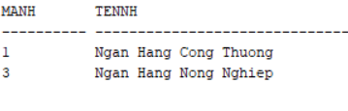
Câu 2:
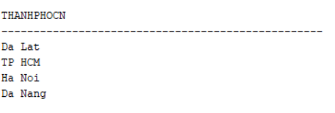
Câu 3:
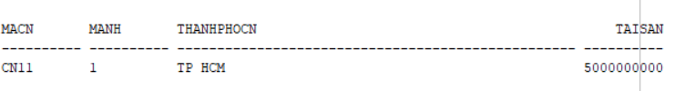
Câu 4:
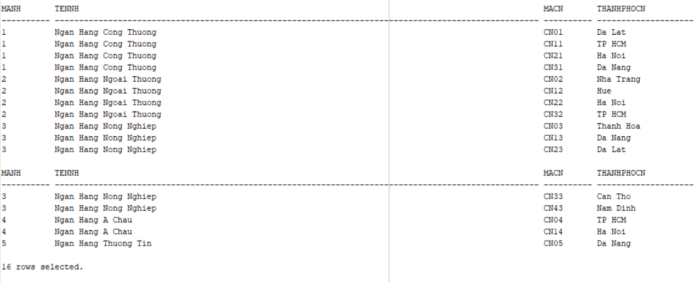
Câu 5:
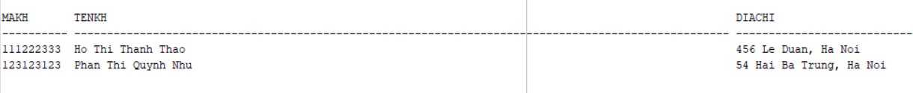
Câu 6:
Câu 7:
Câu 8:
Câu 9:
Câu 10:
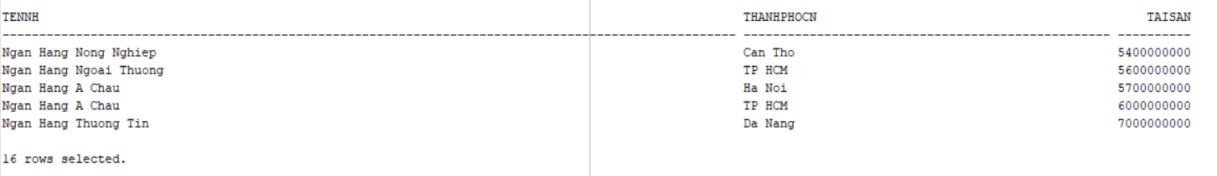
Câu 11:
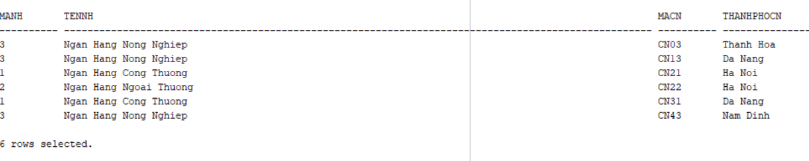
Câu 12:
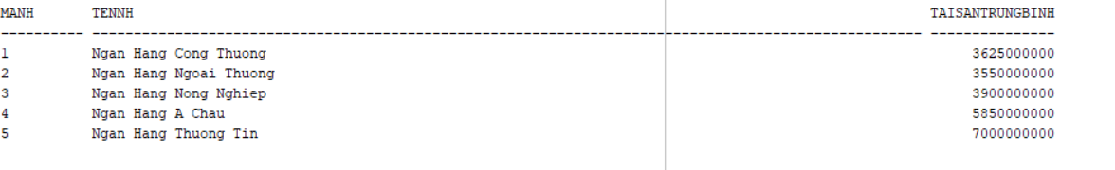
Câu 13:

Câu 1:

