**ASSIGNMENT—2**

1. Write a python program to design simple calculator for the operators

+ (addition),

* (subtraction),

* (multiplication),

/ (division),

% (modulus),

** (exponent),

// (Floor division).

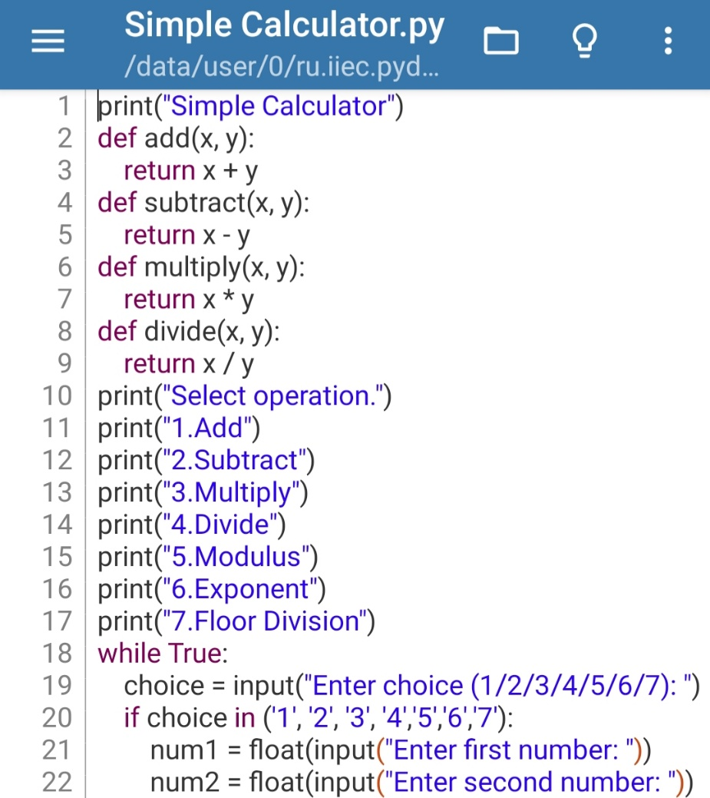Ans. **CODE:-**

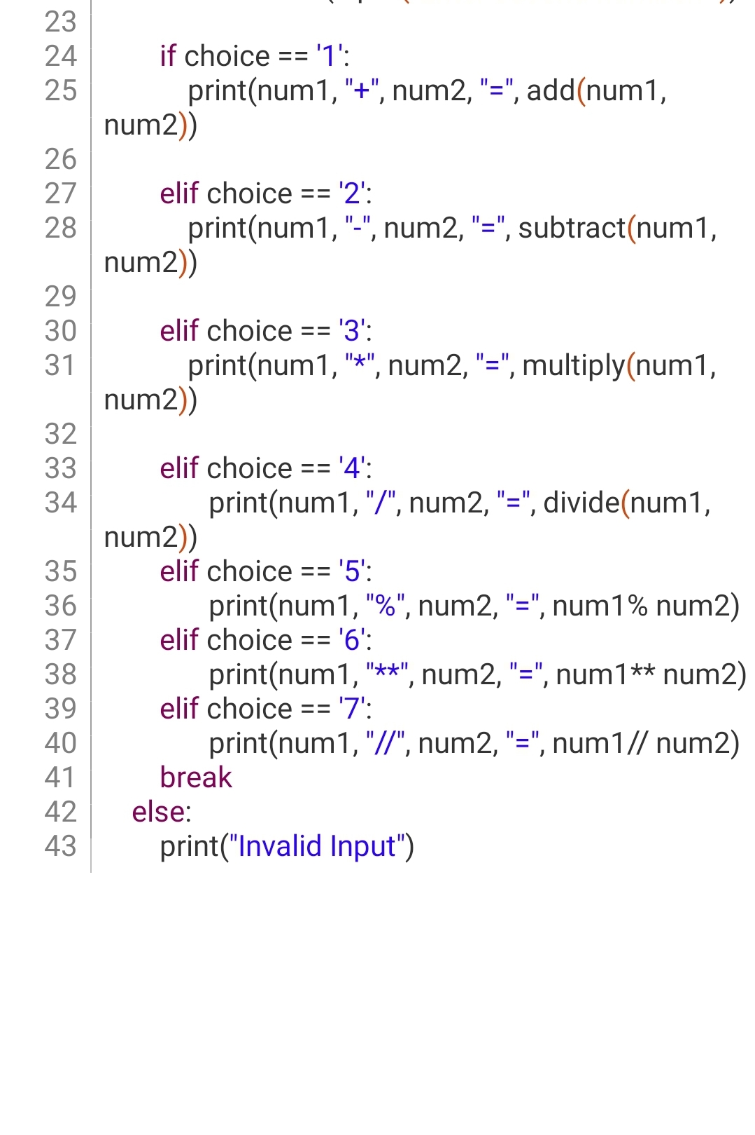

**OUTPUT:-**

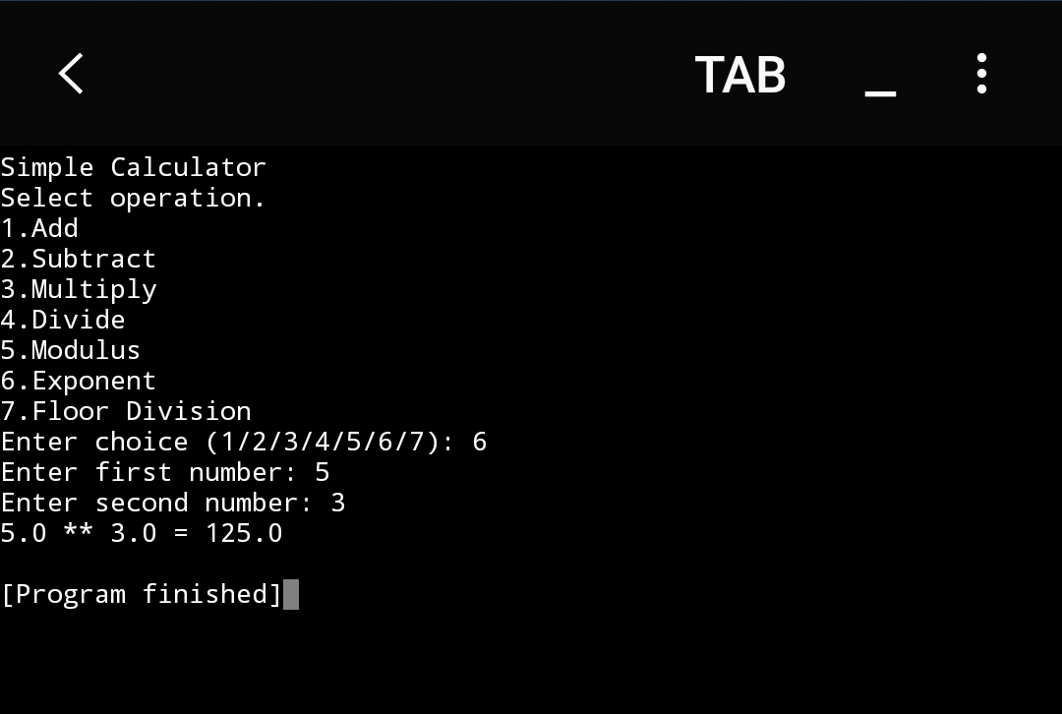

1. Write a python program to calculate simple interest.

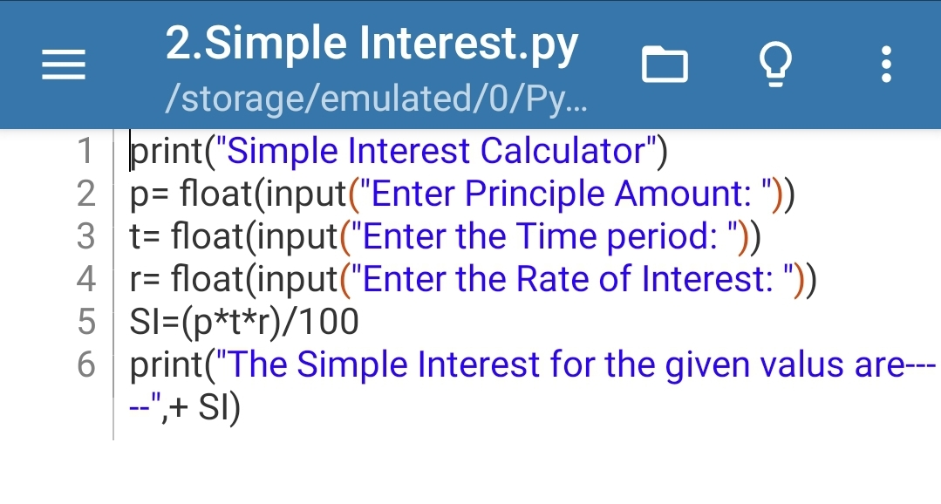Ans. CODE:-

**OUTPUT:-**

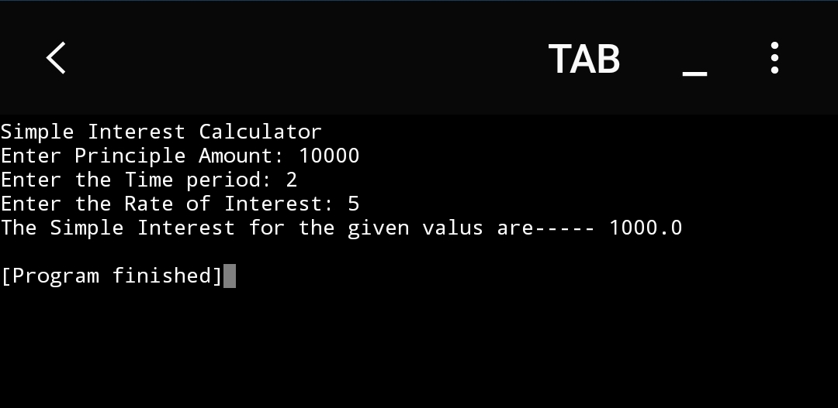

1. Write a python program to calculate area of a circle.

Ans. CODE:-

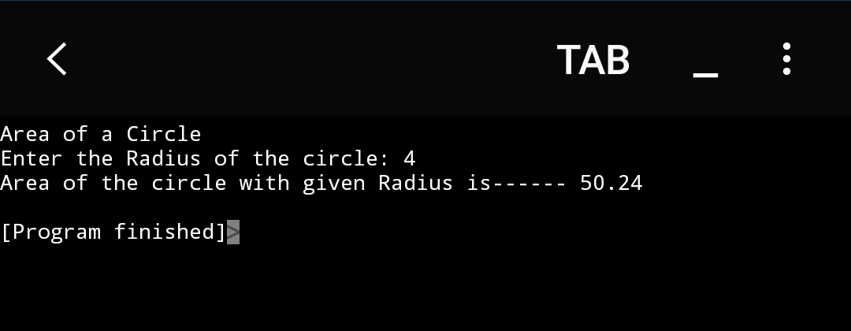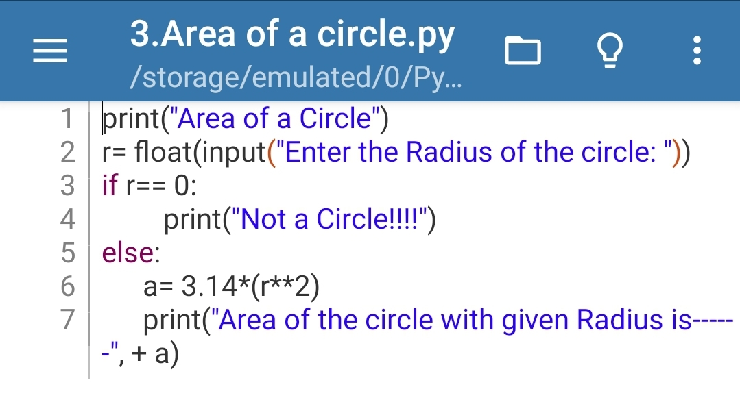 OUTPUT:-

1. Write a python program to calculate area of a triangle.

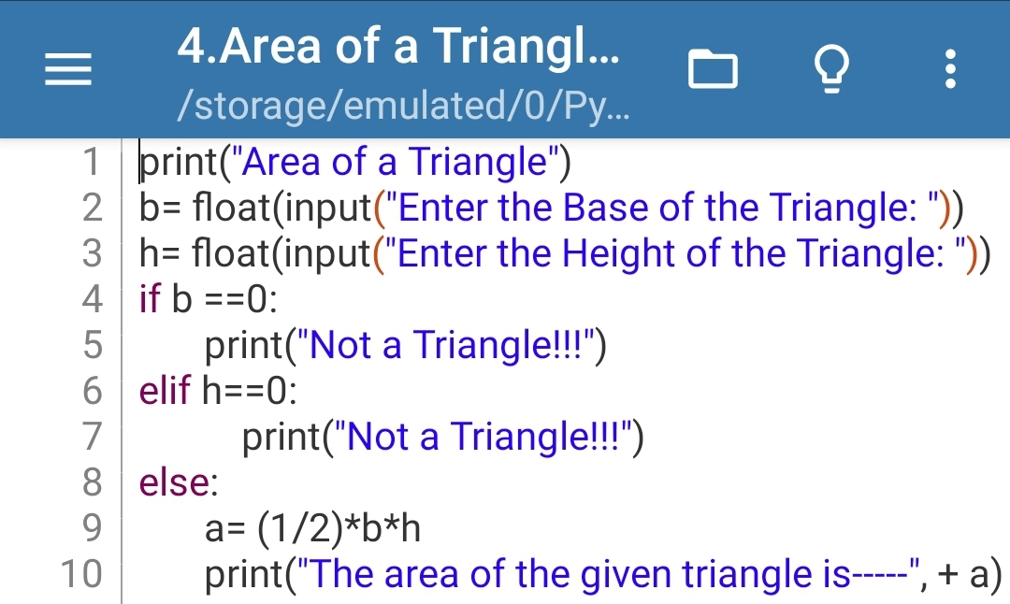Ans. CODE:-

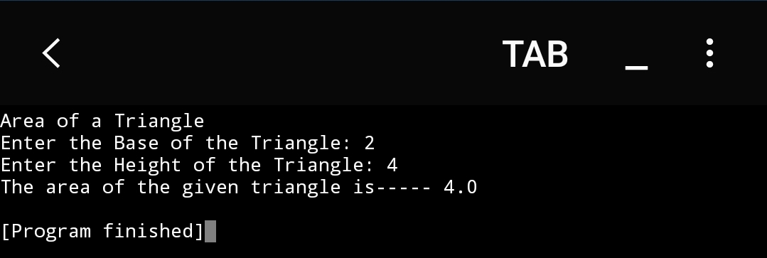 OUTPUT:-

1. Write a python program to temperature in Celsius to Fahrenheit.

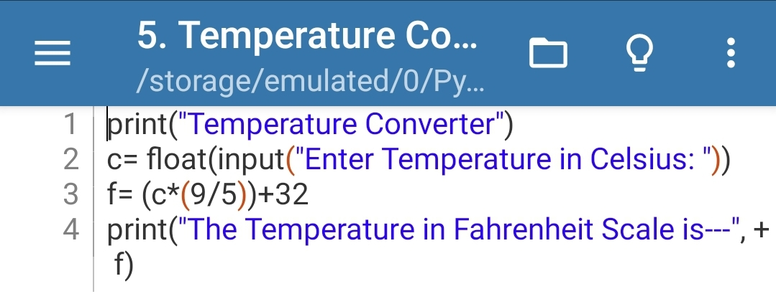Ans. CODE:-

OUTPUT:-

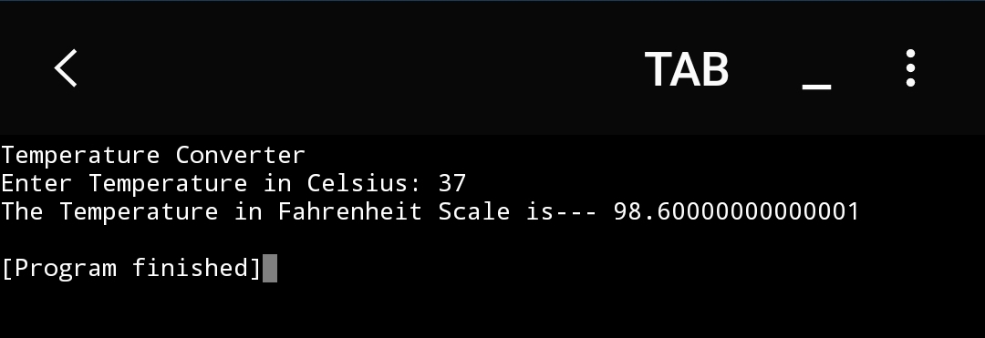

1. Write a python program to calculate area of rectangle.

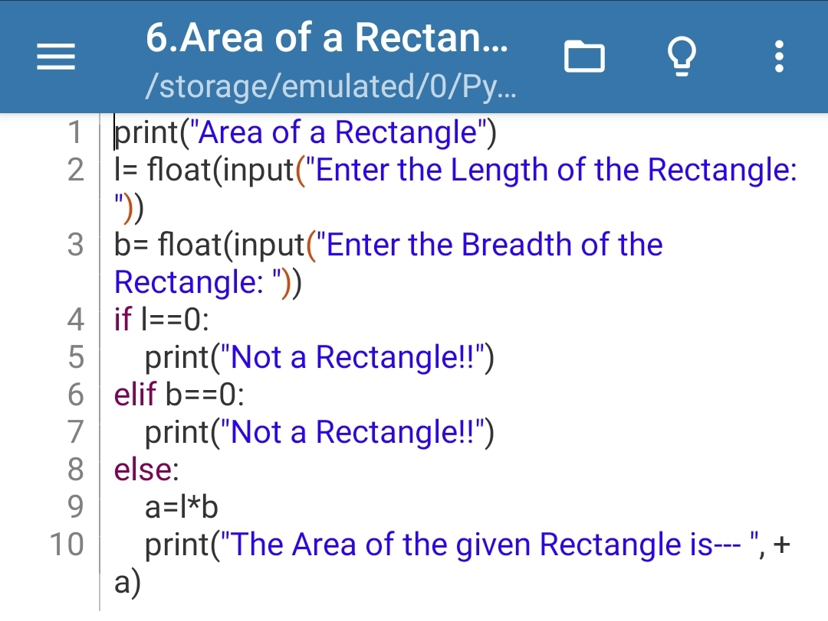Ans. CODE:-

1. 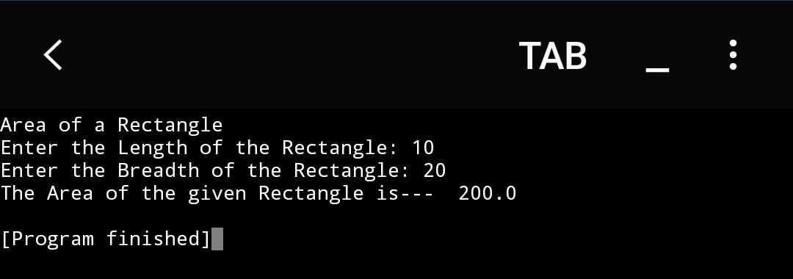**OUTPUT:-**
2. Write a python program to calculate perimeter of a square.

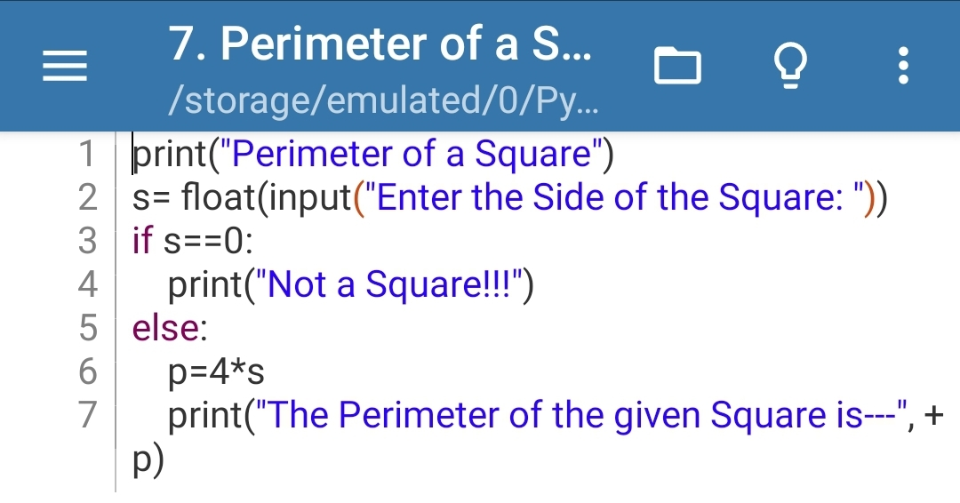Ans. CODE:-

**OUTPUT:-**

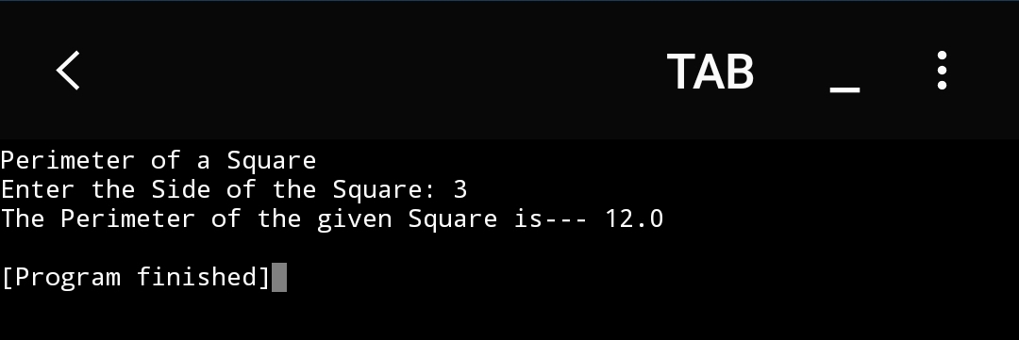

1. Write a python program to calculate circumference of a circle.

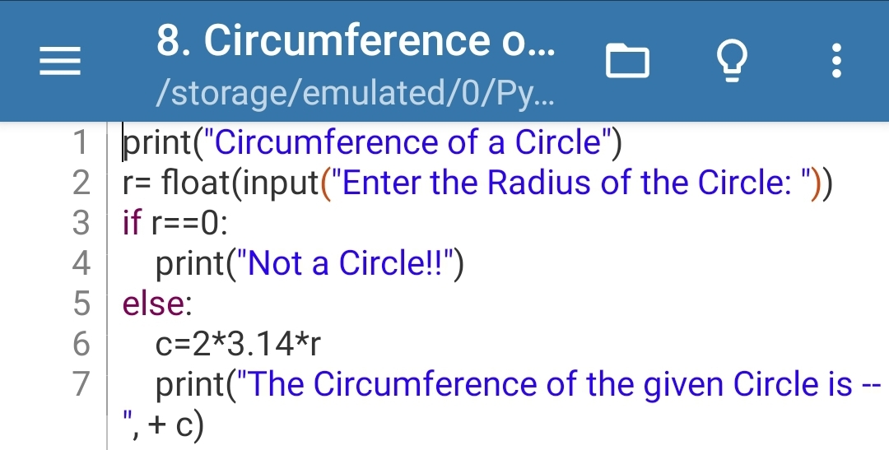Ans. CODE:-

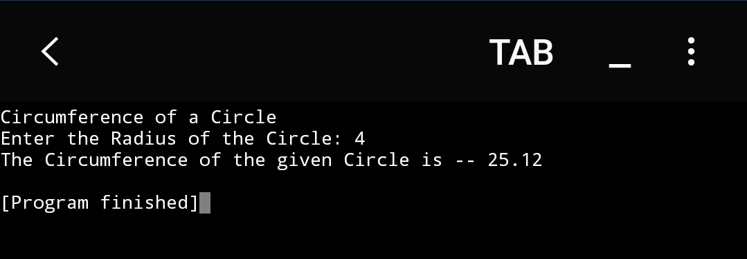OUTPUT:-

1. Write a python program to swap two numbers.

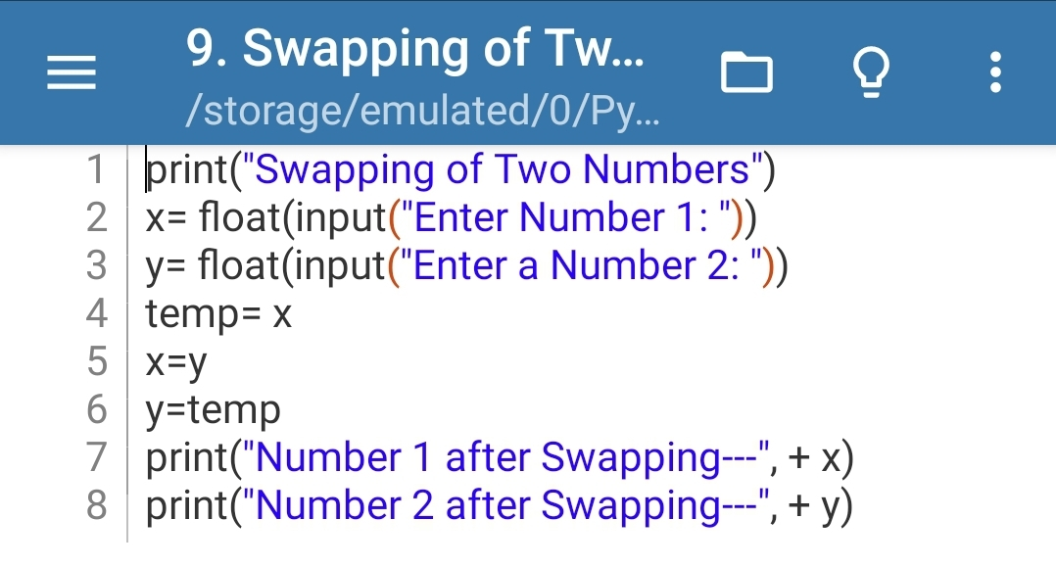Ans. CODE:-

OUTPUT:-

