**ASSIGNMENT**

1. **What is dictionary in Python? Explain with an example?**

**Ans.** Dictionaries are another example of a data structure. A dictionary is used to map or associate things you want to store the keys you need to get them. A dictionary in Python is just like a dictionary in the real world. Python Dictionary are defined into two elements Keys and Values.

* Keys will be a single element
* Values can be a list or list within a list, numbers, etc.

**Syntax for Python Dictionary**:

Dict = { ' Tim': 18, xyz,.. }

Dictionary is listed in curly brackets, inside these curly brackets, keys and values are declared. Each key is separated from its value by a colon (:) while each element is separated by commas.

**Properties of Dictionary Keys:**

There are two important points while using dictionary keys

* More than one entry per key is not allowed ( no duplicate key is allowed)
* The values in the dictionary can be of any type while the keys must be immutable like numbers, tuples or strings.
* Dictionary keys are case sensitive- Same key name but with the different case are treated as different keys in Python dictionaries.

**EXAMPLE:**

**CODE---**

**Dict = {'Tom': 18,'Jerry':12}**

**print (Dict['Jerry'])**

**OUTPUT---**

**12**

1. **What is dictionary in Python? Explain with an Example?**

**Ans.** Dictionaries are another example of a data structure. A dictionary is used to map or associate things you want to store the keys you need to get them. A dictionary in Python is just like a dictionary in the real world. Python Dictionary are defined into two elements Keys and Values.

* Keys will be a single element
* Values can be a list or list within a list, numbers, etc.

**Syntax for Python Dictionary**:

Dict = { ' Tim': 18, xyz,.. }

Dictionary is listed in curly brackets, inside these curly brackets, keys and values are declared. Each key is separated from its value by a colon (:) while each element is separated by commas.

**Properties of Dictionary Keys:**

There are two important points while using dictionary keys

* More than one entry per key is not allowed ( no duplicate key is allowed)
* The values in the dictionary can be of any type while the keys must be immutable like numbers, tuples or strings.
* Dictionary keys are case sensitive- Same key name but with the different case are treated as different keys in Python dictionaries.

**EXAMPLE:**

**CODE---**

**Dict = {'Tom': 18,'Jerry':12}**

**print (Dict['Jerry'])**

**OUTPUT---**

**12**

1. **Write a Python program to sum all the items in a list?**

**Ans. CODE---**

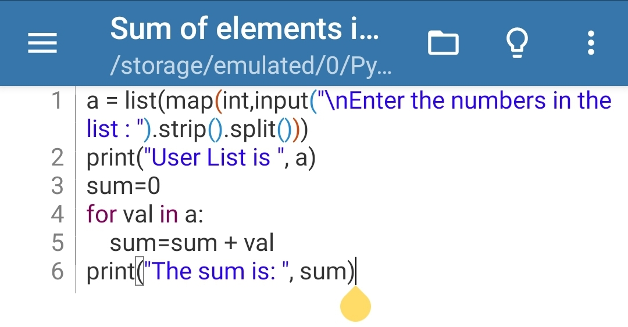**OUTPUT---**

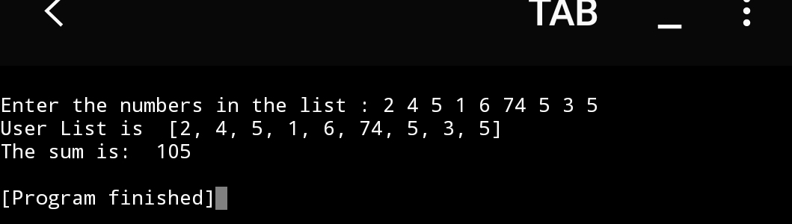

1. **Write a Python program to create a list of empty dictionaries?**

**Ans. CODE---**

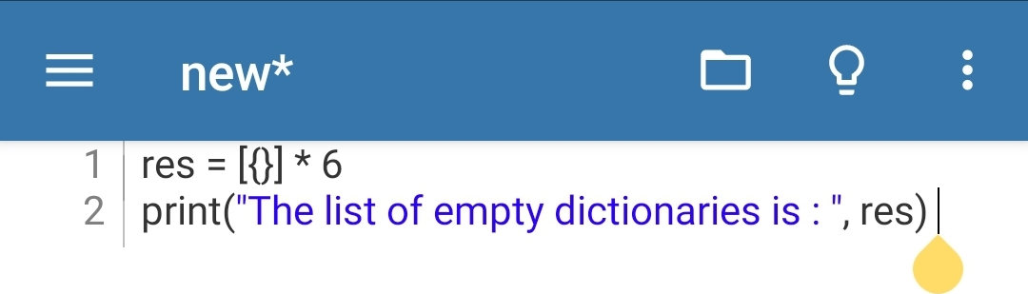**OUTPUT---**

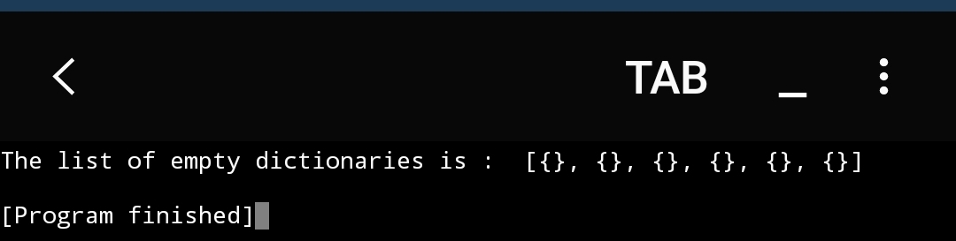

1. **Write a Python program to access dictionary keys element by index?**

**Ans. CODE---**

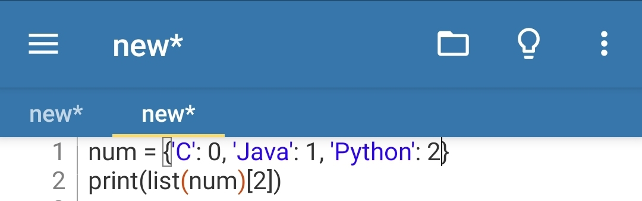**OUTPUT---**

