**ASSIGNMENT**

# Take two inputs from user and check whether they are equal or not.

Ans. CODE---

x= input("Enter something: ")

y= input("Enter something: ")

if x==y:

print("EQUAL")

else:

print("Not Equal!!!!")

OUTPUT----

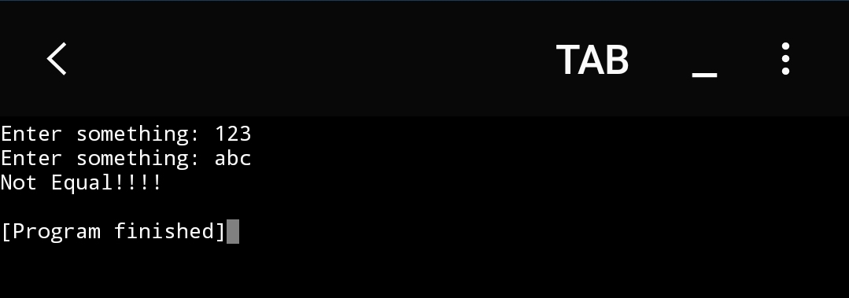

1. Take 3 inputs from user and check :  
              all are equal  
              any of two are equal  
              ( use **and or )**

Ans. CODE---

x= input("Enter something (x): ")

y= input("Enter something (y): ")

z= input("Enter something (z): ")

if x==y and y==z and z==x:

print("All 3 are EQUAL")

elif x==y or y==z or z==x:

print("Only Two are EQUAL")

else:

print("None are Equal!!!!")

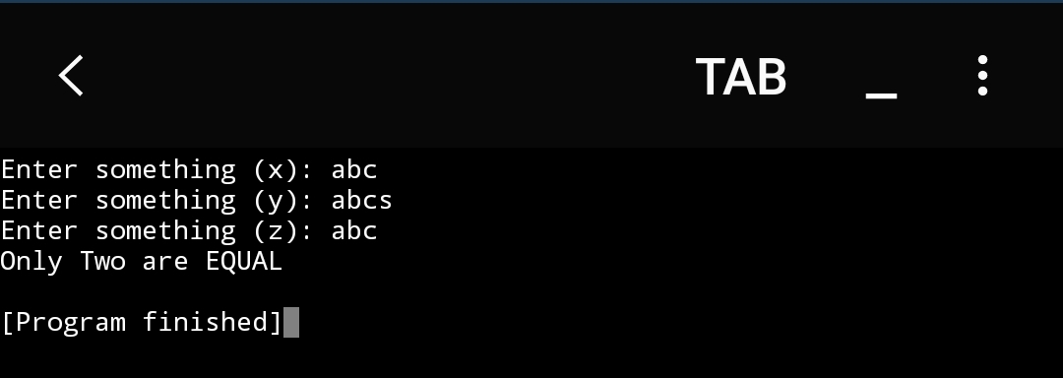OUTPUT-----

1. Take two number and check whether the sum is greater than 5, less than 5 or equal to 5.

Ans. CODE-----

x= float(input("Enter a Number: "))

y= float(input("Enter a Number: "))

sum= x+y

if sum==5:

print("Sum is Equal to 5.....")

elif sum>5:

print("Sum is Greater than 5.....")

else:

print("Sum is Less than 5.......")

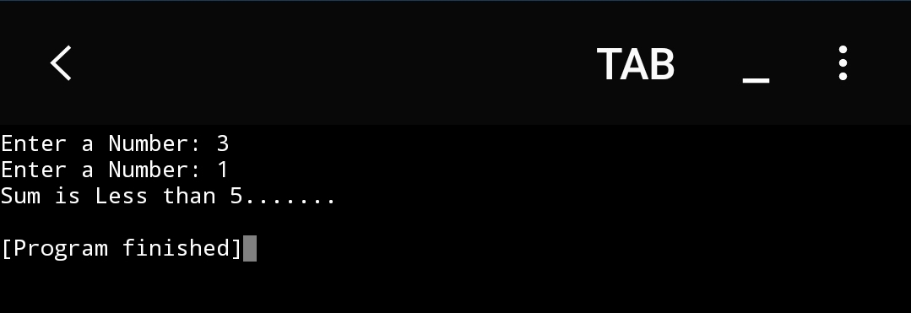 OUTPUT-----

1. Suppose passing marks of a subject is 35. Take input of marks from user and check whether it is greater than passing marks or not.

Ans. CODE-----

x= float(input("Enter Your Marks: "))

if x>35:

print("You Secured more than 35 and You are Passed in this Subject...")

else:

print("Sorry!! You secured less than 35 and you Failed in this Subject!!!")

OUTPUT-----

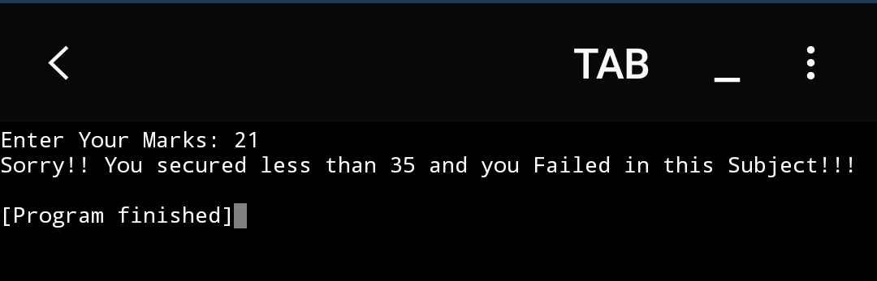

1. Write a Python function to find the Max of three numbers

Ans. CODE-----

def maximum(a, b, c):

if (a >= b) and (a >= c):

largest = a

elif (b >= a) and (b >= c):

largest = b

else:

largest = c

return largest

a = float(input("Enter a number: "))

b = float(input("Enter a number: "))

c = float(input("Enter a number: "))

print("The Maximum Number is--", + maximum(a, b, c))

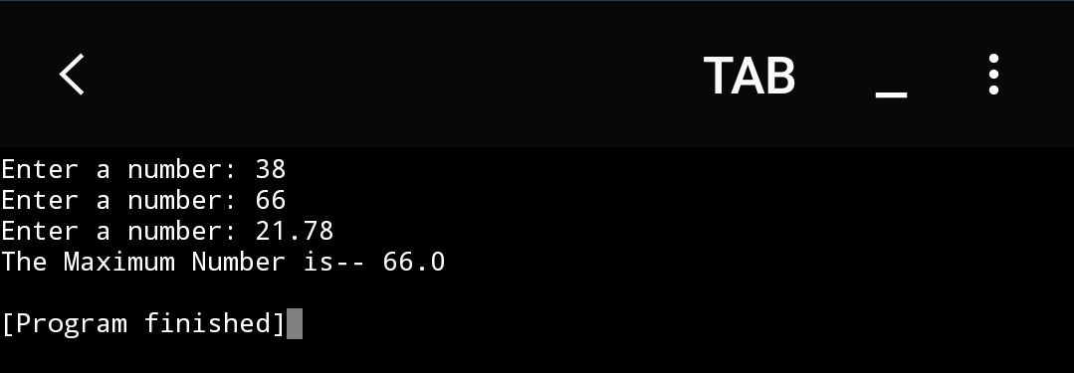OUTPUT-----