**ASSIGNMENT**

1. Write a Python function to find the Max of three numbers.

Ans. CODE---

def maximum(a, b, c):

if (a >= b) and (a >= c):

largest = a

elif (b >= a) and (b >= c):

largest = b

else:

largest = c

return largest

a = float(input("Enter a number: "))

b = float(input("Enter a number: "))

c = float(input("Enter a number: "))

print("The Maximum Number is--", maximum(a, b, c))

OUTPUT---

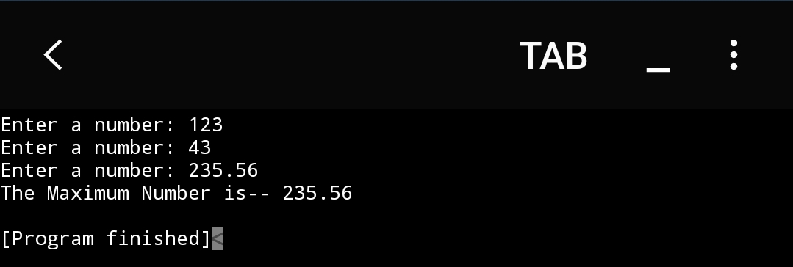

1. Write a Python program to reverse a string.

Ans. CODE—

def reverse(x):

return x[::-1]

a= input("Enter a String: ")

print("The Reversed String: ", reverse(a))

OUTPUT---

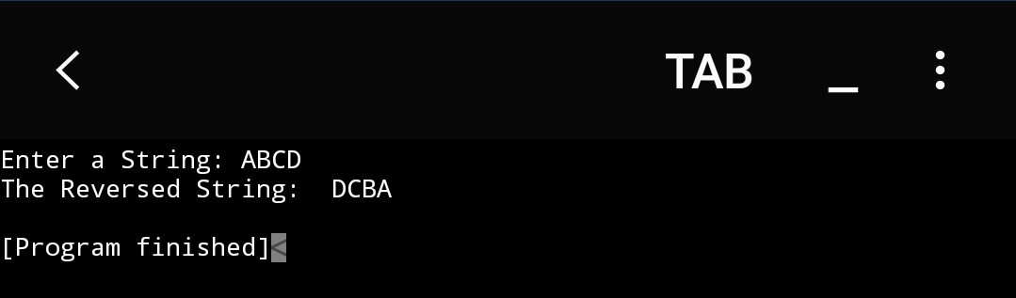

1. Write a Python function to check whether the number is prime or not.

Ans. CODE—

def test_prime(n):

if (n==1):

return print(n,"is neither prime nor composite")

elif (n==2):

return print(n,"is a Prime Number")

else:

for x in range(2,n):

if(n % x==0):

return print(n,"is Not a prime number")

return print(n,"is a Prime number")

a=int(input("Enter a number: "))

print(test_prime(a))

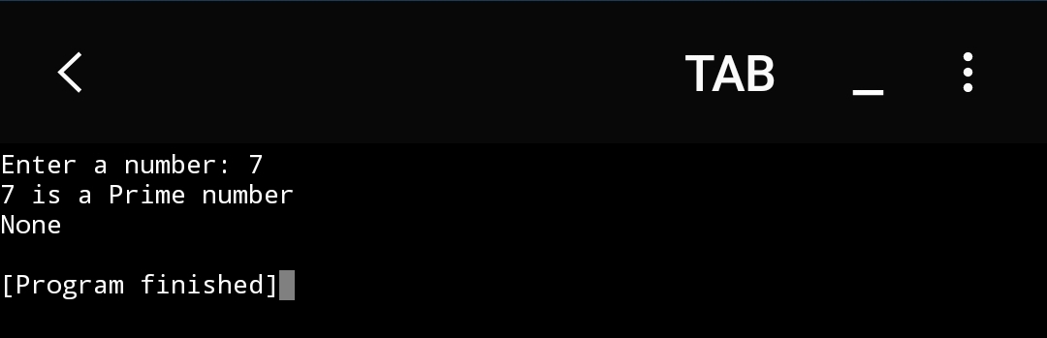 OUTPUT----

1. Use try, except, else and finally block to check whether the number is palindrome or not.(Raise error when input is not proper).

Ans. CODE----

a = input('Enter any number : ')

try:

b= int(a)

if a == str(a)[::-1]:

print('The given number is PALINDROME')

else:

print('The given number is NOT a palindrome')

except ValueError:

print("That's not a valid number, Try Again !")

finally :

print("Thank you!!")

OUTPUT---

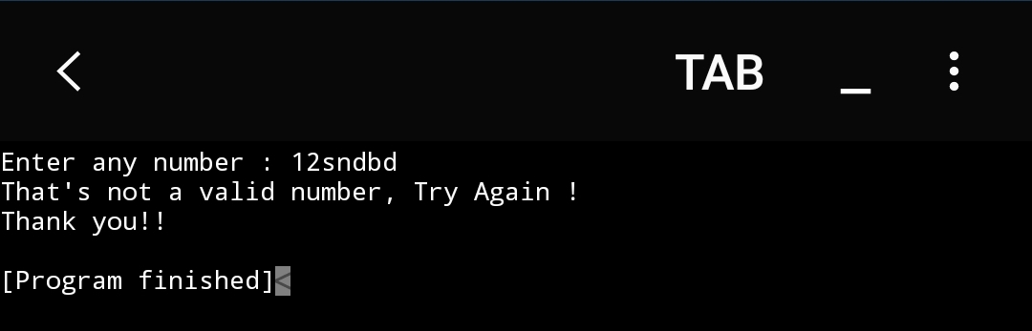

1. Write a python function to find sum of squares of first n natural numbers.

Ans. CODE---

def square(x):

sum=0

for i in range(1, x+1):

sum+=(i**2)

return sum

n= int(input("Enter the number of natural numbers you want the sum of squares for--- "))

print("The sum is ----- ", square(n))

OUTPUT---

