**ASSIGNMENT**

1. Write a python program to find the area of a circle using math function?

Ans. CODE---

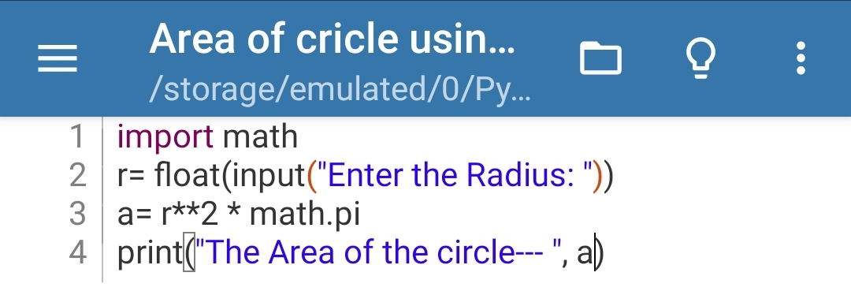 OUTPUT---

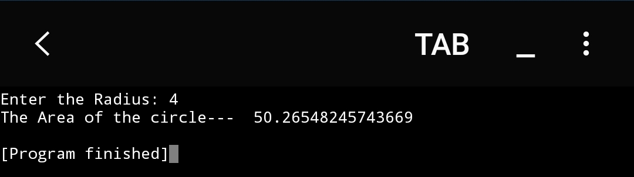

1. Write a python program to find the area of a regular polygon?

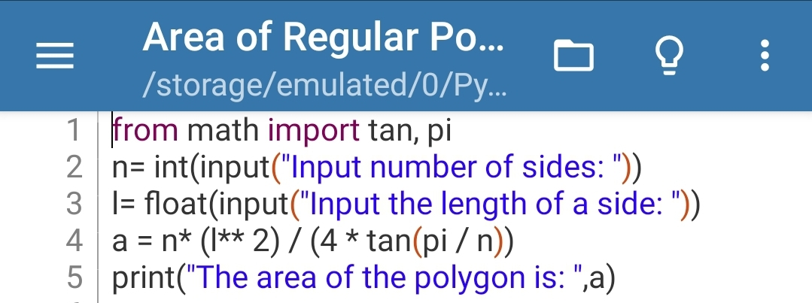Ans. CODE---

OUTPUT---

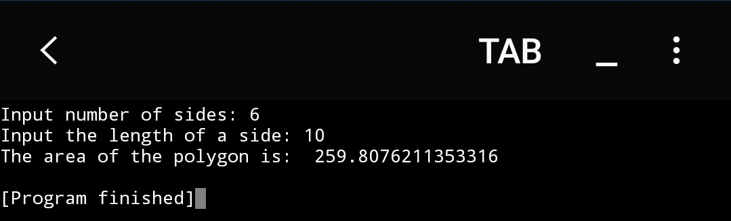

1. Write a program to generate the random numbers between 1 and 1000?

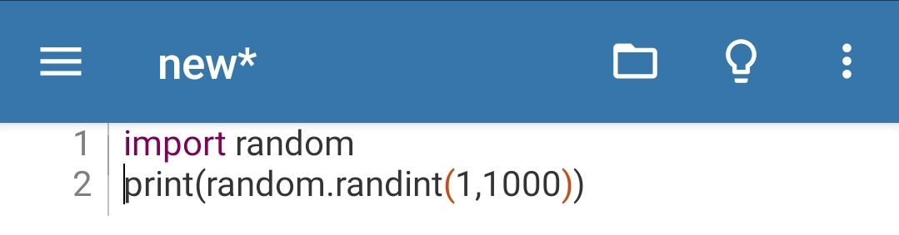Ans. CODE---

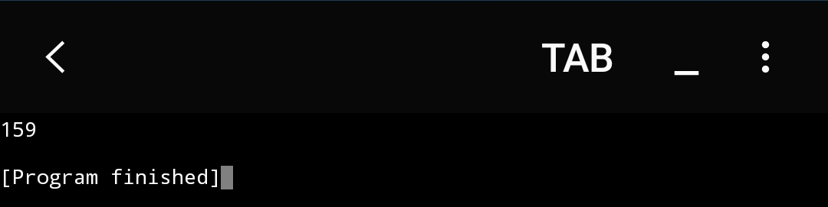 OUTPUT---

1. Write a python program by using math module to find----

Sin(60):

Cos(pi):

Tan(90):

5^8:

Square Root 400:

Floor and Ceiling value of 23.56:

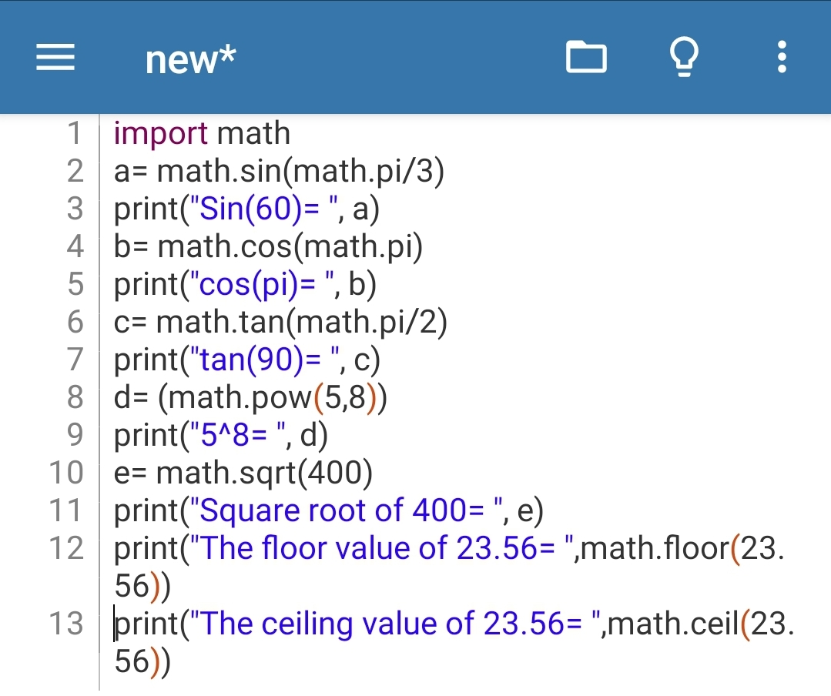Ans. CODE---

OUTPUT---

