**ASSIGNMENT**

1. Write a python program to convert binary number to decimal number?

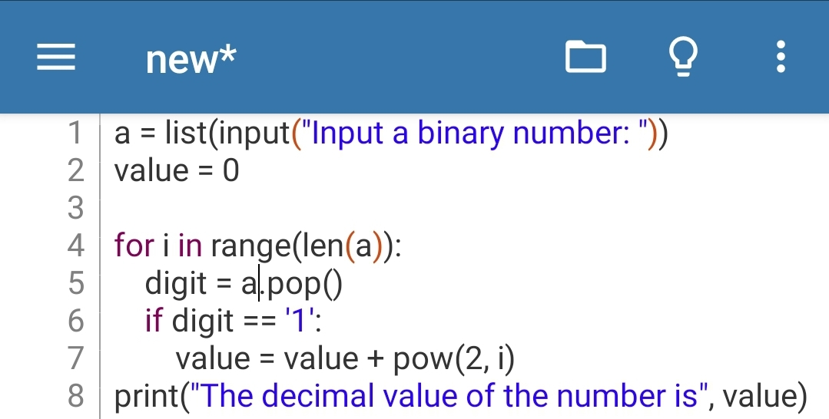**Ans.**  CODE----

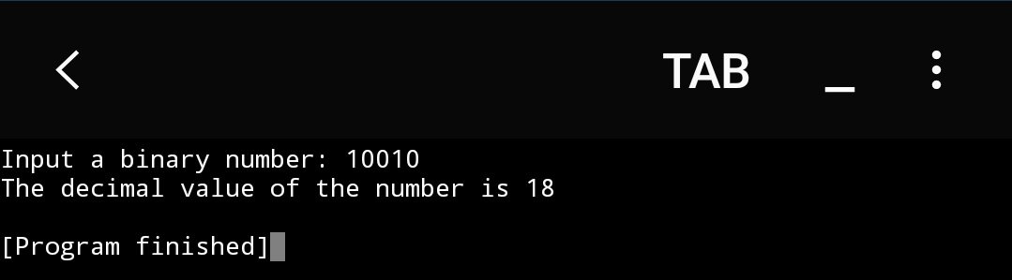 OUTPUT---

1. Write a python program to generate the first N numbers of Fibonacci numbers. Take the value of N from user?

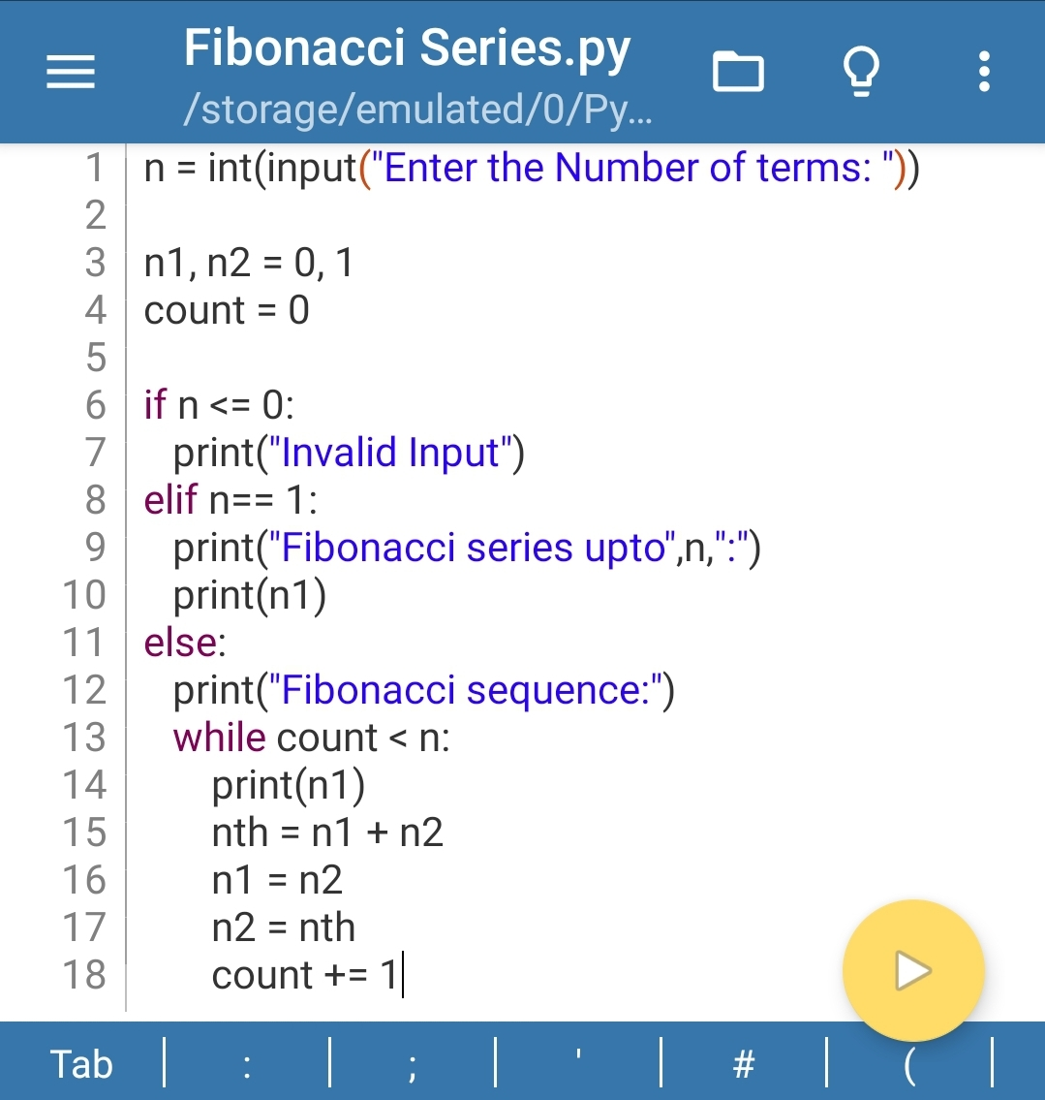**Ans.** CODE---

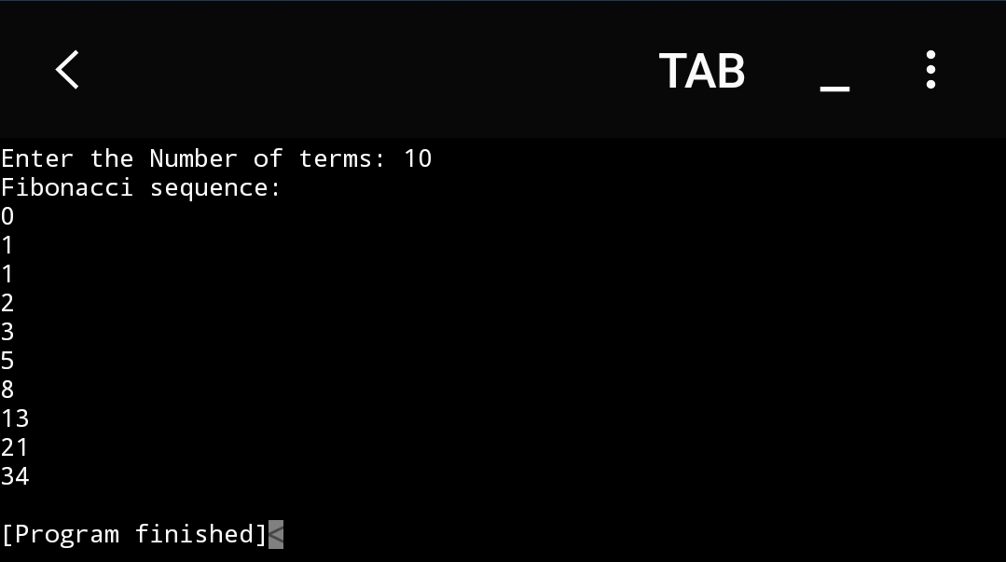 OUTPUT---

1. Write a python program to display the multiplication table of K. Take K value from user?

**Ans. CODE---**

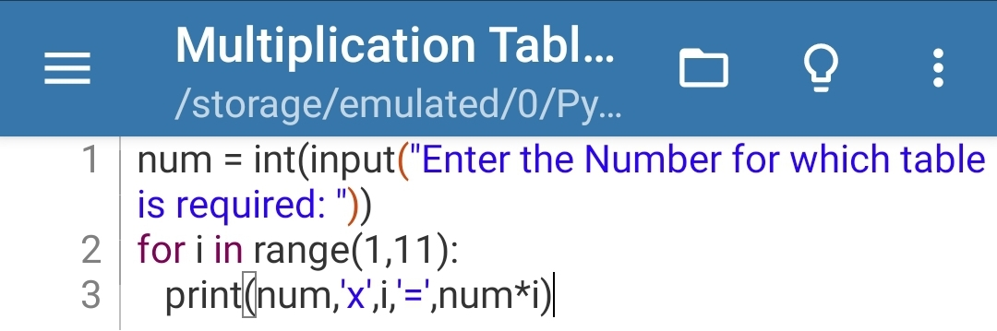 **OUTPUT---**

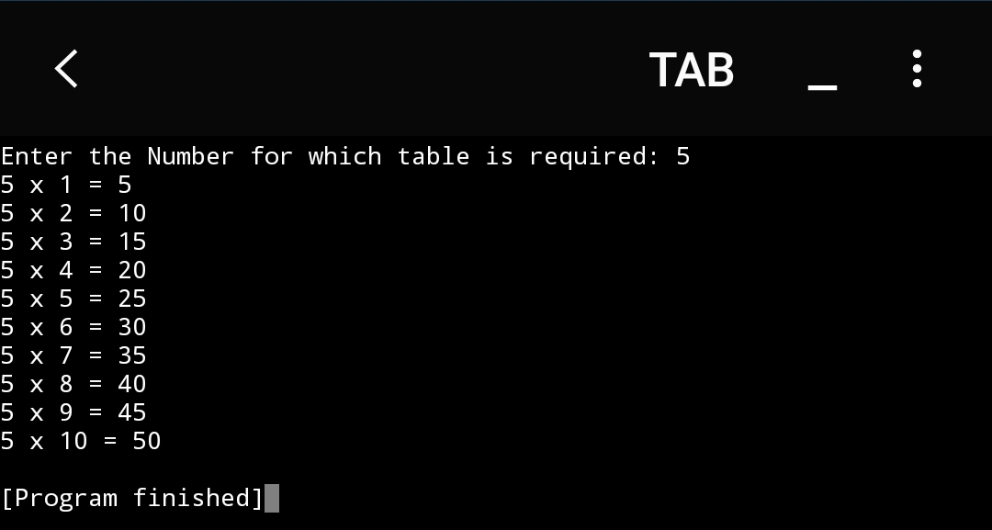

1. **Write a python program to take 10 integers from keyboard using loop and print their average value on the screen?**

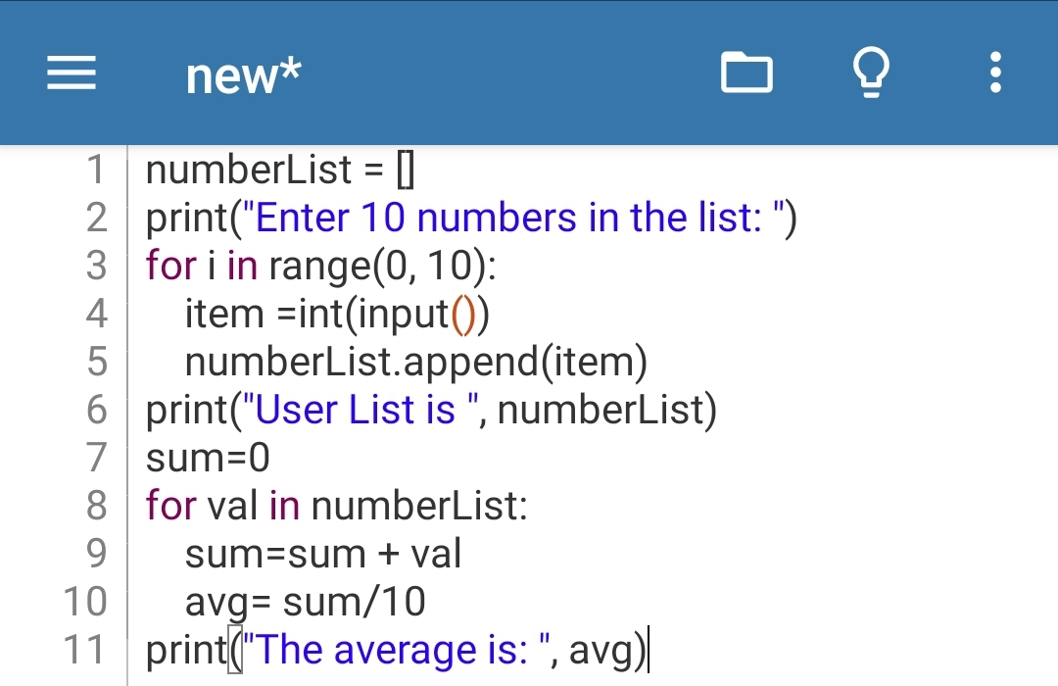**Ans. CODE---**

**OUTPUT---**

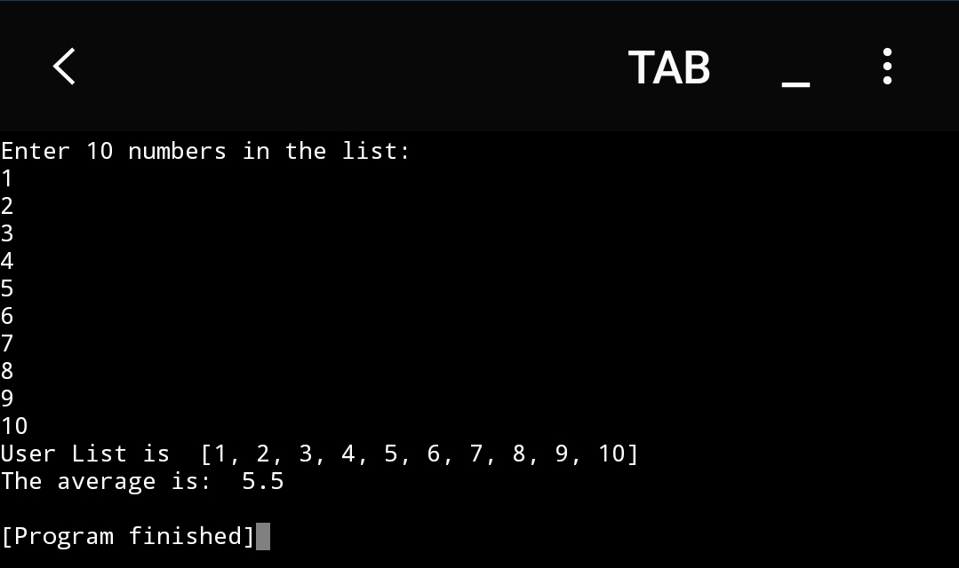

* **Write a python program to print the following pattern,**

**\***

**\*\***

**\*\*\***

**\*\*\*\***

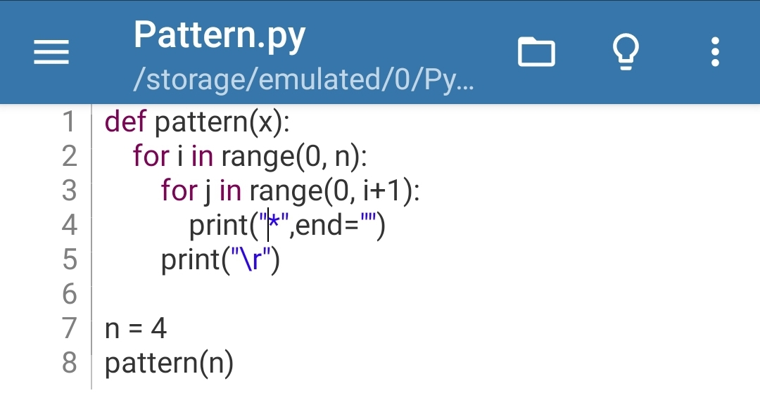**Ans. CODE---**

**OUTPUT---**

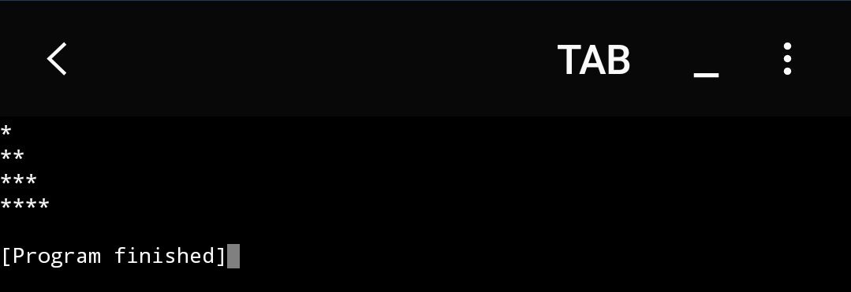

1. **Write a python program to find GCD or HCF of given two numbers?**

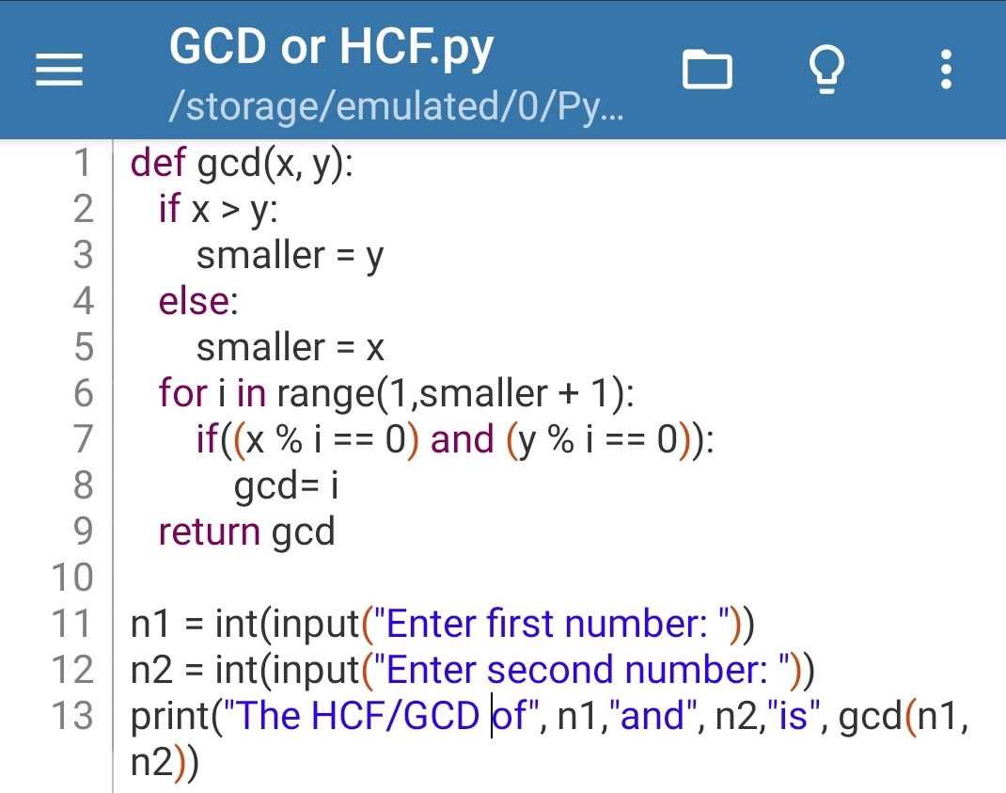**Ans. CODE---**

**OUTPUT---**

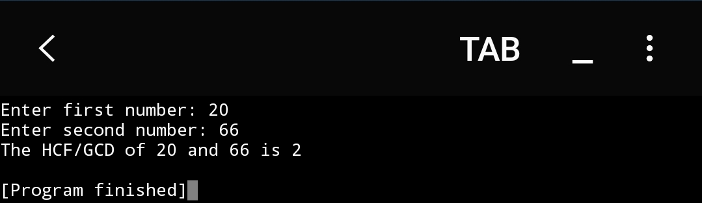

1. **Write a python program that accepts a word from the user and reverses it?**

**Ans. CODE---**

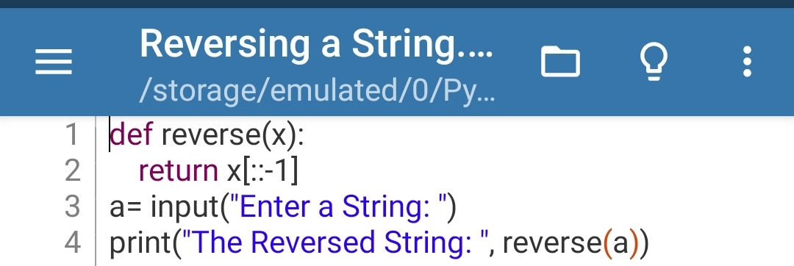 **OUTPUT---**

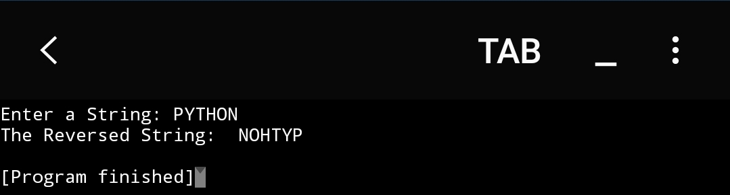

1. **Write a python program to count the number of even and odd numbers from a series of numbers?**

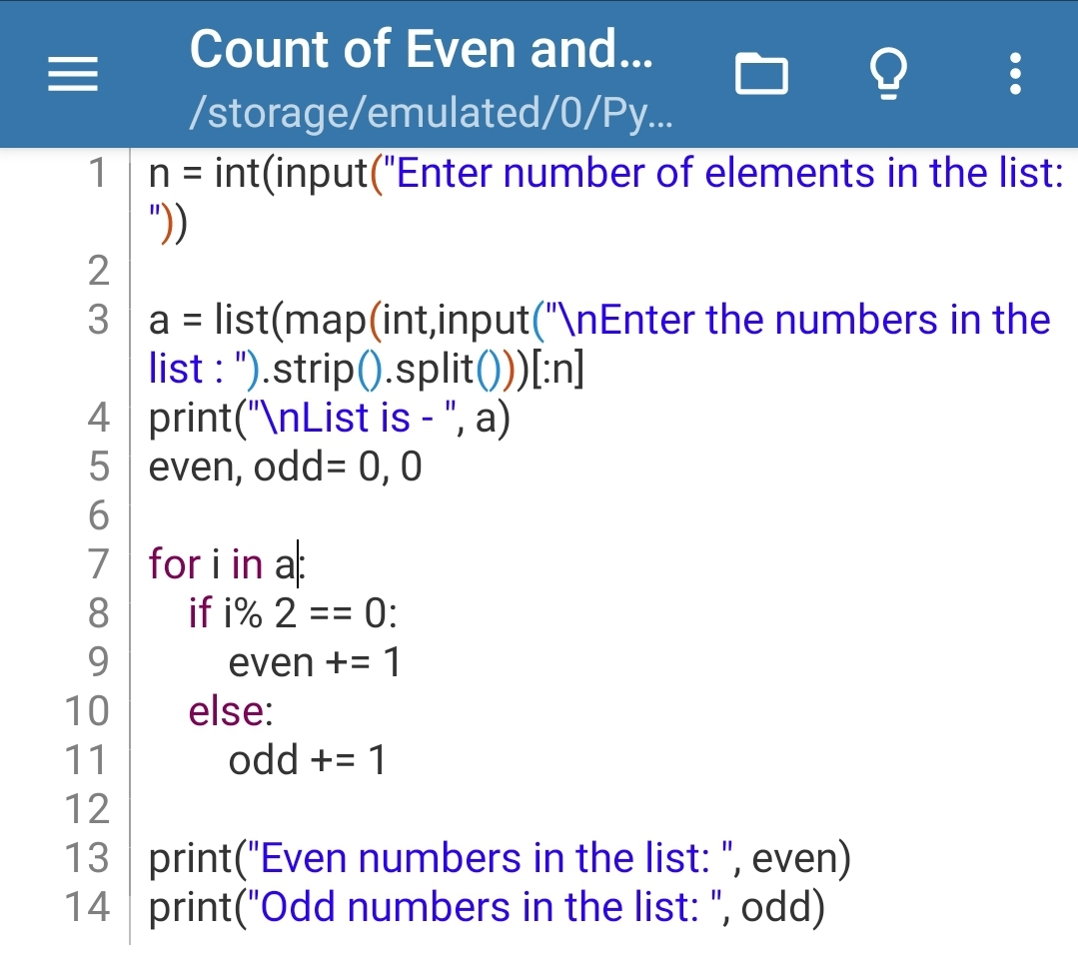**Ans. CODE---**

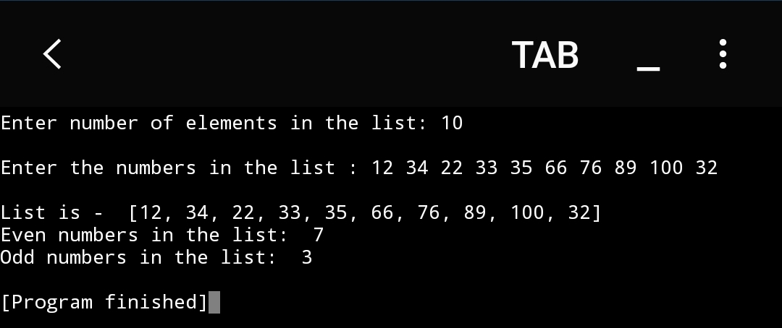**OUTPUT---**

1. **Write a python program that prints all the numbers from 0 to 6 except 3 and 6?**

**Ans. CODE---**

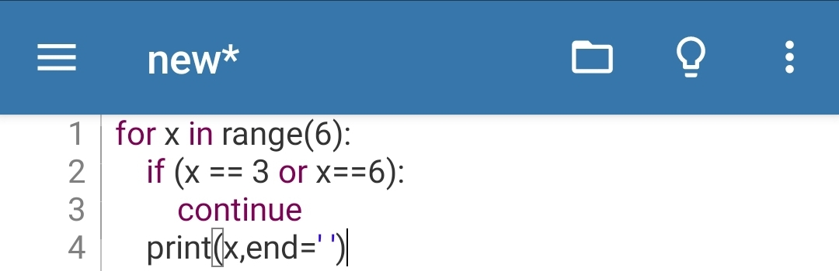 **OUTPUT---**

