**ASSIGNMENT**

1. **Write a python program to calculate length of a string?**

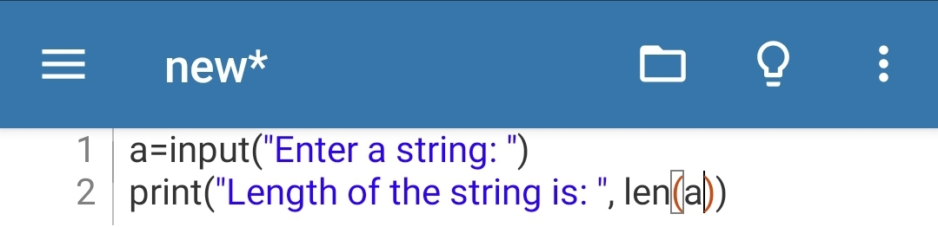**Ans. CODE---**

**OUTPUT---**

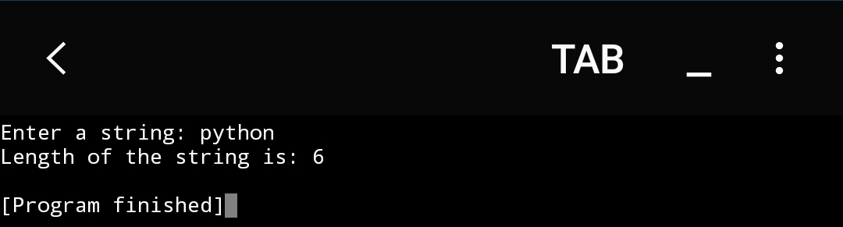

1. **Write a python program to count the number of characters (characters frequency in string)?**

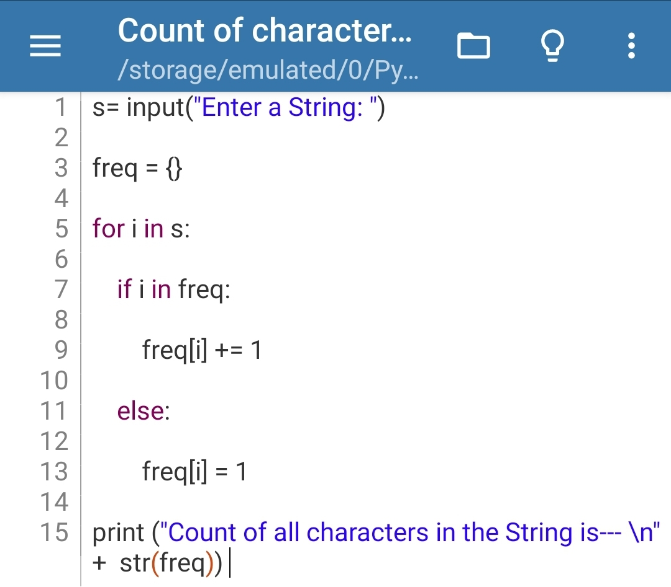**Ans. CODE---**

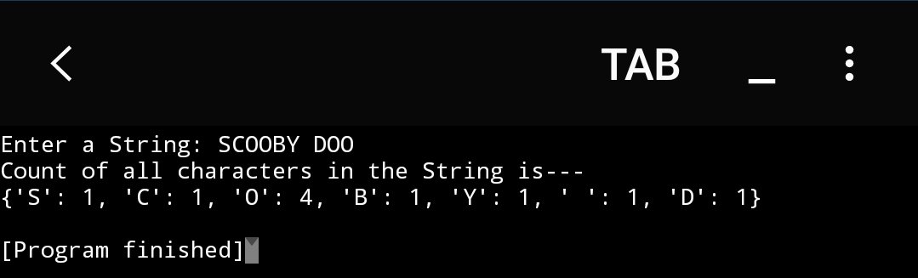**OUTPUT---**

1. **Write a python program to get a single string from two given string?**

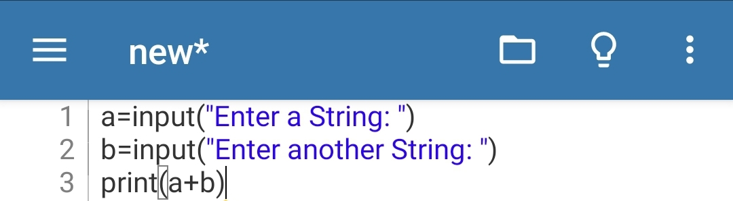**Ans. CODE---**

**OUTPUT---**

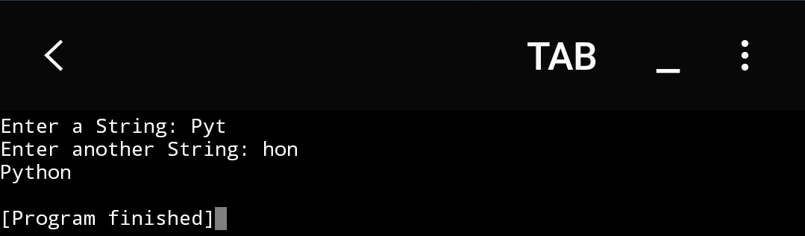

1. **Write a python program to convert string in a list?**

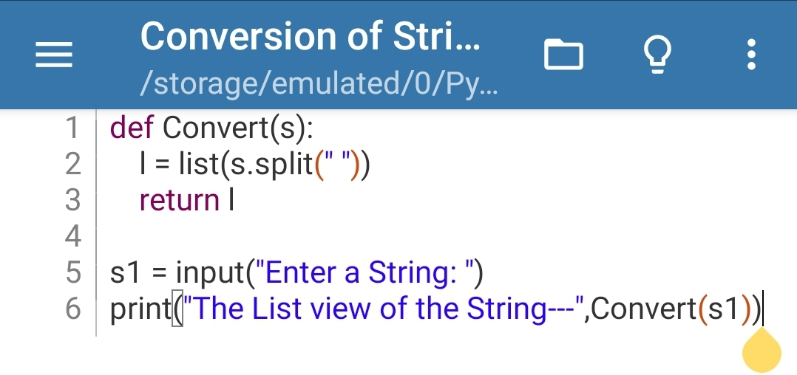**Ans. CODE---**

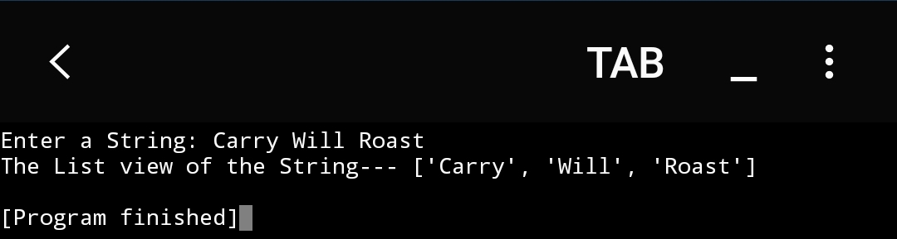**OUTPUT---**

1. **Write a Python program to remove the characters which have odd index values of a given string?**

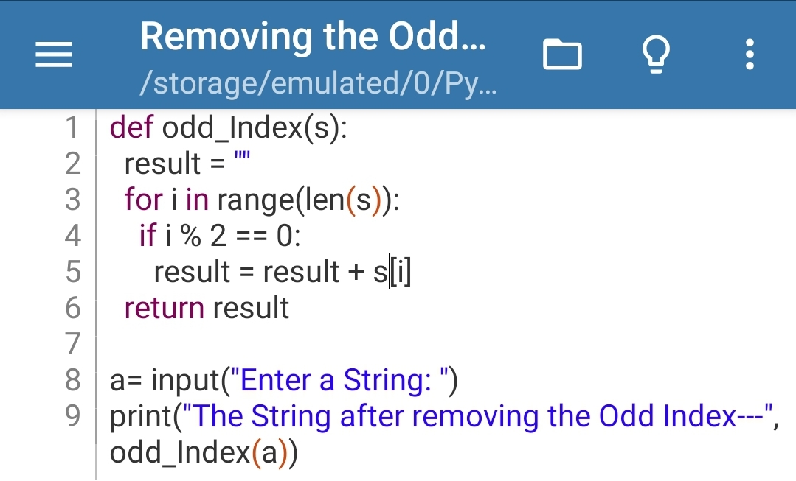**Ans. CODE---**

**OUTPUT---**

