**ASSIGNMENT**

1. **Write a python program to Print First 10 natural numbers using while loop?**

**Ans. CODE---**

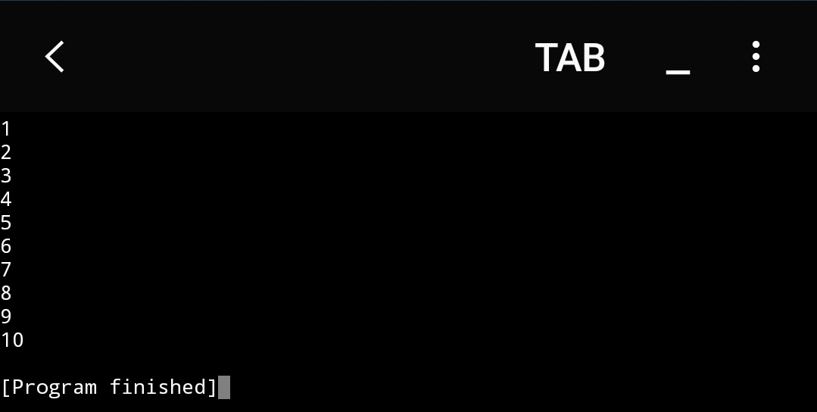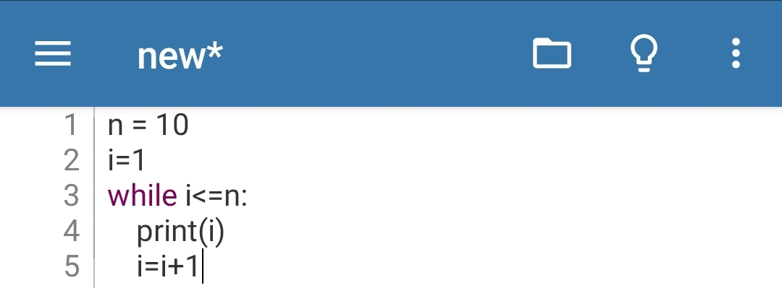 **OUTPUT---**

1. **Write a python program to sort array element in the ascending/descending order?**

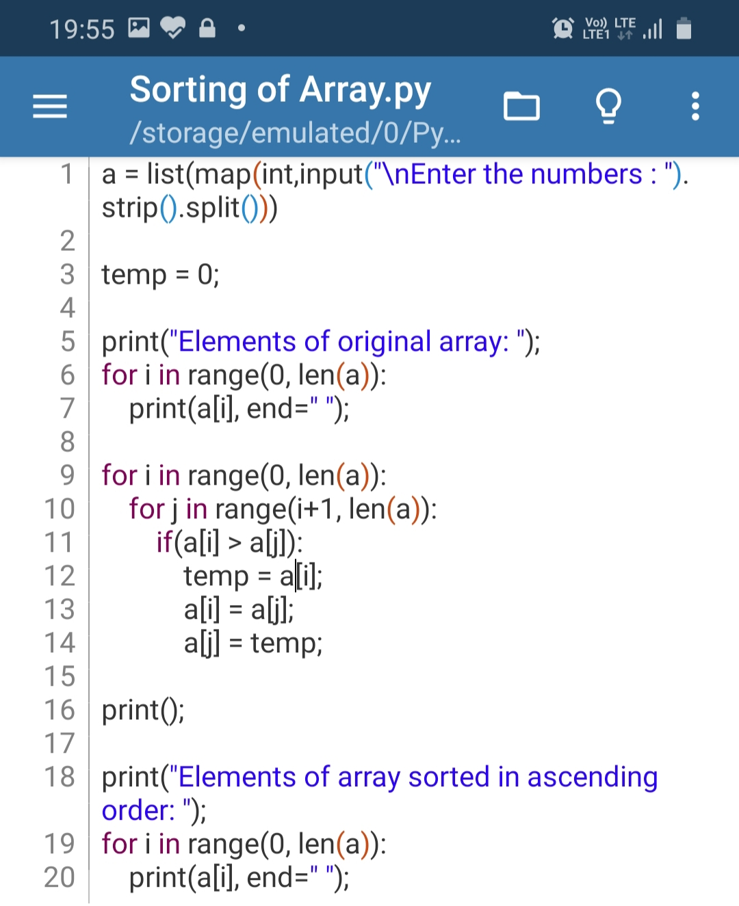**Ans. CODE---**

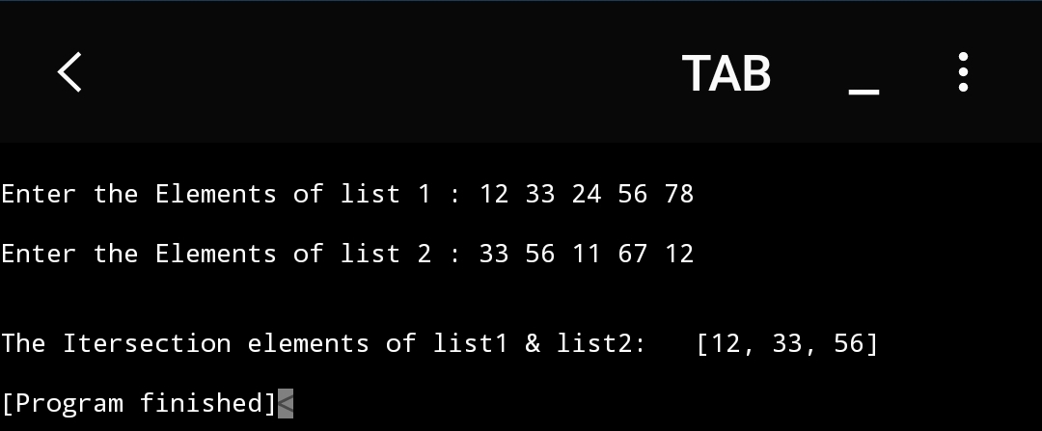**OUTPUT---**

1. **Write a python program to find the maximum and minimum number in a list of 10 elements and also find the index position of the following numbers?**

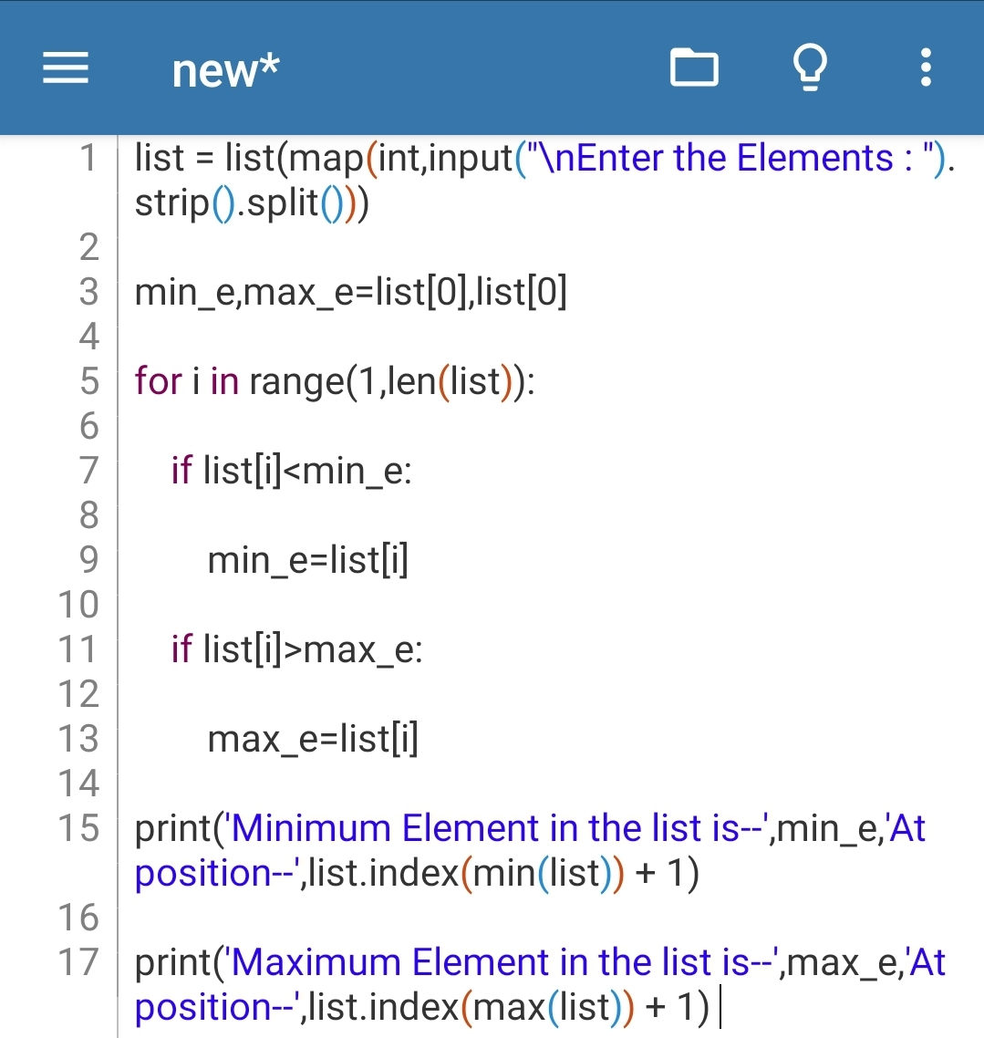**Ans. CODE---**

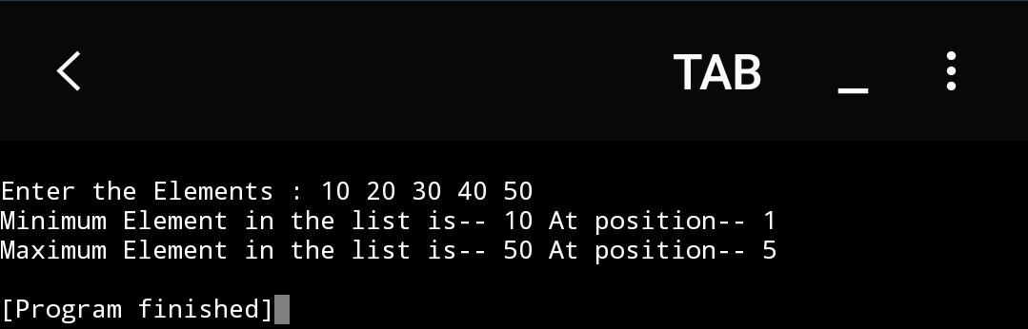**OUTPUT---**

1. **Write a python program to find the intersection of elements from two list?**

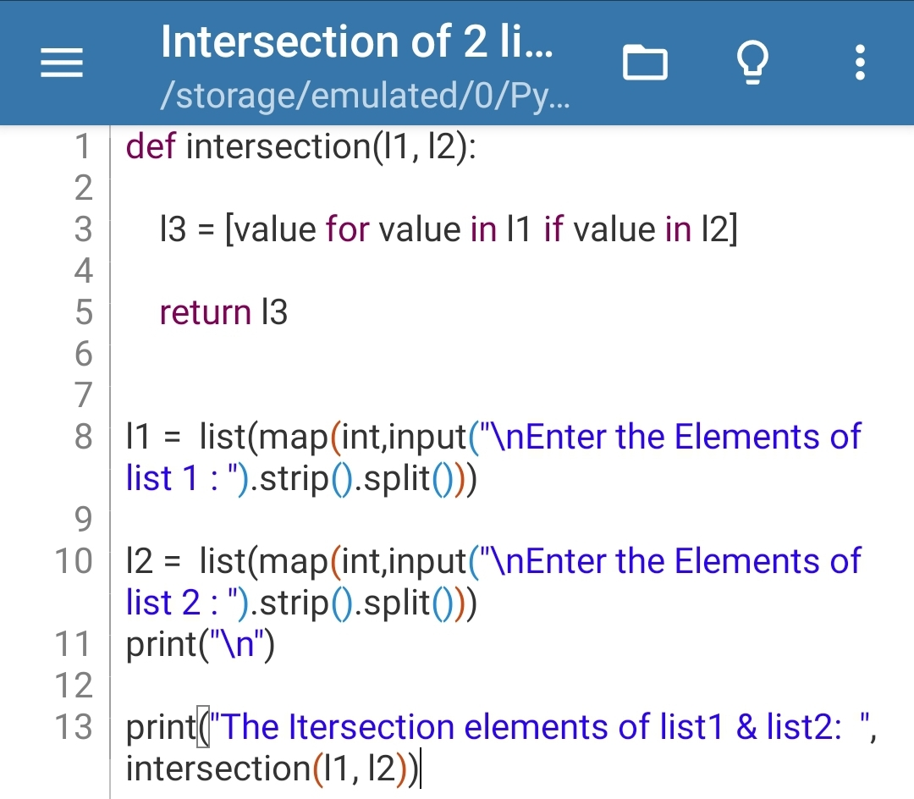**Ans. CODE---**

**OUTPUT---**

**5. Write a python program to fetch only Email ID from text file which include following fields -:**

**i)Name**

**ii)Mobile Number**

**iii)Roll Number**

**iv)Email ID**

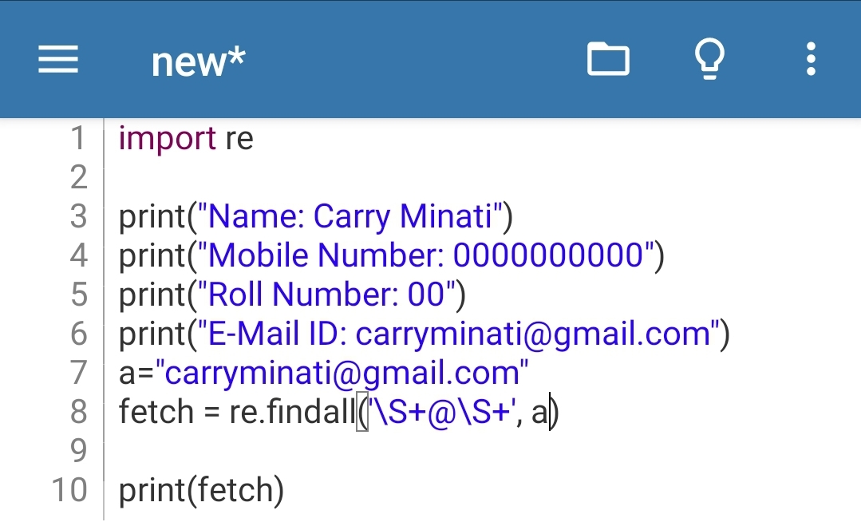**Ans. CODE---**

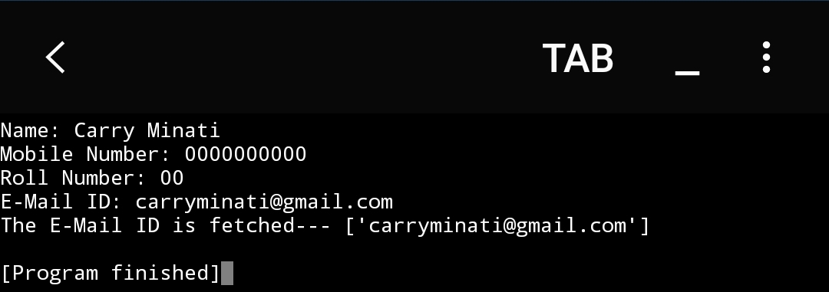**OUTPUT---**