**ASSIGNMENT**

1. Write a python program to read an entire text file?

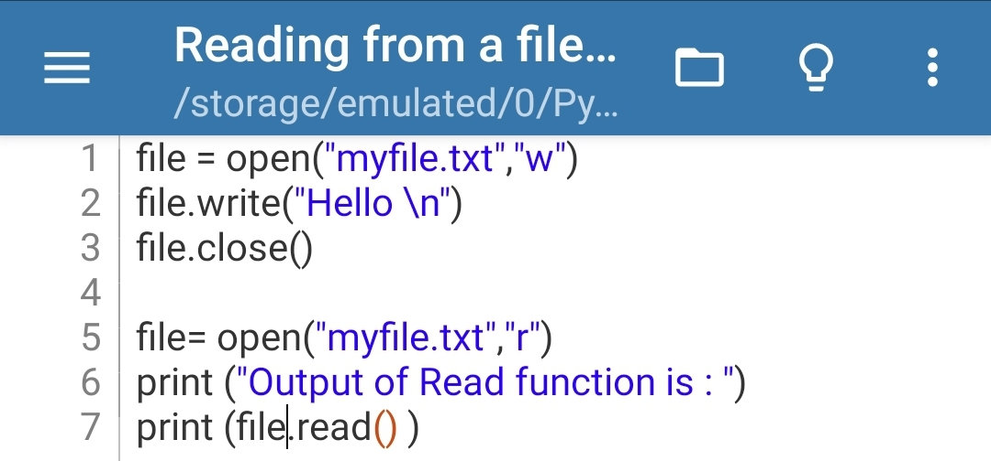Ans. CODE---

OUTPUT---

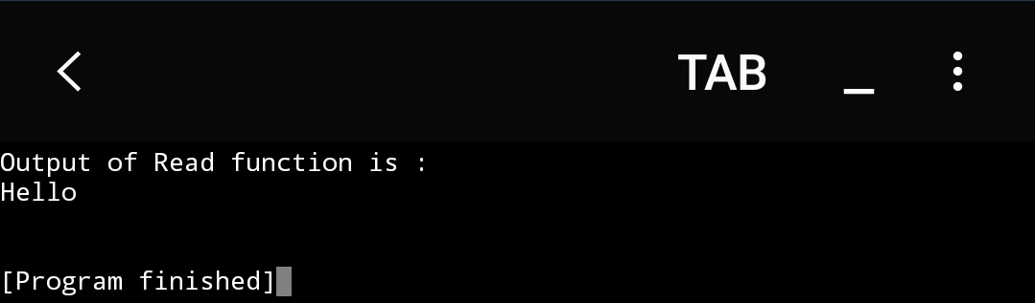

1. Write a python program to append text to a file and display the text?

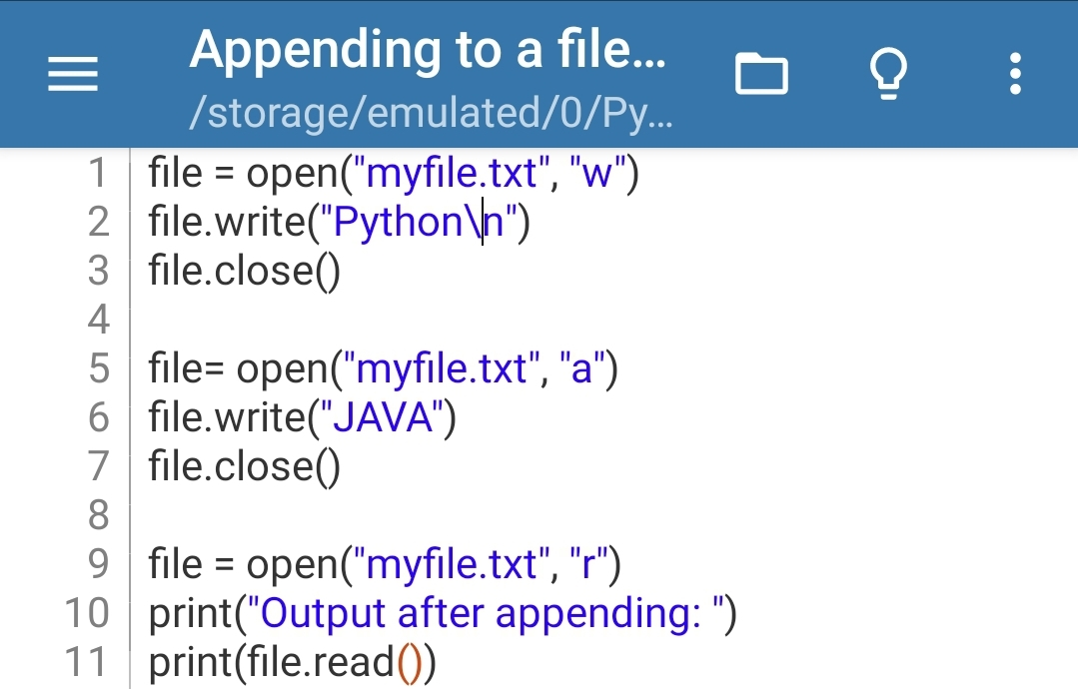Ans. CODE---

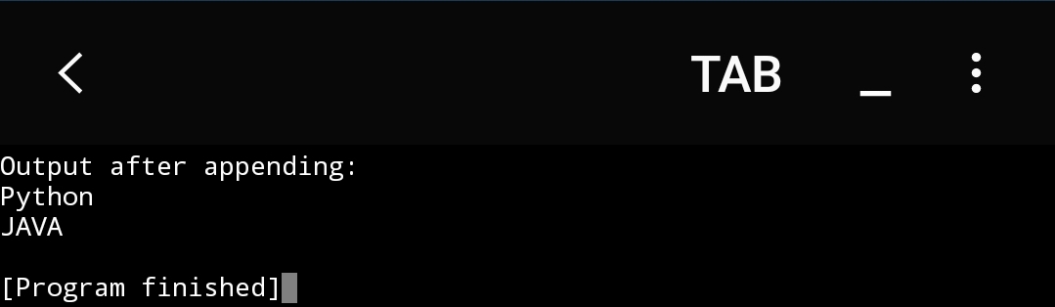OUTPUT---

1. Write a python program to read a file line by line and store it in a variable?

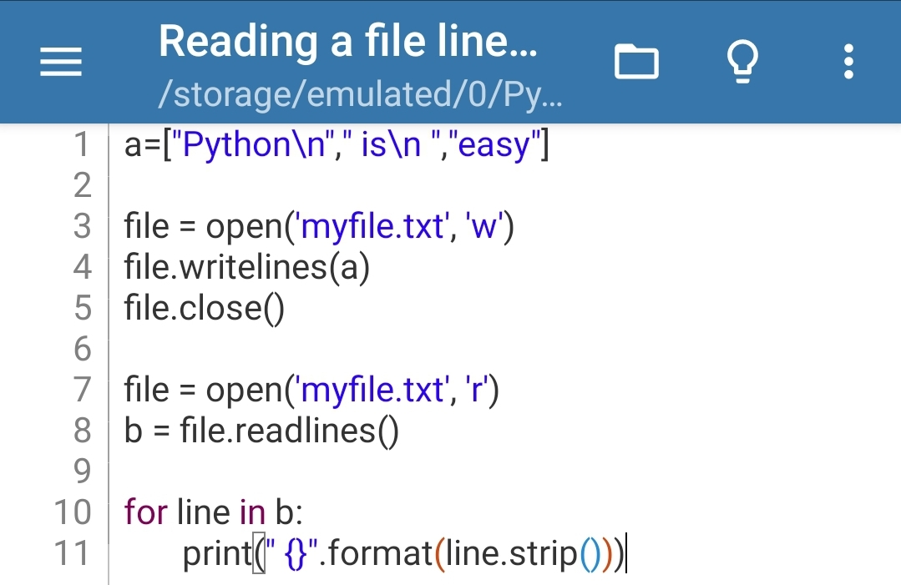Ans. CODE---

OUTPUT---

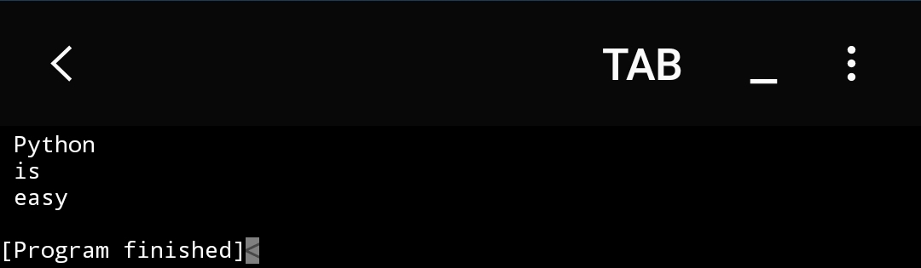

1. Write a python program to read contents of a file using for loop?

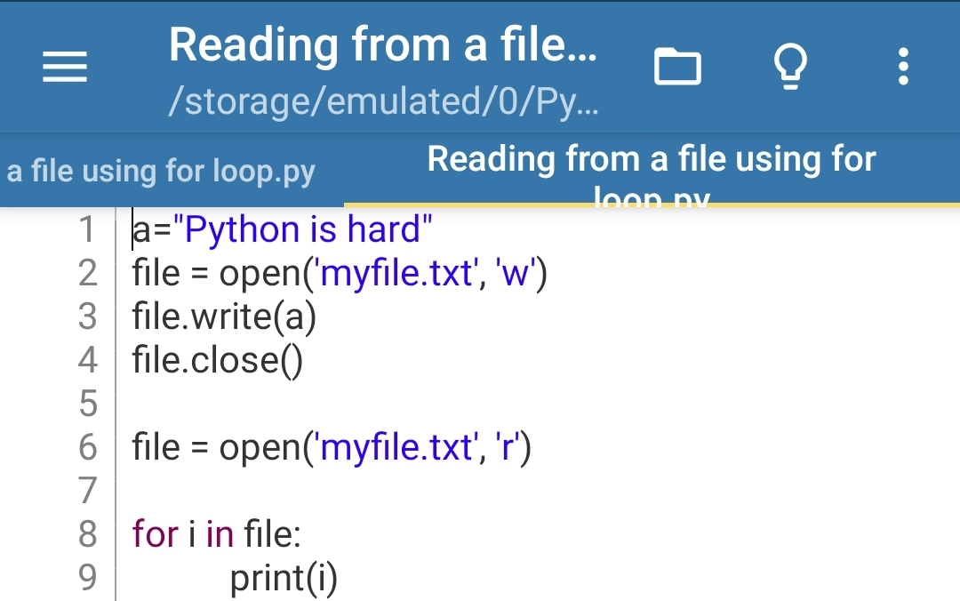Ans. CODE---

OUTPUT---

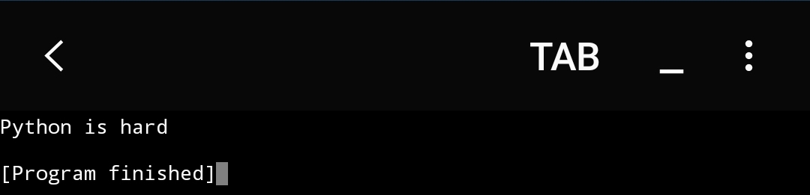

1. Write a python program to remove leading and trailing spaces from a string?

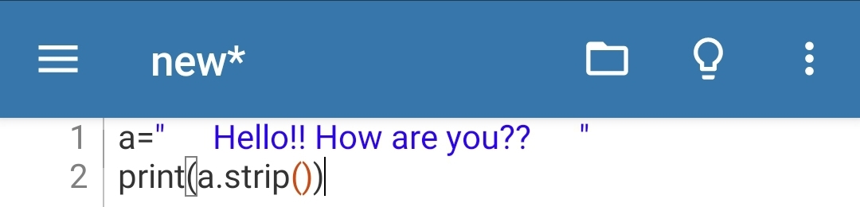Ans. CODE---

OUTPUT---

