**ASSIGNMENT**

1. **Write a Python program to read an entire text file?**

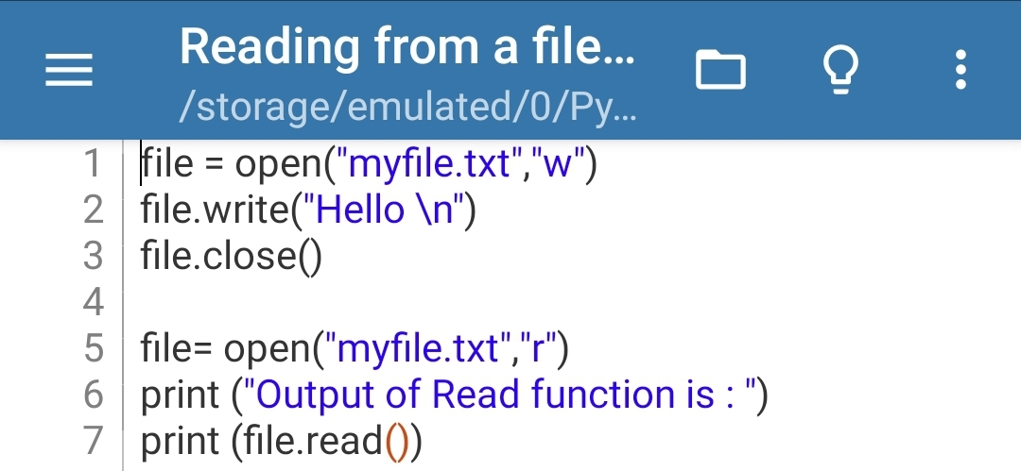**Ans. CODE---**

**OUTPUT---**

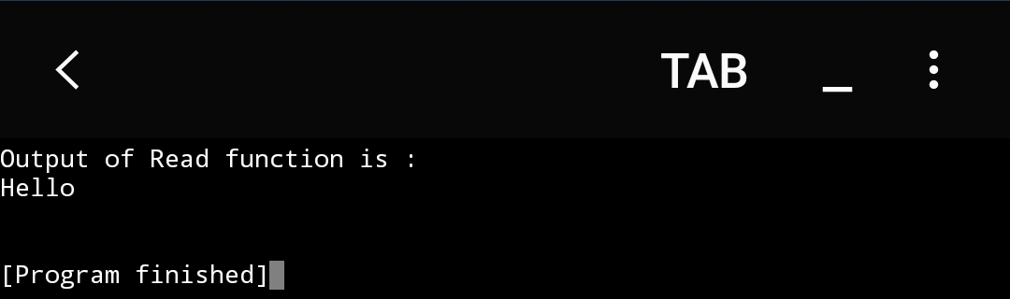

1. **Write a Python program to append text to a file and display the text?**

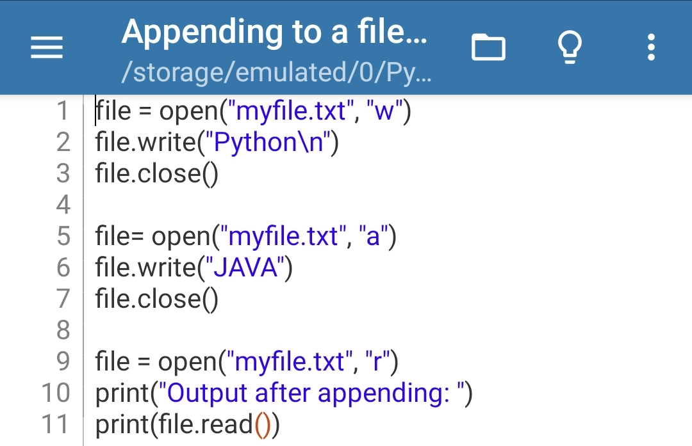**Ans. CODE---**

**OUTPUT---**

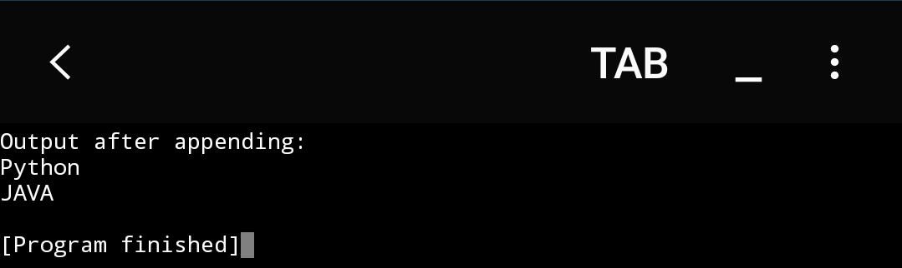

1. **Write a Python program to read a file line by line and store it into a list?**

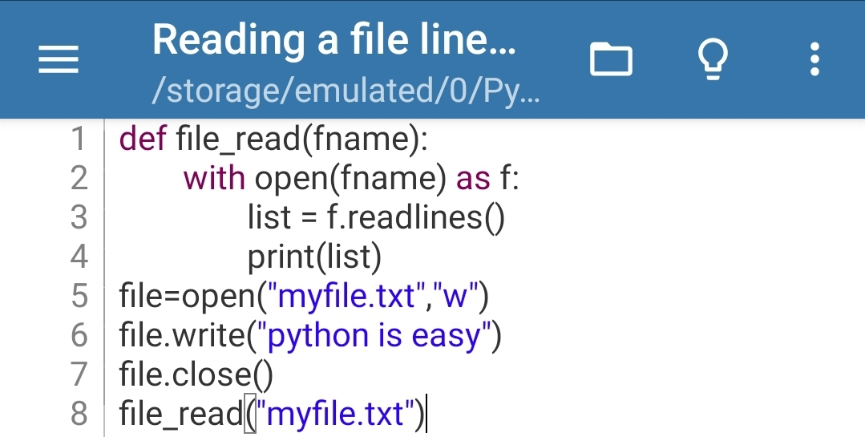**Ans. CODE---**

**OUTPUT---**

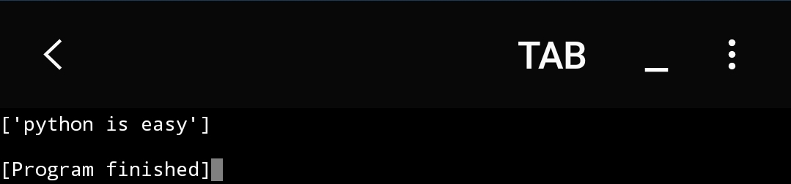

1. **Write a python program to find the longest words?**

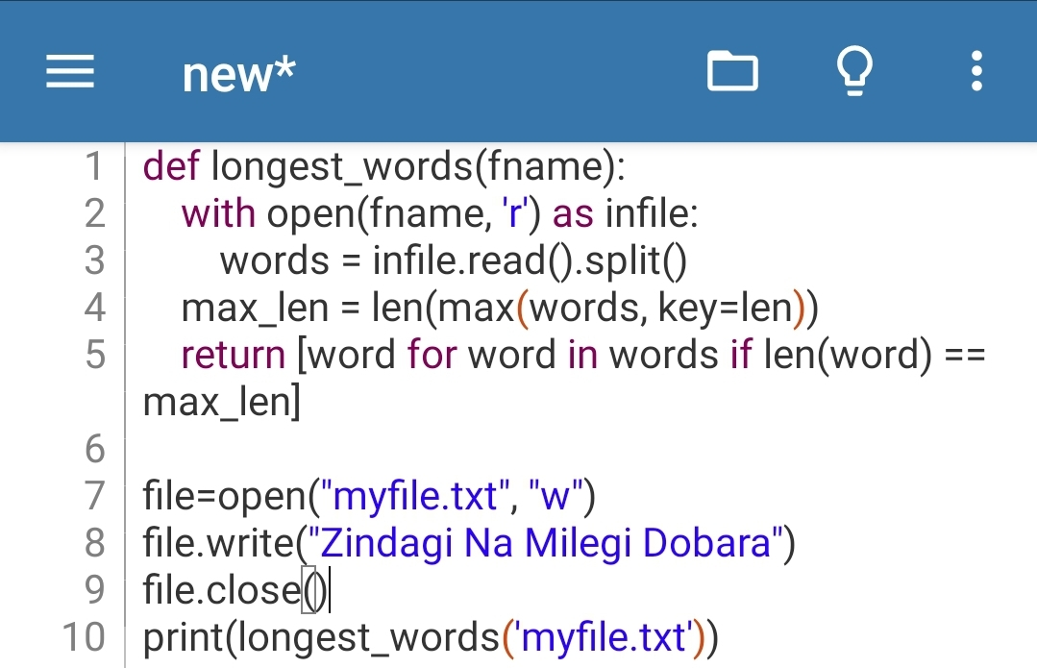**Ans. CODE---**

**OUTPUT---**

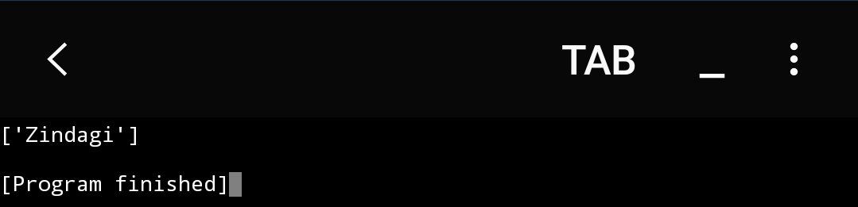

1. **Write a Python program to count the number of lines in a text file?**

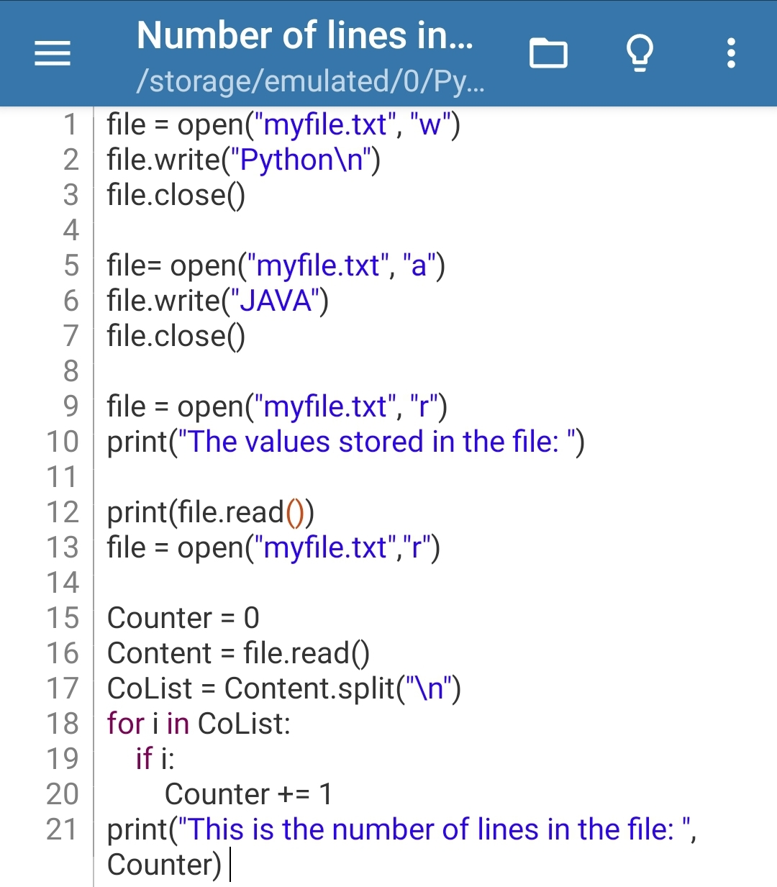**Ans. CODE---**

**OUTPUT---**

