**ASSIGNMENT**

1. **Write a python program to get the 4th element from the first and 4th element from the last in a tuple?**

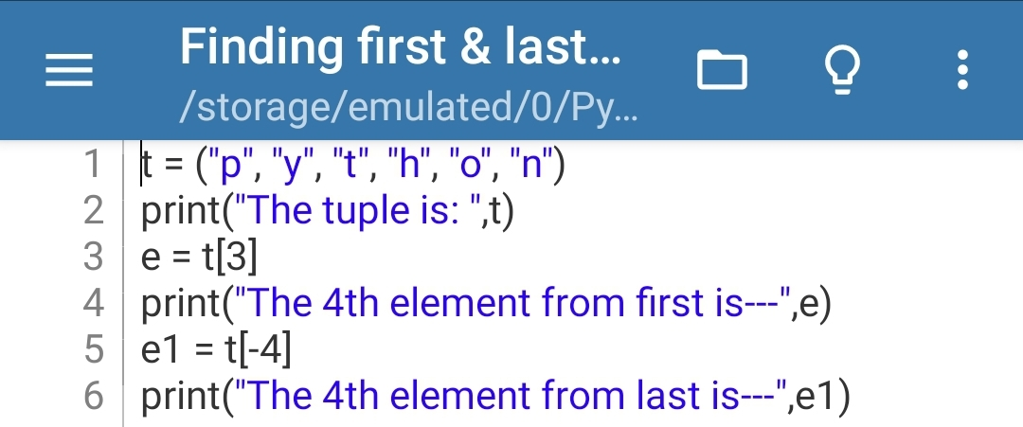**Ans. CODE---**

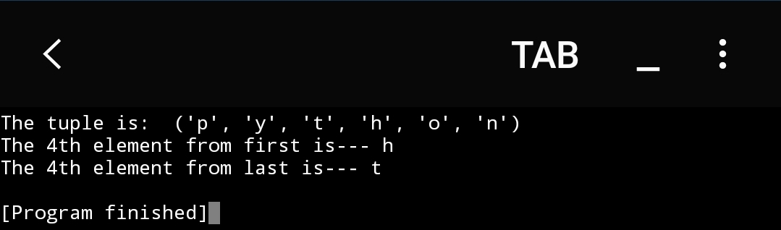**OUTPUT---**

1. **Write a python program to create the colon of a tuple?**

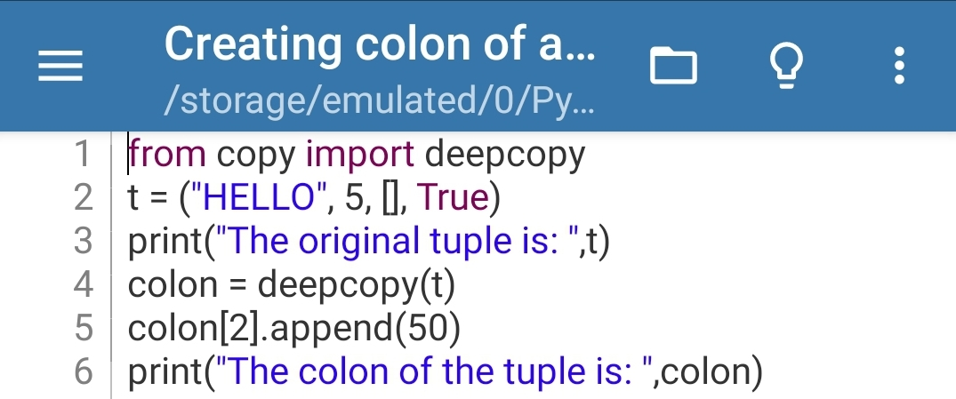**Ans. CODE---**

**OUTPUT---**

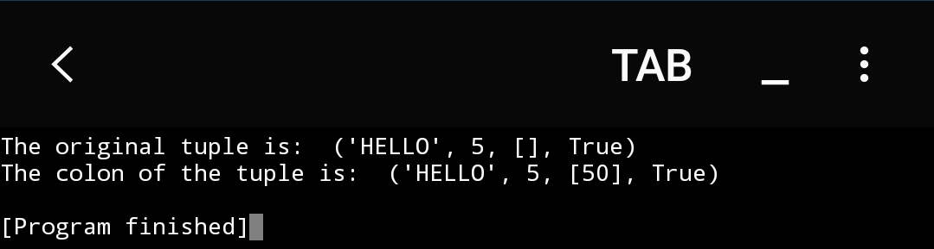

1. **Write a python program to find the repeated items of a tuple?**

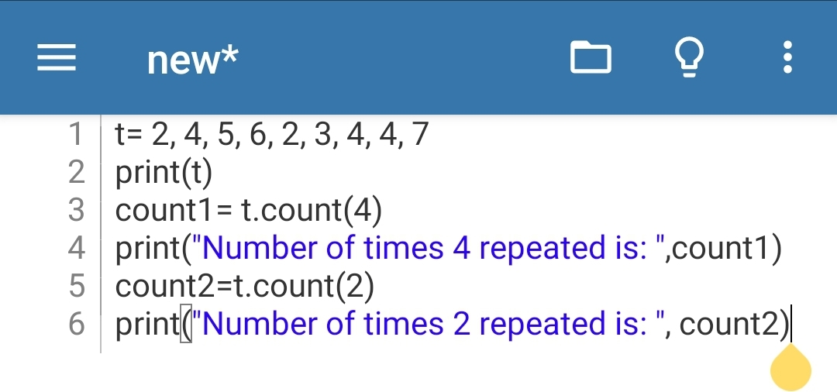**Ans. CODE---**

**OUTPUT---**

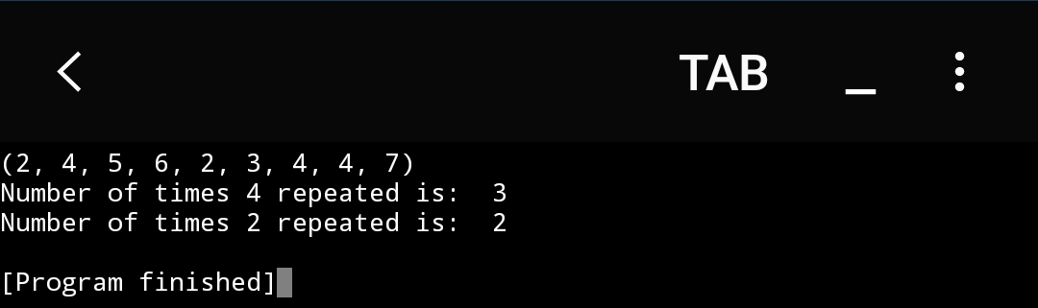

1. **Write a python program to remove an item from a tuple?**

**Ans. CODE---**

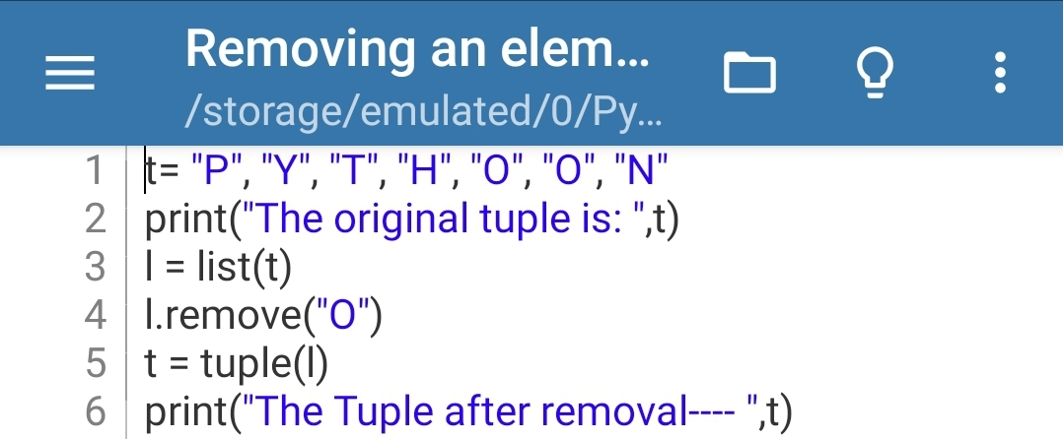**OUTPUT---**

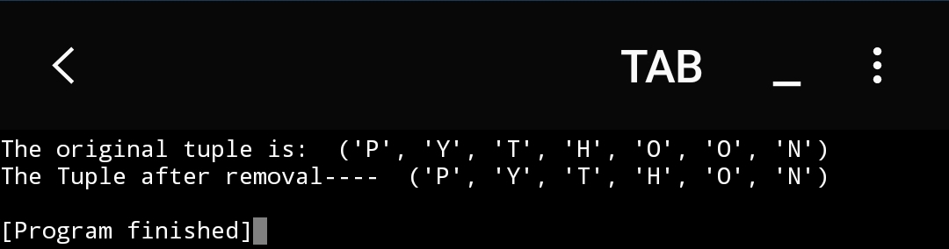

1. **Write a python program to check whether an element exists within a tuple?**

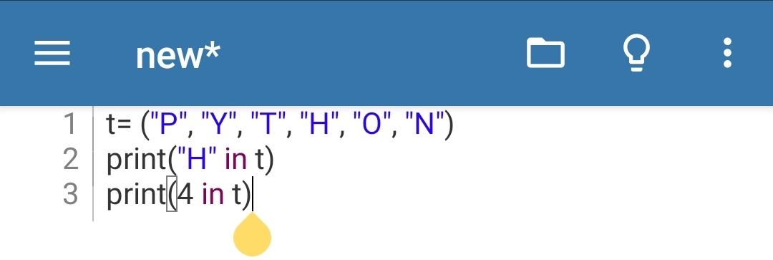**Ans. CODE---**

**OUTPUT---**

