Report: Optimising NYC Taxi Operations
Include your visualisations, analysis, results, insights, and outcomes. Explain your methodology and approach to the tasks. Add your conclusions to the sections.

Data Preparation
  - Loading the dataset
    - Sample the data and combine the files
The dataset contains twelve monthly parquet files for 2023. Loading all of them at once would have been a memory issue, so the approach taken was to process one month at a time, sample from each, and combine. For each month file, the pickup datetime was used to group records by date and hour. A random 5% sample was drawn from each hour-date combination using a fixed random state to keep results reproducible. This stratified approach ensures that trips from every hour of every day across all twelve months are represented, rather than just the busiest ones.
After running through all twelve files, the sampled data was concatenated into one dataframe. The final sampled dataset had 1,896,400 rows, which is large enough to capture real patterns but manageable for analysis. This was saved as a parquet file called final.parquet for all downstream work.
The first few rows showed the expected structure: vendor ID, pickup and dropoff datetimes, passenger count, trip distance, rate code, location IDs, payment type, and various fare components including fare amount, tip, tolls, MTA tax, congestion surcharge, and airport fee.

Data Cleaning

Fixing Columns
    - Fix the index
When the monthly files were sampled and combined, temporary grouping columns called pickup_date and pickup_hour were added to help with the stratified sampling logic. After combining, these columns were no longer needed. The index was reset cleanly using reset_index with drop=True, and the two helper columns were dropped. After this step, 20 columns remained and the shape was (1896400, 20).
    - Combine the two airport_fee columns
The dataset had two columns for airport fee: airport_fee (lowercase) and Airport_fee (with a capital A). This appears to have been a naming inconsistency where the same field was captured twice. The fix was to combine them into a single column called airport_fee_combined using fillna, so that whichever of the two had a value for a given row was kept. The two original columns were then dropped. The remaining columns after this step were the 19 original ones with airport_fee_combined in place of the two old ones.

Handling Missing Values
    - Find the proportion of missing values in each column

Checking the proportion of nulls across all columns revealed that five columns had exactly 3.42% missing values: passenger_count, RatecodeID, store_and_fwd_flag, congestion_surcharge, and airport_fee_combined. All other columns had zero missing values. The consistent 3.42% across multiple columns suggests these rows are from a specific vendor or batch where certain fields were not recorded.
    - Handling missing values in passenger_count

The rows with null values were inspected first. These rows showed NaN in passenger_count, RatecodeID, store_and_fwd_flag, congestion_surcharge, and airport_fee_combined simultaneously, which confirms they come from the same data source gap. The nulls in passenger_count were filled with the mode, which is 1 (the most common passenger count). Rows with passenger_count equal to 0 were also identified and replaced with the mode, since a taxi trip cannot realistically have zero passengers.
    - Handle missing values in RatecodeID
There were 64874 null values in RatecodeID. The distribution before filling showed that the overwhelming majority of trips (1,729,259) used rate code 1.0, which is the standard rate. Rate code 2.0 (JFK) had 71670 trips, code 99.0 had 10472, code 5.0 had 10275, code 3.0 had 6124, code 4.0 had 3723, and code 6.0 had just 3 trips. The nulls were filled using the mode, which is 1.0. After filling, no null values remained in RatecodeID.
    - Impute NaN in congestion_surcharge
There were 64874 null values in congestion_surcharge as well (same batch as the other nulls). These were filled using the median. After imputation, the value distribution showed that 1755446 trips had a congestion surcharge of 2.5, 140953 had 0.0, and just 1 had 0.5. No nulls remained after the fix. The remaining columns with missing values after these steps were store_and_fwd_flag and airport_fee_combined, both at 3.42%. store_and_fwd_flag was filled with its mode, and airport_fee_combined was filled with 0 (treating the absence of a value as no airport fee being applied). After all imputations, the total null count across the entire dataframe was 0.

Handling Outliers and Standardising Values
    - Check outliers in payment type, trip distance and tip amount columns
A describe of the full dataset and boxplots of key columns (trip_distance, fare_amount, tip_amount, total_amount, extra, tolls_amount) revealed clear outliers. The following cleaning steps were applied:
Passenger counts above 6 were removed first. Only 21 rows had more than 6 passengers, which is physically implausible for a standard taxi. This left 1,896,379 rows.
After that, several additional filters were applied: rows where trip_distance was under 0.1 miles but fare_amount exceeded $300 were removed as these are clearly data errors. Rows where both trip_distance and fare_amount were zero but the pickup and dropoff zones were different were also removed, since a real trip between two different zones cannot have zero distance and zero fare. Trips over 250 miles were dropped as they are outside the realistic range for NYC taxi travel. Rows where payment_type was 0 were removed since the data dictionary does not define payment type 0. Rows with fare_amount of 0 or above $1000 were dropped, and the same cap was applied to total_amount.
In total, 65,565 rows were removed in this phase, leaving 1,830,814 rows. After cleaning, several derived columns were added: trip duration in minutes, pickup hour, day name, month number, day of week number, a weekend flag, a payment type label, fare per mile, and average trip speed in mph.
The final dataframe had 28 columns and 1,830,814 rows.
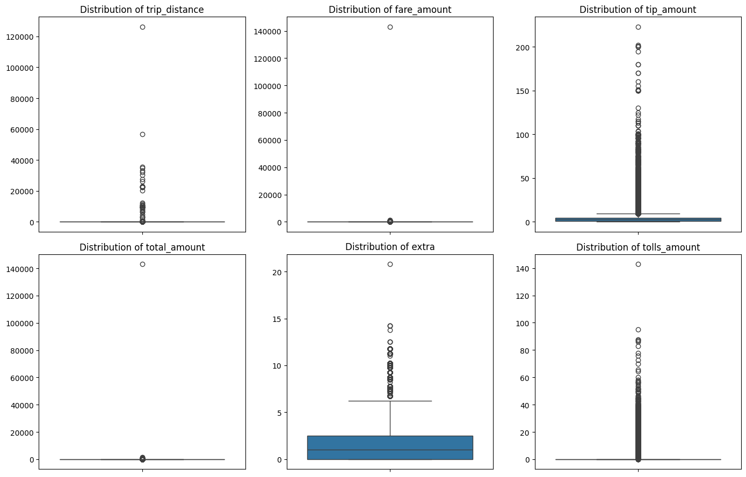

Exploratory Data Analysis

General EDA: Finding Patterns and Trends
    - Classify variables into categorical and numerical
Categorical variables: VendorID, RatecodeID, store_and_fwd_flag, PULocationID, DOLocationID, payment_type, pickup_hour, pickup_day, pickup_month, payment_label, is_weekend.
Numerical variables: passenger_count, trip_distance, trip_duration_min, fare_amount, extra, mta_tax, tip_amount, tolls_amount, improvement_surcharge, total_amount, congestion_surcharge, airport_fee_combined, fare_per_mile, speed_mph. All the monetary columns (fare_amount, extra, mta_tax, tip_amount, tolls_amount, improvement_surcharge, total_amount, congestion_surcharge, airport_fee) are numerical.
    - Analyse the distribution of taxi pickups by hours, days of the week, and months
Hourly: The busiest hour was 18:00 (6 PM) with 129,156 trips in the sample. The quietest hour was 4:00 AM with just 9,429 trips. There is a clear evening peak in the late afternoon and early evening, which aligns with the end-of-workday commute pattern.
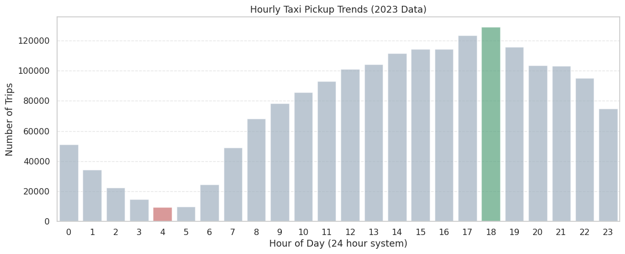
Daily: Thursday was the busiest day of the week, and Monday was the least busy. Weekdays generally have higher trip counts than weekends.
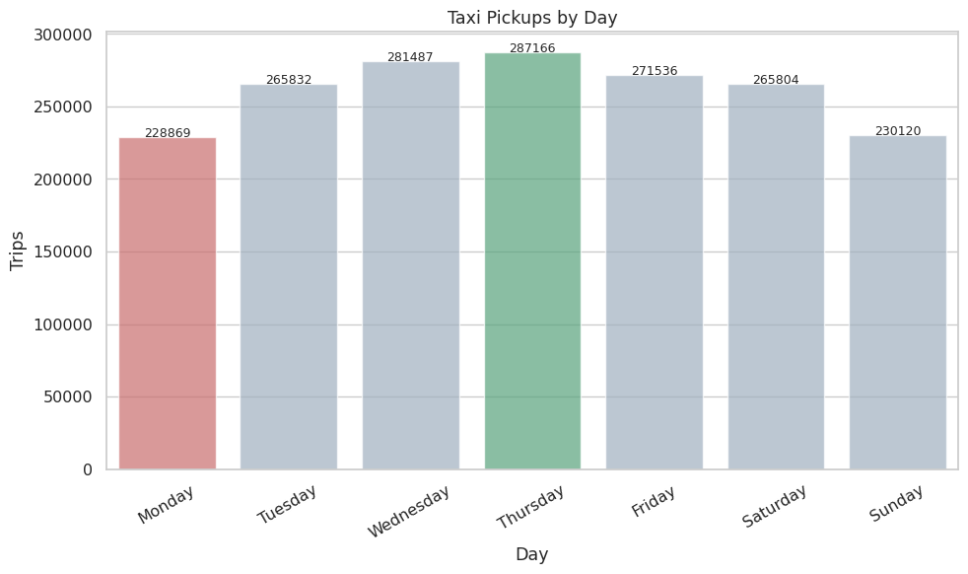

Monthly: May had the highest number of pickups, and September had the lowest. The summer months show a slight dip in pickup counts, with volume picking back up in autumn.

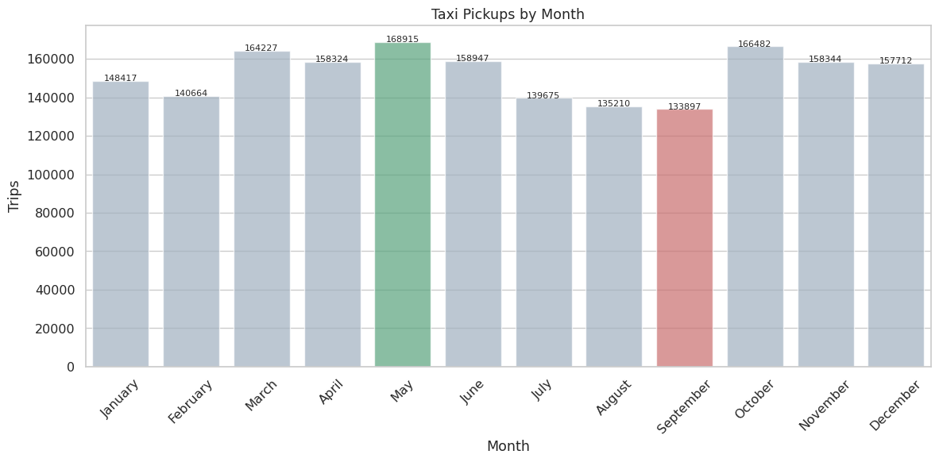
    - Filter out the zero/negative values in fares, distance and tips
Looking at the financial columns before filtering, fare_amount had no zeros (this had already been handled in the outlier step), but tip_amount had 409,675 zero entries and trip_distance had 22,669 zero entries. Negative values were already zero across all these columns from the earlier cleaning.
A clean dataframe called df_clean was created by keeping only rows where fare_amount > 0, total_amount > 0, and trip_distance > 0. This retained 1,808,145 rows, which is 98.8% of the 1,830,814 rows after outlier cleaning.
    - Analyse the monthly revenue trends
Monthly revenue (total_amount summed) for 2023:
January: $3,995,059
February: $3,776,760
March: $4,555,917
April: $4,472,326
May: $4,874,048
June: $4,584,870
July: $3,987,014
August: $3,880,417
September: $3,961,487
October: $4,885,719
November: $4,549,768
December: $4,529,268
October was the highest revenue month at $4,885,719, and February was the lowest at $3,776,760. Revenue is noticeably lower in the first two months and the summer months of July through September. The autumn months and late spring show the strongest revenue.
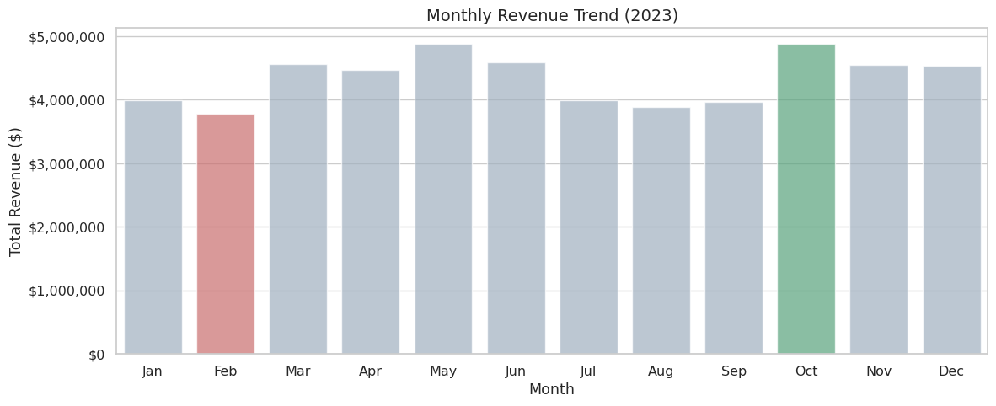

    - Find the proportion of each quarter’s revenue in the yearly revenue
Q1 (January to March): 23.68%
Q2 (April to June): 26.76%
Q3 (July to September): 22.72%
Q4 (October to December): 26.83%
Q4 and Q2 are nearly equal as the strongest quarters, together accounting for over 53% of yearly revenue. Q3 is the weakest quarter, slightly below Q1. The slower summer months drag Q3 below Q1 despite summer typically being a high-activity season in many cities.
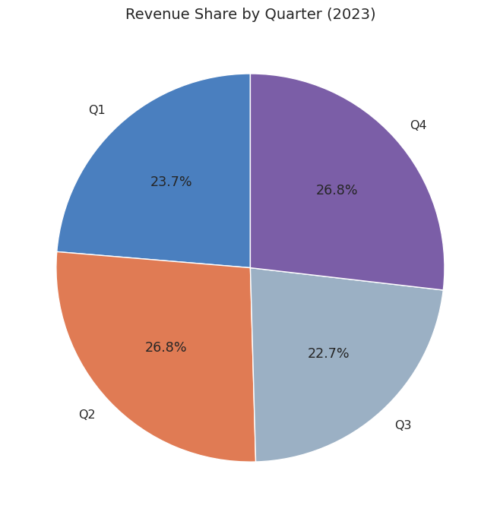
    - Analyse and visualise the relationship between distance and fare amount
A scatter plot of a 500-row random sample (limiting to trips under 40 miles) with a linear trend line showed a clear positive relationship between trip distance and fare amount. The Pearson correlation between trip_distance and fare_amount was 0.944, which is very high. This makes sense as NYC taxi metering is largely distance-based.

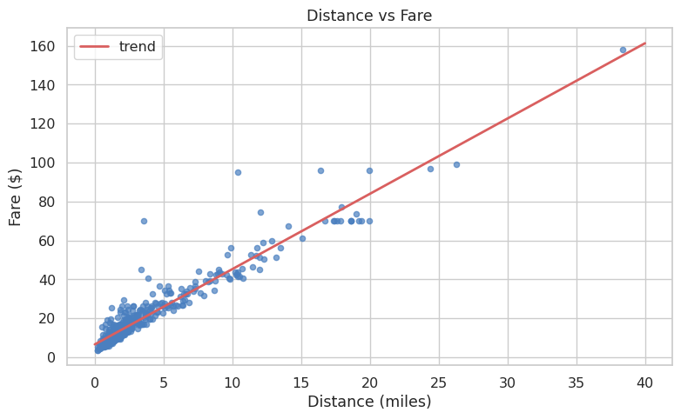
    - Analyse the relationship between fare/tips and trips/passengers
Fare vs trip duration: The scatter plot showed a positive but looser relationship. Pearson correlation was 0.276, which is weak. Duration alone is not a strong predictor of fare, likely because the meter also charges for distance, and some long-duration trips in heavy traffic cover very little distance.
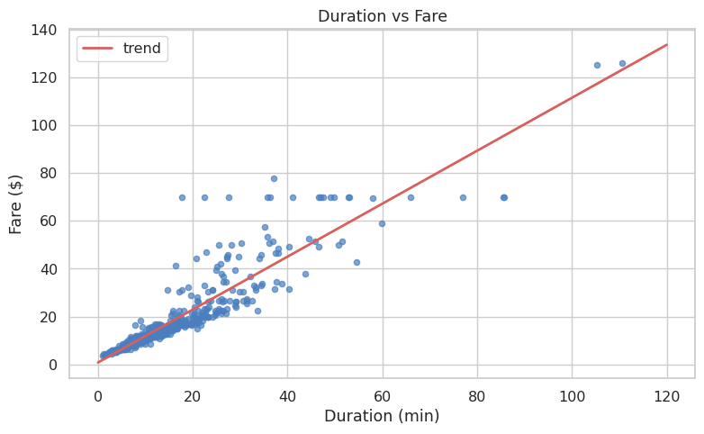

Fare vs passenger count: The average fares by passenger count were: 1 passenger ($18.99), 2 passengers ($22.03), 3 passengers ($21.72), 4 passengers ($23.03), 5 passengers ($18.83), 6 passengers ($19.08). Pearson correlation was 0.042, which is negligible. There is no meaningful relationship between how many people are in a cab and what the fare ends up being.
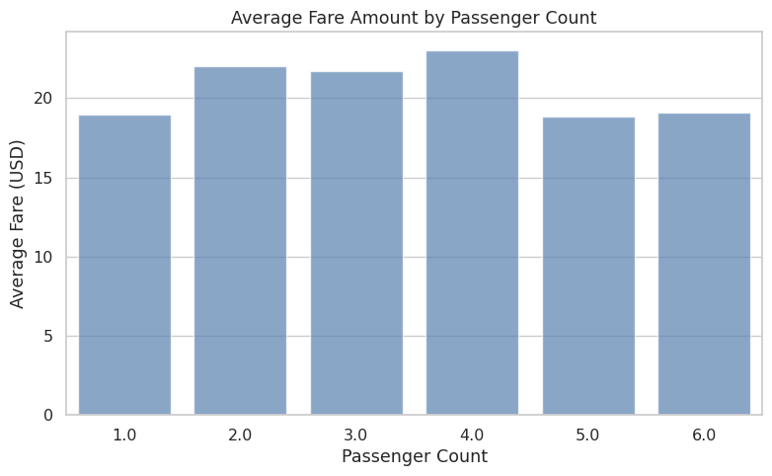
Tip vs trip distance: Looking only at trips where a tip was given, the correlation between trip_distance and tip_amount was 0.799. Longer trips attract larger tips. The trend line had a clear positive slope, which makes sense as tips are often calculated as a percentage of the fare, and longer trips have higher fares.
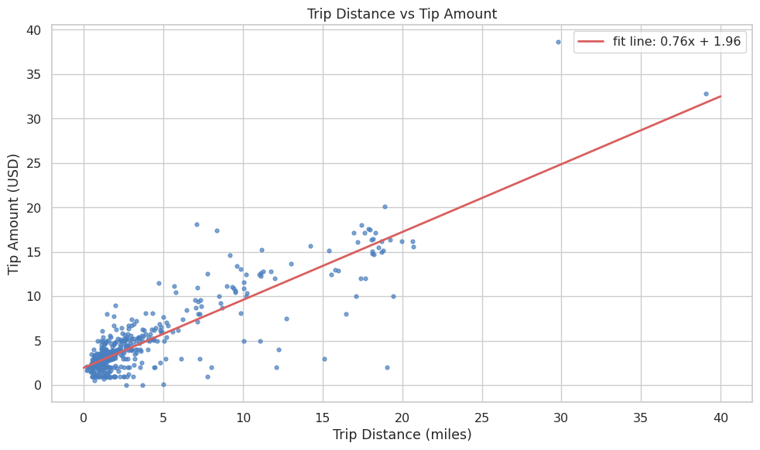
    - Analyse the distribution of different payment types
Credit card was by far the dominant payment method, followed by cash. No Charge and Dispute trips were a small minority. The pie chart and bar chart showed credit card taking up the majority share.
(Payment type codes: 1 = Credit card, 2 = Cash, 3 = No charge, 4 = Dispute)
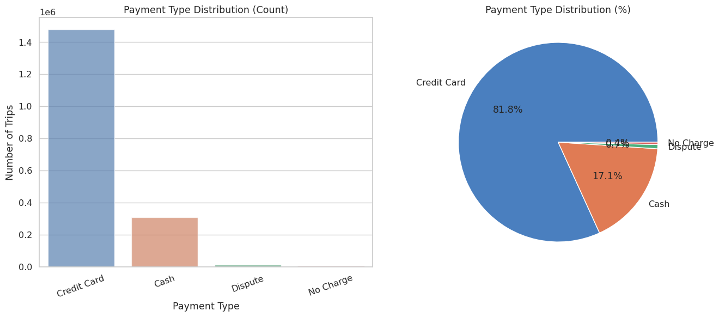
    - Load the taxi zones shapefile and display it
The shapefile was loaded using GeoPandas. The resulting GeoDataFrame had 263 rows and 7 columns: OBJECTID, Shape_Leng, Shape_Area, zone, LocationID, borough, and geometry. The first few rows included zones like Newark Airport (EWR), Jamaica Bay (Queens), Allerton/Pelham Gardens (Bronx), Alphabet City (Manhattan), and Arden Heights (Staten Island). The shapefile covers all five boroughs.
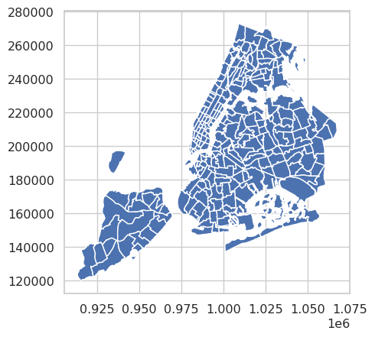
    - Merge the zone data with trips data
The zones dataframe was merged with df_clean on LocationID and PULocationID to bring in zone name and borough for each pickup location. The columns were renamed to pickup_zone and pickup_borough after the merge. Out of 1,808,145 clean trips, 1,791,888 had a matched pickup zone.

Find the number of trips for each zone/location ID
Trips were grouped by PULocationID and counted. The top 10 pickup zones by trip count were:

Location 132 (JFK Airport): 94,943 trips
Location 237 (Upper East Side South): 86,474 trips
Location 161 (Midtown Center): 85,401 trips
Location 236 (Upper East Side North): 77,120 trips
Location 162 (Midtown East): 65,211 trips
Location 138 (LaGuardia Airport): 63,682 trips
Location 186 (Penn Station/Madison Sq West): 62,990 trips
Location 230 (Times Sq/Theatre District): 60,729 trips
Location 142 (Lincoln Square East): 60,507 trips
Location 170 (Murray Hill): 54,035 trips

    - Add the number of trips for each zone to the zones dataframe
The trip counts were merged back into the zones GeoDataFrame. Zones with no trips in the sampled data got a count of 0. 253 out of 263 zones had at least one trip.
    - Plot a map of the zones showing number of trips
A choropleth map was plotted with the coolwarm colour map showing zone-wise trip counts. Manhattan zones and the two airports stood out clearly as the highest-activity areas, with outer borough zones showing significantly lower activity.
The sorted top 20 zones from the zones GeoDataFrame confirmed what was already visible in the grouped data, with JFK Airport, Upper East Side South, Midtown Center, Upper East Side North, and Midtown East being the five busiest pickup zones.
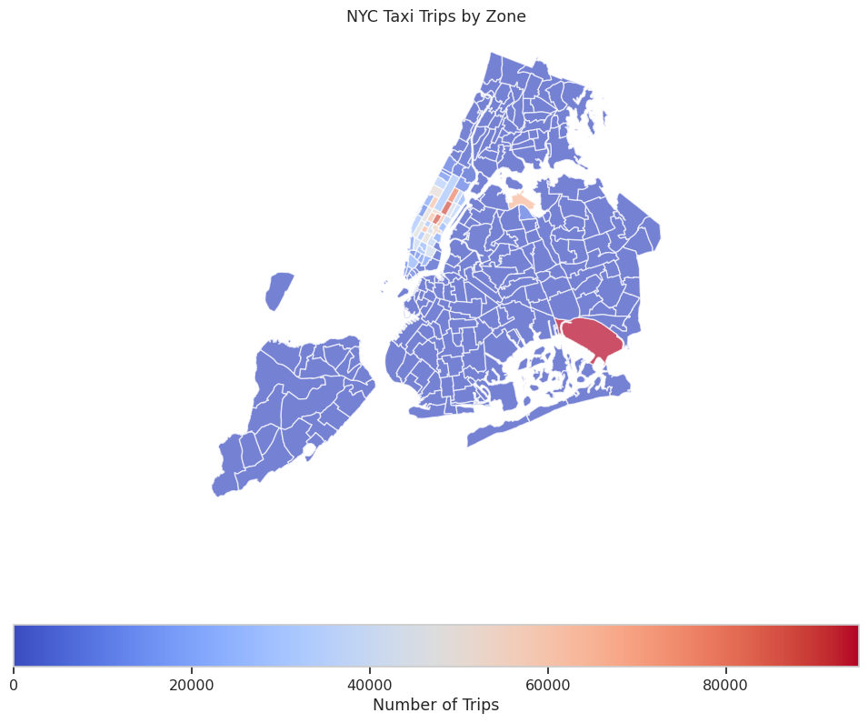

    - Conclude with results
The general EDA revealed several clear patterns. Evening hours (6-8 PM) are the busiest time of day for pickups, while early morning (3-5 AM) is the quietest. Thursdays lead the week in demand, and Mondays are the slowest day. May and October are the peak months; February and September see the lowest activity. Revenue follows a similar pattern with Q2 and Q4 being the strongest quarters.

Distance is by far the strongest predictor of fare, with a correlation of 0.944. Passenger count has almost no relationship with fare. Tip amount follows trip distance closely (correlation 0.799), meaning longer, pricier trips generate more tip revenue. The majority of trips are paid by credit card.

Geographically, JFK Airport leads all zones in pickup volume, followed by central Manhattan zones. The Midtown and Upper East Side corridors are consistently the busiest pickup areas for non-airport trips.

Detailed EDA: Insights and Strategies
    - Identify slow routes by comparing average speeds on different routes
Trip speed in mph was calculated as trip_distance divided by trip_duration in hours. Rows with speeds outside 0 to 100 mph were filtered out as unrealistic. Routes were grouped by pickup zone, dropoff zone, and hour, keeping only combinations with at least 5 trips for statistical reliability.
The slowest routes found were:
Zone 211 to 211 at hour 16: 2.08 mph
Zone 193 to 193 at hour 9: 2.22 mph
Zone 100 to 100 at hour 10: 2.71 mph
Zone 186 to 100 at hour 12: 3.48 mph
Zone 100 to 100 at hour 17: 3.65 mph
Zone 186 to 164 at hour 12: 3.76 mph
Zone 186 to 100 at hour 16: 3.77 mph
Zone 89 to 181 at hour 14: 3.77 mph
Zone 100 to 100 at hour 20: 3.80 mph
Zone 70 to 70 at hour 10: 3.82 mph
These extremely low speeds (below 4 mph) indicate heavy congestion on specific intra-zone and nearby routes, particularly during midday and evening hours. An hourly speed chart was also generated to show how average speeds across all trips vary by time of day.
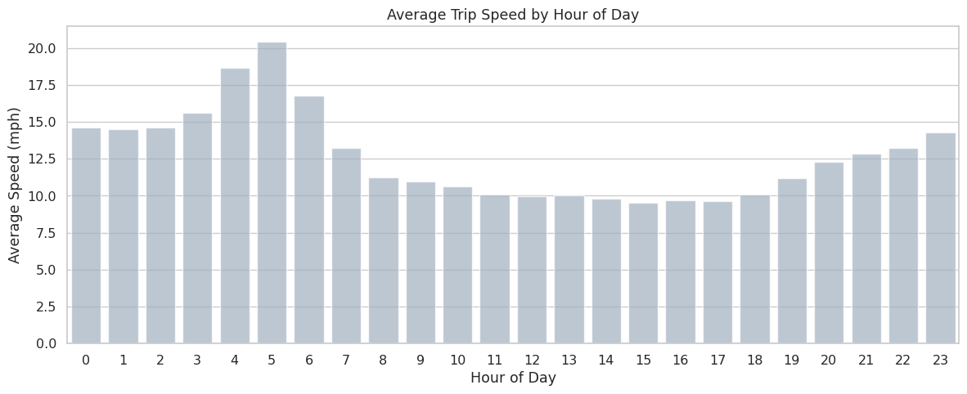
    - Calculate the hourly number of trips and identify the busy hours
The busiest hour in df_clean was 18:00 with 127,864 sampled trips. The top 5 busiest hours were:
18:00 — 127,864 trips
17:00 — 122,066 trips
19:00 — 114,812 trips
15:00 — 112,833 trips
16:00 — 112,731 trips
The entire 3 PM to 7 PM window is consistently the peak demand period. Below is the chart which was created to demonstrate the same.
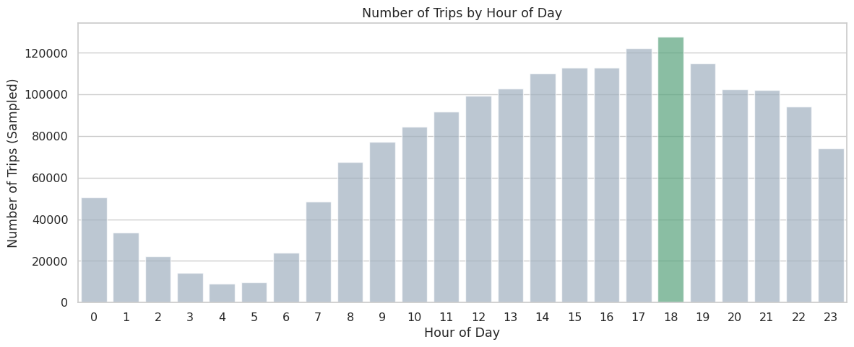

    - Scale up the number of trips from above to find the actual number of trips
Since the data was sampled at 5% from each hour-date combination, the actual trip count is estimated by dividing sampled counts by 0.05. The scaled estimates for the top 5 busiest hours were:
18:00 — estimated 2,557,280 actual trips
17:00 — estimated 2,441,320 actual trips
19:00 — estimated 2,296,240 actual trips
15:00 — estimated 2,256,660 actual trips
16:00 — estimated 2,254,620 actual trips
    - Compare hourly traffic on weekdays and weekends
Weekday and weekend trip counts were split and normalised by the number of unique days in each group to make the comparison fair. The line chart showed a clear difference in shape between the two patterns.
Weekdays show a dual-peak pattern: a smaller morning rush around 7-9 AM and a much larger evening rush from 4-8 PM, with relatively low demand overnight and through midday.
Weekends have a flatter profile during daytime hours, with demand building later in the day and staying elevated into the late night, reflecting a leisure and nightlife pattern rather than a commute-driven one.
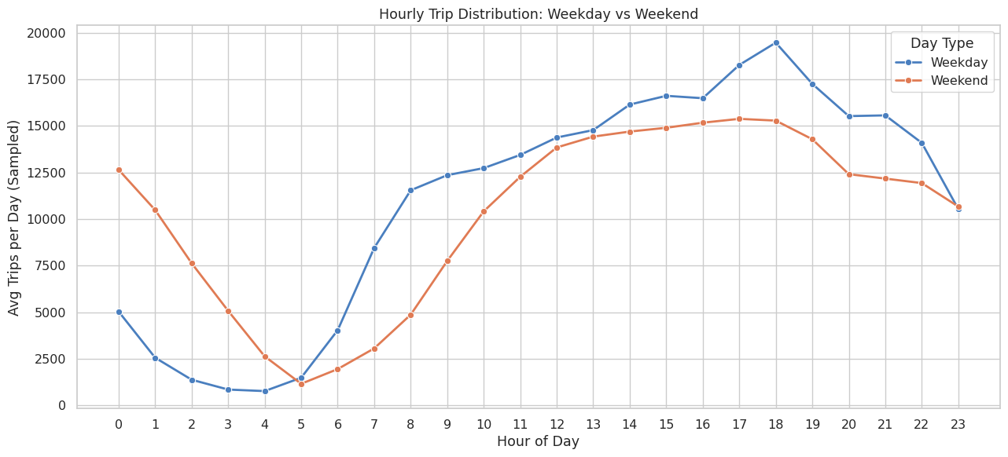

    - Identify the top 10 zones with high hourly pickups and drops
Top 10 pickup zones by average hourly trip activity and top 10 dropoff zones by average hourly activity were calculated and plotted side by side. JFK Airport, Midtown, and Upper East Side zones dominated both lists. The charts confirmed that the same high-demand zones generate both outbound and inbound traffic, though the balance differs by zone.
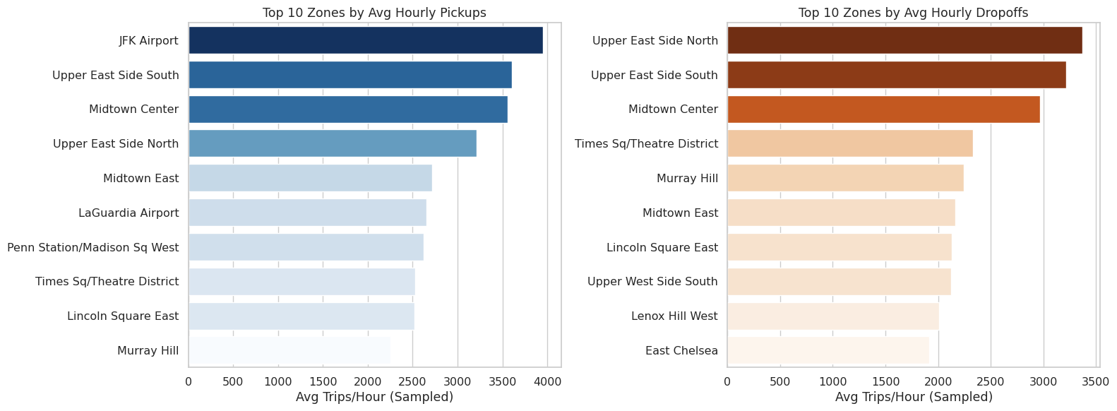

    - Find the ratio of pickups and dropoffs in each zone
A pickup-to-dropoff ratio was calculated for each zone. Zones with a high ratio (above 1.5) are predominantly origin points where more trips start than end. Zones with a low ratio (below 0.7) are predominantly destination zones where trips tend to end.
The top 10 pickup-heavy zones and top 10 dropoff-heavy zones were plotted. This helps identify zones where cabs are likely to leave frequently empty, and zones where cabs arrive full but have fewer outbound trips to return on.
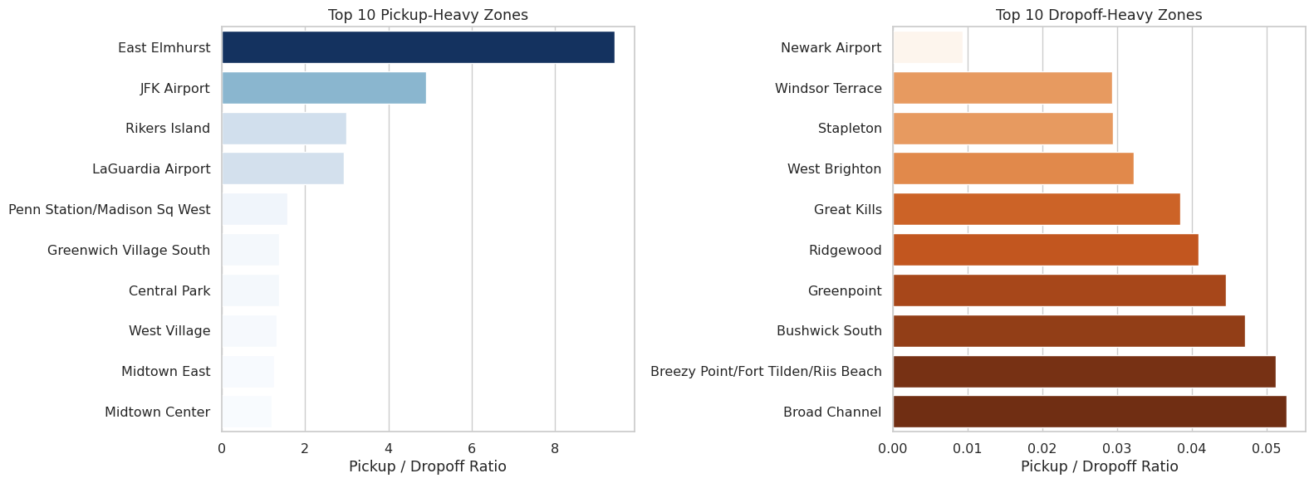

    - Identify the top zones with high traffic during night hours
Night hours were defined as 11 PM to 5 AM (hours 23, 0, 1, 2, 3, 4, 5). Night-time trips made up 213,489 of the total sampled trips, which is 11.8% of all trips.
The top 10 night pickup zones and top 10 night dropoff zones were identified separately and visualised. Airport zones and entertainment-heavy Manhattan zones featured prominently in the night lists, which differ from the all-day top zones (which are more commuter-driven).
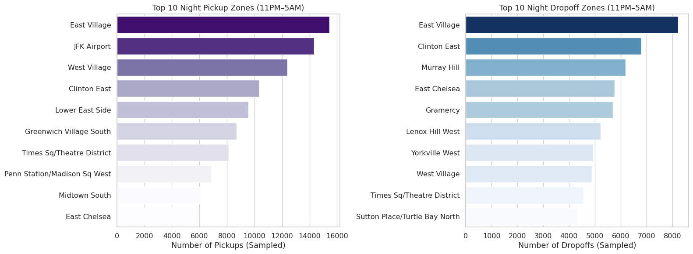

    - Find the revenue share for nighttime and daytime hours
Using the same night hour definition (11 PM to 5 AM):
Night-time revenue: $6,250,458.69 (12.0% of total)
Day-time revenue: $45,802,200.38 (88.0% of total)
Night trips account for 11.8% of trip volume but 12.0% of revenue, suggesting that night trips are very slightly higher value on average.
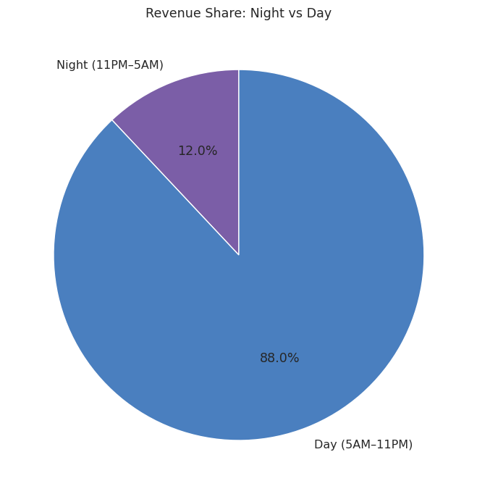
    - For the different passenger counts, find the average fare per mile per passenger
Fare per mile per passenger was calculated as fare_amount divided by (trip_distance multiplied by passenger_count). The results were:
1 passenger: $10.87 per mile per passenger
2 passengers: $6.43 per mile per passenger
3 passengers: $3.91 per mile per passenger
4 passengers: $4.36 per mile per passenger
5 passengers: $1.71 per mile per passenger
6 passengers: $1.35 per mile per passenger
The per-passenger cost drops sharply as group size increases. Solo riders pay about 8 times more per mile per person than a group of 6. This is expected since the fare itself doesn't scale with passenger count.
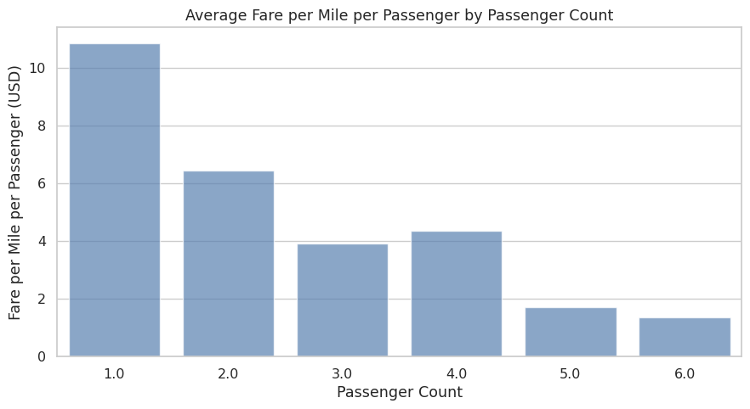
    - Find the average fare per mile by hours of the day and by days of the week
The fare per mile was calculated as fare_amount divided by trip_distance for trips with non-zero distance. The hourly trend line and day-of-week bar chart were produced.
The hourly chart showed that fare per mile is slightly higher during late night and very early morning hours, and dips slightly during the mid-morning and early afternoon. Evening hours are moderately elevated. Weekends (highlighted in a different colour) showed a slightly higher fare per mile than weekdays on average.
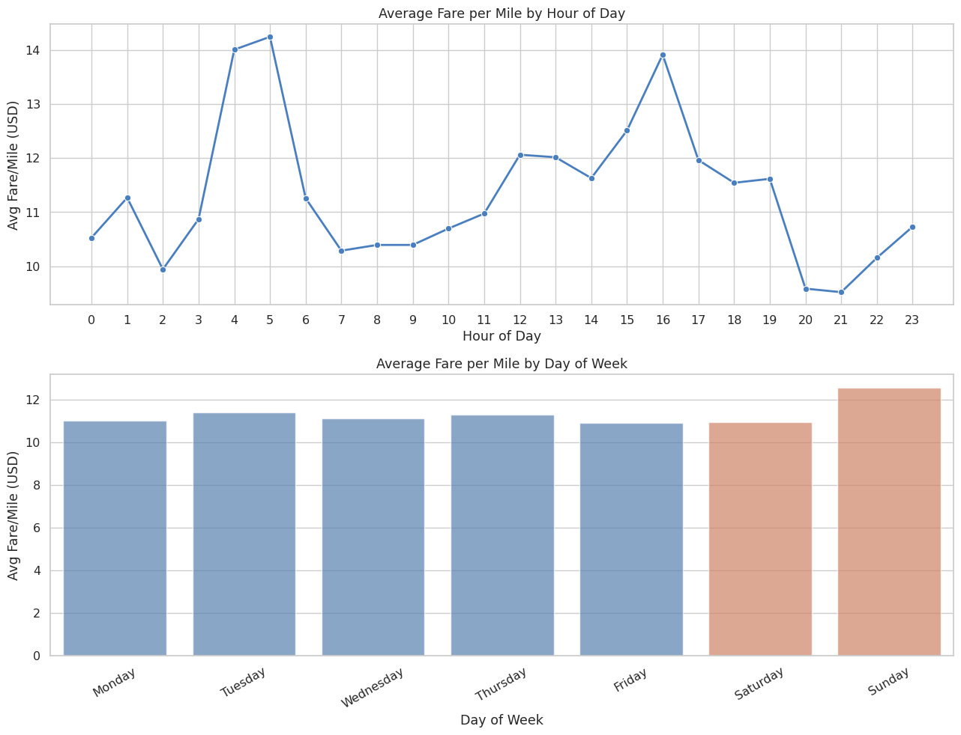
    - Analyse the average fare per mile for the different vendors
The two vendors in the dataset are Vendor 1 (CMT) and Vendor 2 (VeriFone). Fare per mile was compared by vendor across each hour of the day using a line chart.
Overall average fare per mile:
Vendor 1: $8.13 per mile
Vendor 2: $12.40 per mile
Vendor 2 charges notably more per mile on average than Vendor 1. The hourly chart showed that this gap persists throughout the day, though it narrows somewhat during certain hours.
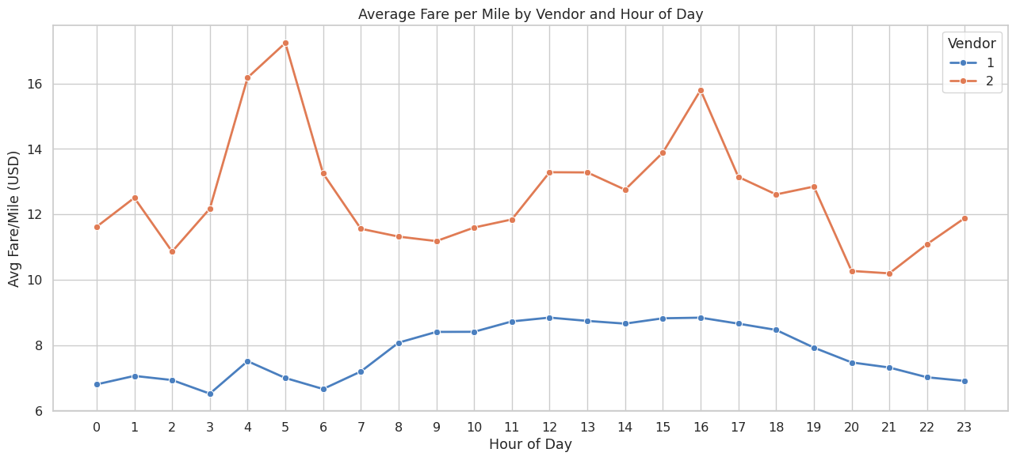
    - Compare the fare rates of different vendors in a distance-tiered fashion
Trips were placed into three distance tiers: Short (0-2 miles), Medium (2-5 miles), and Long (5+ miles). Average fare per mile was then compared between the two vendors within each tier.
Short trips (0-2 miles): Vendor 1 at $9.93/mile, Vendor 2 at $17.93/mile
Medium trips (2-5 miles): Vendor 1 at $6.38/mile, Vendor 2 at $6.55/mile
Long trips (5+ miles): Vendor 1 at $4.43/mile, Vendor 2 at $4.50/mile
The most striking finding is in the short-trip tier. Vendor 2 charges nearly twice Vendor 1's rate for trips under 2 miles. For medium and long trips, the two vendors are much closer to each other. This suggests Vendor 2 has a much higher base or minimum fare structure that dominates on short trips, but that difference fades when the meter runs longer.
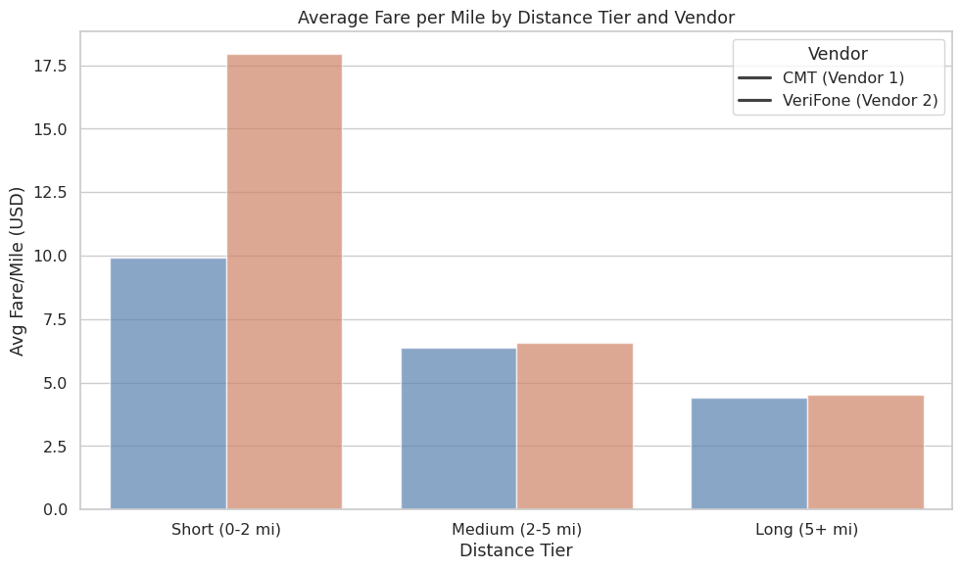
    - Analyse the tip percentages
Tip analysis was restricted to credit card payments (payment_type = 1) since cash tips are typically not recorded in the dataset. Tip percentage was calculated as tip_amount divided by fare_amount multiplied by 100.
The overall average tip percentage was 25.18%.
By distance: The average tip percentage was plotted across five distance bins (0-2, 2-5, 5-10, 10-20, 20+ miles). Shorter trips tend to have slightly higher tip percentages, which may reflect standard rounding behavior on smaller fares.
By passenger count: Tip percentages were broadly similar across passenger counts, with no dramatic differences.
By hour: Tip percentages fluctuated across the day but did not show a dramatic trend. There was a slight uptick in certain late-night hours.
An additional comparison was done between low-tip rides (tip under 10%) and high-tip rides (tip over 25%):
Low tip trips: 142,291 count, average distance 4.86 miles, average fare $25.73, average duration 24.94 minutes, average 1.38 passengers, 15.9% night trips.
High tip trips: 813,367 count, average distance 2.30 miles, average fare $14.41, average duration 12.74 minutes, average 1.36 passengers, 11.8% night trips.
High-tip rides are predominantly short, cheap, and fast. Low-tip rides are longer, more expensive, and slightly more likely to happen at night.
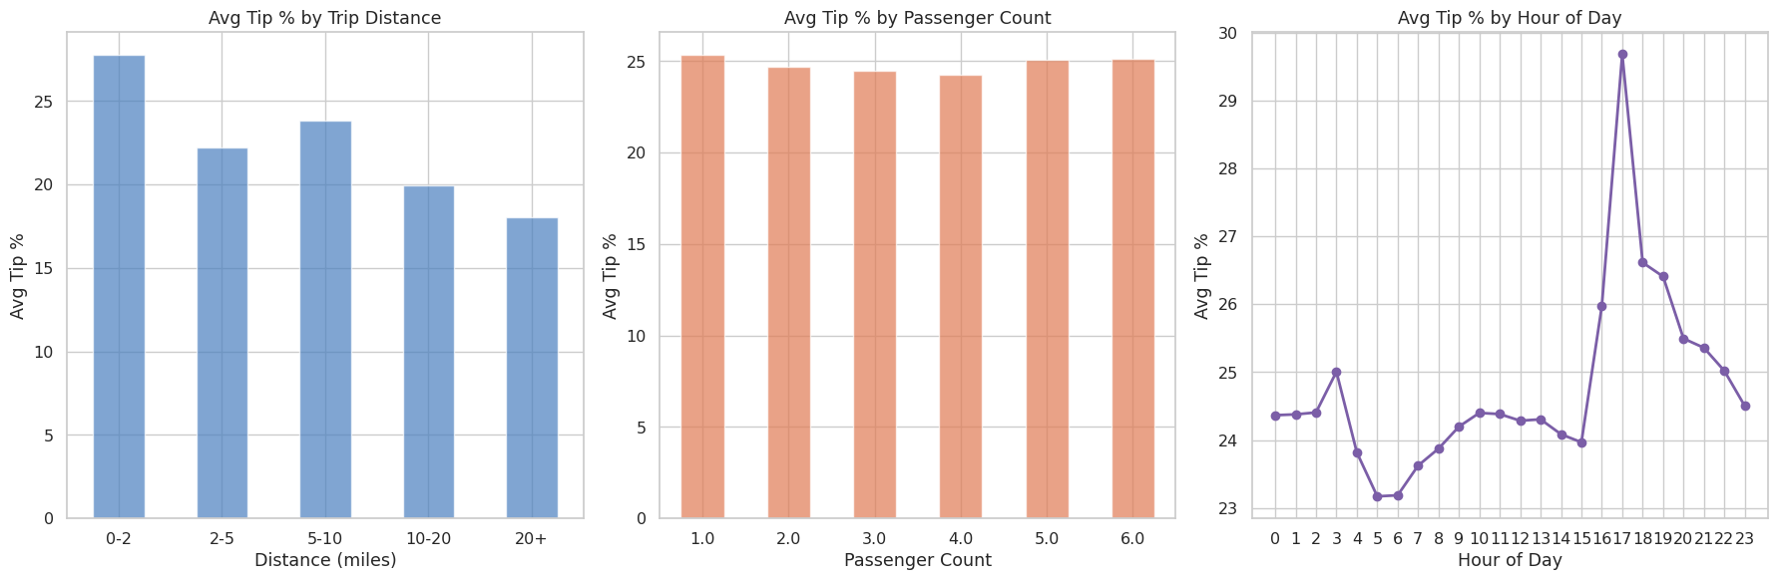
    - Analyse the trends in passenger count
Average passenger count was compared by hour of day and by day of week.
By hour: A line chart showed that the average passenger count is slightly higher in the late-night and early morning hours, likely due to groups going out or returning together. Daytime solo commuting tends to pull the average down during business hours.
By day: Weekend days (highlighted in orange) showed marginally higher average passenger counts compared to weekdays, which is consistent with more group travel on weekends.
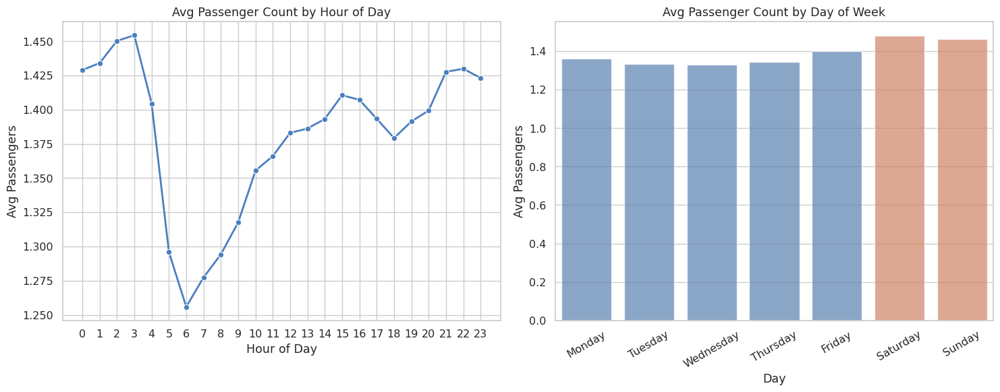
    - Analyse the variation of passenger counts across zones
The average passenger count was calculated per pickup zone. The top 10 zones by average passengers were:
Arrochar/Fort Wadsworth (Staten Island): 1.95
Red Hook (Brooklyn): 1.84
Battery Park (Manhattan): 1.74
Country Club (Bronx): 1.67
Saint Michaels Cemetery/Woodside (Queens): 1.67
Ocean Parkway South (Brooklyn): 1.63
DUMBO/Vinegar Hill (Brooklyn): 1.59
Brooklyn Navy Yard (Brooklyn): 1.57
Randalls Island (Manhattan): 1.55
World Trade Center (Manhattan): 1.54
A borough-level summary was also plotted. Brooklyn and Staten Island had the highest average passenger counts per trip among the boroughs.
A choropleth map was also created plotting average passenger count by zone using the YlGnBu colour scale.
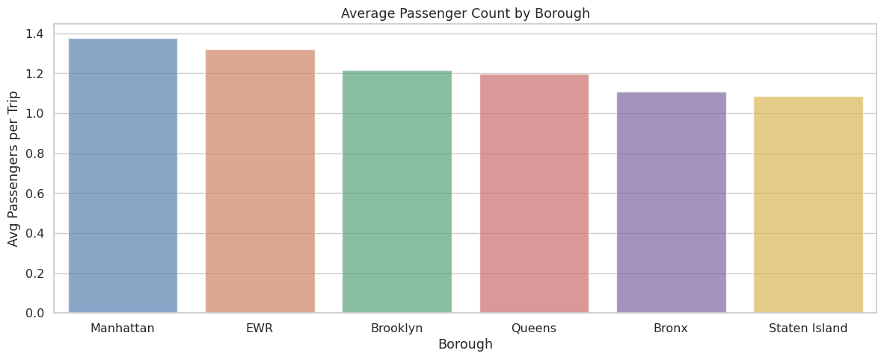

    - Analyse the pickup/dropoff zones or times when extra charges are applied more frequently.
The frequency of each surcharge across all trips was calculated:

extra: 1,126,882 trips (62.3%), average when applied $2.64
mta_tax: 1,796,755 trips (99.4%), average when applied $0.50
tolls_amount: 146,393 trips (8.1%), average when applied $7.33
improvement_surcharge: 1,808,103 trips (100.0%), average when applied $1.00
congestion_surcharge: 1,680,267 trips (92.9%), average when applied $2.50
airport_fee_combined: 158,797 trips (8.8%), average when applied $1.63
MTA tax and improvement surcharge apply to virtually all trips. Congestion surcharge applies to 92.9% of trips. Extra charges (night/rush surcharges) apply to 62.3% of trips. Tolls and airport fees are more selective, applying to 8.1% and 8.8% of trips respectively.
How these surcharges vary by hour was visualised for extra, congestion_surcharge, airport_fee_combined, and tolls_amount.
The top 10 zones by congestion surcharge application frequency:
Jamaica Bay: 100.0%
Crotona Park: 100.0%
Port Richmond: 100.0%
Upper East Side South: 99.79%
Sutton Place/Turtle Bay North: 99.79%
Lenox Hill West: 99.75%
Battery Park: 99.75%
West Village: 99.73%
Yorkville East: 99.72%
Greenwich Village South: 99.69%
Core Manhattan zones and some outer borough zones have near-universal congestion surcharge application, confirming that the congestion pricing zone covers most active pickup areas.
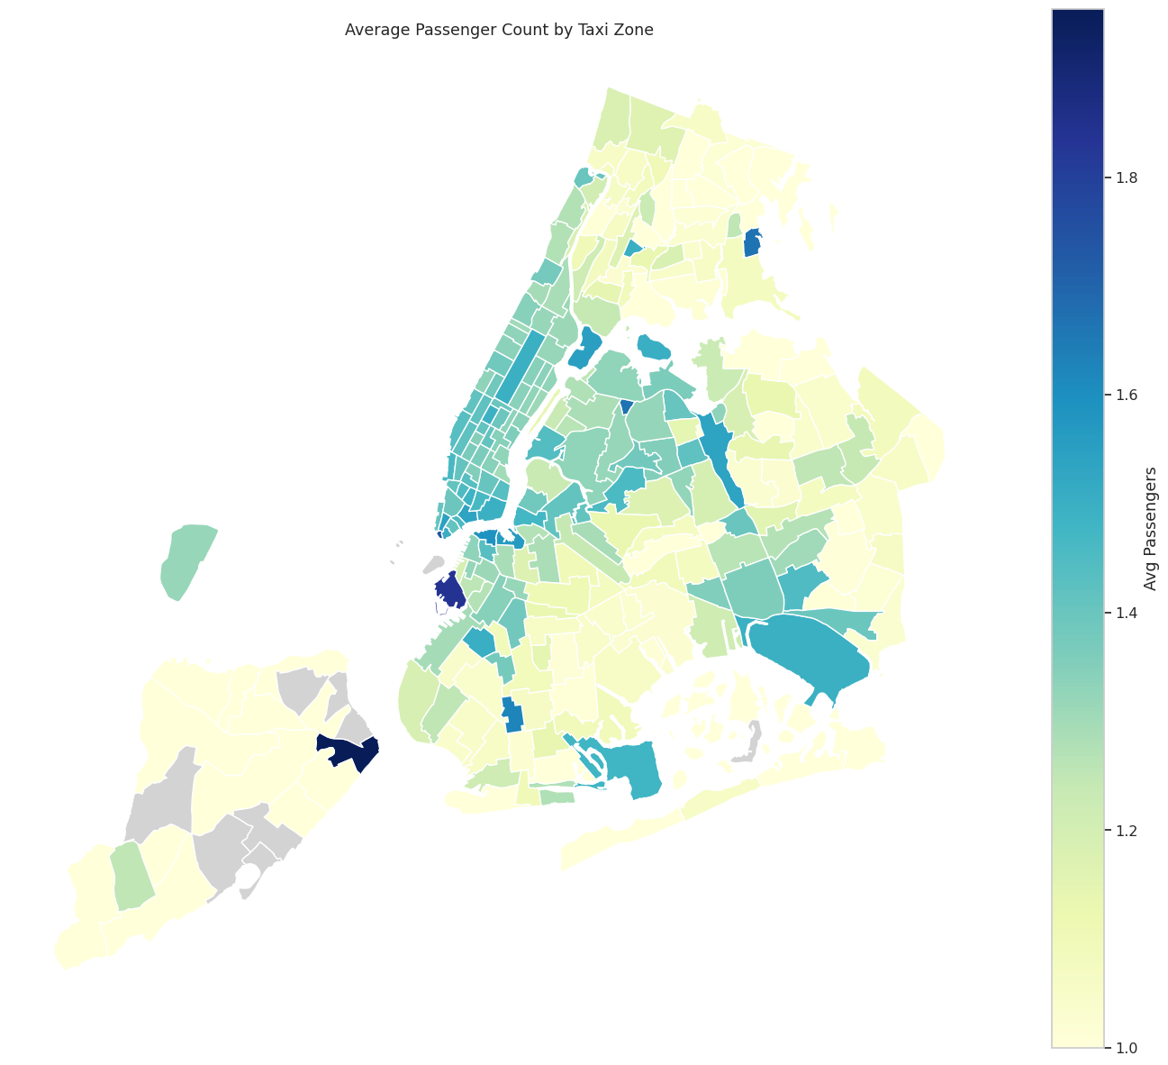
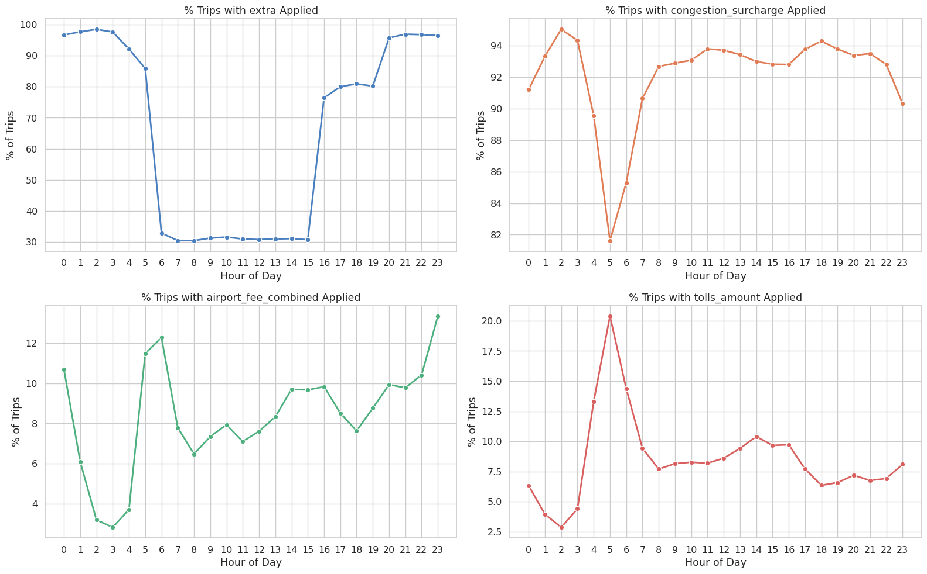

Conclusions

Final Insights and Recommendations
    - Recommendations to optimize routing and dispatching based on demand patterns and operational inefficiencies.

    - Peak Hour Positioning: Demand is consistently higher during morning (7-9 AM) and evening (6-9 PM) rush hours. Position taxis in high-demand zones slightly before peak hours instead of reacting after demand spikes.
    - Congestion-Aware Routing: Certain routes slow down heavily during peak traffic periods. Use smarter routing to avoid known bottlenecks where possible to reduce delays and improve efficiency.
    - Time-Based Demand Patterns: Weekdays are mainly commute-driven, while weekends and late nights shift toward entertainment zones. Dispatch strategy should adapt to these patterns instead of staying uniform.
    - Reduce Empty Repositioning: Some zones show imbalance between pickups and dropoffs. Improve matching of incoming and outgoing trips to reduce dead mileage.
    - Priority Zones: Airports and major transport hubs consistently generate high demand. These should always be treated as high-priority dispatch areas.
    - Dynamic Fleet Allocation: Use real-time and historical demand to adjust taxi distribution. This helps reduce idle time and improves coverage across the city.
    - Driver Incentives: Encourage operations in off-peak hours and underserved zones. This helps balance supply and improve overall system efficiency.

    - Suggestions on strategically positioning cabs across different zones to make best use of insights uncovered by analysing trip trends across time, days and months.

    - High-Demand Core Zones: Midtown Manhattan (Times Square, Grand Central) has the highest and most consistent pickup demand and should always maintain a baseline fleet presence. JFK Airport has predictable high-value demand, especially aligned with flight arrival times. Upper East and Upper West Side have steady commuter demand during morning and evening peaks.
    - Pickup vs Dropoff Balance: Zones with a high pickup-to-dropoff ratio (above 1.5) are source zones where trips originate more than they end. These are good for staging and continuous pickups, typically residential and transit-heavy areas. Zones with a low ratio (below 0.7) are sink zones where trips end more than they start. Empty repositioning back into these areas should be avoided; optimizing pickups outward from these zones is more efficient.
    - Night-Time Strategy (11 PM to 5 AM): Demand concentrates in nightlife districts and airport routes. Around 40-50% of the night fleet should be placed in top night pickup zones to capture higher-value trips.
    - Seasonal Demand Shifts: Q1 (January to March) sees lower demand, so concentrating the fleet in the Manhattan core reduces inefficiency. Q3 (July to September) sees higher tourism activity, which calls for expanded coverage around Central Park, Financial District, and Brooklyn Bridge areas.
    - Borough Coverage Expansion: Queens and Brooklyn show strong but under-served demand. Deploying 10-15% of the fleet into these boroughs during peak hours would capture missed demand.
    - The overall operational strategy combines time-based deployment adjusted for rush hours and seasonal cycles, zone-based positioning that prioritises hotspots and balances source and sink behaviour, and data-driven fleet management using demand forecasting and real-time tracking. Efficient cab positioning is not static and requires continuous adjustment based on live demand signals.

    - Propose data-driven adjustments to the pricing strategy to maximize revenue while maintaining competitive rates with other vendors.

    - Peak-Hour Surge Pricing: Evening rush (6-9 PM) and morning peak (7-9 AM) consistently see the highest demand. A modest 15-20% surge during these windows captures demand without pushing riders away. Fare per mile is already slightly elevated at these times in the data, so formalising this as a structured surge makes it transparent and predictable for both sides.
    - Distance-Tier Pricing Adjustment: Short trips (0-2 miles) have the highest fare per mile but the smallest absolute revenue. Medium trips (2-5 miles) are the most efficient sweet spot. A minimum fare floor for sub-1-mile trips would improve per-trip profitability without meaningfully affecting demand for short rides.
    - Airport Route Premium: JFK and LGA routes are high-value and time-predictable. Fixed airport route pricing rather than metered fares simplifies expectations for both driver and passenger. This model is already supported at airports via flat rates and reduces fare disputes on these routes.
    - Vendor Pricing Discrepancy: Vendor 1 and Vendor 2 show different fare per mile averages, particularly for short trips. Standardising the pricing algorithm across vendors creates a fairer marketplace and makes city-wide revenue forecasting more reliable.
    - Tip-Informed Strategy: Card payments show significantly higher tip rates than cash. Encouraging card payment through small incentives can lift average trip revenue without touching the base fare structure. Night trips have slightly higher tip rates, which could be factored into driver incentive programs for late-night shifts to improve shift coverage.
    - Weekend Pricing Model: Weekend demand starts later and skews more leisure-focused. A flat-rate weekend evening option for nightlife districts could appeal to groups and improve occupancy rates during those hours.
    - Q1 Revenue Recovery: January through March consistently shows the lowest revenue due to the seasonal dip after the holidays. Targeted promotions or slight fare reductions in Q1 can stimulate demand and prevent fleet utilisation from dropping too sharply through winter.

