Data Preparation
Our data is checked for Missing values, anomalies, data types and is fine to move forward with. Moreover, Normalization has also been done on continuous variables apart from our target variable ‘cnt’ and the two splits of it ‘registered’ and ‘casual’. Leaving the latter 2 un-normalized makes sense as they are a direct inference of the target variable itself.

Exploratory Analysis

Descriptive Statistics
Hour Data Statistics Daily Data Statistics
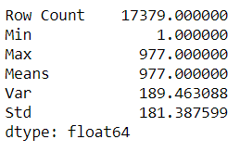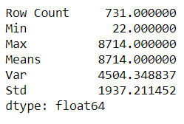

Distribution
Below is the distribution of our ‘cnt’ variables with Total rents on x-axis and frequencies on y-axis:
Hourly Data Distribution Daily Data Distribution
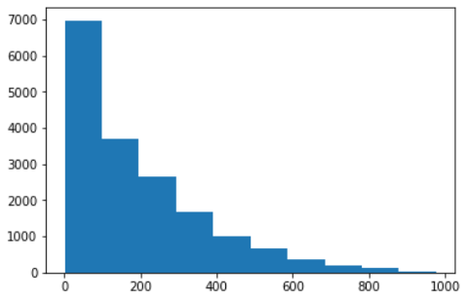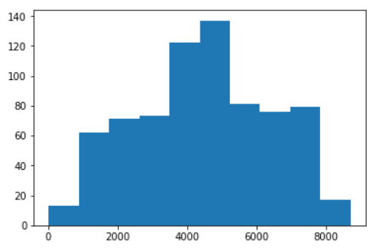

Feature Engineering

Feature Extraction
#new_cols() function
From the ‘weathersit’ column of the hour data, I extracted 3 sets of new columns:
- Clear_others: Separate Clear weather from others
- rainySnowy_others: Separate rainy and snowy weather from non rainy or non snowy weather
- heavy_rain_snow: Separate heavy rain and snow from others

Feature Selection
With the statistic test function we test for correlation between our target variable ‘cnt’ and our predictor variable. The ‘instant’ (index) and ‘dteday’ (information contained in other fields) will not be considered for the model training.

Statistical Tests:
- Mann Whitney U Test for 2-Category variables (yr,holiday,workingday,). Not enough Correlation between any of them and ‘cnt’.
- Kruskal Wallis Test for variables with 3 or more categories (season,mnth,hr,weekday,weathersit,). Not enough Correlation between any of them and ‘cnt’.
- Spearman rank order test as hour ‘cnt’ is not normally distributed (temp,atemp,hum,windspeed,casual,registered,cnt). Only ‘windspeed’ fails the correlation test.
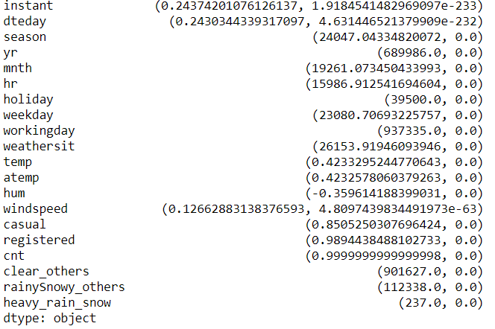
We have a small number of attributes so it is reasonable to still try training our model using all (except ‘instant’ and ‘dteday’) and then eliminating them stepwise while checking for improvement. Also we want to avoid overfitting.

Part 1

Which Regression Model?
What we know is that our problem is a regression problem. What model to use for predicting it will depend on some exploratory analysis that is done next.

Equidispersion, Overdispersion or Underdispersion
#Tested with Function check_dispersion()
Our dependent variable,’cnt’, contains Count Data which means an absolute count of events over a fixed period (day or hour). Hence, we consider the following models:
Poisson model assumes Equidispersion which means the variance of our “cnt” variable has to be equal to its means. Below, we see that is not the case:
Hour data: Variance is 32901.461104311245 and Mean is 189.46308763450142
Day Data: Variance is 3752788.2082828935 and Mean is 4504.3488372093025

Negative Binomial Model however assumes Overdispersion (Variance greater than Means), which is what we have here. It will be ideal for this problem unless there are excess zeros (Zero Inflated Problem) recorded in our ‘cnt’ variable. We test for that using our check_zero_count()function and see we don’t have excess zeros. In fact we have none. So we move ahead with the Negative Binomial Model.

The results however weren’t good at all after various combinations of the Negative Binomial model. However, with Linear Regression model the results were really good with the correlated independent variables.

Model
The model I settled for is the Linear Regression (statsmodels ols) model and the Mean Absolute Error using a 10 fold cross validation is reported below.

Mean Absolute Deviation
Inverted Mean absolute deviation derived using SkLearn’s cross_val_score:
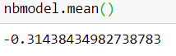
Using SkLearn’s cross_val_predict function to generate an ideal value for each point: and plotted below: 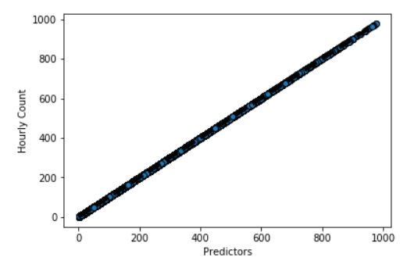

Code Maintenance
The code should be as self-explanatory and readable as possible. Separating classes and functions properly, using meaningful naming convention, using comments and only where necessary, good documentation, indentation consistency, avoid code repetition, avoid deprecated functions as they will be invalid in near the future and so on.

Part 2

Scaling up
The model will need to be transferred to a platform specifically designed for handling Big-Data like Spark. In this case Pyspark as I worked with python. My dataframes will be converted into Pyspark dataframes (spark.createDataframe(df)) for parallel processing. The functions are also passed into a Spark User Defined Function for the same parallel processing power. Spark also has a General Linear Regression module that we can consider use for our model otherwise we will have to pass that function calling it into a spark UDF as well. Parallelization of operations and the ability to store and access the database from one or multiple points (Database distribution) is the whole idea here.
Scaling properties include the various loops, conditional statements and dataframes. The various nodes that help realize the parallelization have parameters like number of cores that can be tweaked depending on the data size and type of tasks. For example, the number of data points to be processed at each node.
Cloud technology help to parallelize the much increased sizes of operations and data. Through a network, our database ad operations are pushed to various nodes that share the workload among each other and a central system (optional). They can simultaneously carry out their share of the workload and hence addresse the increased data size and operations problem.
Challenges of systems distributed through cloud services include update and data latency, system heterogeneity, maintanance complexities, privacy and data security issues (third party software).
Such services include Apache Spark, Apache haddop, Amazon Kinesis and Apache storm. I have hands on experience with Apache Spark.

