Table of Contents

Design Document
Architecture, dimensional model, ETL design and justifications
Group X - Member 1, Member 2, Member 3

1. Introduction

1.1 The problem
The University Library runs three separate legacy systems that do not talk to each other:
System | Technology | Records
Book Lending System | MySQL database (book_transactions) | book checkouts and returns
Digital Resources System | Excel workbook (digital_usage.xlsx) | e-book, journal and article downloads
Study Room Booking System | web application with CSV exports (room_bookings.csv) | study-room reservations
Every month the Library Director copies data from the three systems by hand. This takes more than 15 hours and the reports are inconsistent, because the systems write the same things in different ways (“CS”, “Computer Science”, “CompSci”; “R101”, “R-101”, “Room101”; three date formats). There is no history, no trend analysis and no dashboard.

1.2 Objectives
We designed and built a data warehouse that:
- consolidates the three sources (plus two reference files) into one database;
- cleans and standardises the data automatically with an ETL process, logging every problem;
- organises the data in a dimensional model (galaxy schema of three star schemas);
- enables OLAP operations: drill-down, roll-up, slice, dice and pivot;
- provides dashboards in Power BI (Executive, Department, Operational);
- secures the data with role-based access control, masking, row-level security and audit logging;
- ensures data quality with validation rules, before/after metrics and an error log;
- plans backup, recovery and scalability.

1.3 Scope and assumptions
- Sample data. No real library data was supplied, so 09_Source_Data/generate_source_data.py simulates the three systems for 2023-2025: 800 students, 72 books, 46 digital resources and 11 study rooms. The data is made dirty on purpose with every issue listed in section 7 of the brief (mixed date formats, inconsistent names, NULLs, exact/logical/near duplicates, numbers stored as text). A fixed random seed makes the data identical on every computer.
- Digital source has no StudentID. It records the user type and faculty, not the person. Analyses per student are therefore only possible for books and rooms (see question 11).
- ResourceTitle is assumed to be exported by the digital system; without it “Top 10 downloaded journals” could not be answered.
- Reference data: a student master list (department, level) and a book catalogue (titles, categories) are assumed to be available from the Registrar and the catalogue system.
- Loan period is 21 days: a loan kept longer is overdue.

1.4 Results in numbers
9,390raw source rows extracted
9,065clean rows loaded
527problems logged and handled
0duplicates in the warehouse
~5 sfull rebuild (was 15+ hours)

2. Approach

2.1 Kimball (bottom-up) instead of Inmon (top-down)
 | Inmon (top-down) | Kimball (bottom-up) - chosen
Starts with | an enterprise-wide normalised (3NF) warehouse, data marts later | dimensional data marts built around business processes
Time to first result | long | short
Best for | large organisations, many subject areas | one department with clear questions
Users | IT specialists | business users, BI tools
Why Kimball: the library is one subject area with a fixed list of business questions and a deadline of 1.5 weeks. Kimball’s dimensional model is easy to understand for non-technical users and is exactly the shape Power BI expects. Each library service (loans, downloads, bookings) is a business process with its own fact table; conformed dimensions (date, department, student) connect them - Kimball’s “bus architecture”. Each fact table with its dimensions is a small data mart (Circulation, Digital, Rooms), and the department views of the security layer are department-level marts.

2.2 ETL instead of ELT
 | ETL - transform before load (chosen) | ELT - load then transform in the database
Where the cleaning happens | Python (pandas) | SQL inside the database
Good for | complex text cleaning, small/medium data | very large data on powerful databases
The cleaning rules (date parsing with several formats, fuzzy duplicates, text-to-number conversion) are easier to write, read and test in Python. The data volume is small. Raw data is still kept in the staging tables, so the cleaning can always be re-run and audited.

3. Architecture
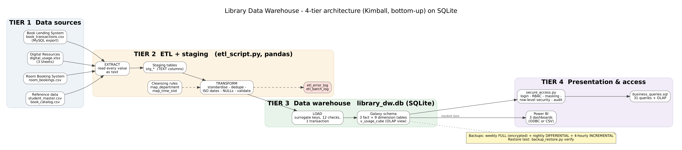 Figure 1 - 4-tier architecture
Tier | Components | Purpose
1. Sources | book_transactions.csv, digital_usage.xlsx (3 sheets), room_bookings.csv, reference/student_master.csv, reference/book_catalog.csv | the original systems’ exports, never changed
2. ETL + staging | etl_script.py; tables stg_* (raw text), map_* (cleansing rules), etl_error_log, etl_batch_log | extract, clean, validate, log
3. Warehouse | library_dw.db: 3 fact tables, 9 dimensions, v_usage_cube | the single source of truth
4. Presentation | secure_access.py, business_queries.sql, Power BI (3 dashboards) | secure analysis and reporting

3.1 Staging area structure
- Every source column is stored as TEXT, exactly as received. A value such as “2 hrs” or “31-Feb-2024” can never make the load fail.
- Audit columns on every staging row: batch_id (which ETL run), source_file, row_num (original line number, so every error can be traced back to the file) and loaded_at.
- Cleansing rules are data: map_department (27 spellings → 8 codes) and map_time_slot (21 spellings → 6 blocks) are read by the ETL at start-up. A new spelling is fixed by inserting one row - no code change.
- etl_error_log stores every rejected, corrected or defaulted value with the reason; etl_batch_log stores one row per run (rows extracted / loaded / rejected, status).

4. Technology choices
Layer | Tool | Why
Database | SQLite 3.53.1 | listed in the brief; no server to install, the whole warehouse is one portable file (2,976 KB) that every team member and the examiner can open; supports everything we need: foreign keys, CHECK constraints, indexes, views, triggers, recursive CTEs and window functions
ETL | Python 3 + pandas | recommended in the brief; flexible text cleaning; SQLite is built into Python
Analysis | SQL (business_queries.sql) + Python | 31 queries, bonus analytics
Dashboards | Power BI Desktop | free, professional; reads SQLite via ODBC or the exported CSV files
GUI for the database | DB Browser for SQLite (free) | browse tables and run queries
Limitations of SQLite and how we handle them
Limitation | Our solution
no user accounts / GRANT | security tables + secure_access.py with SQLite’s authorizer (section 10)
one writer at a time | only the nightly ETL writes; everyone else reads
no built-in encryption | encrypted backups (AES), BitLocker on the server disk; SQLCipher possible
not a network server | for many concurrent users, migrate to MySQL/PostgreSQL (section 11)

5. Dimensional model

5.1 Star vs snowflake vs galaxy
Schema | Description | Verdict
Star | one fact table, denormalised dimensions | good, but one fact table cannot hold three different processes cleanly
Snowflake | dimensions split into sub-tables (normalised) | more joins, slower, harder in Power BI → rejected
Galaxy (fact constellation) | several fact tables sharing dimensions | chosen - each fact table is itself a clean star
Justification. The three services are measured differently and at different grains (loan duration, number of downloads, booking hours). The suggested single library_usage_fact would be mostly NULL columns. With three facts sharing conformed dim_date and dim_department we can still compare services in one report (e.g. “books vs downloads vs rooms per month”). For questions that need all services in one result, the view v_usage_cube stacks the three facts on the shared dimensions (date, department, service). All dimensions are kept denormalised (one level), which gives the speed and simplicity of a star schema.
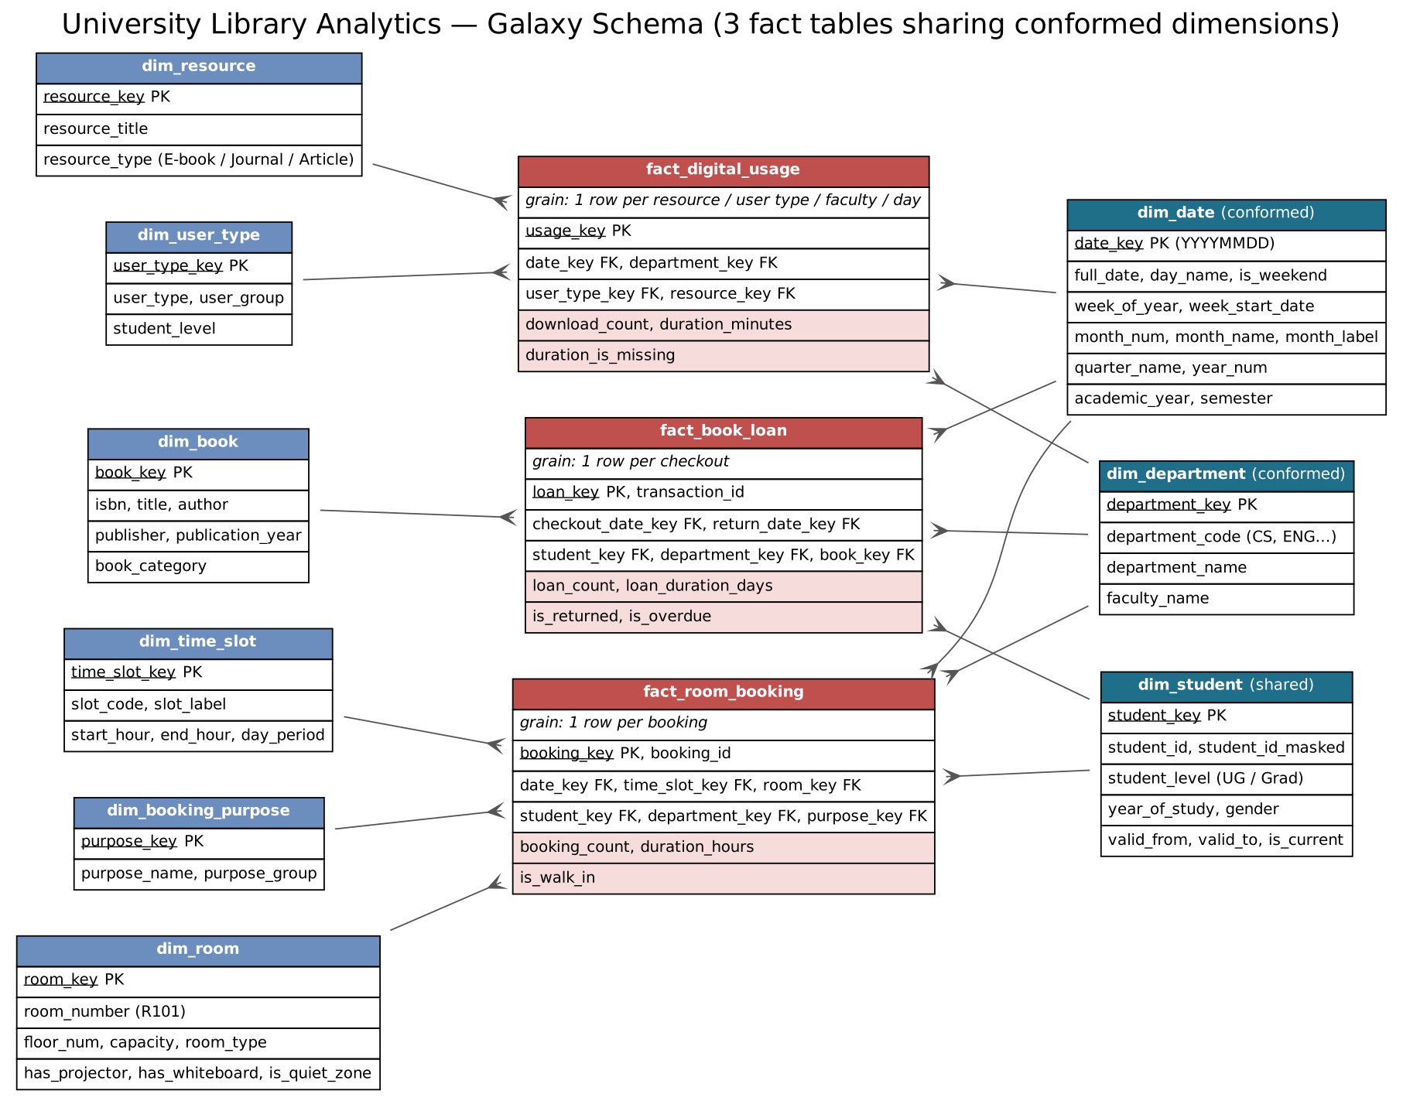 Figure 2 - Galaxy schema: three fact tables (red) sharing conformed dimensions (dark blue)

5.2 Fact tables
Fact table | Grain (one row =) | Measures | Dimension keys | Rows
fact_book_loan | one book checkout | loan_count (=1), loan_duration_days, is_returned, is_overdue | checkout date, return date, student, department, book | 2,205
fact_digital_usage | downloads of one resource by one user type of one faculty on one day | download_count, duration_minutes, duration_is_missing | date, department, user type, resource | 4,023
fact_room_booking | one booking | booking_count (=1), duration_hours, is_walk_in | date, time slot, room, student, department, purpose | 2,837
transaction_id and booking_id are kept as degenerate dimensions (source IDs) with a UNIQUE constraint, so a record can never be loaded twice. fact_room_booking also has UNIQUE(room, date, time slot): a room cannot be double-booked.

5.3 Dimension tables
Dimension | Key | Main attributes | Notes
dim_date | date_key (YYYYMMDD) | day, day name, weekend, week, week start, month, quarter, year, academic year, semester | 2023-2027, generated by a recursive SQL query; row −1 = “not returned”
dim_department | department_key | code, name, faculty | conformed; 8 departments + Unknown
dim_student | student_key | student_id, student_id_masked, level, year of study, gender, home department, valid_from/valid_to/is_current | shared by loans and rooms; SCD type 2 columns
dim_book | book_key | ISBN, title, author, publisher, year, category | from the catalogue
dim_resource | resource_key | title, type (E-book / Journal / Article) | built from the digital data
dim_user_type | user_type_key | user type, group, student level | lets us compare undergraduates and graduates for downloads
dim_room | room_key | room number, floor, capacity, type, projector, whiteboard, quiet zone | answers “why are rooms popular?”
dim_time_slot | time_slot_key | code, label, start/end hour, part of day | 6 standard 2-hour blocks
dim_booking_purpose | purpose_key | purpose, group (individual / collaborative)

5.4 Key design decisions
Question from the brief | Decision
How to handle dates across systems? | The ETL converts every format to ISO 8601; every fact points to the one dim_date table through date_key = YYYYMMDD. All hierarchies (day → week → month → quarter → year, academic year, semester) live in dim_date.
Fact table(s)? | three: fact_book_loan, fact_digital_usage, fact_room_booking
Dimensions? | time (dim_date), student, resource (dim_book, dim_resource), location (dim_room) + department, user type, time slot, purpose
One fact table or several? | several (galaxy) - section 5.1
Surrogate keys | integer keys created by the warehouse; the source IDs are kept as natural keys, so a change of ID format in a source does not break the warehouse
Missing values | each dimension has an Unknown member (key 1); a walk-in booking points to the Unknown student instead of NULL; a book not returned has return_date_key = −1
History | dim_student has SCD type 2 columns for students who change department or level
Privacy | student_id_masked (STU-****-001) is the only ID analysts, heads and Power BI ever see
Data-quality guards | CHECK constraints (no negative counts or durations, hours 0-12, flags 0/1), foreign keys ON, UNIQUE keys

6. Entity-Relationship Diagram
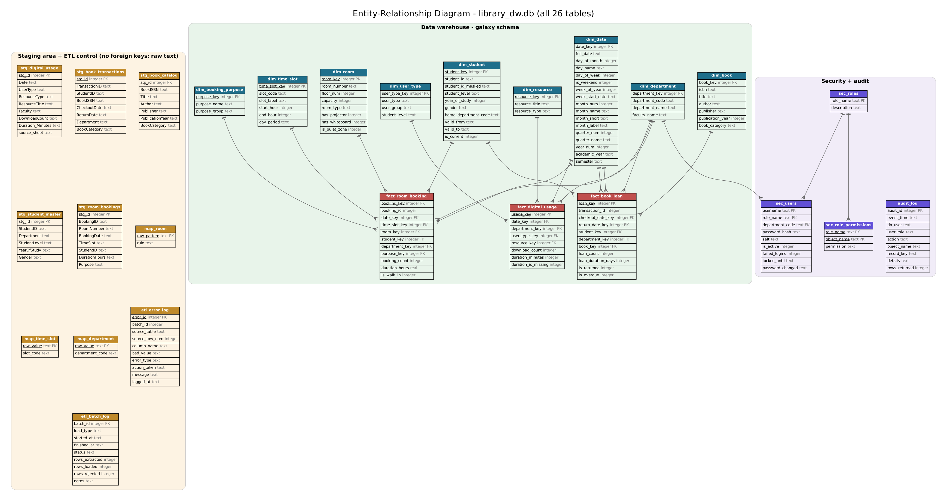 Figure 3 - All 26 tables of library_dw.db. Crow’s foot = “many”; the staging tables have no foreign keys because they hold raw text.
Relationships (all one-to-many, dimension → fact): dim_date → the three facts (and return_date_key → dim_date); dim_department → the three facts and sec_users; dim_student → loans and bookings; dim_book → loans; dim_resource, dim_user_type → downloads; dim_room, dim_time_slot, dim_booking_purpose → bookings; sec_roles → sec_users, sec_role_permissions.

7. Data dictionary

7.1 Fact tables
fact_book_loan
Column | Type | Description
loan_key | INTEGER PK | surrogate key
transaction_id | INTEGER UNIQUE | TransactionID from the lending system (degenerate dimension)
checkout_date_key | INTEGER FK → dim_date | day borrowed
return_date_key | INTEGER FK → dim_date | day returned; −1 = not returned yet
student_key | INTEGER FK → dim_student | borrower (1 = Unknown)
department_key | INTEGER FK → dim_department | standardised department
book_key | INTEGER FK → dim_book | book (1 = Unknown Book)
loan_count | INTEGER | always 1; SUM = number of loans
loan_duration_days | INTEGER, ≥ 0 | return − checkout; NULL if not returned
is_returned | INTEGER 0/1 | 1 = returned
is_overdue | INTEGER 0/1 | 1 = kept longer than 21 days
etl_batch_id, loaded_at |  | audit: which ETL run, when
fact_digital_usage
Column | Type | Description
usage_key | INTEGER PK | surrogate key
date_key | INTEGER FK → dim_date | download day
department_key | INTEGER FK → dim_department | faculty of the users
user_type_key | INTEGER FK → dim_user_type | undergraduate / graduate / faculty / staff
resource_key | INTEGER FK → dim_resource | resource downloaded
download_count | INTEGER ≥ 0 | number of downloads
duration_minutes | INTEGER, nullable | reading time; NULL for legacy records
duration_is_missing | INTEGER 0/1 | 1 = duration was missing in the source
etl_batch_id, loaded_at |  | audit
fact_room_booking
Column | Type | Description
booking_key | INTEGER PK | surrogate key
booking_id | INTEGER UNIQUE | BookingID from the booking system
date_key | INTEGER FK → dim_date | booking day
time_slot_key | INTEGER FK → dim_time_slot | standard 2-hour block
room_key | INTEGER FK → dim_room | standardised room
student_key | INTEGER FK → dim_student | 1 = Unknown (walk-in)
department_key | INTEGER FK → dim_department | department of the student
purpose_key | INTEGER FK → dim_booking_purpose | reason
booking_count | INTEGER | always 1
duration_hours | REAL, 0-12 | length of the booking
is_walk_in | INTEGER 0/1 | 1 = no StudentID in the source
etl_batch_id, loaded_at |  | audit

7.2 Dimension tables
Table | Column | Type | Description
dim_date | date_key | INTEGER PK | YYYYMMDD, e.g. 20240115
 | full_date | TEXT UNIQUE | ISO date 2024-01-15
 | day_of_month, day_name, day_of_week, is_weekend |  | 1 = Monday … 7 = Sunday
 | week_of_year, week_start_date |  | week number (weeks start on Monday) and its Monday
 | month_num, month_name, month_short, month_label |  | 1, January, Jan, 2024-01
 | quarter_num, quarter_name, year_num |  | 1, Q1, 2024
 | academic_year, semester |  | 2023/2024 (starts in September); Semester 1 / 2 / Break
dim_department | department_key, department_code, department_name, faculty_name |  | CS / Computer Science / Faculty of Computing & IT
dim_student | student_key | INTEGER PK | surrogate key
 | student_id | TEXT | real ID - hidden from every non-admin role
 | student_id_masked | TEXT | STU-****-001
 | student_level, year_of_study, gender, home_department_code |  | Undergraduate / Graduate
 | valid_from, valid_to, is_current |  | SCD type 2 history
dim_book | book_key, isbn, title, author, publisher, publication_year, book_category |  | category: Textbook, Research, Reference, Fiction
dim_resource | resource_key, resource_title, resource_type |  | E-book, Journal, Article
dim_user_type | user_type_key, user_type, user_group, student_level
dim_room | room_key, room_number, floor_num, capacity, room_type, has_projector, has_whiteboard, is_quiet_zone
dim_time_slot | time_slot_key, slot_code, slot_label, start_hour, end_hour, day_period |  | 08-10 … 18-20
dim_booking_purpose | purpose_key, purpose_name, purpose_group |  | Individual / Collaborative

7.3 Staging, control and security tables
Table | Purpose
stg_book_transactions, stg_digital_usage, stg_room_bookings | raw copy of each source (all TEXT) + batch_id, source_file, row_num, loaded_at
stg_student_master, stg_book_catalog | raw reference data
map_department, map_time_slot, map_room | cleansing rules stored as data
etl_batch_log | one row per ETL run: type, start/end, status, rows extracted/loaded/rejected
etl_error_log | every problem: source, row, column, bad value, error type, action, message
sec_roles, sec_role_permissions | the 5 roles and the permission matrix
sec_users | users, role, department (heads), PBKDF2 password hash + salt, lock-out fields
audit_log | logins, queries (allowed and refused) and changes recorded by triggers
Views: v_usage_cube (OLAP cube), v_dim_student_masked, v_dept_book_loans, v_dept_digital_usage, v_dept_room_bookings, v_dept_monthly_summary, v_audit_report.

8. ETL design
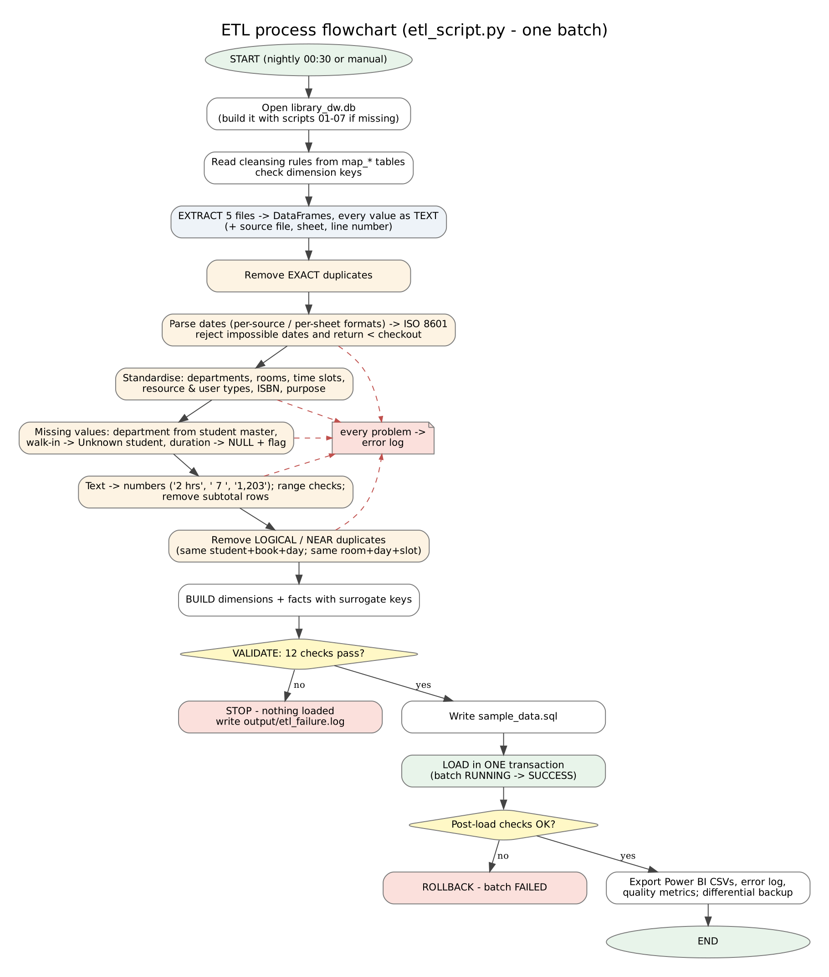{: style=“max-height:205mm”} Figure 4 - ETL process flowchart

8.1 Extraction plan
Source | How it is read | Special handling
book_transactions.csv | pandas.read_csv(dtype=str) | empty cells → NULL; “N/A” kept as text so it can be logged
digital_usage.xlsx | pandas.read_excel(sheet_name=None) - all sheets stacked | sheet name stored (needed for its date format)
room_bookings.csv | read_csv(dtype=str)
student_master.csv, book_catalog.csv | read_csv(dtype=str) | clean reference data

8.2 Transformation logic
The 30 cleansing rules are listed in 04_ETL_Files/transformation_rules.xlsx; the main ones:
- Dates → ISO 8601. Each source has a list of known formats that are tried in order. The Excel file uses one format per sheet; because “2024-05-03” means 5 March on the 2024 sheet (year-day-month) but 3 May elsewhere, the sheet’s own rule is used and the year is checked.
- Names → codes through the map_* tables (lower-case, spaces trimmed): departments, time slots; dictionaries for resource types, user types and purposes; rooms by keeping the digits (“Room 101” → “R101”).
- Text → numbers: spaces, commas, decimals and units removed (“2 hrs”, ” 7 “,”1,203”).
- Missing values: department filled from the student master; walk-ins → Unknown student; missing reading time kept as NULL + flag (no invented data); return date missing = not returned yet.
- Duplicates at three levels: exact (identical row), logical (same student + book + day, new ID), near (same room + day + slot after standardising - catches “Morning”/“8AM-10AM”, “R-101”/“Room101”).
- Subtotal rows typed into the Excel sheets (QUARTER TOTAL) are removed.

8.3 Loading strategy
- Full load (current): one batch replaces staging and warehouse contents inside one transaction; at ~9,000 rows it takes about one second. Dimensions first, then facts.
- Incremental load (designed for growth): the facts carry etl_batch_id, and transaction_id / booking_id are UNIQUE. An incremental batch would extract only source rows newer than the last loaded date (watermark stored in etl_batch_log), add new dimension members with INSERT OR IGNORE and insert new facts - the UNIQUE keys make a repeated run harmless.

8.4 Error handling
Situation | What happens
a bad value | logged in etl_error_log with action REJECTED / CORRECTED / DEFAULTED; the run continues
a validation check fails (12 checks) | the batch stops before loading; nothing changes; message in output/etl_failure.log
an SQL error while loading | the transaction is rolled back; batch marked FAILED
a mismatch after loading | post-load row counts and foreign-key check raise an error

8.5 Data refresh schedule
Frequency | Job
daily 00:30 | run_nightly_etl.bat: ETL + differential backup
every 4 h (08:00-20:00) | incremental backup
weekly (Sunday 01:00) | encrypted full backup
monthly (1st working day) | Director reviews the dashboards and the error-log summary; data-quality meeting

9. Indexes and performance
SQLite indexes primary keys and UNIQUE columns automatically but not foreign keys, so script 05 adds:
Index | Columns | Used by
idx_date_hierarchy | year, quarter, month, day | drill-down (Q6)
idx_date_week, idx_date_month | week_start_date; month_label | roll-up (Q7), monthly trends (Q1)
idx_loan_date, idx_loan_dept_date | checkout date; department + date | trends, department ranking, loan duration (Q1, Q2, Q5)
idx_loan_book | book_key | top 10 books (Q4)
idx_dig_date_dept, idx_dig_dept_res, idx_dig_resource | date+dept; dept+resource; resource | dicing (Q9), pivot (Q10), top journals (Q4)
idx_room_date_slot | date + time slot | peak times heat map (Q3)
idx_student_id_current | student_id, is_current | ETL key lookups (SCD)
All 31 queries run in well under a second.

10. Security, backup and OLAP (summary)
- OLAP cube: v_usage_cube (date × department × service); hierarchies Year → Quarter → Month → Day and Day → Week → Month in dim_date. Demonstrated in olap_operations_demo.pdf.
- Security: 5 roles; analysts read-only with masked StudentID; department heads see only their own department; passwords hashed; lock-out after 3 failures; every login and query in audit_log. Details: RBAC_policy.pdf, security_implementation.pdf.
- Backup: weekly encrypted full + nightly differential + 4-hourly incremental, SHA-256 checksums, automatic restore test. Details: backup_recovery_plan.pdf.

11. Scalability
Change | How the design copes
New library branch next year | add dim_branch (branch_key, name, campus) and a branch_key column to the three facts (existing rows → “Main library”); rooms get a branch attribute; dashboards gain a Branch slicer. No existing table is redesigned.
E-book reading-time tracking | duration_minutes already exists in fact_digital_usage; for detailed sessions add fact_reading_session (one row per session: start/end, pages) sharing dim_date, dim_resource, dim_user_type - another star in the galaxy.
More data (10× - 100×) | SQLite handles many GB; switch the ETL to incremental loads; archive staging rows older than one year.
Many simultaneous users or web access | migrate to MySQL / PostgreSQL: the model is standard SQL; scripts change only in data types and the security layer becomes database GRANTs.

12. Answers to the stakeholder questions
# | Question | Short answer
1 | Walk us through your ETL pipeline. How do you handle failures? | Extract to text staging → transform (30 rules) → 12 validation checks → load in one transaction → post-load checks. A failed check stops the batch before anything changes; an SQL error rolls everything back and marks the batch FAILED. Every bad value is logged.
2 | Why a star (galaxy) schema and not snowflake? | Fewer joins = faster and simpler for users and Power BI; dimensions are small, so normalising them saves nothing. Three stars share conformed dimensions.
3 | How do you handle incremental loads? | Batch IDs + watermark in etl_batch_log, UNIQUE source IDs, INSERT OR IGNORE for new dimension members (section 8.3). Today a full reload takes ~1 second.
4 | Which indexes and why? | Date hierarchy, week/month, fact foreign keys used in joins and filters (section 9).
5 | A new branch next year? | Add dim_branch + branch_key (section 11).
6 | Add e-book reading-time tracking? | duration_minutes exists; add fact_reading_session for detailed sessions.
7 | Most surprising insight? | Downloads per book loan doubled from 5.9 (2023) to 12.3 (2025), and the October 2024 drop of -57.3% is detected automatically - the pattern of an e-resource platform outage. Graduates keep books 17.9 days vs 12.8 for undergraduates.
8 | Monthly reports: now vs before? | Before 15+ hours of manual work; now the nightly ETL refreshes everything automatically and a complete rebuild takes about 5 seconds; dashboards are always up to date.
9 | How do you ensure student privacy? | Masked IDs everywhere outside admin, column-level block on student_id, department-only access for heads, audit log, encrypted backups; Power BI files contain no real IDs.
10 | What if the room booking system changes its format? | Raw text staging never fails; new spellings = one row in map_*; unknown values are defaulted and logged; validation stops a broken batch before it reaches the warehouse.
11 | Who can access salary information? | Nobody: the warehouse stores no salary or HR data (data minimisation). If ever added, it would be a separate restricted table readable only by dw_admin.
12 | How quickly can you recover after a failure? | RPO ≤ 4 hours (incremental backups), RTO < 15 minutes; the measured restore of the full chain took under one second (backup_test_results.txt).

13. Project files and how to run
Folder | Content
01_Design | architecture, ERD, galaxy schema, ETL flowchart (PNG + Graphviz sources)
03_Database_Files | SQL scripts 01-07, sample_data.sql, build_database.py, library_dw.db
04_ETL_Files | etl_script.py, quality report, transformation rules, error log
05_Analytics_Package | business_queries.sql (31 queries), results, OLAP demo, bonus analytics
06_Dashboards | Power BI data, DAX measures, theme, dashboard images, guide
07_Security_Documentation | policies, secure_access.py, backup_restore.py, test results
09_Source_Data | the three messy sources + generator
pip install pandas openpyxl matplotlib cryptography
python run_all.py # rebuilds everything from scratch (about 5 seconds)

