Table of Contents

User Guide
For library staff, the Director and department heads (no technical knowledge needed)
Group X - Member 1, Member 2, Member 3

1. What is the library data warehouse?
Until now, the library kept its information in three separate places: the book lending system, the digital resources spreadsheet and the study room booking system. Every month someone spent more than 15 hours copying numbers between them, and the totals did not always agree.
The data warehouse collects the information from the three systems every night, corrects the mistakes automatically (for example “CS”, “CompSci” and “Computer Science” all become Computer Science) and stores everything in one place. The dashboards in Power BI show the result as charts that are always up to date.
In short: you no longer prepare reports - you open a dashboard. The numbers are refreshed every morning, all three services use the same names, dates and departments, and nobody can see a student’s real ID.
What is inside
Service | What is counted | Period
Book lending | every loan: which book, which department, how long it was kept, returned or not | 2023-2025
Digital resources | downloads of e-books, journals and articles per faculty and user type | 2023-2025
Study rooms | every booking: room, day, time slot, hours, purpose, walk-in or student | 2023-2025

2. Who can see what?
You are | You can | You cannot
Library Director / analyst | see all departments and all services, filter, export summaries | see real student IDs, change data
Head of department | see everything about your own department | see other departments, real student IDs, change data
Desk staff | use the Operational dashboard | change data
IT administrator | manage the system, users and backups | -
Student IDs always appear like STU-****-001. This protects students’ privacy; you can still count how many different students used a service.

3. Getting access
- Ask the Library Director for an account (one account per person - never share it).
- You receive a username and a first password. Passwords must have at least 12 characters with capital letters, small letters, numbers and a symbol; they expire every 90 days.
- After 3 wrong passwords your account is locked for 24 hours. Ask the IT administrator if you need it unlocked sooner.
- The dashboards are opened in Power BI (desktop app or the web link you receive).

4. The Executive dashboard (for the Director) {: .newpage}
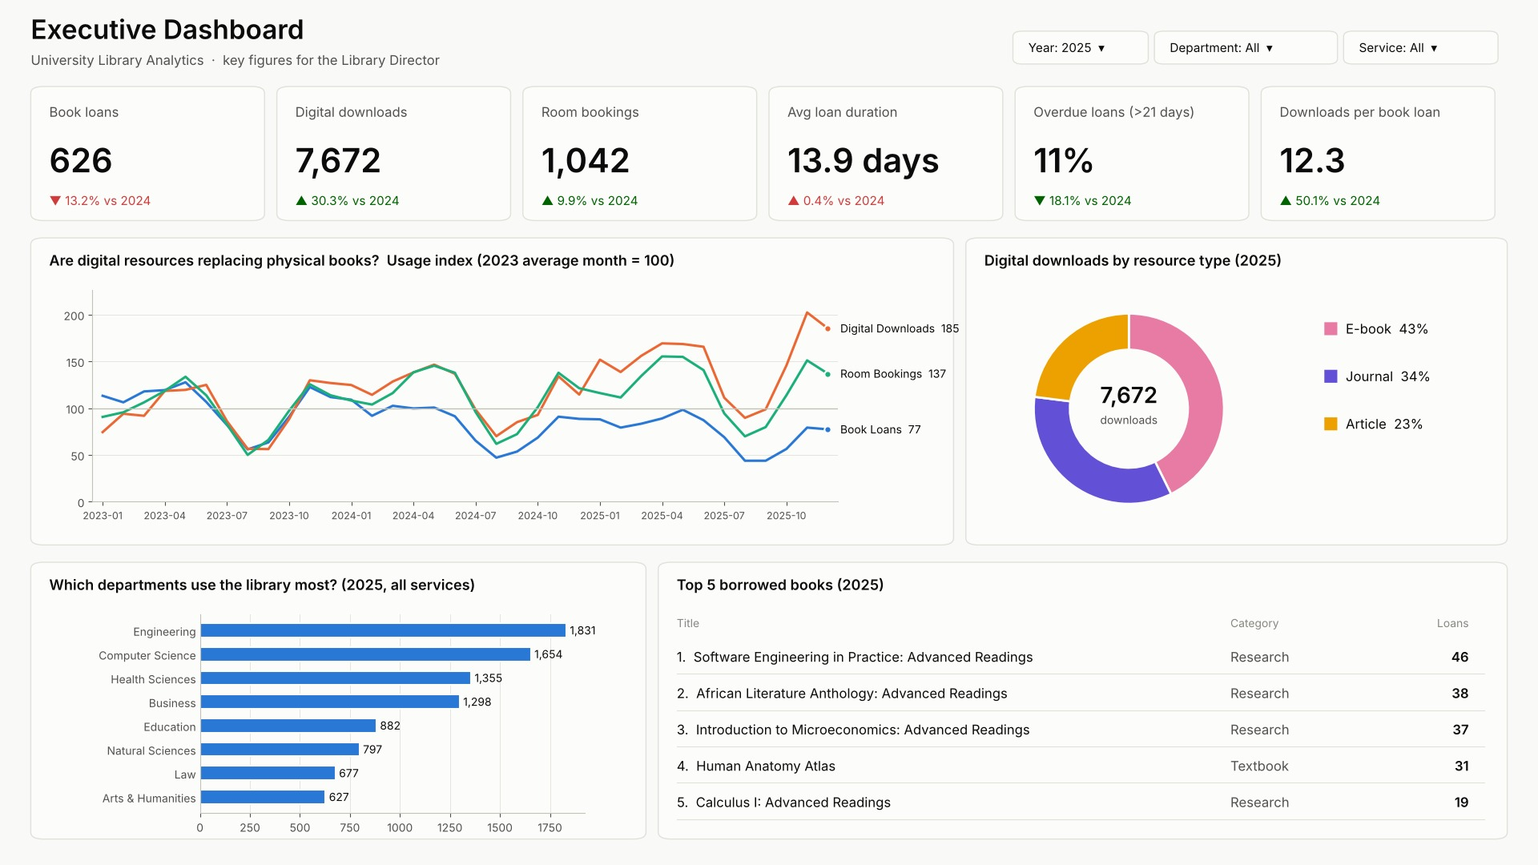
exec
Part | What it tells you
Six cards at the top | the big numbers for the selected year: book loans, digital downloads, room bookings, average loan duration, % of loans kept too long (more than 21 days), and downloads per book loan. The small line below compares with the previous year: ▲ up / ▼ down, green = good news, red = needs attention.
Line chart | the three services on one scale (100 = a normal month of 2023). If the orange line (downloads) rises while the blue line (books) falls, digital resources are replacing physical books.
Donut | how digital downloads are split between e-books, journals and articles.
Department bars | which departments use the library most (all services together).
Top 5 books | the most borrowed titles - useful for buying extra copies.
Main findings in the current data: digital downloads grew 30.3% in 2025 while book loans changed by -13.2%; Engineering and Computer Science use the library most; the busiest study-room time is Wednesday 14:00 - 16:00.

5. The Department dashboard (for heads of department) {: .newpage}
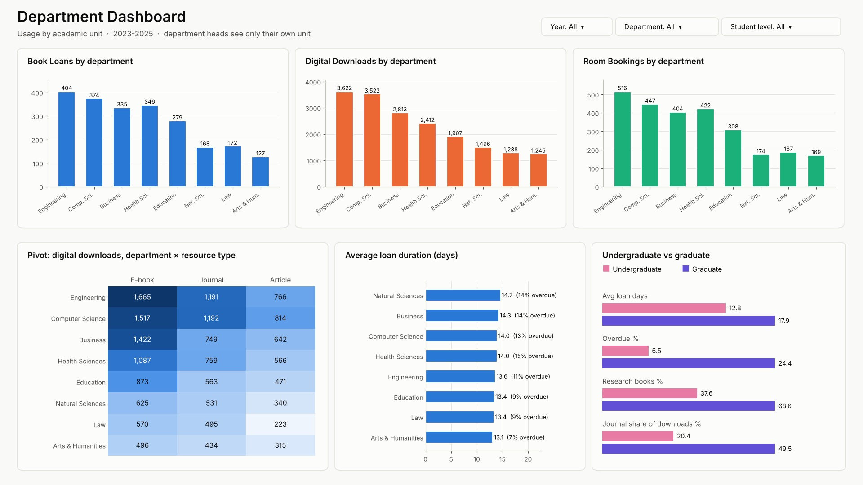
dept
Part | What it tells you
Three bar charts | loans, downloads and room bookings per department (each service has its own colour: blue = books, orange = digital, green = rooms).
Coloured table (pivot) | downloads per department and resource type; darker = more downloads.
Average loan duration | how many days books are kept on average, and the % kept longer than 21 days.
Undergraduate vs graduate | graduates keep books longer (17.9 vs 12.8 days) and use more journals (49.5% vs 20.4% of their downloads).
Department heads automatically see only their own department in this dashboard.

6. The Operational dashboard (for desk staff) {: .newpage}
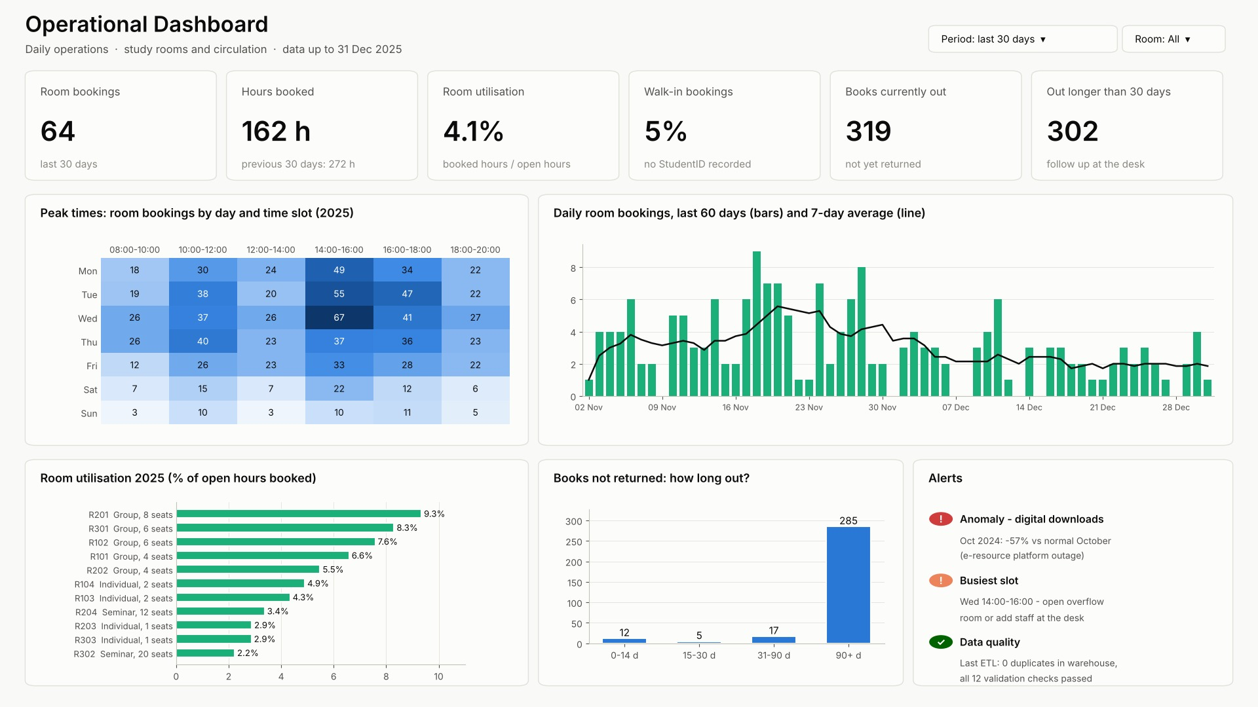
ops
Part | What it tells you | Typical action
Cards | bookings and hours in the last 30 days, room use, walk-ins, books still out
Heat map | room bookings per day and time slot; dark blue = busy | plan staff and cleaning at quiet times
Daily bookings | bars per day + 7-day average line | spot unusual days
Room utilisation | % of opening hours each room is booked | the busiest rooms are group rooms with a projector (R201)
Books not returned | how long books have been out | send reminders for books out more than 30 days
Alerts | red = problem, orange = attention, green = OK | e.g. the sudden drop of digital downloads in October 2024

7. How to use the dashboards {: .newpage}
I want to … | Do this
choose a year or department | use the drop-down boxes (slicers) at the top of the page
choose several values | hold Ctrl and click
see the exact number | hover the mouse over a bar, point or cell
filter the whole page by one item | click it (e.g. the Engineering bar); click again to undo
go from year to months to days (drill-down) | on a chart with dates, click the ↓ arrow in its top corner, then click a bar
go back up (roll-up) | click the ↑ arrow
see the numbers as a table | right-click the visual → Show as a table
save the numbers to Excel | … (top corner of the visual) → Export data
start again | Reset to default (top bar)

Examples
“How many journals did Engineering download in March 2024?” Department dashboard → slicer Department = Engineering, Year = 2024 → in the pivot table look at the Journal column; or click March in a monthly chart.
“Which room should we equip with a second projector?” Operational dashboard → Room utilisation: the top rooms are the group rooms with projectors.
“Are students returning books on time?” Executive dashboard → card Overdue loans: currently 12.0% of returned loans were kept longer than 21 days.

8. For analysts: asking your own questions
Analysts and department heads can also query the warehouse directly with the access program (it checks your role and records every query):
python secure_access.py --user analyst_amina
SQL> SELECT department_name, COUNT(*) FROM fact_book_loan
JOIN dim_department USING (department_key) GROUP BY department_name;
Department heads use their own tables, for example:
python secure_access.py --user head_cs
SQL> SELECT month_label, book_loans, digital_downloads, room_bookings
FROM my_monthly_summary ORDER BY month_label DESC;
Ready-made questions (31 of them) are in 05_Analytics_Package/business_queries.sql, with their answers in query_results.xlsx.

9. Where do the numbers come from, and are they correct?
- Every night at 00:30 the system reads the three source systems, cleans the data and reloads the warehouse. The dashboards show the data up to the previous day.
- “Unknown” in a chart means the source did not say: e.g. a walk-in room booking without a student ID, or a download record without a faculty. These records are still counted.
- Duplicates (the same loan or booking saved twice by a system error) are removed automatically.
- Every correction is written in an error log. In the last load: 9,390 records read, 9,065 loaded, 325 rejected (mostly duplicates).
- If a number looks wrong: note the dashboard, filter and value, and tell the IT administrator. Do not try to correct numbers in Excel - the source system must be corrected, and the next night’s load fixes the warehouse.

10. Privacy rules (please read)
- Never share your password or let someone else use your account.
- Do not try to find out who a masked student is.
- Exported data stays inside the library; do not e-mail personal data.
- Every query and every login is recorded (who, when, what).
- Report anything suspicious to the IT administrator the same day.

11. Words you may meet
Word | Meaning
Dashboard | a page of charts that answers questions at a glance
KPI | Key Performance Indicator - an important number (e.g. total loans)
Slicer | a filter box on a dashboard
Drill-down / roll-up | moving from yearly totals to months and days, and back
Slice / dice | looking at one period only / filtering on several things at once
Pivot | a table with categories in rows and columns (e.g. departments × resource types)
Masked ID | STU-****-001: a student number with the hidden part replaced by stars
Data warehouse | the central database that combines the three library systems
ETL | the nightly program that Extracts, Transforms (cleans) and Loads the data

12. Help
Problem | Contact
password, account locked, access to another department | IT administrator (lib_admin) - add name and phone
a number looks wrong | ETL specialist - add name
a new report or chart | analytics lead - add name

