Table of Contents

Dashboard Guide
Building and using the three Power BI dashboards
Group X - Member 1, Member 2, Member 3

1. The three dashboards
Dashboard | For | Answers
Executive | Library Director | headline KPIs vs last year, digital vs physical trend, department ranking, resource mix, top books
Department | Deans, department heads | usage per department and service, pivot of resource types, loan duration, undergraduate vs graduate
Operational | Desk staff, room managers | last 30 days, peak-time heat map, daily bookings, room utilisation, books not returned, alerts
The images in this folder (executive_dashboard.jpg, department_dashboard.jpg, operational_dashboard.jpg) are the design of each page, drawn from the real warehouse data by build_dashboard_images.py. Section 4 shows how to build the same pages in Power BI; after building, save your own screenshots over these files.
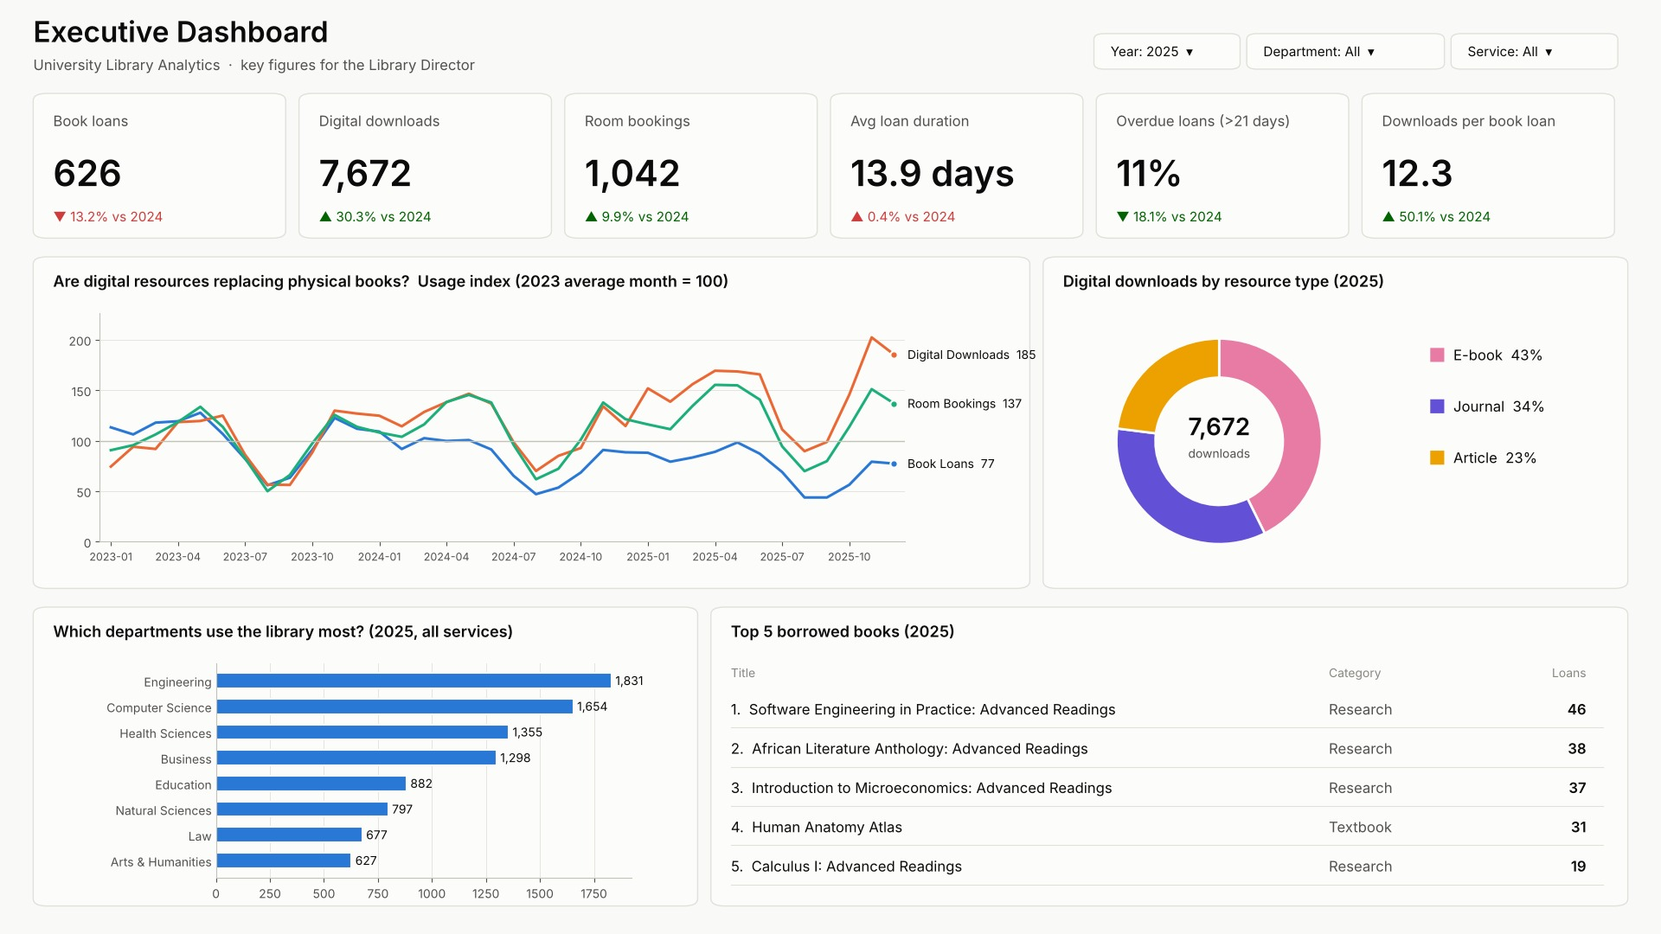 Executive dashboard (design)

2. What you need
Item | Where | Notes
Power BI Desktop | free from Microsoft (Microsoft Store or powerbi.microsoft.com) | Windows only
The data | 06_Dashboards/PowerBI_Data/*.csv or 03_Database_Files/library_dw.db | CSV = easiest
DAX measures | 06_Dashboards/PowerBI_DAX_measures.txt | copy & paste
Theme | 06_Dashboards/LibraryDW_PowerBI_theme.json | colours used in the designs
SQLite ODBC driver (only for option B) | “SQLite ODBC Driver” by Christian Werner (ch-werner.de/sqliteodbc), 64-bit version | free

3. Load the data and build the model

3.1 Option A (recommended): the CSV files
- Run the ETL once (python etl_script.py) - it writes fresh CSV files into 06_Dashboards/PowerBI_Data.
- Power BI Desktop → Home → Get data → Text/CSV → choose dim_date.csv → Transform Data.
- Repeat for the other 11 table files (dim_*.csv, fact_*.csv). Tip: after the first file, use New Source → Text/CSV inside Power Query.
- dim_student.csv contains only the masked student ID - the real ID never reaches Power BI.

3.2 Option B: live connection to library_dw.db (ODBC)
- Install the 64-bit SQLite ODBC driver.
- Windows → ODBC Data Sources (64-bit) → tab User DSN → Add → SQLite3 ODBC Driver → Data Source Name LibraryDW, Database Name: browse to library_dw.db → OK.
- Power BI → Get data → More… → Other → ODBC → DSN LibraryDW → Navigator: tick the 3 fact_* tables, the dimensions and v_dim_student_masked instead of dim_student (privacy) → Transform Data.
- In Power Query rename v_dim_student_masked to dim_student.

3.3 Clean-up in Power Query (both options)
Table | Step
dim_date | filter date_key → untick -1 (the “not returned” row; a date table must have continuous dates); set full_date and week_start_date to type Date
all tables | check that keys are Whole number, duration_hours Decimal number, flags (is_returned, is_overdue, is_walk_in …) Whole number
Click Close & Apply.

3.4 Relationships (Model view)
Power BI usually detects them; check this list and fix if needed (all many-to-one, single direction, from the dimension to the fact):
From (one) | To (many) | Active
dim_date[date_key] | fact_book_loan[checkout_date_key] | yes
dim_date[date_key] | fact_book_loan[return_date_key] | no (inactive; use with USERELATIONSHIP if needed)
dim_date[date_key] | fact_digital_usage[date_key] | yes
dim_date[date_key] | fact_room_booking[date_key] | yes
dim_department[department_key] | each of the 3 facts [department_key] | yes
dim_student[student_key] | fact_book_loan, fact_room_booking [student_key] | yes
dim_book[book_key] | fact_book_loan[book_key] | yes
dim_resource[resource_key] | fact_digital_usage[resource_key] | yes
dim_user_type[user_type_key] | fact_digital_usage[user_type_key] | yes
dim_room / dim_time_slot / dim_booking_purpose | fact_room_booking | yes
The result is the galaxy schema of the design document: three stars sharing dim_date and dim_department.

3.5 Date table, sorting and the hierarchy
- Select dim_date → Table tools → Mark as date table → column full_date.
- Select month_name → Column tools → Sort by column → month_num. Do the same: month_short by month_num, day_name by day_of_week, slot_label (in dim_time_slot) by start_hour.
- Create the hierarchy for drill-down: in the Data pane right-click year_num → Create hierarchy; then right-click quarter_name, month_name, day_of_month → Add to hierarchy in that order. Name it Calendar.
- Hide the key columns (right-click → Hide in report view) so users only see readable fields.

3.6 Measures and theme
- Home → Enter data → name the table _Measures → Load.
- Select _Measures → New measure → paste one measure from PowerBI_DAX_measures.txt → Enter. Repeat for every measure (Total Loans, Total Downloads, Total Bookings, Total Usage, Avg Loan Days, Overdue %, YoY measures, Index measures, Room Utilisation %, Walk-in %, Books Currently Out, Journal Share %, Anomaly).
- Format: % measures → Percentage, 1 decimal; totals → Whole number with thousands separator.
- View → Themes → Browse for themes → LibraryDW_PowerBI_theme.json.
One extra calculated column for the Operational page (select fact_book_loan → New column):
Days Out =
IF ( fact_book_loan[is_returned] = 0,
DATEDIFF ( RELATED ( dim_date[full_date] ), DATE ( 2025, 12, 31 ), DAY ) )
Out Bucket =
SWITCH ( TRUE (),
ISBLANK ( fact_book_loan[Days Out] ), BLANK (),
fact_book_loan[Days Out] <= 14, "0-14 d",
fact_book_loan[Days Out] <= 30, "15-30 d",
fact_book_loan[Days Out] <= 90, "31-90 d",
"90+ d" )
(In daily use replace DATE ( 2025, 12, 31 ) by TODAY ().)

4. Build the pages
Canvas: View → Page view → Fit to page, page size 16:9. Rename pages Executive, Department, Operational.

4.1 Executive page
# | Visual | Fields | Settings
1 | Slicer (Dropdown) | dim_date[year_num] | select 2025
2 | Slicer (Dropdown) | dim_department[department_name]
3 | 6 × Card | Total Loans, Total Downloads, Total Bookings, Avg Loan Days, Overdue %, Downloads per Loan | under each card a small card with the YoY % measure (or, in Card (new), add the YoY measure as reference label)
4 | Line chart | X: dim_date[month_label]; Y: Loans Index, Downloads Index, Bookings Index | one axis (indexes are comparable); edit interactions so the Year slicer does not filter it
5 | Donut chart | Legend: dim_resource[resource_type]; Values: Total Downloads | detail labels: category + percent
6 | Bar chart (horizontal) | Y: dim_department[department_name]; X: Total Usage | sort descending; filter department ≠ Unknown
7 | Table | dim_book[title], dim_book[book_category], Total Loans | filter title: Top N = 5 by Total Loans; exclude “Unknown Book”

4.2 Department page
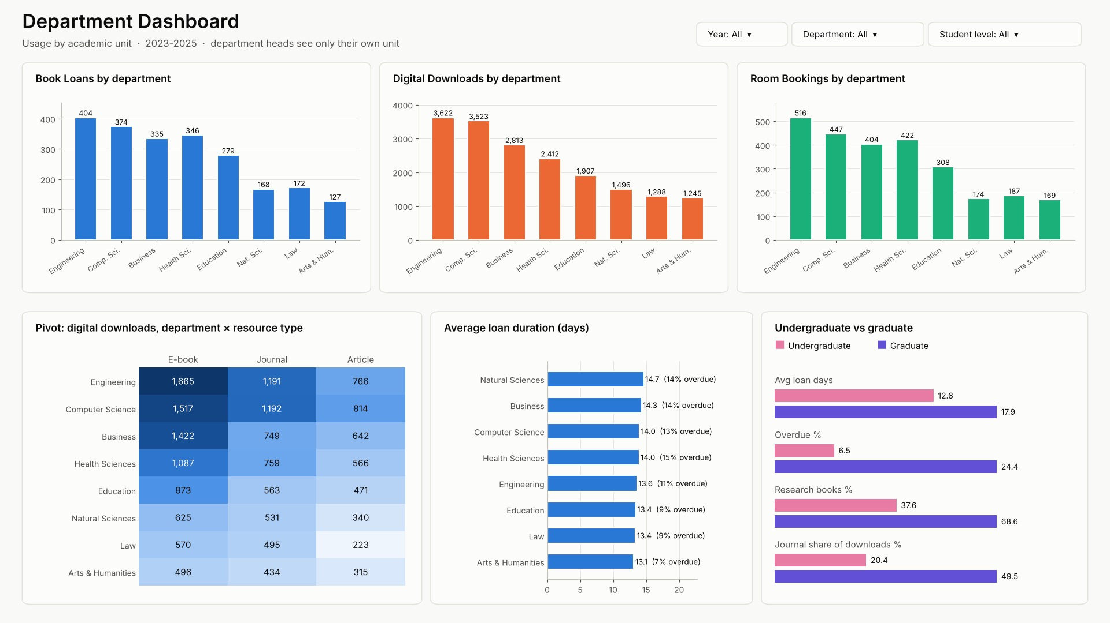
dept
# | Visual | Fields | Settings
1 | Slicers | year_num, department_name, dim_student[student_level]
2 | 3 × Clustered column chart | X: department_name; Y: Total Loans / Total Downloads / Total Bookings | one chart per service, each in its service colour (blue / orange / green)
3 | Matrix (the pivot) | Rows: department_name; Columns: dim_resource[resource_type]; Values: Total Downloads | Format → Cell elements → Background colour → gradient (heat map)
4 | Bar chart | Y: department_name; X: Avg Loan Days; Tooltips: Overdue % | data labels on
5 | Clustered bar chart | Y: dim_student[student_level]; X: Avg Loan Days, Overdue % (two small charts) | filter level ≠ Unknown
6 | Clustered bar chart | Y: dim_user_type[student_level]; X: Journal Share % | shows UG vs Grad for digital

4.3 Operational page
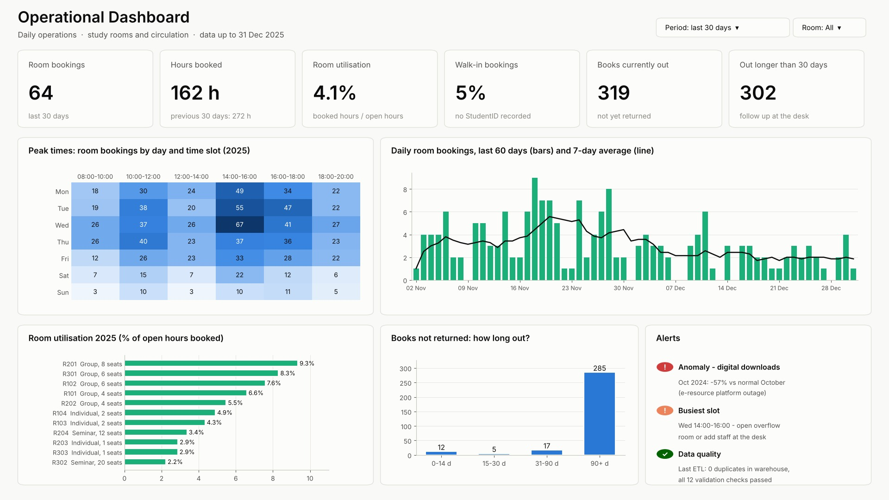
ops
# | Visual | Fields | Settings
1 | Slicer (Between) | dim_date[full_date] | set to the last 30 days (or Relative date: Last 30 days in daily use)
2 | Cards | Total Bookings, Hours Booked, Room Utilisation %, Walk-in %, Books Currently Out | Books Currently Out: edit interactions → not filtered by the date slicer
3 | Matrix heat map | Rows: dim_date[day_name]; Columns: dim_time_slot[slot_label]; Values: Total Bookings | background colour gradient; filter slot ≠ Unknown
4 | Line and clustered column chart | X: dim_date[full_date]; Column: Total Bookings | last 60 days; add a trend/average line in Analytics
5 | Bar chart | Y: dim_room[room_number]; X: Room Utilisation %; Tooltips: room_type, capacity, has_projector | sorted descending
6 | Column chart | X: fact_book_loan[Out Bucket]; Y: count of loan_key
7 | Table “Alerts” | dim_date[month_label], Total Downloads, Downloads Normal Month, Anomaly | visual filter: Anomaly = “ANOMALY - sudden drop”

4.4 Save and export
- File → Save as LibraryDW_Dashboards.pbix in 06_Dashboards.
- For the submission images: show each page full screen and save a screenshot as executive_dashboard.jpg, department_dashboard.jpg, operational_dashboard.jpg (or File → Export → Export to PDF).

5. OLAP operations in Power BI
Operation | How to do it in the report
Drill-down | put the Calendar hierarchy on the X axis of a chart → click the down arrow (drill mode) → click a year bar → its quarters → a quarter → its months → days
Roll-up | click the up arrow (drill up), or the double down arrow “Go to the next level” to see all quarters together
Slice | one slicer, e.g. Year = 2024 and Quarter = Q1
Dice | several slicers together, e.g. Department = Engineering + Month = March + Resource type = Journal
Pivot | the Matrix visual: drag a field from Rows to Columns to rotate the view

6. Department-level security in Power BI (Row-Level Security)
When the report is published to the Power BI service, department heads must see only their own department - the same rule as secure_access.py.
- Load PowerBI_Data/powerbi_rls_users.csv (e-mail → department code) as table rls_users (no relationship needed).
- Modeling → Manage roles → New role Department Head → table dim_department → DAX filter:
[department_code] =
LOOKUPVALUE ( rls_users[department_code], rls_users[user_email], USERPRINCIPALNAME () )
- Because dim_department filters all three facts, every visual now shows only that department.
- Test: Modeling → View as → Department Head + Other user head.cs@university.example → only Computer Science is visible.
- In the Power BI service: dataset → Security → add the department heads’ accounts to the role. The Director and analysts are not added to the role and see everything.

7. Refreshing the data
- The nightly ETL (00:30) reloads the warehouse and rewrites the CSV files.
- In Power BI Desktop: Home → Refresh. In the Power BI service: schedule a refresh at 06:00 (needs the on-premises data gateway on the computer that holds the files).
- Always check the Data quality alert on the Operational page after a refresh.

8. Using the dashboards (for everyone)
- Hover over any bar, line point or cell to see the exact numbers.
- Click a bar (e.g. Engineering) to filter all other visuals on the page; click again to clear.
- Slicers at the top change the whole page; Ctrl+click to choose several values.
- Drill: on charts with the Calendar hierarchy, use the arrows in the top-right corner of the visual.
- See the data behind a visual: right-click → Show as a table; export with … → Export data (staff accounts only).
- Reset to the default view: Reset to default (top bar in the Power BI service).
- KPI arrows: ▲/▼ compare with the same period last year; green means good for the library, red means needs attention (e.g. a ▼ in loans is red, a ▼ in overdue loans is green).

