Table of Contents

Data Quality Report
Before / after metrics, cleansing results and error handling
Group X - Member 1, Member 2, Member 3

1. Summary
The ETL (04_ETL_Files/etl_script.py, batch 1) read 9,390 raw rows from the three sources, found and logged 527 data-quality problems and loaded 9,065 clean rows into the warehouse. 325 rows were rejected (mainly duplicates); every rejected row is still in the staging tables and in etl_error_log, so nothing is lost and every decision can be checked.
9,390rows read
9,065rows loaded
325rows rejected
527problems logged
12 / 12validation checks passed
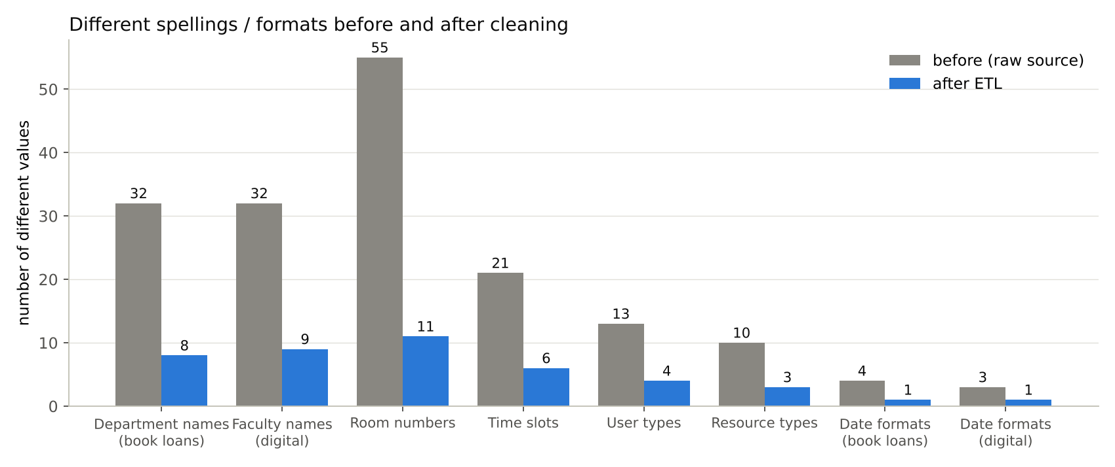 Figure 1 - every inconsistent attribute is reduced to one standard set of values

2. Before / after metrics per source

2.1 Book Lending System (book_transactions.csv)
Metric | Before | After
Rows | 2,278 | 2,205
Exact duplicates (same TransactionID twice) | 44 | 0
Logical duplicates (same student + book + day) | 22 | 0
Different department spellings | 32 | 8 departments
Date formats (incl. invalid text) | 4 | 1 (ISO 8601)
ISBN formats (with / without dash) | 2 | 1
Book category spellings | 12 | 4
Missing department | 79 | 0 (filled from student master)
Missing return date (not returned) | 331 | 319 kept, flagged is_returned = 0

2.2 Digital Resources System (digital_usage.xlsx)
Metric | Before | After
Rows (3 sheets) | 4,113 | 4,023
Exact duplicates | 60 | 0
Date formats (one per sheet) | 3 | 1
Faculty spellings | 32 | 9 (incl. Unknown)
Resource type spellings (E-book / e-Book …) | 10 | 3
User type spellings | 13 | 4
DownloadCount stored as text | 77 | 0
Missing Duration_Minutes (legacy) | 968 | 937 kept as NULL + flag
Missing faculty | 91 | 0 (→ Unknown department)

2.3 Study Room Booking System (room_bookings.csv)
Metric | Before | After
Rows | 2,999 | 2,837
Exact duplicates | 112 | 0
Near duplicates (same room + day + slot) | 43 | 0
Room number spellings | 55 | 11 rooms
Time slot spellings | 21 | 6 standard blocks
Date formats | 2 | 1
DurationHours with text (“2 hrs”, “1.5h”) | 1,471 | 0
Purpose spellings | 10 | 6
Missing StudentID (walk-ins) | 214 | 0 → 207 bookings point to the “Unknown” student

3. What was done with each problem
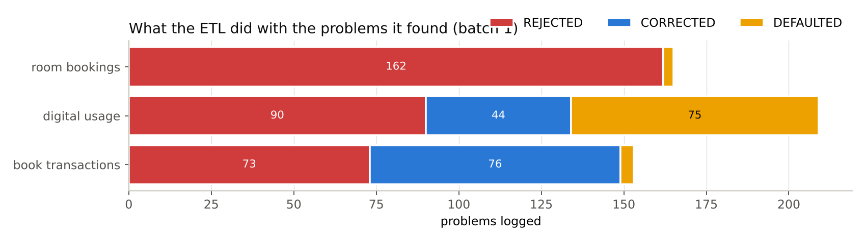
actions
source | error type | action | rows
book_transactions | DUPLICATE_EXACT | REJECTED | 44
book_transactions | DUPLICATE_LOGICAL | REJECTED | 22
book_transactions | INVALID_DATE | REJECTED | 4
book_transactions | INVALID_RANGE | REJECTED | 3
book_transactions | MISSING_VALUE | CORRECTED | 76
book_transactions | UNKNOWN_REFERENCE | DEFAULTED | 4
digital_usage | DUPLICATE_EXACT | REJECTED | 60
digital_usage | INVALID_NUMBER | REJECTED | 18
digital_usage | MISSING_VALUE | DEFAULTED | 75
digital_usage | SUBTOTAL_ROW | REJECTED | 12
digital_usage | TEXT_NUMBER | CORRECTED | 44
room_bookings | DUPLICATE_EXACT | REJECTED | 112
room_bookings | DUPLICATE_NEAR | REJECTED | 43
room_bookings | INVALID_DATE | REJECTED | 3
room_bookings | INVALID_NUMBER | REJECTED | 4
room_bookings | UNKNOWN_REFERENCE | DEFAULTED | 3
Actions
- REJECTED - the row is not loaded (duplicates, impossible dates, invalid numbers, subtotal rows). It stays in staging and in the error log.
- CORRECTED - the value was fixed automatically (department filled from the student master, number stored as text converted).
- DEFAULTED - the value was replaced by the Unknown member (key 1) or NULL so the rest of the row can still be used.
One example of each error type (full list: output/etl_error_log.csv, readable sample: error_log_sample.txt):
row | source | column | bad value | error type | action
171 | book_transactions | TransactionID | 1169 | DUPLICATE_EXACT | REJECTED
2258 | book_transactions | TransactionID | 3213 | DUPLICATE_LOGICAL | REJECTED
2845 | room_bookings | BookingID | 7843 | DUPLICATE_NEAR | REJECTED
877 | book_transactions | CheckoutDate | 2023-00-12 | INVALID_DATE | REJECTED
530 | digital_usage | DownloadCount | two | INVALID_NUMBER | REJECTED
257 | book_transactions | ReturnDate | Apr 02, 2023 | INVALID_RANGE | REJECTED
13 | book_transactions | Department |  | MISSING_VALUE | CORRECTED
148 | digital_usage | ResourceTitle | QUARTER 1 TOTAL = 1,131 | SUBTOTAL_ROW | REJECTED
189 | digital_usage | DownloadCount | 1 | TEXT_NUMBER | CORRECTED
560 | book_transactions | BookISBN | 978-1238724937 | UNKNOWN_REFERENCE | DEFAULTED

4. Validation before loading
The load only starts when all 12 checks pass; otherwise nothing is changed.
validation check | result
No duplicate TransactionID in fact_book_loan | PASS
No duplicate BookingID in fact_room_booking | PASS
No room double-booked in the same slot | PASS
All checkout dates inside 2023-2025 | PASS
All download dates inside 2023-2025 | PASS
All booking dates inside 2023-2025 | PASS
Loan durations are never negative | PASS
Download counts are never negative | PASS
Booking hours between 0 and 12 | PASS
Every student_key exists in dim_student | PASS
Every book_key exists in dim_book | PASS
No NULL department_key in any fact | PASS
After loading, the ETL also checks that the row count of every warehouse table equals the prepared data and that PRAGMA foreign_key_check finds 0 problems. Query Q19 in business_queries.sql proves there are 0 duplicates in the final warehouse.

5. Handling of missing values - choices and reasons
Field | Missing | Strategy | Why
ReturnDate | 319 loans | kept; is_returned = 0, return_date_key = -1, duration NULL | a missing date means “not returned yet” - a real business state, not an error
StudentID (rooms) | 207 bookings | “Unknown” student (key 1), is_walk_in = 1 | the booking happened; it must count in room usage
Duration_Minutes | 937 rows | NULL + duration_is_missing = 1 | we do not invent reading times; averages simply ignore NULL; the flag shows how complete the data is
Department | 79 rows | looked up in the student master | the correct value exists in another system
Faculty (digital) | 91 rows | Unknown department | the digital system has no student to look up

6. Error handling procedure
- Every run writes one row to etl_batch_log (status RUNNING → SUCCESS / FAILED, rows extracted / loaded / rejected).
- Value-level problems never stop the run: they are logged in etl_error_log (source, line number, column, bad value, error type, action, message).
- Batch-level problems (a validation check fails, an SQL error, a row-count mismatch) stop the batch. Because the load is one transaction, the warehouse keeps yesterday’s correct data. The reason is written to output/etl_failure.log.
- Daily review (librarian, 5 minutes): open error_log_sample.txt or run SELECT * FROM etl_error_log WHERE batch_id = (SELECT MAX(batch_id) FROM etl_batch_log).
- Fixing a recurring problem: a new spelling → insert one row in map_department / map_time_slot; a wrong source record → correct it in the source system; then run the ETL again (it is safe to re-run: no duplicates are created).
- Escalation: if a batch fails two nights in a row, the ETL specialist checks etl_failure.log; the dashboards keep showing the last good data meanwhile.

