Table of Contents

OLAP Operations Demo
Drill-down, roll-up, slice, dice and pivot - with SQL and results
Group X - Member 1, Member 2, Member 3

1. The OLAP cube
OLAP (On-Line Analytical Processing) means looking at the same data from different angles and at different levels of detail. Our “cube” has three main dimensions:
Cube dimension | Table | Hierarchy / members
Time | dim_date | Year → Quarter → Month → Day, and Day → Week → Month (plus academic year, semester)
Department | dim_department | Faculty → Department
Service | the three fact tables | Book Loans, Digital Downloads, Room Bookings
and further dimensions per service (resource type, user type, room, time slot, book category, student level). The view v_usage_cube (script 04) stacks the three fact tables on the shared dimensions so that one query can compare all services:
CREATE VIEW v_usage_cube AS
SELECT checkout_date_key AS date_key, department_key, student_key,
'Book Loans' AS service, loan_count AS usage_count FROM fact_book_loan
UNION ALL
SELECT date_key, department_key, NULL, 'Digital Downloads', download_count FROM fact_digital_usage
UNION ALL
SELECT date_key, department_key, student_key, 'Room Bookings', booking_count FROM fact_room_booking;
How to reproduce every result in this document: open 03_Database_Files/library_dw.db in DB Browser for SQLite → tab Execute SQL → paste the query → Ctrl+Return; or run python run_business_queries.py (all results go to query_results.xlsx). In Power BI, the same operations are done by clicking (see dashboard_guide.pdf, section 5).
Operation | In one sentence | Query
Drill-down | from summary to detail (Year → Day) | Q06a-d
Roll-up | from detail to summary (Day → Month) | Q07a-d
Slice | fix ONE dimension to one value | Q08a-b
Dice | filter SEVERAL dimensions at once | Q09a-b
Pivot | turn rows into columns (matrix) | Q10a-b

2. Drill-down: Year → Quarter → Month → Day
Business question 6. We start with the yearly totals and go one level deeper each time, always keeping the same measure. We follow 2024 → Q2 (exam season) → April.
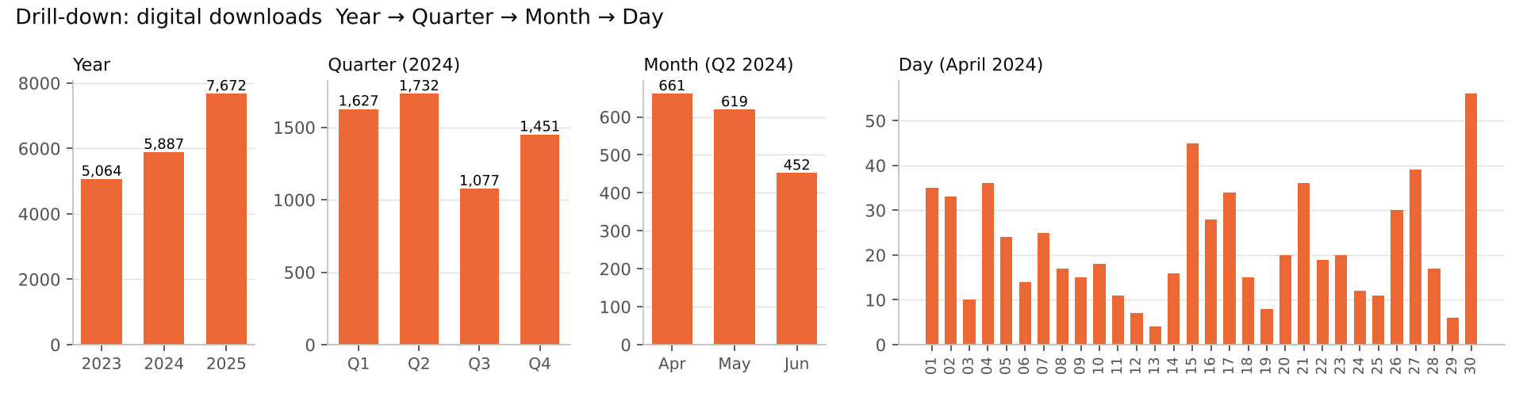
drill
Level 1 - Year (Q06a)
SELECT d.year_num,
SUM(CASE WHEN u.service = 'Book Loans' THEN u.usage_count ELSE 0 END) AS book_loans,
SUM(CASE WHEN u.service = 'Digital Downloads' THEN u.usage_count ELSE 0 END) AS digital_downloads,
SUM(CASE WHEN u.service = 'Room Bookings' THEN u.usage_count ELSE 0 END) AS room_bookings
FROM v_usage_cube u
JOIN dim_date d ON d.date_key = u.date_key
GROUP BY d.year_num
ORDER BY d.year_num
year_num | book_loans | digital_downloads | room_bookings
2023 | 858 | 5064 | 847
2024 | 721 | 5887 | 948
2025 | 626 | 7672 | 1042
Level 2 - Quarters of 2024 (Q06b) - the only change: WHERE d.year_num = 2024 and GROUP BY d.year_num, d.quarter_name.
year_num | quarter_name | book_loans | digital_downloads | room_bookings
2024 | Q1 | 220 | 1627 | 246
2024 | Q2 | 196 | 1732 | 292
2024 | Q3 | 115 | 1077 | 153
2024 | Q4 | 190 | 1451 | 257
Level 3 - Months of Q2 2024 (Q06c) - WHERE ... AND d.quarter_num = 2, GROUP BY d.month_label.
month_label | month_name | book_loans | digital_downloads | room_bookings
2024-04 | April | 78 | 661 | 125
2024-05 | May | 66 | 619 | 100
2024-06 | June | 52 | 452 | 67
Level 4 - Days of April 2024 (Q06d) - WHERE d.month_label = '2024-04', GROUP BY d.full_date.
full_date | day_name | book_loans | digital_downloads | room_bookings
2024-04-01 | Monday | 3 | 35 | 5
2024-04-02 | Tuesday | 3 | 33 | 4
2024-04-03 | Wednesday | 5 | 10 | 2
2024-04-04 | Thursday | 5 | 36 | 9
2024-04-05 | Friday | 4 | 24 | 3
2024-04-06 | Saturday | 0 | 14 | 4
2024-04-07 | Sunday | 0 | 25 | 2
2024-04-08 | Monday | 4 | 17 | 5
2024-04-09 | Tuesday | 2 | 15 | 6
2024-04-10 | Wednesday | 2 | 18 | 4
2024-04-11 | Thursday | 2 | 11 | 9
2024-04-12 | Friday | 4 | 7 | 2
(first 12 of 30 rows)
Reading. Digital downloads grow every year; within 2024 the third quarter (July-August holidays) is the quietest, and April - the exam month - is the busiest month of Q2.

3. Roll-up: Day → Week → Month
Business question 7. The opposite of drill-down: daily room bookings are added up to weeks and months.
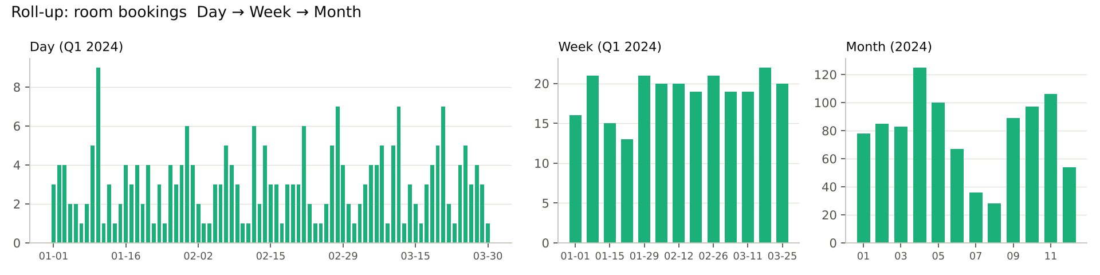
rollup
Weekly summary (Q07b)
SELECT d.week_start_date,
COUNT(*) AS bookings,
ROUND(SUM(f.duration_hours), 1) AS hours_booked,
COUNT(DISTINCT d.full_date) AS days_with_bookings
FROM fact_room_booking f
JOIN dim_date d ON d.date_key = f.date_key
WHERE d.year_num = 2024 AND d.quarter_num = 1
GROUP BY d.week_start_date
ORDER BY d.week_start_date
week_start_date | bookings | hours_booked | days_with_bookings
2024-01-01 | 16 | 37.5 | 6
2024-01-08 | 21 | 53.5 | 6
2024-01-15 | 15 | 40.5 | 5
2024-01-22 | 13 | 32 | 5
2024-01-29 | 21 | 52 | 7
2024-02-05 | 20 | 38 | 7
2024-02-12 | 20 | 56.5 | 6
2024-02-19 | 19 | 38 | 7
2024-02-26 | 21 | 56.5 | 6
2024-03-04 | 19 | 40 | 6
2024-03-11 | 19 | 38.5 | 6
2024-03-18 | 22 | 52 | 6
(first 12 of 13 rows)
Monthly summary 2024 (Q07c)
month_label | bookings | hours_booked | avg_bookings_per_active_day
2024-01 | 78 | 194.5 | 3.1
2024-02 | 85 | 200.5 | 3
2024-03 | 83 | 187 | 3.2
2024-04 | 125 | 299.5 | 4.5
2024-05 | 100 | 246.5 | 3.8
2024-06 | 67 | 166 | 2.7
2024-07 | 36 | 82.5 | 1.7
2024-08 | 28 | 65 | 1.8
2024-09 | 89 | 219.5 | 3.9
2024-10 | 97 | 214.5 | 3.5
2024-11 | 106 | 239.5 | 4.1
2024-12 | 54 | 128 | 2.2
All levels in one result (Q07d). MySQL has GROUP BY ... WITH ROLLUP; SQLite does not, so we write the three levels and glue them with UNION ALL. Week rows add up to the MONTH TOTAL rows, and the months add up to the GRAND TOTAL.
WITH q1 AS (
SELECT d.month_label, d.week_start_date, f.duration_hours
FROM fact_room_booking f
JOIN dim_date d ON d.date_key = f.date_key
WHERE d.year_num = 2024 AND d.quarter_num = 1
)
SELECT * FROM (
SELECT month_label, week_start_date, 'week' AS level,
COUNT(*) AS bookings, ROUND(SUM(duration_hours), 1) AS hours_booked
FROM q1 GROUP BY month_label, week_start_date
UNION ALL
SELECT month_label, NULL, 'MONTH TOTAL',
COUNT(*), ROUND(SUM(duration_hours), 1)
FROM q1 GROUP BY month_label
UNION ALL
SELECT NULL, NULL, 'GRAND TOTAL',
COUNT(*), ROUND(SUM(duration_hours), 1)
FROM q1
)
ORDER BY month_label IS NULL, month_label, week_start_date IS NULL, week_start_date
month_label | week_start_date | level | bookings | hours_booked
2024-01 | 2024-01-01 | week | 16 | 37.5
2024-01 | 2024-01-08 | week | 21 | 53.5
2024-01 | 2024-01-15 | week | 15 | 40.5
2024-01 | 2024-01-22 | week | 13 | 32
2024-01 | 2024-01-29 | week | 13 | 31
2024-01 | nan | MONTH TOTAL | 78 | 194.5
2024-02 | 2024-01-29 | week | 8 | 21
2024-02 | 2024-02-05 | week | 20 | 38
2024-02 | 2024-02-12 | week | 20 | 56.5
2024-02 | 2024-02-19 | week | 19 | 38
2024-02 | 2024-02-26 | week | 18 | 47
2024-02 | nan | MONTH TOTAL | 85 | 200.5
(first 12 of 19 rows)

4. Slice: one time period only (Q1 2024)
Business question 8. A slice fixes one dimension to one value - here time = Q1 2024 - and shows the rest of the cube.
SELECT u.service,
SUM(u.usage_count) AS total_usage,
COUNT(DISTINCT u.date_key) AS active_days,
ROUND(1.0 * SUM(u.usage_count) / COUNT(DISTINCT u.date_key), 1) AS avg_per_active_day
FROM v_usage_cube u
JOIN dim_date d ON d.date_key = u.date_key
WHERE d.year_num = 2024 AND d.quarter_name = 'Q1' -- <== the slice
GROUP BY u.service
ORDER BY u.service
service | total_usage | active_days | avg_per_active_day
Book Loans | 220 | 76 | 2.9
Digital Downloads | 1627 | 89 | 18.3
Room Bookings | 246 | 79 | 3.1
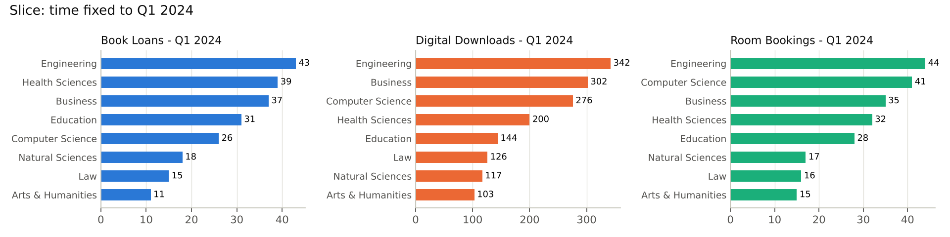
slice
The same slice by department (Q08b)
department_name | book_loans | digital_downloads | room_bookings
Arts & Humanities | 11 | 103 | 15
Business | 37 | 302 | 35
Computer Science | 26 | 276 | 41
Education | 31 | 144 | 28
Engineering | 43 | 342 | 44
Health Sciences | 39 | 200 | 32
Law | 15 | 126 | 16
Natural Sciences | 18 | 117 | 17
Unknown | 0 | 17 | 18

5. Dice: several dimensions at once
Business question 9 - “Engineering students’ digital downloads in March” (department = ENG and month = March 2024 and user group = Student):
SELECT r.resource_type,
ut.user_type,
SUM(f.download_count) AS downloads,
ROUND(AVG(f.duration_minutes), 0) AS avg_reading_minutes
FROM fact_digital_usage f
JOIN dim_date d ON d.date_key = f.date_key
JOIN dim_department dp ON dp.department_key = f.department_key
JOIN dim_resource r ON r.resource_key = f.resource_key
JOIN dim_user_type ut ON ut.user_type_key = f.user_type_key
WHERE dp.department_code = 'ENG' -- dimension 1: department
AND d.month_label = '2024-03' -- dimension 2: time
AND ut.user_group = 'Student' -- dimension 3: user type
GROUP BY r.resource_type, ut.user_type
ORDER BY downloads DESC
resource_type | user_type | downloads | avg_reading_minutes
E-book | Undergraduate Student | 64 | 70
Article | Graduate Student | 30 | 102
E-book | Graduate Student | 16 | 77
Journal | Undergraduate Student | 13 | 78
Article | Undergraduate Student | 10 | 90
Journal | Graduate Student | 7 | 68
A bigger dice (Q09b): (CS, Engineering) × (Journal, E-book) × (January-March 2024):
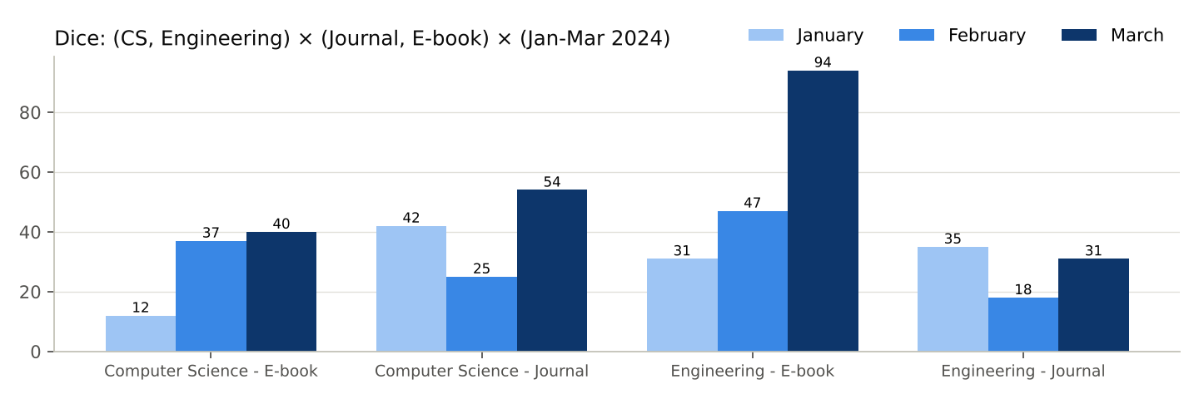
dice
department_name | resource_type | month_name | downloads
Computer Science | E-book | January | 12
Computer Science | E-book | February | 37
Computer Science | E-book | March | 40
Computer Science | Journal | January | 42
Computer Science | Journal | February | 25
Computer Science | Journal | March | 54
Engineering | E-book | January | 31
Engineering | E-book | February | 47
Engineering | E-book | March | 94
Engineering | Journal | January | 35
Engineering | Journal | February | 18
Engineering | Journal | March | 31

6. Pivot: resource types across departments
Business question 10. A pivot turns the values of one dimension (resource type) into columns; departments stay as rows. In SQL this is done with SUM(CASE WHEN ... ); in Power BI with the Matrix visual.
SELECT dp.department_name,
SUM(CASE WHEN r.resource_type = 'E-book' THEN f.download_count ELSE 0 END) AS e_books,
SUM(CASE WHEN r.resource_type = 'Journal' THEN f.download_count ELSE 0 END) AS journals,
SUM(CASE WHEN r.resource_type = 'Article' THEN f.download_count ELSE 0 END) AS articles,
SUM(f.download_count) AS row_total,
ROUND(100.0 * SUM(CASE WHEN r.resource_type = 'Journal' THEN f.download_count ELSE 0 END)
/ SUM(f.download_count), 1) AS journal_share_pct
FROM fact_digital_usage f
JOIN dim_department dp ON dp.department_key = f.department_key
JOIN dim_resource r ON r.resource_key = f.resource_key
GROUP BY dp.department_name
ORDER BY row_total DESC
department_name | e_books | journals | articles | row_total | journal_share_pct
Engineering | 1665 | 1191 | 766 | 3622 | 32.9
Computer Science | 1517 | 1192 | 814 | 3523 | 33.8
Business | 1422 | 749 | 642 | 2813 | 26.6
Health Sciences | 1087 | 759 | 566 | 2412 | 31.5
Education | 873 | 563 | 471 | 1907 | 29.5
Natural Sciences | 625 | 531 | 340 | 1496 | 35.5
Law | 570 | 495 | 223 | 1288 | 38.4
Arts & Humanities | 496 | 434 | 315 | 1245 | 34.9
Unknown | 146 | 106 | 65 | 317 | 33.4
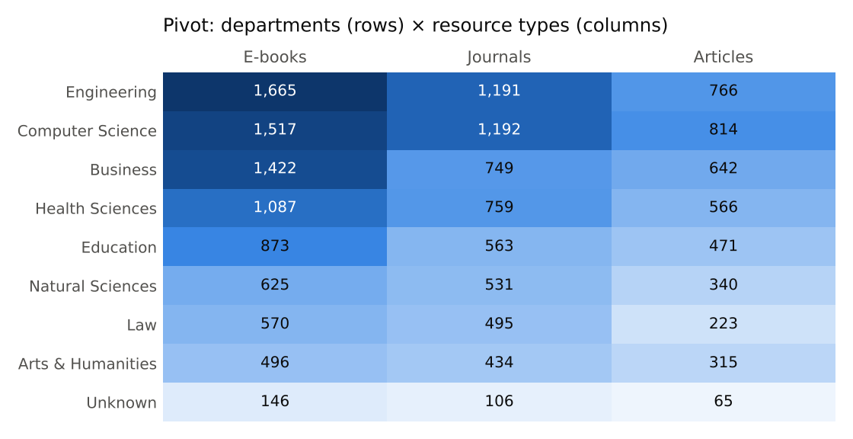{: style=“max-width:75%”}
Reading. E-books are the most downloaded type in every department. Engineering and Computer Science download the most in absolute numbers, but the share of journals is highest in Law (38%) and lowest in Business (27%) - useful when the library decides which journal subscriptions to renew.
Second pivot (Q10b): services per year by department - shows that every department borrows fewer books in 2025 than in 2023 but downloads more:
department_name | loans_2023 | loans_2025 | downloads_2023 | downloads_2025 | rooms_2023 | rooms_2025
Arts & Humanities | 46 | 43 | 375 | 511 | 41 | 73
Business | 132 | 91 | 800 | 1050 | 93 | 157
Computer Science | 150 | 109 | 915 | 1387 | 144 | 158
Education | 94 | 84 | 616 | 695 | 94 | 103
Engineering | 171 | 104 | 954 | 1541 | 167 | 186
Health Sciences | 132 | 104 | 615 | 1104 | 138 | 147
Law | 65 | 45 | 340 | 553 | 56 | 79
Natural Sciences | 68 | 46 | 340 | 688 | 49 | 63

7. Advanced analytics (bonus questions 11-13)
Question | SQL query | Python (advanced_analytics.py) | Result
11 Correlation | Q11: Pearson r on department-month pairs | scatter chart, r with and without the calendar effect | r = 0.341: moderate positive link
12 Forecast | Q12: linear trend for downloads | trend × seasonal pattern for all three services | 2026: ≈ 8,461 downloads, 482 loans, 1,083 bookings
13 Anomaly | Q13: seasonal index vs other years | expected value = trend × median season | only 2024-10 flagged (-57.3%)
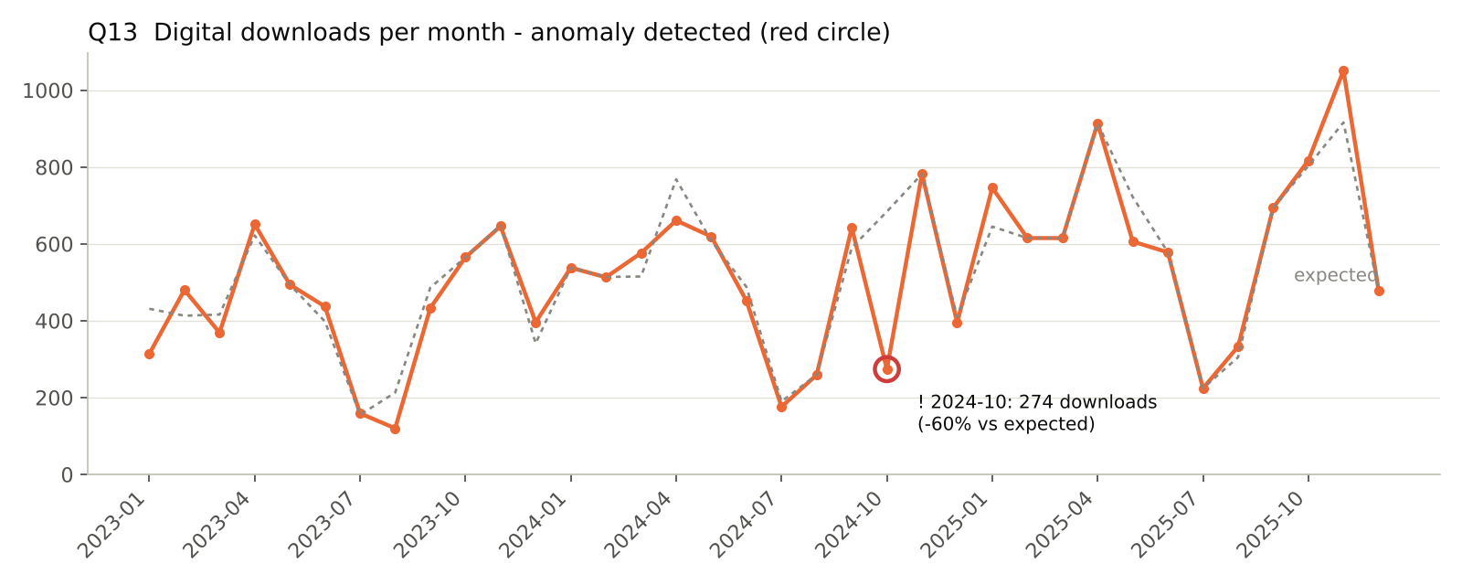
anomaly
month_label | downloads | seasonal_index | normal_index | change_pct | status
2023-01 | 314 | 0.74 | 1.13 | -34.3 | normal
2023-02 | 480 | 1.14 | 1 | 13.3 | normal
2023-03 | 369 | 0.87 | 1.07 | -18.1 | normal
2023-04 | 651 | 1.54 | 1.39 | 11.1 | normal
2023-05 | 494 | 1.17 | 1.1 | 6 | normal
2023-06 | 437 | 1.04 | 0.91 | 13.5 | normal
2023-07 | 159 | 0.38 | 0.35 | 6.3 | normal
2023-08 | 120 | 0.28 | 0.52 | -45.8 | normal
2023-09 | 433 | 1.03 | 1.2 | -14.3 | normal
2023-10 | 565 | 1.34 | 0.92 | 45.8 | normal
2023-11 | 646 | 1.53 | 1.62 | -5.4 | normal
2023-12 | 396 | 0.94 | 0.78 | 20.7 | normal
(first 12 of 36 rows)

