DATE TIME CHECKER
User Requirement

Project Code: FU-SWT
Document Code: URD-FU-SWT– v<0.1>

Record of change

*A - Added M - Modified D - Deleted
Effective Date | Changed Items | A*  M, D | Change Description | New Version
16-6-2010 | New document | A |  | 0.1
SIGNATURE PAGE

ORIGINATOR:
Name, Title Date

REVIEWERS:
Name, Title Date

Name, Title Date

APPROVAL:
Name, Title Date
TABLE OF CONTENTS
1 INTRODUCTION 5
1.1 Purpose 5
1.2 Scope 5
1.3 Definitions, acronyms and abbreviations 5
1.4 References 6
1.5 Overview 6
2 FUNCTIONALITY 7
2.1 User Interface 7
2.2 “Close” function 7
2.3 “Clear” function 8
2.4 Check Date Time function 8
3 REABILITY 12
4 PERFOMANCE 13
5 TECHNOLOGY RULES AND LIMITATIONS 14
5.1 Running Environment 14
5.2 Development Environment 14
5.3 Hardware 14

INTRODUCTION

Purpose
This URD describe the requirements of DateTimeChecker application. This document is used as a course material of Software Quality Assurance and Testing at FU.

Scope
We need an application, DateTimeChecker, which can check whether the date time input is valid or not.
The release product must have characterizes:
- Program is written with C# language
- The program will be run all Windows platform with .NET framework 2.0 or upper.
- Release product includes: source code , installation software, test cases and test report.
- The user interface must be friendly and easy to use.
- Source code follow the C# coding convention.
- All functions must be tested.
- Duration of project is 14 days.

Definitions, acronyms and abbreviations
No | Acronym/Abbreviation | Description
1 | UDD | User Requirement Document
2 | DTC | Date Time Checker application
3 | FU | FPT University

References

Overview
In next sections, UDD will describe detail of each requirement of DTC. Requirements are divided in to sub-categories:
- Functionality
- Usability
- Reliability
- Performance

FUNCTIONALITY

User Interface
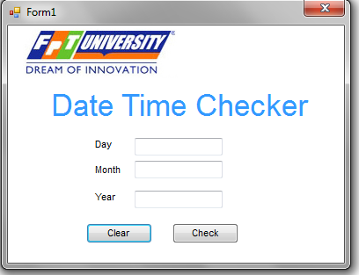
Figure 1: Screen Layout of DTC
Application must have the layout as figure 1:
- Picture box with FU Logo at the top-left corner.
- “Date Time Checker” text with fore color is “Blue” and Font Name is “Arial” and size is 26.
- “Day”, ”Month”, ”Year” texts must be left-align.
- Three textbox for inputting day, month, year
- Two button “Clear”, “Check”.
- Form without Maximize and Minimize box

“Close” function
If user click “X” button, red button at the top-right, user will be asked by a Message Box:
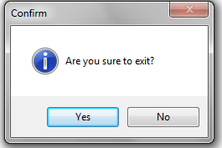
Figure 2: Confim Message Box
If user selects “Yes” option, application will exit.
If user selects “No” option, message box will close and application still exist.

“Clear” function
If user click “Clear” button, text in 3 textboxes will be clear.

Check Date Time function
- Algorithm for checking valid date time must be followed flowcharts below:
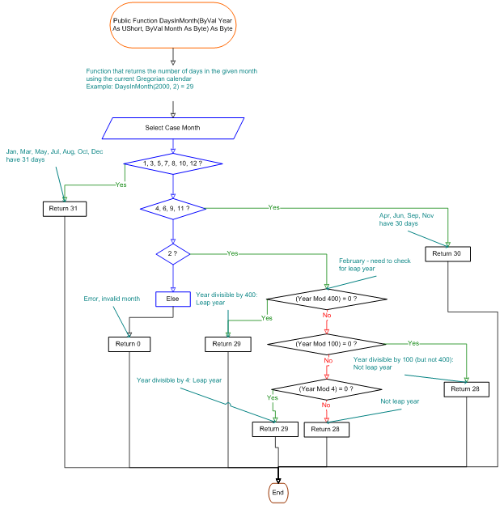
Figure 3: Check Day in Month
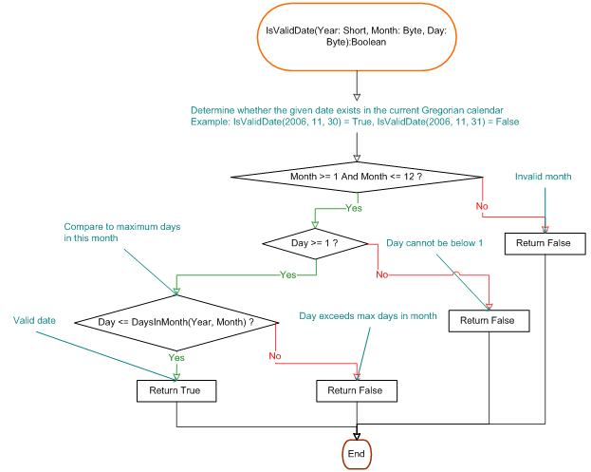
Figure 4: Check Date

- In “Day” textbox, user must be input integer number in rang 1-31.
- In “Month” textbox, user must be input integer number in rang 1-12.
- In “Day” textbox, user must be input integer number in rang 1000-3000.
- When user click button “Check”
  - If “Day” data input is not a number , Message Box will be shown:
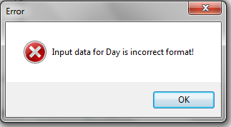
Figure 5: Error Message
  - If “Day” data input is a number but not in range, Message Box will be shown:
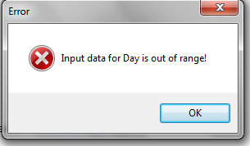
Figure 6: Error Message Out-of-Range

- Similar validation for “Month” and “Year” text box.
- If user input correct format of date time, DTC will check whether the data is valid or not:
  - If data is valid date time, Message Box will be shown (dd/mm/yyyy is replaced by actual value).
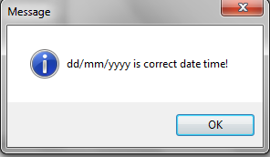
Figure 7: Correct Date Time Message Box
  - If data is invalid date time, Message Box will be shown (dd/mm/yyyy is replaced by actual value).
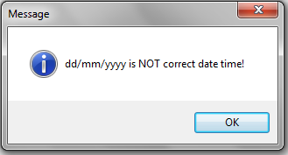

REABILITY
- Application run smoothly without any crash failure.
- Checking result is compatible with Georgian calendar.

PERFOMANCE
- Checking result must be appeared 1 second after clicking the “Check” button.

TECHNOLOGY RULES AND LIMITATIONS

Running Environment
- Application run on Windows XP SP2 or higher
- Application can run on .NET Framework 2.0 or higher.

Development Environment
- DTC will be developed on VS2005 or VS2008

Hardware
Machine for running DTC application:
- CPU: Pentim IV or higher
- RAM: 512 or higher

